To login SAP double click on “Production”.
Click here to login
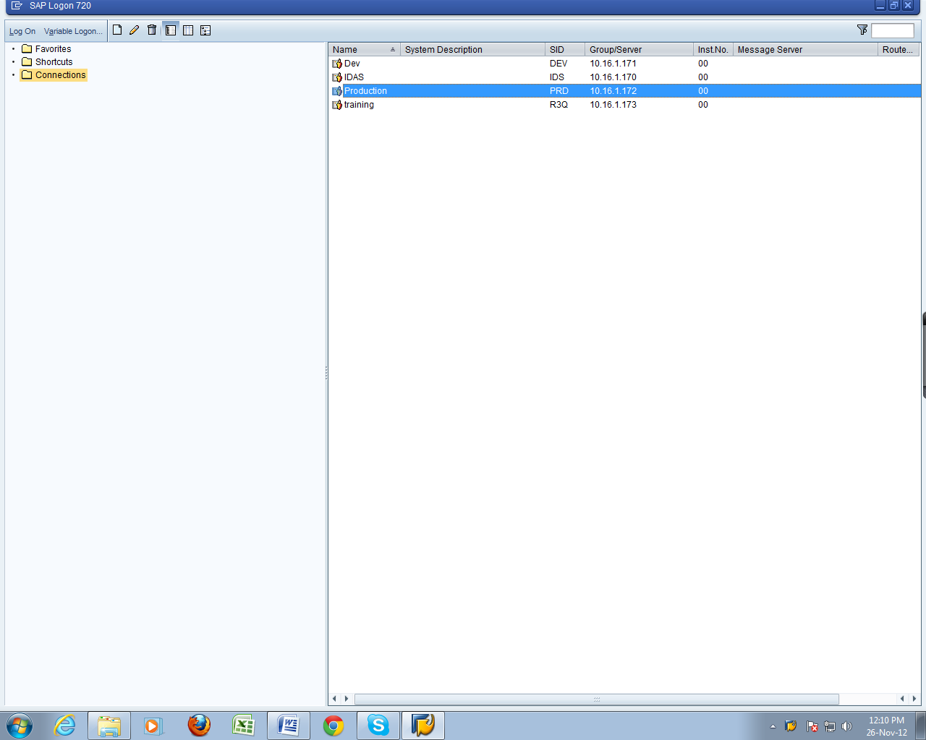

Now enter Username and Password to login.
Enter Username and Password here
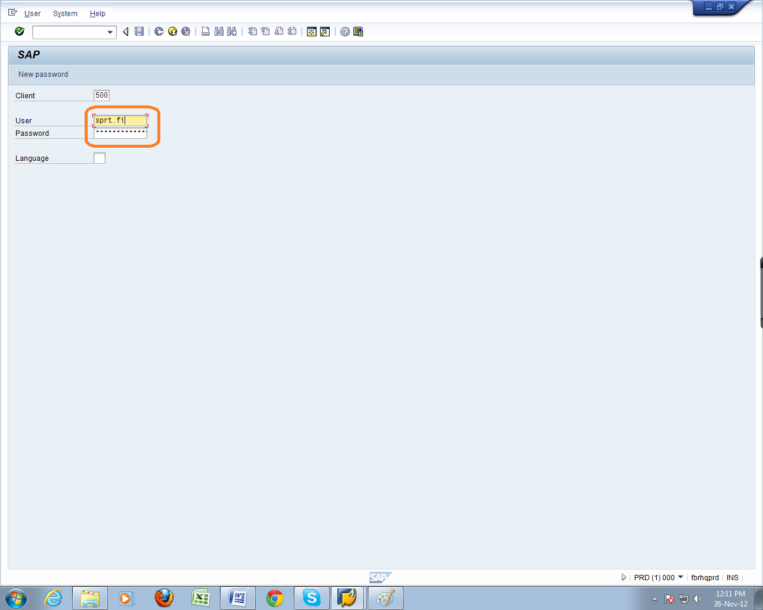

Click on “SAP Business Workplace” button.
Click here (SAP Business Work Place)
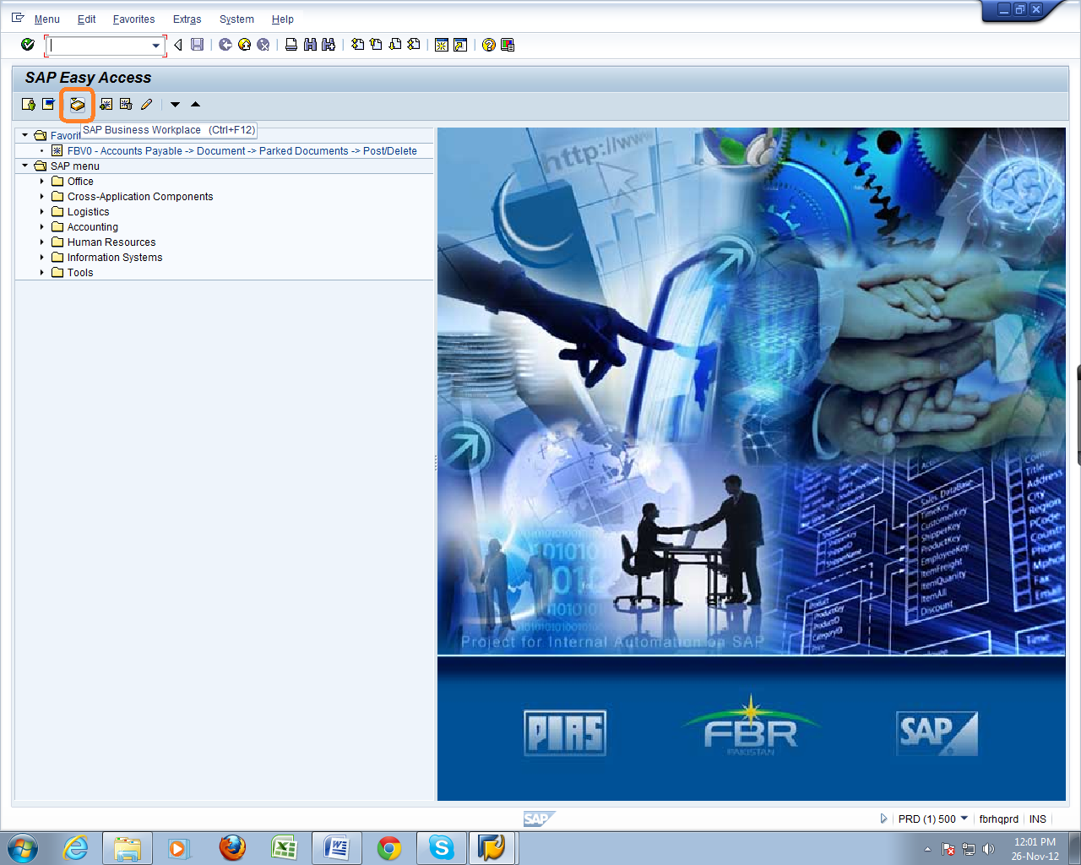

Click on “New Message” to create a message.

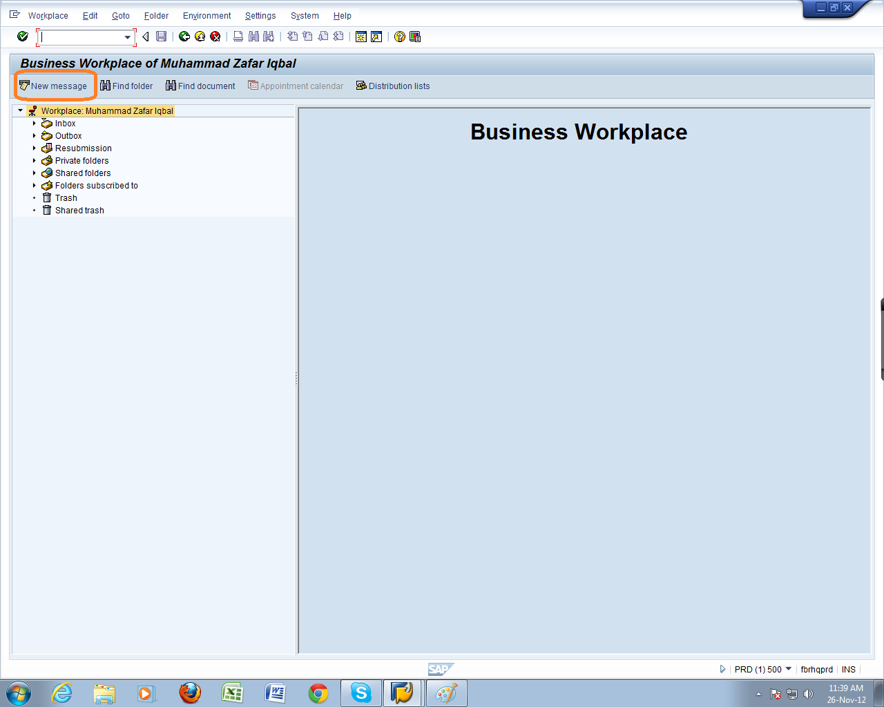
Click here
Click on “Create Attachment” to attach a document.

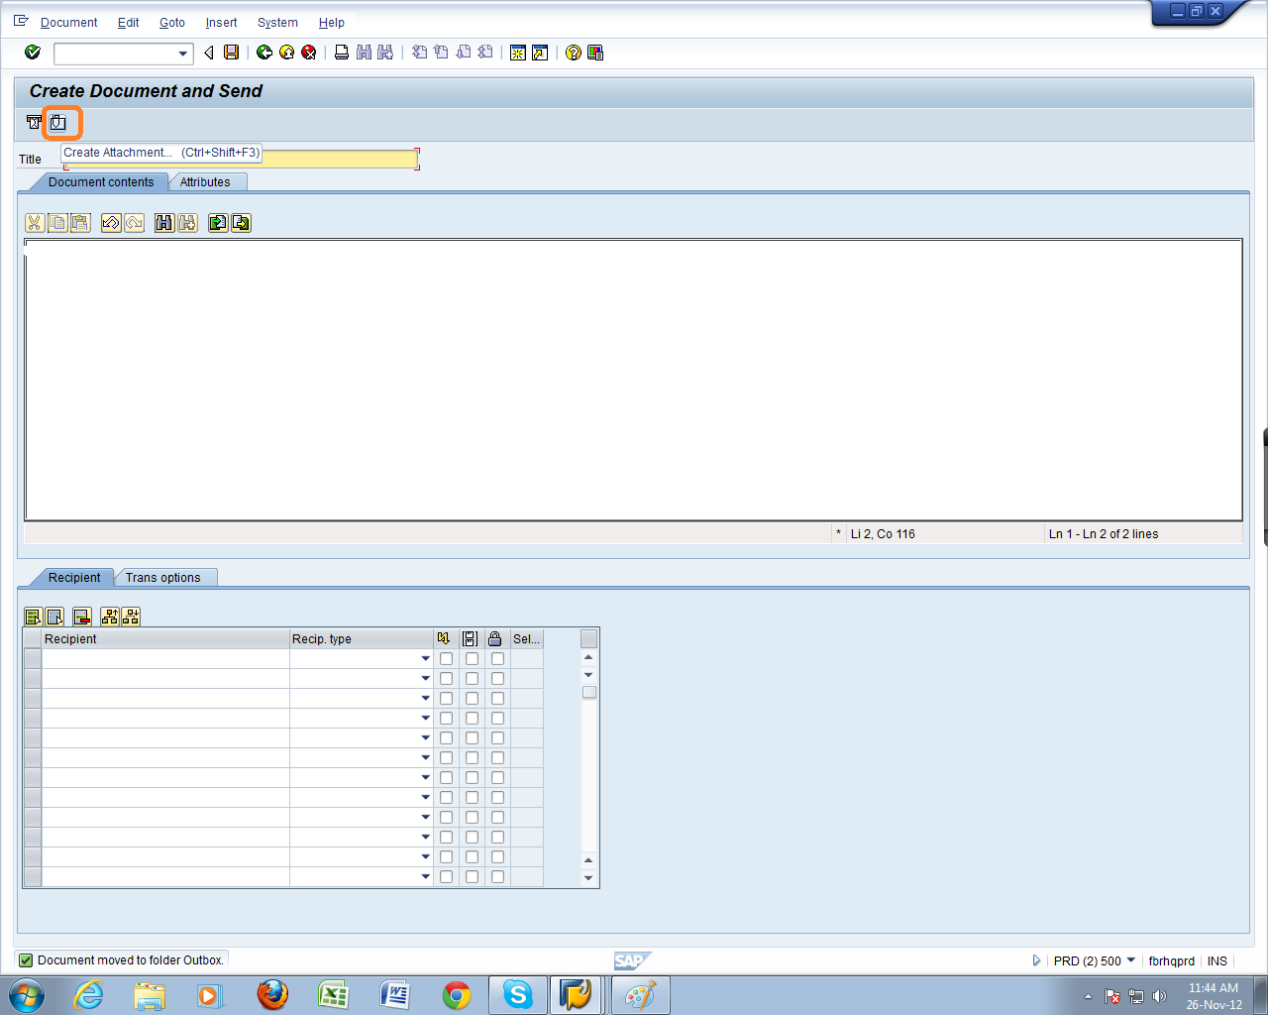
Click here
Now add recipient’s address. For Customs Demands enter “STAFF.CUSEXP” and for IR enter “STAFF.SSIRB” in recipient field.
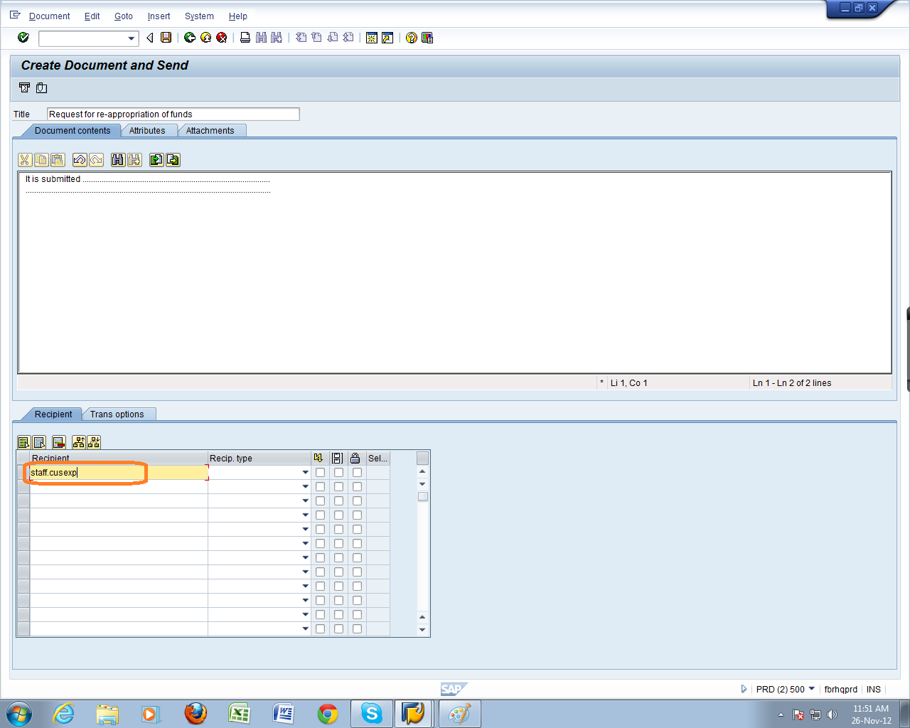
Enter Recipient here

You can see the attached document by clicking on “Attachment” tab. In case of error / mistake, Click “Delete Attachment” button to remove the current file and attach the other file by following the above steps again
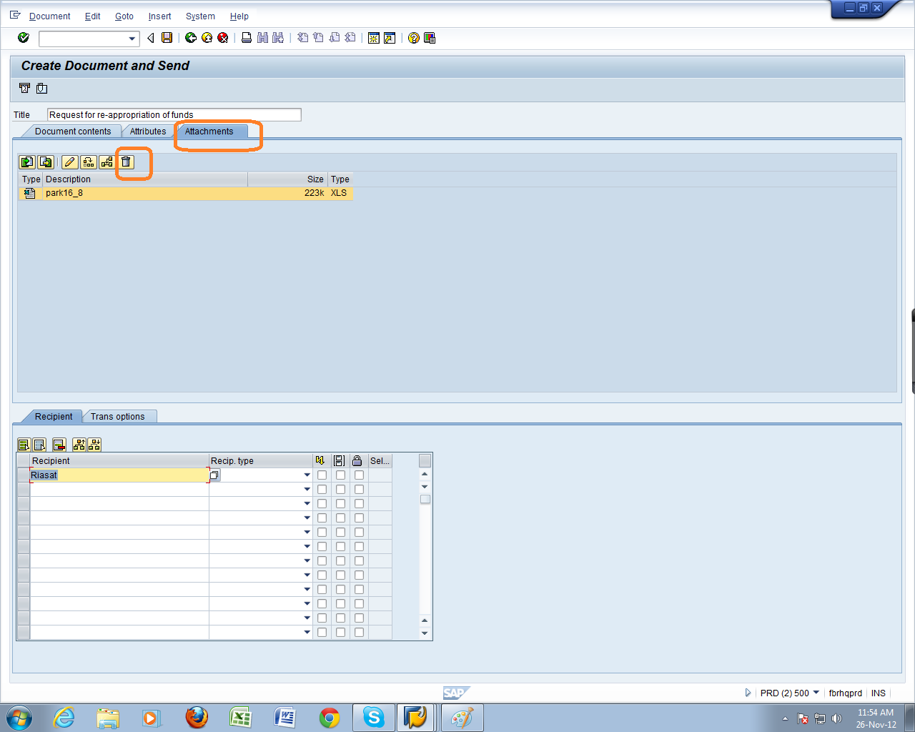
2-Click if want to delete and attach another file
1-Click here to see attachment

Click on the “Send” button to send the message.
Click to send
