(TO BE PUBLISHED IN THE GAZETTE OF PAKISTAN PART-II)

GOVERNMENT OF PAKISTAN
REVENUE DIVISION
FEDERAL BOARD OF REVENUE
****************

C.No. 57(2)S.DOS/2011-28916-R Islamabad, the 28th February,2011

NOTIFICATION
(Inland Revenue Wing, FBR)

Subject: JURISDICTION OF COMMISSIONRS INLAND REVENUE, REGIONAL TAX OFFICE, MULTAN.

In exercise of the powers conferred under sub-section (1) of section 209 of the Income Tax Ordinance, 2001 (hereinafter read as ‘Ordinance’), sub-section (1) of section 30 and section 31 of the Sales Tax Act, 1990, sub-section (1) of section 29 of the Federal Excise Act, 2005, and in supersession of the all earlier orders or notifications of the Board in respect of jurisdiction of RTO, Multan, (except the jurisdiction of Chief Commissioner Inland Revenue, RTO, Multan) the Federal Board of Revenue is pleased to direct that the Commissioners of Inland Revenue specified in column (2), shall exercise the powers and functions, as specified in column (3), in respect of the persons or classes of persons or cases or classes of cases or areas as specified in column (4) of the Table below (excluding cases or classes of cases or persons or classes of persons assigned to other RTOs/LTUs).

2. This notification shall take effect from 1st March, 2011.

TABLE

S.# | Commissioner Inland Revenue | Powers and functions | Jurisdiction
(1) | (2) | (3) | (4)
1 | Commissioner Inland Revenue (Zone-I), RTO, Multan. | The Commissioner Inland Revenue shall exercise powers and perform functions as assigned in:  - Income Tax Ordinance, 2001 and Rules thereunder;  - Sales Tax Act, 1990 and Rules thereunder;  - Federal Excise Act, 2005 and Rules thereunder;  - Wealth Tax Act, 1963 (repealed) and  - Finance Act, 1989 (Act No. V of 1989), as amended vide Finance Act, 2010. | - All cases or classes of cases, persons or classes of persons (other than companies and their directors) whose place of business is situated within the Civil Division of Dera Ghazi Khan and District Multan.  - All cases or classes of cases or classes of persons otherwise assigned to any other Commissioner of Inland Revenue.  - All cases of employees of Federal/ Provincial Government, paid by the AGPR, Sub-office, and AG Punjab/Government of Punjab, employees of Banks, Private and Public Limited Companies, Corporations; Authorities, Non-profit Organizations/Non-Government Organizations and other persons, whose place of employment falling within the Civil Division of D.G. Khan and District Multan;  - Monitoring and Enforcement of withholding taxes under the Provisions of the laws and rules specified in column 3 (of the table) in respect of all withholding agents existing in the territorial limits CIR, Zone-I, RTO, Multan.  - Cases or classes of cases, persons or classes of persons or cases assigned by the Federal Board of Revenue from time to time;
2 | Commissioner Inland Revenue (Zone-II), RTO, Multan. | The Commissioner Inland Revenue shall exercise powers and perform functions as assigned in:  - Income Tax Ordinance, 2001 and Rules thereunder;  - Sales Tax Act, 1990 and Rules thereunder;  - Federal Excise Act, 2005 and Rules thereunder;  - Wealth Tax Act, 1963 (repealed) and  - Finance Act, 1989 (Act No. V of 1989), as amended vide Finance Act, 2010. | - All cases of companies whose registered office is situated within the areas falling in the Civil Districts of Multan, Khanewal, Dera Ghazi Khan, Muzaffargarh, Layyah, Rajanpur, Sahiwal, Pakpattan and Vehari and the following non-corporate class or classes of cases whose place of business is situated within the territorial jurisdiction of Tehsil Multan.  - Ghee mills, solvent plants and Tea;  - Soap/Soap stocks;  - Shoe maker;  - Medical profession/business/ hospitals/clinics/ medicines/chemicals/ Pharmaceutical/Pesticides/ Fertilizers and seeds;  - Legal, engineering and consultancy profession;  - Ice Factories and cold storages;  - Auto parts, motorcycles, battery and agri. Tractors, computer parts, show rooms of vehicles/car dealers  - Hotels, Restaurants, Guest Houses, Marriage halls, Tent Services, Food items, Sugar, Beverages, Fruit Juices, Aerated water, Bakers, Confectioneries, Sweets Makers / Meat Sellers.  - Electronics Goods, Plastic products, Misc. products.  - Private Educational Institutions including Tuition Centers.  - Jewelers.  - General order suppliers.  - Iron Steel/Metal Containers, PVC/RCC pipes.  - Textile, Power Looms, Cloth Articles, Spinning, Weaving, Sizing, Calendaring, Scouring, Mercerizing , Printing and other allied processing.  - Importers/Exporters, Customs agents.  - Paper cone/packages.  - Building components, timber merchants/furniture.  - Energy producers.  - Advertisement.  - Arms and Ammunitions dealers.  - Cigarettes dealers.  - Property Dealers, Real Estate Developers.  - Commission Agents/Traders of Ghallah Mandi/Sabzi Mandi.  - Wool merchant, Tanners/ Leather Merchants.  - Co-operative societies.  - Travel Agencies.  - Licensees of card pay phone service.  - Plying of passenger motor vehicles and goods transport vehicles including carriage contractors.  - AOPs, RF, URF & Individuals engaged in the business of Petrol Pumps/Petroleum Products, CNG Stations, CNG Kits/Composite Units and Flour Mills excluding Atta Chakkies located in the Districts of Multan, Khanewal, Dera Ghazi Khan, Muzaffargarh, Layyah, Rajanpur, Sahiwal, Pak Pattan and Vehari of the Province of Punjab;  - AOPs, RF, URF & Individuals engaged in the business of cotton ginning, oil mills/composite units located in the districts of Multan, Khanewal, Muzaffargarh, D.G. Khan, Layyah & Rajanpur.  - All cases of Directors of companies as specified in Paragraph (a).  - All cases of non-resident persons or classes of persons falling within the Civil Districts of Multan, Khanewal, Dera Ghazi Khan, Muzaffargarh, Layyah, Rajanpur, Sahiwal, Pak Pattan and Vehari of the Province of Punjab;  - Monitoring and Enforcement of withholding taxes under the Provisions of the laws and rules specified in column 3 (of the table) in respect of all withholding agents existing in the territorial limits of CIR, Zone-II, RTO, Multan.  - Cases or classes of cases, persons or classes of persons assigned by the Federal Board of Revenue from time to time.
3 | Commissioner Inland Revenue (Zone-III), RTO, Multan. | The Commissioner Inland Revenue shall exercise powers and perform functions as assigned in:  - Income Tax Ordinance, 2001 and Rules thereunder;  - Sales Tax Act, 1990 and Rules thereunder;  - Federal Excise Act, 2005 and Rules thereunder;  - Wealth Tax Act, 1963 (repealed) and  - Finance Act, 1989 (Act No. V of 1989), as amended vide Finance Act, 2010. | - All cases or classes of cases, persons or classes of persons (other than companies and their Directors) whose place of business is situated in the areas falling within the Civil Districts of Sahiwal, Pakpattan, Vehari, and Khanewal.  - All cases or classes of cases or persons or classes of persons otherwise not assigned to any other Commissioner of Inland Revenue.  - All cases of employees of Federal/ Provincial Government, paid by the AGPR, Sub-office, and AG Punjab/Government of Punjab, employees of Banks, Private and Public Limited Companies, Corporations; Authorities, Non-profit Organizations/ Non-Government Organizations and other persons, whose place of employment is in the Civil Districts of Sahiwal, Pakpattan, Vehari and Khanewal.  - All cases of representatives assessable under sections 172 and 173 of the Income Tax Ordinance, 2001, falling within the territorial limits of RTO, Multan.  - Monitoring and Enforcement of withholding taxes under the Provisions of the laws and rules specified in column 3 (of the table) in respect of all withholding agents existing in the territorial limits of CIR, Zone-III, Multan.  - Cases or classes of cases, persons or classes of persons or cases assigned by the Federal Board of Revenue from time to time; and
4. | Commissioner Inland Revenue, Information Processing & TFD), RTO, Multan | - Maintenance of physical and electronic records;  - Receipt of communication received in Tax Facilitation Division and from other Inland Revenue Authorities;  - Data entry of receipts and information contained in the communication received in Tax Facilitation Division and from other Inland Revenue Authorities;  - Cross matching of information collected from taxpayers and other sources and issuance of discrepancy report to Inland Revenue Authorities;  - Dispatch of hard copies to Inland Revenue Authorities on demand or otherwise;  - Storage of information, documents, statements returns and all other communications received from all Inland Revenue Authorities and sources;  - Receive returns, statements, statutory notices, documents applications from taxpayers, mail from other Inland revenue Authorities, tax payment receipts (Challans) from Banks and all outside communications;  - Sort and /disseminate information, documents returns, statements and mail mentioned at (a) above, to concerned Inland Revenue Authorities.  - Communicate assessment orders/ penalty orders and demand notices to taxpayers. | All cases or classes of cases, persons or classes of persons pertaining to the jurisdiction of RTO, Multan.
5. | Commissioner Inland Revenue, (Human resource Management Division), RTO, Multan. | To support line management in identifying HR needs of the Unit, to ensure staff recruitment in line with FBR’s policies, training and development of staff, maintenance of easily retrievable employees’ data detailed as under:  - Posting of Officers / Officials (BS1-18) in the RTO with the approval of Chief Commissioner;  - Career planning.  - Help line management in identifying HR needs.  - Maintenance of employees’ profiles and personal files.  - Development of job descriptions.  - Positive attitude building.  - Regulation of performance related pecuniary incentives.  - Training and development according to training needs analysis.  - Coordination with FBR on various HRM areas.  - Initiation of disciplinary proceedings, processing and finalization thereof; and  - Monitoring and implementation performance appraisal system. | All Officers / Officials posted in RTO, Multan.
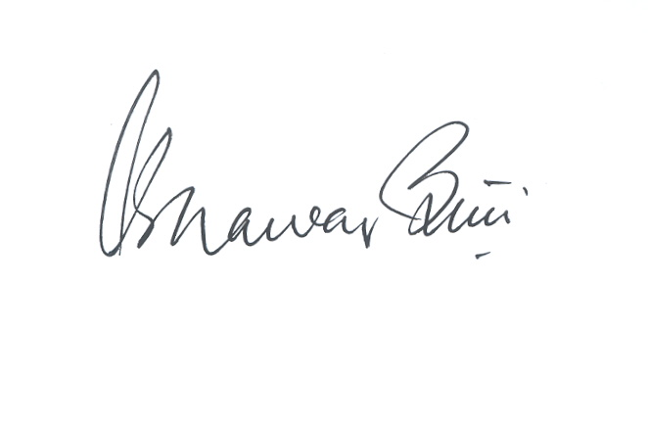
(Khawar Khurshid Butt)
Member (Inland Revenue)
The Manager,
Printing Corporation of Pakistan Press,
Islamabad.

Distribution:

- The Staff Officer to Chairman, FBR.
- All Members, FBR, Islamabad.
- The Chief Commissioners Inland Revenue, LTUs, Karachi/Lahore/Islamabad.
- All Chief Commissioners Inland Revenue, Regional Taxpayers’ Offices.
- The Director General, Withholding Taxes, Karachi.
- The Director General, Internal Audit (DT), Islamabad.
- The Director General, RRA,(Audit) North, Lahore.
- The Director General, Training & Research (DOT), Lahore.
- The Chief (Management), FBR, Islamabad.
- The CEO, PRAL, Islamabad- with the request to make necessary changes on the FBR Web-portal under intimation to taxpayers and this office.
- All officers of the Board.
- The Joint Director (CRO), FBR, Islamabad.
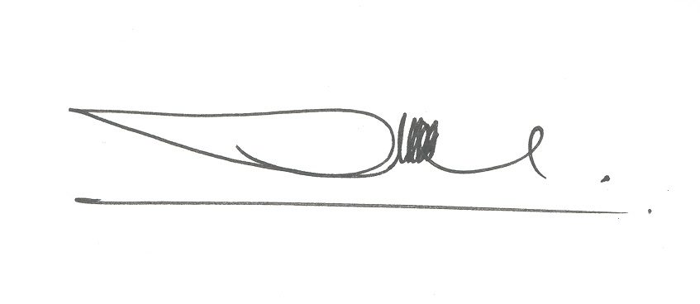
(Ali Husnain)
Secretary (Inland Revenue-III)

