THE SALES TAX RULES 2006

Updated by a team of ST&FE Policy Wing, FBR consisting of
Badruddin Ahmad Quraishi, Chief;
Ghulam Sarwar Shah, Secretary (L&P);
Muhammad Zaheer Qureshi, Secretary (STB);
Zahid Baig, I.R.Audit Officer and
Tahir Akram, Stenotypist (STB)

Updated upto 11.08.2014

(Any inadvertent error may kindly be reported for necessary correction to any of above mentioned officers at following phone numbers):

Ph: 051-9219544
Ph: 051-9222276
Ph: 051-9206802
Ph: 051-9207540-327

May not be use as a reference in courts

Sales Tax Rules 2006
THE SALES TAX RULES, 2006................................................................................................................6 1. Short title, application and commencement..............................................................................6 2. Definitions.....................................................................................................................................6 CHAPTER- I..............................................................................................................................................12 REGISTRATION, COMPULSORY REGISTRATION AND DE-REGISTRATION.......................12 3. Application..................................................................................................................................12
4. Requirement of registration......................................................................................................12 5. Application for registration ......................................................................................................13 6. Compulsory registration ...........................................................................................................14 7. Change in the particulars of registration.................................................................................15 8. Transfer of registration.............................................................................................................15 9. Option to file application with LRO.........................................................................................16 10. Cancellation of multiple registrations......................................................................................16 11. De-registration............................................................................................................................16 12. Blacklisting and suspension of registration.............................................................................17
CHAPTER-II..............................................................................................................................................19 FILING OF RETURNS.............................................................................................................................19 13. Application..................................................................................................................................19 [14. Filing of returns..........................................................................................................................19 15. Receipt of return by the Bank...................................................................................................19 16. Payment of service charges to the Bank ..................................................................................20 17. Filing of Annual Sales Tax return............................................................................................21 [18. Electronic filing of Sales Tax return. .......................................................................................21 CHAPTER-III............................................................................................................................................22 CREDIT AND DEBIT NOTE AND DESTRUCTION OF GOODS.....................................................22 19. Application..................................................................................................................................22 20. Cancellation or return of supply ..............................................................................................22 21. Change in value of supply or amount of sales tax...................................................................22 22. Adjustment of input and output tax.........................................................................................23 23. Destruction of goods ..................................................................................................................24 CHAPTER-IV............................................................................................................................................25 APPORTIONMENT OF INPUT TAX....................................................................................................25 24. Application..................................................................................................................................25 25. Determination of input tax........................................................................................................25 CHAPTER-V..............................................................................................................................................26 REFUND.....................................................................................................................................................26 26. Application..................................................................................................................................26 27. Establishment of Refund Division and posting of officers.....................................................27 28. Filing of refund claim................................................................................................................28 29. Scrutiny and processing of refund c1aim................................................................................29 30. Sanction and payment of refund c1aim...................................................................................29 31. Scrutiny and processing of refund claims filed by manufacturers of specified goods.........30 32. Scrutiny and processing of refund claims relating to commercial exporters.......................31 32 Extent of payment of refund c1aim..........................................................................................31 [34. Refund of excess input tax not relating to zero-rated supplies..............................................31 35. Responsibility of the claimant...................................................................................................33 36. Post-sanction audit of refund claims........................................................................................33 37. Action on inadmissible claims...................................................................................................33 38. Supportive documents...............................................................................................................33 39. Miscellaneous and savings.........................................................................................................35

1

Sales Tax Rules 2006
[39A. Processing of refund claims in LTUs........................................................................................35 CHAPTER VI.............................................................................................................................................37 SPECIAL AUDIT......................................................................................................................................37 40. Application..................................................................................................................................37 41. Special Audit...............................................................................................................................37 42. Scope of special audit.................................................................................................................37 43. Form of audit report..................................................................................................................37 44. Penalty.........................................................................................................................................37 CHAPTER VII...........................................................................................................................................38
ZERO-RATING OF SUPPLIES AGAINST INTERNATIONAL TENDER FOR AFGHAN REFUGEES................................................................................................................................................38
45. Application..................................................................................................................................38 46. Procedure and conditions for making zero-rated supplies....................................................38 47. Maintenance of records.............................................................................................................38 48. Refund.........................................................................................................................................39 49. Penalty.........................................................................................................................................39 50. Other International Tenders.....................................................................................................39 CHAPTER VIII .........................................................................................................................................40
SUPPLY OF ZERO-RATED GOODS TO DIPLOMATS, DIPLOMATIC MISSIONS, PRIVILEGED PERSONS AND PRIVILEGED ORGANISA TIONS.................................................40
51. Application..................................................................................................................................40 52. Supplies to diplomat and diplomatic missions........................................................................40 53. Supplies to privileged persons...................................................................................................40 54. Supply of POL products to privileged persons.......................................................................41 55. Refund.........................................................................................................................................41 56. Supplies to the United Nations and organizations working under it....................................41 57. Supplies to Privileged Organizations other than the United Nations...................................42 CHAPTER IX.............................................................................................................................................43 TAXPAYER'S AUTHORIZED REPRESENTATIVES........................................................................43 58. Application..................................................................................................................................43 59. Persons authorized to represent a taxpayer............................................................................43 60. Disqualifications.........................................................................................................................43 61. Procedure to appoint authorized representative ....................................................................44 62. Power to disqualify ....................................................................................................................44 CHAPTER X..............................................................................................................................................45 ALTERNATIVE DISPUTE RESOLUTION..........................................................................................45 63. Application..................................................................................................................................45 64. Application for Alternative Dispute Resolution......................................................................45 65. Appointment of Alternative Dispute Resolution Committee................................................45 66. Working of the Committee........................................................................................................45 67. Recommendations of the Committee .......................................................................................46 68. Reconsideration by the committee ...........................................................................................46 69. Decision of the Board.................................................................................................................46 CHAPTER XI.............................................................................................................................................48 RECOVERY PART-I................................................................................................................................48 70. Application...................................................................................................................................48 71. Initiation of recovery action........................................................................................................48 72. Stoppage of clearances and sealing of business premises.........................................................48 73. Demand Dote..............................................................................................................................49 74. Attachment and sale of property..............................................................................................49

2

Sales Tax Rules 2006
75. Master registers to be maintained by the referring authority and the Recovery Officer...49 76. Power to require information to be furnished. .......................................................................50 77. Mode of service of notice...........................................................................................................50 78. Disposal of proceeds of execution.............................................................................................50 80. Property liable to attachment and sale in execution...............................................................50 81. Objections and investigations, thereof.....................................................................................52 82. Removal of attachment on satisfaction of cancellation of a demand note............................52 83. Officer entitled to attach and sell. ............................................................................................52 84. Adjournment or stoppage of sale..............................................................................................52 85. Defaulter not to interfere with attached property..................................................................52 86. Prohibition against bidding or purchase by officer................................................................52 87. Assistance for action..................................................................................................................53 PART-II......................................................................................................................................................54 A TT ACHMENT AND SALE OF MOVABLE PROPERTY..............................................................54 88. Warrant of attachment..............................................................................................................54 89. Service of copy of warrant ........................................................................................................54 90. Attachment.................................................................................................................................54 91. Property attached how to be dealt with...................................................................................54 92. Search how to be made..............................................................................................................54 93. Seizure after search of a building or premises...........................................................................54 94. Seizure between sunrise and sunset .........................................................................................55 95. Seizure not to be excessive.........................................................................................................55 96. Attachment of movable property which cannot be removed due to certain reasons..........55 97. Storage of seized movable property.........................................................................................55 98. Attachment of negotiable instrument.......................................................................................55 99. Attachment of property in custody of public officer..............................................................55 100. Attachment of share in movable property...............................................................................55 101. Attachment of' property in partnership..................................................................................55 102. Sales.............................................................................................................................................56 103. Proclamation of sale...................................................................................................................56 104. Sale after fifteen days.................................................................................................................56 105. Sale by public auction................................................................................................................56 106. Sale by tender or sealed bids.....................................................................................................57 107. Preference for the co-owner......................................................................................................57 108. Transfer of title ..........................................................................................................................57 109. Irregularity not to vitiate sale...................................................................................................57 110. Negotiable instrument or share in a corporation....................................................................57 111. Order for payment of coin or currency notes to the Referring Authority...........................57 PART-III.....................................................................................................................................................58 A TTACHMENT AND SALE OF IMMOVABLE PROPERTY..........................................................58 112. Attachment of immovable property..........................................................................................58 113. Service of order ..........................................................................................................................58 114. Proclamation of attachment.......................................................................................................58 115. Sale and proclamation of sale....................................................................................................58 117. Time of sale..................................................................................................................................58 118. Sale to be by public auction or tender.......................................................................................59 119. Deposit by purchaser and re-sale in default.............................................................................59 120. Procedure in default of payment...............................................................................................59 121. Amount recoverable from purchaser in default ......................................................................59 122. Authority to bid............................................................................................................................59

3

Sales Tax Rules 2006
123. Application to set aside sale of immovable property................................................................59 124. Application to set aside sale of immovable property on ground of non-service of
proclamation or irregularity.....................................................................................................60 125. Setting aside of sale where defaulter has no saleable interest..................................................60 126. Confirmation of sale ....................................................................................................................60 127. Return of purchase money in certain cases...............................................................................60 128. Sale Certificate.............................................................................................................................61 129. Postponement of sale to enable defaulter to raise amount due under notice.........................61 130. Issue of fresh proclamation before re-sale.................................................................................61 131. Bid of co-owner to have preference............................................................................................61
PART - IV...................................................................................................................................................62 APPOINTMENT OF RECEIVER...........................................................................................................62 132. Appointment of receiver for business ......................................................................................62 133. Appointment of receiver for immovable property..................................................................62 134. Qualification for receiver..........................................................................................................62 135. Manner of working of receiver.................................................................................................62 136. Withdrawal of management......................................................................................................63 PART-V ......................................................................................................................................................64 MISCELLANEOUS ..................................................................................................................................64 137. Offences and penalties...............................................................................................................64 138. Continuance of proceedings......................................................................................................64 139. Recovery from surety ................................................................................................................64 140. Receipt to be given.....................................................................................................................64 141. Delivery of property in occupancy of defaulter ......................................................................64 142. Delivery of property in occupancy of tenant...........................................................................64 143. Resistance or obstruction by defaulter. ...................................................................................64 144. Resistance or obstruction by a bona fide claimant.................................................................65 145. Dispossession by certificate holder or purchaser....................................................................65 146. Bona fide claimant to be restored to possession......................................................................65 147. Rules not applicable to transferee pendente lite.....................................................................65 148. Delivery of moveable property, debts and share.....................................................................65 149. Execution of documents and endorsement of negotiable instruments..................................66 150. Form............................................................................................................................................66 [CHAPTER XII..........................................................................................................................................67 SPECIAL PROCEDURE FOR ACCESSING THE COMPUTERIZED SYSTEM...........................67 150A. Application..................................................................................................................................67 150B. Authorization..............................................................................................................................67 150C. Unique User Identifier................................................................................................................67 150D. Access to computerized system..................................................................................................67 150E. Responsibility of the user...........................................................................................................67 150F. Cancellation of registration.......................................................................................................67 150G. Recording of transmissions........................................................................................................68 150H. Scrutiny of records......................................................................................................................68 CHAPTER XIII .........................................................................................................................................69 ELECTRONIC INTERMEDIARIES..................................................................................................69 150J. Appointment of e-intermediary:................................................................................................69 150K. Cancellation of appointment.....................................................................................................70 150L. Procedure to be followed by registered persons.......................................................................70 150M. Procedure to be followed by e-intermediary. ..........................................................................70 150N. Responsibilities of e-intermediary.............................................................................................70

4

Sales Tax Rules 2006
150O. Responsibility of e-dec1aration Administrator........................................................................71 150P. Scrutiny of records......................................................................................................................71 CHAPTER XIV..........................................................................................................................................72
SPECIAL PROCEDURE FOR ISSUANCE OF ELECTRONIC SALES TAX INVOICES BETWEEN BUYERS AND SELLERS ...................................................................................................72
150Q. Application.. ...............................................................................................................................72 150R. Eligibility to use electronic invoicing system...........................................................................72 150S. Issuance of electronic invoice and record................................................................................72 150T. Transmission of electronic invoice to the Collector................................................................72 150U. Use of formats and controls over transmission of electronic invoices...................................72 150V. Conditions for electronic storage..............................................................................................73 150W. Audit............................................................................................................................................73 150X. Same conditions to apply in respect of buyer for receiving electronic invoices...................73 150Y. Failure to meet the conditions for electronic invoicing system..............................................74 150Z. Provisions of Electronic Transactions Ordinance, 2002, to apply.........................................74 [CHAPTER XV..........................................................................................................................................74 REPEAL.....................................................................................................................................................74 151. Repeal..........................................................................................................................................74

5

Sales Tax Rules 2006
1Notification No.S.R.O.555(1)/2006, dated 5th June, 2006.--In exercise of the powers conferred by sub-section (I) of section 4 and section 40 of the Federal Excise Act, 2005, section 219 of the Customs Act, 1969 (IV of 1969), section 50 of the Sales Tax Act, 1990, read with sub-section (2) of section 8 2[, clause (b) of sub-section (1) of section 8], clause (ii) of sub-section (2) of section 8B, sections 9, 10, 14, 21 and 28, clause (c) of sub-section (1) of section 22, first proviso to sub-section (1) of section 23, section 26, section 33, sub-section (6) of section 47 A, sections 48, 50A, 3[52, 52A] and 66 thereof, the 4[Federal] Board of Revenue is pleased to make the following rules, namely;

THE SALES TAX RULES, 2006

1. Short title, application and commencement.--(I) These Rules may be called the Sales Tax Rules, 2006.
(2) They shall be applicable to such persons or class of persons as are specified in the respective Chapters.
(3) They shall come into force on the first day of July, 2006.

2. Definitions. -- (1) In these Rules, unless there is anything repugnant to the subject or context,--
(i) "Act" means the Sales Tax Act, 1990;

(ii) "Accountant" means—

3. Reported as PTCL 2007 st. 190.
4. The comma, words, brackets figures and letters inserted by Notification No .S.R.O 307(1)/2008,dated 24 March, 2008, reported as PTCL2008 St.1822(ii)
5 The words, figures, brackets and comma inserted by Notification No. S.R.O. 191(I)/2012, dated 23rd February, 2012, w.e.f. 1st March, 2012, reported as PTCL 2012 St. 807

6 The words, figures, brackets and comma inserted by Notification No. S.R.O. 793(I)/2011, dated 24th August, 2011, w.e.f. 1st July, 2011, reported as PTCL 2012 St. 364

7 The words, figures, brackets and comma inserted by Notification No. S.R.O. 191(I)/2012, dated 23rd February, 2012, w.e.f. 1st March, 2012, reported as PTCL 2012 St. 807

8 Substituted for the figure “52” by Notification No. S.R.O 470(1)/2007, dated 9th June, 2007 w,e,f Ist day of July, 2007, reported as PTCL 2007 st.1726.

9 Substituted for the figure “Central” by Notification No. S.R.O 307(1)/2008, dated 24th March, 2008, reported as PTCL 2007 st. 1822(ii)
6

(a) a Chartered Accountant within the meaning of the Chartered Accountants.
Ordinance, 1961 (X of 1961); or

(b) a Cost and Management Accountant within the meaning of the Cost and
Management Accountants Act, 1966 (XIV of 1966); or

(c.) a member of any association of accountants recognized in this behalf by the
Federal Government;

(iii) "Adjudicating authority" means any officer appointed to Adjudicate and decide cases

under section 179 of the Customs Act, 1969 (IV of 1969), section 45 of the Sales Tax

Act, 1990, and section 31 of the Federal Excise Act, 2005;

(iv) "Agreement" means the agreement executed between the Board and the Bank for the

purposes of payment of tax and submission of tax returns;

(v) "attachment officer" means an officer, not below the rank of Principal Appraiser or Superintendent or Senior Auditor, authorized by the Recovery Officer to perform any of the functions under these rules;
(vi) "Bank" means the National Bank of Pakistan or any of its branches designated, by

notification in the official Gazette, for the purpose of filing of returns and payment of

sales tax;

(vii) "Board" means the 5[Federal Board Of Revenue];

(viii) "claimant" means any registered person who files a claim for refund of sales tax under these rules;
ix) "Collector" means the Collector of Sales Tax having jurisdiction;
___________________________
10 Any reference to “Superintendent” and Senior Auditor” shall be construed as reference to “Superintendent Inland Revenue and Senior Auditor Inland Revenue” respectively by virtue of section 72A of the Sales Tax Act, 1990. Powers and functions of “Superintendent of Sales Tax” and “Senior Auditor of Sales Tax” shall be exercised by “Superintendent Inland Revenue” and “Senior Auditor Inland Revenue” respectively vide FBR’s Order C. No. 1(6)IR-Judicial/2009, dated 11th November, 2009, w.e.f. 28th October, 2009

11 Sbustituted for the words “Central Board of Revenue” by Notification No. S.R.O. 530(I)/2008, dated 11th June, 2008, w.e.f. 1st July, 2008, reported as PTCL 2008 St. 1882

12 Any reference to “Collector” shall be construed as reference to “Commissioner Inland Revenue” by virtue of section 72A of the Sales Tax Act, 1990. Powers and functions of “Collector of Sales Tax” shall be exercised by “Commissioner Inland Revenue” vide FBR’s Order C. No. 1(6)IR-Judicial/2009, dated 11th November, 2009, w.e.f. 28th October, 2009.
7
Sales Tax Rules 2006

(x) "Collectorate" means the office of the Collector of Sales Tax having jurisdiction and

includes the Large Taxpayers Unit (LTU) and the Regional Tax Office (RTO), where the

offices of Income Tax, Sales Tax and Federal Excise are co-located;

(xi) "commercial exporter" means a person registered as 6[an] exporter, who does not have his

own manufacturing facility and is exporting the goods, whether in the same state or after

getting them processed or manufactured from one or more registered persons, and holds

a valid sales tax invoice for such processing, manufacturing or conversion;

(xii) "committee" means a committee constituted under sub-section (2) of section 47A of the

Act;

(xiii) "Computerized Payment Receipt" means a computer generated receipt showing payment of tax to the designated branch of the National Bank of Pakistan;

7[(xiii-a) "CREST" means "Computerized Risk-based Evaluation of Sales Tax;]

(xiv) "CRO" means Central Registration Office established for the purposes of centralized sales tax registration;
(xv) "CSTRO" means Centralized Sales Tax Refund Office to be established in the 8[Federal

Board of Revenue] for disbursement of refund of sales tax;

(xvi) "defaulter" means a person mentioned in the demand note, who has failed to discharge his liabilities in payment of Government dues;

(xvii) "demand note" means a note received by the Sales Tax Recovery Officer from the

referring authority specifying the details regarding the defaulter and the Government dues;

^{13.} Now Regional Tax Office (RTO)

14. Substituted for the words “a commercial” by Notification No. S.R.O 470(1)/2007, dated 9th June, 2007 w.e.f Ist day of July, 2007 reported as PTCL 2007 st.1726.

15 Clause (xiii-a) inserted by Notification No. S.R.O 470(1)/2007, dated 9th June, 2007 w.e.f Ist day of July, 2007 reported as PTCL 2007 st.1726
16 Substituted for the words “Central Board of Revenue” by Notification No. S.R.O 530(1)/2008, dated 11th June, 2008, w.e.f. Ist day of July, 2008 reported as PTCL 1882.

7

Sales Tax Rules 2006 9[(xviii) * * *]

(xix) "diplomat" means a person entitled to immunities and privileges under the

Diplomatic and Consular Privileges Act, 1972 (IX of 1972);

(xx) "diplomatic mission" means a mission recognized as such under the Diplomatic and Consular Privileges Act, 1972 (IX of 1972);

(xxi) "dispute" means a case where, for evidently valid reasons, a registered person is aggrieved

in connection with the order of the sales tax officer passed in any matter of sales tax

specified in sub-section (1) of section 47 A of the Act and prima facie deserves relief for

the elimination of possible hardship;

10(xxi-a) "e-declaration administrator" means an officer not below the rank of an Additional Collector of Sales Tax, authorized by the Collector for the purpose of administration of the scheme envisaged under these Rules;

(xxi-b) "electronic data interchange (EDI)" means a system of secure transmission of electronic

information, based on an agreed and internationally accepted standards and can be

understood and treated automatically without human intervention;

(xxi-c) "electronic invoicing" means electronic transmission and storage of sales tax invoices,

without the delivery of paper documents;]

(xxii) "Electronic Sales Tax Return Form" means a Form of sales tax Return available on the 11[Federal Board of Revenue]’s

17 Clause (xviii) omitted by Notification No. S.R.O 530(1)/2008, dated 11 June, 2008, w.e.f. Ist day of July,, 2008 reported as PTCL 2008 st.1882.
18. Clause (xxi-a), (xxi-b) & (xxi-c) inserted by Notification No. S.R.O 470(1)/2007, dated 9 June, 2007, w.e.f. Ist day of July, 2007 reported as PTCL 2007 St. 1726.

19 Any reference to “Additional Collector” shall be construed as reference to “Additional Commissioner Inland Revenue” by virtue of section 72A of the Sales Tax Act, 1990. Powers and functions of “Additional Collector of Sales Tax” shall be exercised by “Additional Commissioner Inland Revenue” vide FBR’s Order C. no. 1(6)IR-Judicial/2009, dated 11th November, 2009, w.e.f. 28th October, 2009.
20 Any reference to “Collector” shall be construed as reference to “Commissioner Inland Revenue” by virtue of section 72A of the Sales Tax Act, 1990. Powers and functions of “Collector of Sales Tax” shall be exercised by “Commissioner Inland Revenue” vide FBR’s Order C. No. 1(6)IR-Judicial/2009, dated 11th November, 2009, w.e.f. 28th October, 2009.
21 Substituted for the words “Central Board of Revenue” by Notification No. S.R.O 530(1)/2008, dated 11th June, 2008, w.e.f. Ist July,, 2008 reported as PTCL 2008 st. 1882.

8

website to be filled in and filed in terms of sub-rule (4) of rule 18;

(xxiii) "execution" means steps taken for the recovery of Government dues in pursuance of a demand note;

(xxiv) "Fast Track Channel" means automated risk based system for processing of claims filed

by the registered persons covered under clause (b) of rule 26;

(xxv) "foreign currency" means foreign currency as defined in clause (c) of section 2 of the

Foreign Exchange Regulation Act, 1947 (VII of l947);

(xxvi) "Government dues" means recoverable amounts of sales tax, default surcharge, penalty or

any other tax, duty or other levy being collected, in the same manner as sales tax is
collected, an adjudged penalty or fine or any amount unpaid which may be payable under

any bond, guarantee or instrument executed under the Act or such other laws or the

rules made thereunder and against the recovery of which there is no bar or valid stay order

from the competent Court;'

(xxvii) "ICRC" means International Committee of the Red Cross;

(xxviii) "immovable property" has the same meaning assigned to it in clause (20) of section 3 of

the General Clauses Act, 1897 (X of 1897);

(xxix) "LRO" means Local Registration Office established in the Collectorate of Sales Tax or Regional Tax Office (RTO) having jurisdiction;

(xxx) "LTU" means the Large Taxpayer Unit having jurisdiction;

(xxxi) "misconduct" means conduct prejudicial to good order, unbecoming of a gentleman and

includes any act on his part to bring or attempt to bring outside or any sort of influence,

directly or indirectly, to bear on the officer of Customs, Federal Excise and Sales Tax

in respect of any matter relating to discharge of his duties under the relevant Acts, or

creating hindrance in discharge of such duties or impersonation or submission of fake

document;

(xxxii) "movable property" means a property which can be taken into custody for removal without physically knocking it down and includes currency and coin, shares, documents and

22 Now Regional Tax Office (RTO)

9

Sales Tax Rules 2006
instruments;
12(xxxiii) * * *]: 13[(xxxiv) * *]

(xxxv) "nil return" means a return indicating that no sales tax is payable by the registered person

in respect of the tax period to which the tax return relates;

14[(xxxv-a) * * *]

(xxxvi) "PACCS" means Pakistan Automated Customs Clearance System;

(xxxvii) "privileged organization" means United Nations and the organizations working under it

and shall include organisations which the Board may, by notification in the official

Gazette, recognise to be a privileged organization;

(xxxviii) "privileged person"—

(a) for the purpose of rule 53, means a person covered by

United Nations (Privileges and Immunities) Act, 1948 (XX of 1948), and shall

include persons entitled to concessions and exemptions under the Model Rules for

customs concessions to privileged personnel arriving under various foreign aid

programmes or projects issued by the Board, under C. No. 10(34)-Cus-III/58, dated

the 18th April, 1963; and

(b) for the purpose of rule 54, means the person so declared under the President’s Salary, Allowances and Privileges Act, 1975 (LVIII of 1975) and the Prime Minister’s Salary, Allowance and Privileges Act, 1975 (LIX of 1975);
(xxxix) “Processing Officer” means audit staff authorized to process a refund claim;

23 Clause (xxxiii) omitted by Notification No. S.R.O 530(1)/2008, dated 11th June, 2008, w.e.f. Ist of July,, 2008 reported as PTCL 2008 St. 1882.

24 Clause (xxxiv) omitted by Notification No. S.R.O 530(1)/2008, dated 11th June, 2008, w.e.f. Ist day of July,, 2008 reported as PTCL 2008 st.1882.

25 Clause (xxxv-a) omitted by Notification No. S.R.O 530(1)/2008, dated 11th June, 2008, w.e.f. Ist July, 2008 reported as PTCL 2008 st.1882. Earlier clause (xxxv-a) was inserted by Notification No. S.R.O 470(1)/2007, dated 9th June, 2007 w.e.f Ist day of July, 2007 reported as PTCL 2007 st. 1726

9

Sales Tax Rules 2006

(xl)

(xli)

(xlii)

(xliii)

(xliv)

(xlv)

²⁹(xlva)

(xlvi)

(xlvii)
"RCPS" means the Refund Claim Preparation Software prescribed by the Board;

"receiver" means a person appointed by the Recovery Officer to manage, run and

account for any attached business or property;

"Recovery Officer" means an Inland Revenue Officer as appointed by the Collector to

exercise powers as contained in sub-section (2) of section 48 of the Act, who shall not be below the rank of Assistant Collector;
"reciprocity" means extension of the same privileges and facilities to a diplomat or diplomatic mission of a country in Pakistan as are extended by such country to diplomats and diplomatic mission of Pakistan in that country;
"records" means the records as provided under section 22 of the Act;

"referring authority" means an officer, not below the rank of an Assistant Collector, desiring to recover Government dues through Recovery Office;
“REGSYS” means the Board computerized system for registration of taxpayer;

"Relevant Acts" means the Act, the Federal Excise Act, 2005 and the Customs Act, 1969 (IV of 1969);
"residual input tax" means the amount of tax paid on raw materials, components and capital goods being used for

26 Any reference to an “Officer of Sales Tax” shall be construed as reference to an “Officer of Inland Revenue” by virtue of section 72A of the Sales Tax Act, 1990. Powers and functions of “officer of Sales Tax with other designation” shall be exercised by “officer of Inland Revenue with any other designation” vide FBR’s Order C. No. 1(6)IR-Judicial/2009, dated 11th November, 2009, w.e.f. 28th October, 2009.

27 Any reference to “Collector” shall be construed as reference to “Commissioner Inland Revenue” by virtue of section 72A of the Sales Tax Act, 1990. Powers and functions of “Collector of Sales Tax” shall be exercised by “Commissioner Inland Revenue” vide FBR’s Order C. No. 1(6)IR-Judicial/2009, dated 11th November, 2009, w.e.f. 28th November, 2009, w.e.f. 28th October, 2009.

28 Any reference to “Assistant Collector” shall be construed as reference to “Assistant Commissioner Inland Revenue” by virtue of section 72A of the Sales Tax Act, 1990. Powers and functions of “Assistant Collector of Sales Tax” shall be exercised by “Assistant Commissioner Inland Revenue” vide FBR’s Order C. No. 1(6)IR-Judicial/2009, dated 11th November, 2009, w.e.f. 28th October, 2009.

29 Clause (xlva) inserted by Notification No. S.R.O. 79(I)/2014, dated 31st January, 2014

10

Sales Tax Rules 2006

making taxable as well as exempt supplies but does not include the input tax paid on raw materials used wholly for making taxable or exempt supplies;

³⁰[(xlviii) * * *]
(xlix) “RTO” means the Regional Tax Office having jurisdiction;

(I) "same-state-goods" means goods purchased by a commercial exporter against tax

invoice for export as such;

(Ii) "share" means share in a corporation and private limited or public limited company and

includes stock, debenture stock, debentures or bonds;

(Iii) "Special Auditor" means a Chartered Accountant or a Cost and Management Accountant appointed under section 32A of the Act;

(liii) "STR Form" any of the sequentially numbered Forms as annexed to these rules;

(liv) "supportive documents", in relation to sales tax refund, means the documents as

mentioned in rule 38 of these rules or such other documents as may be prescribed

by the Board;

(Iv) "taxpayer" means any person who is required, or liable, to pay, or is paying duty, or tax, or any sum under any or all of the relevant Acts, or the rules and includes any person, other than a government employee, who is assigned any duty or responsibility under any of the relevant Acts or the rules;
(1vi) “terms of reference”, in relation to special audit, means the terms of reference as specified in the appointment letter issued by the Board to the special auditor regarding his appointment;
(1vii) “transmit” means to transmit data or documents through electronic means;
(1viii) “UNDP” means the United Nations Development Program;
(1ix) “UNHCR” means the United Nations High Commission for Refugees;
(1x) “UNICEF” means the United Nations International Children’s Emergency Fund;
³¹[(1x-a) “unique user identifier” means a unique identification name,
______________________
30 Clause (xlviii) omitted by Notification No. S.R.O. 470(I)/2007, dated 9th June, 2007, w.e.f. 1st day of July, 2007, reported as PTCL 2007 St. 1726.
31 Clause (1x-a) inserted by Notification No. S.R.O. 470(I)/2007, dated 9th June, 2007, w.e.f. 1st day of July, 2007, reported as PTCL 2007 St. 1726.

11

number or password allotted by the Board to the authorized user of computerized system under section 50A of the Act;]
(1xi) “WFP” means the World Food Program;
(1xii) “WHO” means the World Health Organization.
(2) Other terms or expressions used but not defined here shall have the same meaning as are assigned to them in the Act.

Sales Tax Rules 2006

CHAPTER- I

REGISTRATION, COMPULSORY REGISTRATION AND DE-REGISTRATION

3. Application.—The provisions of this Chapter shall apply to the following persons, namely:--
(a) a person required to be registered under the Act;
(b) a person required, under any other Federal law or Provincial law, to be registered for the purpose of any duty or tax collected or paid as if it were sales tax under the Act;
(c) a person who is subject to compulsory registration;
(d) a person who is already registered and requires a change in the name, address or other particulars of registration;
(e) a person who is blacklisted or whose registration is suspended; and
(f) a person who is required to be de-registered;

4. Requirement of registration.— The following persons engaged in making of taxable

supplies in Pakistan (including zero-rated supplies) in the course or furtherance of any taxable activity carried on by them, if not already registered, are required to be registered in the manner specified in this Chapter, namely:--
32[(a) a manufacturer not being a cottage industry;]

(b) a retailer whose value of supplies, in any period during the last twelve months exceeds five million rupees;
(c) an importer;

(d) a wholesaler (including dealer) and distributor; 33[* * *]

__________________________________________________
32 Clause (a) substituted by Notification No. S.R.O. 530(I)/2008, dated 11th June, 2008, w.e.f. 1st July, 2008, reported as PTCL 2008 St. 1882.

12
Sales Tax Rules 2006

(e) a person required, under any other Federal law or Provincial law, to be registered for the purpose of any duty or tax collected or paid as if it were a levy of sales tax to be collected under the Act 34[; and]
35[(f) a commercial exporter, who intends to obtain sales tax refund against his zero-rated supplies.]
5. Application for registration.— (1) A person required to be registered under the Act

shall, before making any taxable supplies, apply ³⁶[for registration through owner, member or authorized director, as the case may be, through REGSYS in the Form STR-1, as annexed to these rules]. Such application will specify the ³⁷[Collectorate] in whose jurisdiction the registration is sought, as per criteria given below, namely:--

(a) in case of listed or unlisted public limited company, the place where the registered office is located;

(b) in case of other companies—
(i) if the company is primarily engaged in manufacture or processing, the place where the factory is situated; and
(ii) if the company is primarily engaged in business other than manufacture or processing the place where main business activities are actually carried on;

(c) in case of a person not incorporated, the jurisdiction where the business is actually carried on,; and

__________________________________________________
33 The word “and” omitted by Notification No. S.R.O. 470(I)/2007, dated 9th June, 2007, w.e.f. 1st day of July, 2007, reported as PTCL 2007 St. 1726.

34 Substituted for the full stop by Notification No. S.R.O. 470(I)/2007, dated 9th June, 2007, w.e.f. 1st day of July, 2007, reported as PTCL 2007 St. 1726.

35 Clause (f) added by Notification No. S.R.O. 470(I)/2007, dated 9th June, 2007, w.e.f. 1st day of July, 2007, reported as PTCL 2007 St. 1726.

36 Substituted for the expression “to the CRO, through electronic means as provided by the Board or otherwise, through owner, member or director, as the case may be. Such application shall be made in the form STR-1, as annexed to these rules, transmitted to the CRO electronically or through registered mail or courier service” by Notification No. S.R.O. 79(I)/2014, dated 31st January, 2014.

37 Now Regional Tax Office (RTO)

38 Substituted for clauses (a) and (b) by Notification No. S.R.O. 945(I)/2013, dated 24th October, 2013, w.e.f. 1st July, 2013, reported as PTCL 2014 St. 67. Earlier substituted for “clauses (a), (b), (c) and the proviso” by Notification No. S.R.O. 506(I)/2013, dated 12th June, 2013, w.e.f. 1st July, 2013 & it was amended by Notification No. S.R.O. 589(I)/2012, dated 1st June, 2012, w.e.f. 2nd June, 2012, reported as PTCL 2013 St. 667.
13
Sales Tax Rules, 2006
(d) In case of a person not incorporated, having a single manufacturing unit and whose business premises and manufacturing unit are located in different areas, the jurisdiction where the manufacturing unit is located:
Provided that the jurisdiction of Large Taxpayers Units shall remain as specified by the Board:

Provided further that the Federal Board of Revenue may transfer the registration of any registered person to a jurisdiction where the place of business or registered office or manufacturing unit is located.]
³⁹[(1A) The applicant shall electronically attach scanned copies of the following documents with his application:--
- CNIC of all owners, members, partners or directors, as the case may be, and the representative (if any), and in case of non-residents, their passports;
- In case of a company or registered AOP, the Registration or Incorporation Certificate, alongwith Form III or Form A as prescribed in the Companies Ordinance, 1984 (XLVII of 1984);
- In case of a partnership, the partnership deed and Statement of Affairs;
- Bank account certificate issued by the bank, in the name of the business;
- Lease or rent agreement, if the premises is on rent, alongwith CNIC of the owner of the premises;
- Ownership documents of the premises, such as registered sale deed or registered transfer deed;
- Latest utility bills (electricity, gas, land-line telephone, and post-paid mobile phones, as the case may be); and
- List of machinery installed, in case of manufacturers.
(1B) The applicant shall also submit GPS-tagged photographs of the business premises, machinery installed (if any), the electricity meter, and gas meter, the case may be using the electronic application provided by the Board for the purpose and electronically submit them to REGSYS.]
(2) Where an applicant has unsold or un-used stocks of tax-paid
__________________________________________

39 Sub-rules (1A) & (1B) inserted by Notification No. S.R.O. 79(I)/2014, dated 31st January, 2014

14
Sales Tax Rules, 2006
inputs on which he desires to claim the benefit of section 59 of the Act, he shall declare such stocks in a statement in the Form set out as STR-4, to be appended with his application for registration.

40[(2a) ***]

⁴¹[(3) The application shall be processed electronically by REGSYS, and if found complete in all respects, shall be assigned a risk score. In case the application is found incomplete or incorrect, Objection Memo shall be issued electronically to the applicant, allowing him a period of ten days to remove the objections before the application is rejected. In case the application is assigned a low risk score, registration certificate will be issued by REGSYS as set out in the Form STR-5 annexed to these rules, which will be sent to the applicant by courier service. The remaining applications shall be sent to the concerned LRO for further inquiry, which may include physical verification. The officer conducting physical verification shall take GPS-tagged photographs, as specified in sub-rule (1B), and electronically load them into REGSYS.]

42[(4) A person who has applied for registration as manufacturer, and is not assigned low risk score by REGSYS, shall be registered only after the LRO has physically verified his manufacturing facility in the manner prescribed in sub-rule (3).]

⁴³[(5) In no case, a person required to be registered under the Act shall be issued more than one ⁴⁴[National Tax Number].
6. Compulsory registration. -- (1) if a person, who is required to be registered under this
Act, does not apply for registration and the LRO or any other office as may be authorized by the
Board or the ⁴⁵[Collector], after such
__________________________________________________
40 Sub-rule (2a) omitted by Notification No. S.R.O. 79(I)/2014, dated 31st January, 2014. Earlier sub-rule (2a) was inserted by Notification No. S.R.O. 429(I)/2009, dated 2nd June, 2009, reported as PTCL 2009 St. 1403.

41 Sub-rule (3) substituted by Notification No. S.R.O. 79(I)/2014, dated 31st January, 2014. Before substitution sub-rule (3) were amended by Notification Nos. S.RO. 610(I)/2010, dated 1st July, 2010, reported as PTCL 2010 St. 1194, w.e.f. 1st October, 2010 & S.R.O. 821(I)/2010, dated 19th August, 2010.

42 Sub-rule (4) substituted by Notification No. S.R.O. 79(I)/2014, dated 31st January, 2014. Earlier sub-rule (4) was added by Notification No. S.R.O. 530(I)/2008, dated 11th June, 2008, w.e.f. 1st July, 2008, reported as PTCL 2008 St. 1882.

43 Sub-rule (5) added by Notification No. S.R.O. 530(I)/2008, dated 11th June, 2008, w.e.f. 1st July, 2008, reported as PTCL 2008 St. 1882.

44 Substituted for the words “registration number” by Notification No. S.R.O. 610(I)/2010, dated 1st July, 2010, reported as PTCL 2010 St. 1194, w.e.f. 1st October, 2010 as amended by Notification No. S.R.O. 821(I)/2010, dated 19th August, 2010.

45 Any reference to “Collector” shall be construed as reference to “Commissioner Inland Revenue” by virtue of section 72A of the Sales Tax Act, 1990. Powers and functions of “Collector of Sales Tax” shall be exercised by “Commissioner Inland Revenue” vide FBR’s Order C. No. 1(6)IR-Judicial/2009, dated 11th November, 2009, w.e.f. 28th October, 2009.

15
inquiry as deemed appropriate, is satisfied that such person is required to be registered, it shall issue notice to such person in the Form set out in the Form STR-6.

(2) In case the LRO receives a written reply from the said person within the time specified in

notice, contesting his liability to be registered, the LRO shall grant such person opportunity of

personal hearing, if so desired by the person, and shall thereafter pass an order whether or not

such person is liable to be registered compulsorily. Copy of the said order shall invariably be

provided to that person.

(3) Where the person to whom a notice is given under sub-rule (2), does not respond within

the time specified in the notice, the LRO shall transmit the particulars of the person to ⁴⁶[REGSYS], which shall compulsorily register the said person and allot him a ⁴⁷[National Tax Number] which shall be delivered to the said person either in person through LRO or through registered mail (acknowledgement due) or through courier service.

(4) A person registered compulsorily as aforesaid, is required to comply with all the provisions of the Act and rules made thereunder from the date of compulsory registration, and in case of failure to do so, the ⁴⁸[Commissioner Inland Revenue] having jurisdiction may issue notice under section 25 of the Act for production of records or documents and appearance in person to assess the amount of sales tax payable under section 11 of the Act, and take any other action as required under the law against such person:

Provided that if it is subsequently established that a person was not liable to be registered but was wrongly registered under .this rule due to inadvertence, error or misconstruction, the ⁴⁹[Commissioner shall send recommendation to REGSYS to] cancel his registration. In case of such cancellation of registration, such person shall not be liable to pay any tax, default surcharge or penalty under the Act or rules made thereunder, subject to

_
------------------------------------------------------------------

“Collector of Sales Tax” shall be exercised by “Commissioner Inland Revenue” vide FBR’s Order C. No. 1(6)IR-Judicial/2009, dated 11th November, 2009, w.e.f. 28th October, 2009.

46 Substituted for the word and leters “the CRO” by Notification No. S.R.O. 79(I)/2014, dated 31st January, 2014.

47 Substituted for the words “registration number” by Notification No. S.R.O. 610(I)/2010, dated 1st July, 2010, reported as PTCL 2010 St. 1194, w.e.f. 1st October, 2010 as amended by Notification No. S.R.O. 821(I)/2010, dated 19th August, 2010.

48 Substituted for the words “Collector of Sales Tax” by Notification No. S.R.O. 79(I)/2014, dated 31st January, 2014

49 Substituted for the letters, comma and word “CRO, shall” by Notification No. S.R.O. 79(I)/2014, dated 31st January, 2014.

14

Sales Tax Rules 2006

the conditions, limitations and restrictions prescribed under section 3B of the Act.

7. Change in the particulars of registration. -- (1) In case there is a change in the name,

address or other particulars as stated in the registration certificate, the registered person shall notify the change in the 50[Form STR-l] to 51[REGSYS], within fourteen days of such change.
[52(2) The change of business category as 'manufacturer' shall be allowed after LRO has verified the manufacturing facility 53[, taken GPS-tagged photographs and entered them on REGSYS in the manner prescribed in Sub-Rule (3) of Rule 5] and confirmed the status as industrial consumer of the electricity and gas distribution companies.]
(3) In case of approval of the change applied for, 54[REGSYS] shall issue revised registration certificate, which will be effective from the date the concerned person has applied for the change.
⁵⁵[(4) The change of nature of business (e.g. from individual to AOP or corporate person) shall be allowed as under, namely:--
- in case of transfer of individual business from any person to his spouses or children, the change shall be made by LRO on receipt of verification of documents from RTO;
- in case of change in nature of business from individual to AOP, the change shall be made by LRO on receipt of verification of documents from RTO;
- in case of change of nature of business from AOP to corporate entity, the same shall only be allowed by LRO on receipt of verification from RTO or LTU, however, this change shall only be allowed in cases where the same persons who are members of AOP are nominated as directors in the corporate entity; and
________________________________
50 Substituted for the word, letters and figure “prescribed form STR-2” by Notification No. S.R.O. 530(I)/2008, dated 11th June, 2008, w.e.f. 1st July, 2008, reported as PTCL 2008 St. 1882.

51 Substituted for the word and letters “the CRO” by Notification No. S.R.O. 79(I)/2014, dated 31st January, 2014.

52 Sub-rule (2) substituted by Notification No. S.R.O. 470(I)/2007, dated 9th June, 2007, w.e.f. 1st day of July, 2007, reported as PTCL 2007 St. 1726.

53 The commas, letters, figures, brackets and words inserted by Notification No. S.R.O. 79(1)/2014 dated 31st January, 2014.

54 Substituted for the word and letters “the CRO” by Notification No. S.R.O. 79(1)/2014 dated 31st January, 2014.

55 Sub-rule (4) added by Notification No. S.R.O. 589(I)/2012, dated 1st June, 2012, w.e.f. 2nd June, 2012, reported as PTCL 2013 St. 667.
15
(iv) in case of transfer of business or change in nature on any other account, a new Sales Tax Registration Number shall be issued to the entity.]

8. Transfer of registration.-- (1) The CRO may, 56[in accordance with clauses (a), (b) and (c) of sub-rule (1) of rule 5], by an order, transfer the 57[territorial] registration of a registered person from the jurisdiction of one 58[LTU or RTO to another].
(2) On transfer of registration,--

(a) all the records and responsibilities relating to such registered person shall be transferred to the 59[* * *] LTU or RTO, in whose jurisdiction the registration has been so transferred; 60[* * *]
(b) notwithstanding the actions already taken, being taken or otherwise pending immediately before the transfer in respect of such registered person under any of the provisions of the Act or the rules made thereunder in the 61[LTU or RT] from where his registration has been transferred, 62[* * *] the LTU or RTO, in whose jurisdiction the registration is so transferred shall exercise the jurisdiction over such person in the manner as if it always had such jurisdiction 63[; and]

64[(c) the return for the tax period in which the registration is

_______________________________

56 Substituted for the words and comma “subject to such conditions, limitations or restriction as it may deem fit to impose” by Notification No. S.R.O. 1131(I)/2010, dated 15th December, 2010.

57 The word inserted by Notification No. S.R.O. 1131(I)/2010, dated 15th December, 2010.

58 Substituted for the words, letters and commas “Collectorate to another Collectorate or, as the case may be, to the LTU or RTO” by Notification No. S.R.O. 79(I)/2014, dated 31st January, 2014.

59 The words and commas “Collectorate or, as the case may be, to the” omitted by Notification No. S.R.O. 79(I)/2014, dated 31st January, 2014.

60 The word “and” omitted by Notification No. S.R.O. 470(I)/2007, dated 9th June, 2007, w.e.f. 1st day of July, 2007, reported as PTCL 2007 St. 1726.

61 Substituted for the word “Collectorate” by Notification No. S.R.O. 79(I)/2014, dated 31st January, 2014.

62 The words and commas “the Collectorate, or as the case may be,” omitted by Notification No. 79(I)/2014, dated 31st January, 2014.

63 Substituted for the full stop by Notification No. S.R.O. 470(I)/2007, dated 9th June, 2007, w.e.f. 1st day of July, 2007, reported as PTCL 2007 St. 1726.
64 Clause (c) added by Notification No. S.R.O. 470(I)/2007, dated 9th June, 2007, w.e.f. 1st day of July, 2007, reported as PTCL 2007 St. 1726.

16
Sales Tax Rules 2006

transferred shall be filed in the 65[LTU or RTO] where the registration is transferred.]

(3) In case of transfer of registration, the CRO shall issue intimation letter to the registered

person along with copy to concerned 66[* * *] Large Taxpayers Unit or RTO.

(4) In case a registered person intends to shift his business activity from the jurisdiction of one

67[LTU or RTO] to another, or he has any other valid reason for such transfer, he shall apply to the CRO for transfer of his registration along with Form 68[STR-I]. The CRO shall follow the procedure as per sub-rules (2) and (3).
⁶⁹[9. Option to file application with LRO.—A person who is unable to file application for registration or change in particulars of registration directly in REGSYS may submit the prescribed application and required documents to the concerned LRO, which shall ensure entry of the application and documents in REGSYS within three days.]
7010. Cancellation of multiple registrations. -- (l) In case a person holds multiple sales tax registrations, he shall retain only one registration and surrender all other registrations under intimation to CRO. Alternatively, such registered persons shall file only one return for the tax period July 2008, and onwards, against the 71[National Tax Number] they wish to retain and all other 71[National Tax Number] shall be cancelled by CRO.72[:]
____________________________________________________

65 Substituted for the word “Collectorate” by Notification No. S.R.O. 79(I)/2014, dated 31st January, 2014.

66 The words “Collectorate, or as the case may be the” omitted by Notification No. S.R.O. 79(I0/2014, dated 31st January, 2014.

67 Substituted for the word “Collectorate” by Notification No. S.R.O. 79(I)/2014, dated 31st January, 2014.

68 Substituted for the letters and figure “STR-2” by Notification No. S.R.O. 429(I)/2009, dated 2nd June, 2009, reported as PTCL 2009 St. 1403.

69 Rule 9 substituted by Notification No. S.R.O. 79(I)/2014, dated 31st January, 2014.

70 Rule 10 substituted by Notification No. S.R.O. 530(I)/2008, dated 11th June, 2008, w.e.f. 1st July, 2008, reported as PTCL 2008 St. 1882. Before submission it was amended by Notification No. S.R.O. 470(I)/2007, dated 9th June, 2007, w.e.f. 1st day of July, 2007, reported as PTCL 2007 St. 1726.

71 Substituted for the words “registration number” by Notification No. S.R.O. 610(I)/2010, dated 1st July, 2010, reported as PTCL 2010 St. 1194, w.e.f. 1st October, 2010 as amended by Notification No. S.R.O. 821(I)/2010, dated 19th August, 2010.

72 Substituted for the full stop by Notification No. S.R.O. 1289(I)/2008, dated 23rd December, 2008, reported as PTCL 2009 St. 780(ii).1726.

17
Sales Tax Rules 2006

73[Provided that the Board may, subject to such conditions as it may deem appropriate, allow or allocate a person separate registration for manufacturing units located in different 74[LTU or RTO].]

(2) The tax liabilities against the registrations cancelled in the aforesaid manner shall be transferred against the registration retained and in case of such registrations being in different

75[LTU or RTO], the 76[Commissioner] having jurisdiction over cancelled registrations shall ensure that tax arrear files are transferred to the 77[LTU or RTO], having jurisdiction over the registration so retained.]

11. De-registration. -- (1) Every registered person who ceases to carry on his business or

whose supplies become exempt from tax, shall apply to the LRO for cancellation of his registration in Form STR-3, and the LRO, 78[on such application or on its own initiative] may recommend to the CRO to cancel the registration of such person from such date as may be specified, but not later than three months from the date of such application or the date all the dues outstanding against such person are deposited by him, whichever is the later.
(2) A registered person whose total taxable turnover during the last twelve months remains

below the limit specified in rule 4, may apply to the LRO for de-registration in Form STR-3 or the

79[Commissioner] may, on his initiative, start proceedings for his de-registration.

(3) The Local Registration Office, upon completion of any audit or inquiry which may have

been initiated consequent upon the application of the registered person for de-registration, shall

direct the applicant to discharge any outstanding liability which may have been raised therein by

filing a final return under section 28.
____________________________________________________
73 Proviso added by Notification No. S.R.O. 1289(I)/2008, dated 23rd December, 2008, reported as PTCL 2009 St. 780(ii).

74 Substituted for the words “Collectorates or Regional Tax Offices” by Notification No. S.R.O. 79(I)/2014, dated 31st January, 2014.

75 Substituted for the word “Collectorates” by Notification No. S.R.O. 79(I)/2014, dated 31st January, 2014.

76 Substituted for the word “Collector” by Notification No. S.R.O. 79(I)/2014, dated 31st January, 2014.

77 Substituted for the word “Collectorate” by Notification No. S.R.O. 79(I)/2014, dated 31st January, 2014.

78 The words inserted by Notification No. S.R.O. 470(I)/2007, dated 9th June, 2007, w.e.f. 1st day of July, 2007, reported as PTCL 2007 St. 1726.

79 Substituted for the word “Collector” by Notification No. S.R.O. 79(I)/2014, dated 31st January, 2014.

18
Sales Tax Rules 2006

(4) If a registered person fails to file tax return for six consecutive months, the LRO may,

without prejudice to any action that may be taken under any other provision of the Act, after

issuing a notice in writing and after giving an opportunity of being heard to such person,

recommend to the CRO for cancellation of the registration after satisfying itself that no tax

liability is outstanding against such person.

(5) The obligations and liabilities of the person whose registration is cancelled under sub-rule

(1) relating to the period when he conducted business as a registered person shall not be affected

by the fact that his registration has been cancelled or that he has ceased to be a registered person.

12. Blacklisting and suspension of registration. – 80[Where the Commissioner or Board has reasons to believe that the registered person is to be suspended or blacklisted, the procedure as prescribed by the Board shall be followed]

CHAPTER-II

FILING OF RETURNS

13. Application. -- The provisions of this Chapter shall apply to all registered persons

required to file a return under section 26 of the Sales Tax Act, 1990.

81[14. Filing of returns.— (1) Every person registered under the Sales Tax Act,1990, or the Federal Excise Act, 2005, shall file the return as specified in the form STR-7, along with all its annexure provided therein, in accordance with the instructions given therewith, in the manner as specified in rule 18.
(2) Where a registered person operates in different sectors for which different dates of filing of return have been prescribed in any rules made under the Sales Tax Act, 1990, or the Federal Excise Act, 2005, such person shall file a single return for all such sectors by the due date applicable to his major activity in terms of sales tax or federal excise duty payable.]
82[l4A. * * *]

-------------------------------------------------
___________
80 Substituted for sub-rules (1), (2), (3), (4) and (5) by Notification No. S.R.O. 589(I)/2012, dated 1st June, 2012, w.e.f. 2nd June, 2012, reported as PTCL 2013 St. 667.

81 Rule 14 substituted by Notification No. S.R.O. 530(I)/2008, dated 11th June, 2008, w.e.f. 1st July, 2008, reported as PTCL 2008. Before substitution Rule 14 was amended by Notification Nos. S.R.O. 470(I)/2007, dated 9th June, 2007, w.e.f. 1st day of July, 2007, reported as PTCL 2007 St. 1726, 824(I)/2007, dated 16th August, 2007, reported as PTCL 2008 St. 543, w.e.f. 1st day of July, 2007 & S.R.O. 307(I)/2008, dated 24th March, 2008, reported as PTCL 2008 St. 1822(ii).

82 Rule 14A omitted by Notification No. S.R.O. 487(I)/2011, dated 3rd June, 2011, w.e.f. 4th June, 2011. At the time of omission it was as under:--.

19

Sales Tax Rules 2006

15. Receipt of return by the Bank. -- (l) The Bank official shall ensure that the particulars entered in all the three copies of the return are identical and that the amount deposited by the registered person tallies with the amount indicated as "TOTAL SALES TAX PAYABLE" in the return, and shall thereafter sign and stamp the return indicating the date of payment of tax and submission of tax return.
(2) The Bank shall forward the original copy of the return to the concerned 83[LTU or RTO], Collectorate of Sales Tax or the LTU, as the case may be. The second copy thereof along with the computer generated receipt shall be delivered to the registered person as a token of receipt of payment of sales tax and filing of return and the third copy shall be retained by the Bank for its record.
(3) In case of payment through cheque, pay order or bank draft, the Bank will receive the return in triplicate along with the instrument of payment for the amount of tax payable indicated in the return and issue a provisional acknowledgement receipt to the registered person.
(4) On clearance of the instrument, the Bank official shall sign and stamp the return indicating the date on which payment is received by the Bank. In cases where the payments are received through pay order or Bank draft, the bank shall affix two stamps on the return indicating the date on which the pay order or Bank draft was received for clearing and the date on which the pay order or bank draft was cleared for payment by transfer.

(5) The date of payment, in case of payment through cash or cheque, shall be treated as the date on which the payment is received by the Bank. In case of payment through pay order or Bank draft, the date on which the pay order or Bank draft is tendered at the Bank counter shall be treated as the

-------------------------------------------------
___________
“14A. Revision of a return by a registered person.—(1) Where any registered person wishes to revise his return resulting in payment of tax over the tax already paid on the original return and prior approval of such revision is required under sub-section (3) of section 26 of the Act, regardless whether or not such person has already filed to the Commissioner any application for approval of such revision, may file his revised return and pay the differential amount of tax alongwith the default surcharge, if any, without such approval from the Commissioner and without any penalty whether adjudged or not.

(2) The time limitation of one hundred and twenty days prescribed in the sub-section (3) shall not apply to revision of returns made by a registered person under sub-rule (1)”

a. Rule 14A inserted by Notification No. S.R.O. 278(I)/2010, dated 28th April, 2010, reported as PTCL 2010 St. 1169. Earlier Rule 14A omitted by Notification No. S.R.O. 530(I)/2008, dated 11th June, 2008, w.e.f. 1st July, 2008, reported as PTCL 2008 St. 1882. At the time of omission Rule 14A was inserted by Notification No. S.R.O. 470(I)/2007, dated 9th June, 2007, w.e.f. 1st day of July, 2007, reported as PTCL 2007 St. 1726.

83 Now Regional Tax Office (RTO).
20
Sales Tax Rules 2006

date of payment and where the pay order or Bank draft, so tendered at the Bank counter, is not cleared on its first presentation for Bank clearing before the due date, the registered person shall, without prejudice to any other action, be liable to pay default surcharge and penalties prescribed under the Act for late payment of sales tax.

16. Payment of service charges to the Bank.--(l) The Bank shall charge ten rupees per return

(including nil returns) as service charges from the 88[Collectorates] having jurisdiction in the areawhere the Bank branches are located.

(2) For the purpose of claiming service charges referred to in sub- rule (1), the Manager of the

main branch of the Bank shall submit the claim to the ⁸⁵[Assistant Collector], Assessment and Processing Division of the concerned ⁸⁴[Collectorate] in the first week of the following month supported by a statement indicating date, number of returns received, number of returns submitted to the ⁸⁴[Collectorate], amount of sales tax collected and amount of sales tax deposited in the State Bank of Pakistan.
(3) The ⁸⁵[Assistant Collector], Assessment and Processing Division, shall verify the statement submitted under sub-rule (2) from the Accounts Section of the ⁸⁴[Collectorate] and from his own record. If the claim is found to be in order and the ⁸⁵[Assistant Collector] is satisfied that the Bank has fulfilled its responsibility under clauses (iv), (vi), paragraphs a and b of the Agreement, he shall sanction the claim and issue a cheque within a week from the date of submission of the claim, provided that in case of delay by the ⁸⁴[Collectorate], it shall pay a penalty at the rate of fifteen per cent per annum for the amount late sanctioned.
(4) If the Bank fails to fulfill the conditions specified in clause (iv), clause (vi), paragraph a, or paragraph b of the Agreement, the ⁸⁵[Assistant Collector] shall deduct the amount of penalty leviable thereunder on the Bank at the rate of 15% per annum against the amount late deposited in the State Bank of Pakistan from the service charges admissible to the Bank.
(5) If the returns are not submitted to the ⁸⁴[Collectorate] within forty-eight hours of the receipt thereof returns in the designated branches of the Bank, the service charges in respect of the returns submitted late shall also be deducted and the remaining amount, if any, shall be sanctioned by the
_______________________________
84 Now Regional Tax Office (RTO).
85 Any reference to “Assistant Collector” shall be construed as reference to “Assistant Commissioner Inland Revenue” by virtue of section 72A of the Sales Tax Act, 1990. Powers and functions of Assistant Collector of Sales Tax” shall be exercised by “Assistant Commissioner Inland Revenue” vide FBR’s Order C. No. 1(6)IR-Judicial/2009, dated 11th November, 2009, w.e.f. 28th October, 2009.
21

Sales Tax Rules 2006
⁸⁵[Assistant Collector] and cheque therefore will be issued to the Bank.

(6) For deduction of any amount under sub-rule (4), the ⁸⁵[Assistant Collector] shall intimate the Bank the reasons thereof within seven days of deduction.

(7) Where it is not clear as to whether deduction should be made, the ⁸⁶[Assistant Collector] shall require the Bank for clarification before taking a decision.

(8) All public holidays and the number of days the ⁸⁷[Collectorate] is prevented from functioning, due to the factors beyond its control, shall be excluded while calculating delay in sanctioning the claim for service charges,

(9) Where the ⁸⁶[Assistant Collector] requires any clarification from the Bank, the time taken by the Bank for this purpose shall be excluded from the time specified for sanctioning the service charges claim.

17. Filing of Annual Sales Tax return.— As stipulated in second proviso to sub-section (1) of section 26 of the Act, every registered person, being a private or public limited company, shall file annual sales tax return, in the Form as set out in STR-10, for a financial year by the 30th September of the following financial year, with the ⁸⁸[Collector] having jurisdiction.

89[18. Electronic filing of Sales Tax return.— 90(1) Every registered person required to file return or other statement as prescribed under section 26 or section 27 of the Act or any notification issued thereunder shall file such a return or, as the case may be, statement, electronically in the manner as

86 Any reference to “Assistant Collector” shall be construed as reference to “Assistant Commissioner Inland Revenue” by virtue of section 72A of the Sales Tax Act, 1990. Powers and functions of “Assistant Collector of Sales Tax” shall be exercised by “Assistant Commissioner Inland Revenue” vide FBR’s Order C. No. 1(6)IR-Judicial/2009, dated 11th November, 2009, w.e.f. 28th October, 2009.

87 Now Regional Tax Office (RTO).

88 Any reference to “Collector” shall be construed as reference to “Commissioner Inland Revenue” by virtue of section 72A of the Sales Tax Act, 1990. Powers and functions of “Collector of Sales Tax” shall be exercised by “Commissioner Inland Revenue” vide FBR’s Order C. No. 1(6)IR-Judicial/2009, dated 11th November, 2009, w.e.f. 28th October, 2009.

89 Rule 18 substituted by Notification No. S.R.O. 49(I)/2008, dated 15th January, 2008, reported as PTCL 2008 St. 1589. Before Rule 18 substitution it was amended by Notification No. S.R.O. 470(I)/2007, dated 9th June, 2007, w.e.f. 1st day of July, 2007, reported as PTCL 2007 St. 1726 & Notification No. S.R.O. 824(I)/2007, dated 16th August, 2007, reported as PTCL 2008 St. 543. This amendment shall be made and shall be deemed to have been so made on the 1st day of July, 2007.

90 Sub-rule (1) substituted by Notification No. S.R.O. 530(I)/2008, dated 11th June, 2008, w.e.f. 1st July, 2008, reported as PTCL 2008 St. 1882.

22

Sales Tax Rules 2006
specified by the Board through a general order.]
(2) A registered person filing returns electronically as stipulated above, shall make payment of the amount of sales tax due, if any, in any of the designated branches of the National Bank of Pakistan on the prescribed payment challan as specified in the STR-11 or through electronic payment system devised for this purposes.]
91[(3) In cases where due date has been prescribed as 15th of a month, the tax due shall be deposited by the 15th and the return shall be submitted electronically by 18th of the same month.]

CHAPTER-III

CREDIT AND DEBIT NOTE AND DESTRUCTION OF GOODS

19. Application.--The provisions of this Chapter apply where a registered person has issued a tax invoice in respect of a supply made by him and as a result of any of the events specified in section 9 of the Sales Tax Act, 1990, the amount shown in the tax invoice or the return needs to be modified.
20. Cancellation or return of supply.— (l) Where a registered person has made a supply, and such supply or part thereof is cancelled or returned, the buyer or the recipient shall issue a Debit Note (in duplicate) in respect of such supply or part thereof, indicating the quantity being returned or the supply of which has been cancelled, its value determined on the basis of the value of supply as shown in the tax invoice issued by the supplier and the amount of related sales tax paid thereon, as well as the following, namely:--

(i) name and ⁹²[Natinal Tax Number] of the recipient;

(ii) name and ⁹²[Natinal Tax Number] of the supplier;

(iii) number and date of the original sales tax invoice;

(iv) the reason of issuance of the Debit Note; and

(v) signature and seal of the authorized person issuing the note.

(2) The original copy of the debit note shall be sent to the 93[supplier] and the duplicate copy shall be retained for record.

91 Sub-rule (3) added by Notification No. S.R.O. 530(I)/2008, dated 11th June, 2008, w.e.f. 1st July, 2008, reported as PTCL 2008 St. 1882.

92 Substituted for the words “registration number” by Notification No. S.R.O. 610(I)/2010, dated 1st July, 2010, reported as PTCL 2010 St. 1194, w.e.f. 1st October, 2010 as amended by Notification No. S.R.O. 821(I)/2010, dated 19th August, 2010.

93 Substituted for the word “buyer” by Notification No. S.R.O. 530(I)/2008, dated 11th June, 2008, w.e.f. 1st July, 2008, reported as PTCL 2008 St. 1882.
23
Sales Tax Rules 2006
(3) In the case of cancellation of supplies made to, or return of goods by, an unregistered person, the supplier shall issue a credit note providing the same particulars as are specified in sub-rule (1) and keep a copy for record.
21. Change in value of supply or amount of sales tax.— (l) Where for any valid reason the value of supply or the amount of sales tax mentioned in the invoice issued has increased, the supplier shall issue a Debit Note (in duplicate), with the following particulars, namely:--
(i) name and ⁹⁴[National Tax Number] of the supplier;
(ii) name and ⁹⁴[National Tax Number] of the recipient;
(iii) number and date of the original sales tax invoice;
(iv) the original value and sales tax as in original invoice; (v) the revised value and sales tax;
(vi) the difference of value and sales tax adjustable;
(vii) the reason for revision of value; and

(viii) signature and seal of the authorized person issuing the note.

(2) Where, for any valid reason, the value of supply or the amount of sales tax mentioned in the invoice issued has decreased, the supplier shall issue a Credit Note (in duplicate), with the same particulars as specified in sub-rule (1).

(3) The original copy of the note as referred to in sub-rules (1) and (2), shall be, sent to the recipient and the duplicate shall be retained for record. In respect of a case falling under sub-rule (2), the recipient shall issue a Debit Note with reference to the Credit Note issued by the suppliers as an acknowledgment of the receipt of the same providing therein the same details as in the corresponding Credit Note.

22. Adjustment of input and output tax.— (l) The buyer shall not be entitled to claim input tax in respect of the supply which has been cancelled or returned to the supplier or in respect of which the amount of tax was reduced.

(2) Where the buyer has already claimed input tax credit in respect of such supplies, he shall reduce or increase the amount of input tax by the corresponding amount as mentioned in the Debit Note or Credit Note, as the case may be, in the return for the period in which the respective note was issued.

94 Substituted for the words “registration number” by Notification No. S.R.O. 610(I)./2010, dated 1st July, 2010, reported as PTCL 2010 St. 1194, w.e.f. 1st October, 2010 as amended by Notification No. S.R.O. 821(I)/2010, dated 19th August, 2010.
24

Sales Tax Rules 2006

(3) Where the supplier has already accounted for the output tax in the sales tax return for the supplies against which Debit Note was issued subsequently, he may increase or reduce the amount of output tax by the corresponding amount as mentioned in the Debit Note, in the return for the period in which the respective note was issued: .
Provided that in case of return of supplies by an unregistered person, the adjustment as aforesaid can be made against the Credit Note issued by the supplier.
(4) The adjustments as herein before noted which lead to reduction in output tax or increase in 95[input] tax can only be made if the corresponding Debit Note or Credit Note is issued within one hundred and eighty days of the relevant supply:
Provided that the ⁹⁶[Collector] may, at the request of the supplier, in specific cases, by giving reasons in writing, extend the period of one hundred and eighty days by a further one hundred and eighty days.
(5) Where the goods relating to a returned or cancelled supply are subsequently supplied to the original buyer or some other person with or without carrying out any repairs, the supplier shall charge sales tax thereon in the normal manner and account for it in his return for the period in which these goods were supplied.

23. Destruction of goods. -- Where any goods are returned by the buyer on the ground that the same are unfit for consumption and are required to be destroyed by the supplier, the goods shall be destroyed after obtaining permission from the ⁹⁶[Collector of Sales Tax] having jurisdiction, and under the supervision of ⁹⁷[an Inland Revenue Officer] not below the rank of an ⁹⁸[Assistant

95 Substituted for the word “output” by Notification No. S.R.O. 530(I)/2008, dated 11th June, 2008, w.e.f. 1st July, 2008, reported as PTCL 2008 St. 1882.

96 Any reference to “Collector” shall be construed as reference to “Commissioner Inland Revenue” by virtue of section 72A of the Sales Tax Act, 1990. Powers and functions of “Collector of Sales Tax” shall be exercised by “Commissioner Inland Revenue” vide FBR’s Order C. No. 1(6)IR-Judicial/2009, dated 11th November, 2009, dated 11th November, 2009, w.e.f. 28th October, 2009.

97 Any reference to an “Officer of Sales Tax” shall be construed as reference to an “officer of Inland Revenue” by virtue of section 72A of the Sales Tax Act, 1990. Powers and functions of “officer of sales tax with any other designation” shall be exercised by “officer of Inland Revenue with any other designation” vide FBR’s Order C. No. 1(6)IR-Judicial/2009, dated 11th November, 2009, w.e.f. 28th October, 2009.

98 Any reference to “Assistant Collector” shall be construed as reference to “Assistant Commissioner Inland Revenue” by virtue of section 72A of the Sales Tax Act, 1990. Powers and functions of “Assistant Collector of Sales Tax” shall be exercised by “Assistant Commissioner Inland Revenue” vide FBR’s Order C. No. 1(6)IR-Judicial/2009, dated 11th November, 2009, w.e.f. 28th October, 2009.

25

Sales Tax Rules 2006
Collector] as may be deputed by the ⁹⁶[Collector] for the purpose 99[and the input tax credit in respect of goods so destroyed shall not be admissible].
CHAPTER-IV

APPORTIONMENT OF INPUT TAX

24. Application.— The provisions of this Chapter shall apply to the registered persons who make taxable and exempt supplies simultaneously.

25. Determination of input tax.— (l) Input tax paid on raw materials relating wholly to the taxable supplies shall be admissible under the law.

(2) Input tax paid on raw materials relating wholly to exempt supplies shall not be admissible.

(3) The amount of input tax incurred for making both exempt and taxable supplies shall be apportioned according to the following formula, namely:--

Residual input tax credit Value of taxable supplies
On taxable supplies = ---------------------------------------------------- x Residual input tax
(Value of taxable + exempt supplies)

(4) Monthly adjustment of input tax claimed by a registered person under this Chapter shall be treated as provisional adjustment and at the end of each financial year, the registered person shall make final adjustment on the basis of taxable and exempt supplies made during the course of that year.

(5) Any input tax adjustment claimed wrongfully on account of incorrect application of formula set out in sub-rule (3) shall be punishable under the respective provisions of law irrespective of the fact that the claim was provisional.

CHAPTER-V

REFUND

26. Application.--This Chapter shall apply to all refund claims filed by--

(a) registered manufacturer-cum-exporters and commercial exporters who zero

rate all or part of their supplies under section 4 of the Act;

(b) registered persons who acquire tax paid inputs for use

----------------------------------------------------

99 The words added by Notification No. S.R.O. 530(I)/2008, dated 11th June, 2008, w.e.f. 1st July, 2008, reported as PTCL 2008 St. 1882.
26
Sales Tax Rules 2006

Sales Tax Rules 2006
100[thereof in the manufacture of goods chargeable to sales tax] at the rate of zero per cent under the Act or a notification issued there-under 101[:]
102[* * *].

103[(c) registered persons claiming refund of the excess amount of input tax as referred to in sub-section (2) of section 8B and first proviso to section 10 of the Act;)
(d) registered persons who acquire tax paid inputs used in the export of goods, local supply of which is exempt under the Act or any notification issued thereunder; 104[* * *]
(e) persons claiming refund of sales tax under section 66 of the Act 105[; and] 106[(f) diplomats, diplomatic missions and privileged persons and organizations
who purchase goods or services on payment of tax and are otherwise entitled to receive zero-rated supply as provided under Chapter X of these rules.]

100. Substituted for the words “ª[in the manufacture of goods which are supplied to registered person]” by Notification No. SRO 907(I)/2007, dated 7th September, 2007, reported as PTCL 2008 St. 579. This amendment shall be made and shall be deemed to have been so made on the 1st day of July, 2007.

a. Substituted for the words “thereof in the manufacture of goods chargeable to sales tax” by Notification No. S.R.O. 470(I)/2007, dated 9th June, 2007, reported as PTCL 2007 St. 1726, w.e.f. 1st day of July, 2007

101. Substituted for the semi colon by Notification No. S.R.O. 831(I)/2007, dated 18th August, 2007, reported as PTCL 2008 St. 66. This amendment shall be made and shall be deemed to have been so made on the 1st day of July, 2007.

102 Proviso omitted by Notification No. SRO 907(I)/2007 dated 07.09.2007, reported as PTCL 2008 St. 579. This amendment shall be made and shall be deemed to have been so made on the w.e.f. Ist day of July, 2007. Before omission this proviso was added by Notification No.S.R.O.831(1)/2007, dated 18th August, 2007, reported as PTCL 2008 St. 66. This amendment shall be made and shall be deemed to have been so made on the w.e.f. Ist day of July, 2007.

103 Clause (c) substituted by Notification No. SRO 307(I)/2008 dated 24.03.2008, reported as PTCL 2008 St. 1822(ii).

104 The word “and” omitted by Notification No. SRO 307(I)/2008 dated 24.03.2008, reported as PTCL 2008 St. 1822(ii).

105 Substituted for full stop by Notification No. SRO 307(I)/2008 dated 24.03.2008, reported as PTCL 2008 St. 1822 (ii)

106. Clause (f) substituted by Notification No. SRO 307(I)/2008 dated 24.03.2008, reported as PTCL 2008 St. 1822(ii).

27

Sales Tax Rules 2006
107"26A. Expeditious processing and payment of refunds.- (1) The refund claims as provided in

this rule shall be processed and paid in the manner as provided and all other claims shall be processed and

paid in the manner as prescribed in this chapter after rule 26A.

(2) Refunds under this rule shall be allowed to the registered manufacturers-cum-exporters of

RTO, Lahore from tax period April, 2010. From tax period July, 2010 all registered manufacturer-cum-

exporters of other RTOs/L TUs will be allowed refund under this rule.

(3) Refunds under this rule shall be allowed to the Active Taxpayers, at the time of processing by the IT System of FBR, as per Active Taxpayers List displayed at FBR's website.

¹⁰⁸[(4) From the first November, 2010 onwards, registered persons claiming refund under this rule shall submit refund claim only electronically in requisite data in RCPS format through FBR web portal by using the user-id, password and pin code allotted to them at the time of e-Enrollment.]

(5) The registered person claiming refund under this rule shall maintain and keep all the paper

documents relating to the refund claim, such as invoices, credit notes, debit notes, goods declarations,

bank credit advice, etc. in his office instead of submitting to the concerned Regional Tax Office or Large

Taxpayers' Unit.

¹⁰⁹[(6) Refund claims under this rule shall be processed by Risk Management System (RMS) of FBR IT System within two working days of electronic submission of refund claim in the RCPS format. The system will automatically clear the amount under no objection. Electronic advice will be issued to the CSTRO and the registered person about the refund amount cleared by the RMS for payment. The objections detected by the system will be communicated to the refund claimant and the concerned RTO/LTU for information. The refund claimant will have upto eight weeks, from the date of aforesaid communication by the system, to get these objections cleared. The system validation checks will be re-run on which the objections have been removed (mainly due to receipt of updated information). Each claim will be re-processed 7 times after its first process. After every run (1 initial and 7 re-runs)

107. Rule 26A inserted by Notification No. S.R.O. 211(I)/2010, dated 29th March, 2010, reported as PTCL 2010 St. 394(ii).

108. Sub-rule (4) substituted by Notification No. S.R.O. 1042(I)/2010, dated 15th November, 2010.

109. Sub-rule (6) substituted by Notification No. S.R.O. 82(I)/2011, dated 28th January, 2011. Earlier sub-rule (6) was substituted by Notification No. S.R.O. 1042(I)/2010, dated 15th November, 2010.

28

Sales Tax Rules 2006

the claimant will be e-mailed regarding the objections and remaining deferred amount on the claim. After each run, RMS will generate the refund payment order (RPO) of the cleared amount. After being so processed if any amount still remains un-cleared, the same shall then be processed under the other rules of this Chapter.]
(7) Concerned RTO/L TU will arrange issuance of cheque for the amount cleared by RMS within seven working days of the receipt of electronic advice.
¹¹⁰[(8) Post refund audit of refund claims process through RMS will be the responsibility of the audit Divisions of respective RTO/LTU.]

27. Establishment of Refund Division and posting of officers. — (1) There shall be

established a CSTRO under the 111[Federal Board of Revenue] for centralized payment of refund amount to such claimants and from such date as the Board may specify.

(2) There shall be established a Refund Division in each ¹¹²[Collectorate of Sales Tax] to receive, process and settle the refund claims filed under these rules.

(3) There shall be posted an officer not below the rank of an ¹¹²[Assistant Collector of Sales Tax], as nominated by the ¹¹⁴[Collector] to be the officer-in-charge of the Refund Division, herein after referred to as the officer-in-charge in this Chapter.

(4) There shall be established a Post Refund Division in each ¹¹²[Collectorate of Sales Tax] headed by an officer not below the rank of an ¹¹³[Assistant Collector of Sales Tax] to audit the refund claims processed and sanctioned by the Refund Division.

110. Sub-rule (8) substituted by Notification No. S.R.O. 82(I)/2011, dated 28th January, 2011. Before substitution it was amended by Notification No. S.R.O. 1042(I)/2010, dated 15th November, 2010.

111. Substituted for the words “Central Board of Revenue: by Notification No. S.R.O. 530(I)/2008, dated 11th June, 2008, w.e.f. 1st July, 2008, reported as PTCL 2008 St. 1882.

112. Now Regional Tax Office (RTO).

113. Any reference to “Assistant Collector” shall be construed as reference to “Assistant Commissioner Inland Revenue” by virtue of section 72A of the Sales Tax Act, 1990. Powers and functions of “Assistant Collector of Sales Tax” shall be exercised by “Assistant Commissioner Inland Revenue” vide FBR’s Order C. No. 1(6)IR-Judicial/2009, dated 11th November, 2009, w.e.f. 28th October, 2009.

114. Any reference to “Collector” shall be construed as reference to “Commissioner Inland Revenue” by virtue of section 72A of the Sales Tax Act, 1990. Powers and functions of “Collector of Sales Tax” shall be exercised by “Commissioner Inland Revenue” vide FBR’s Order C. No. 1(6)IR-Judicial/2009, dated 11th November, 2009, w.e.f. 28th October, 2009.

29

Sales Tax Rules 2006

28. Filing of refund claim. -- (l) Monthly sales tax return filed by a claimant shall be treated as a refund claim once all the supportive documents including the requisite data in the format or software (RCPS), has been received:

Provided that no refund claim shall be entertained if the claimant fails to furnish the claim on the prescribed software (RCPS) along-with the supportive documents within 115[one hundred and twenty] days of the filing of return:
Provided further that the period of 116[one hundred and twenty] days as aforesaid, in case of a commercial exporter, shall be reckoned from the date when the BCA is issued to him by the concerned Bank 117[:]
118[Provided also that if a claimant is exporting goods manufactured by him as well as the goods purchased in the same state, in the same tax period, the period of 119[one hundred and twenty] days shall be reckoned from date of filing of return or the date of issuance of BCA, whichever is later.]
120[(1A) Any registered person claiming refund under this Chapter shall have the option to electronically file refund claim through FBR web portal by using the user-id, password and pin code allotted to him at the time of e-Enrollment.]
(2) In cases where such supportive documents are not submitted to the officer-in-charge

within the time specified under sub-rule (1), the ¹²¹[Collector of Sales Tax] having jurisdiction may, on a written request from the claimant justifying the reasons for delay in submission of such documents or

115. Substituted for the word “sixty” by Notification No. S.R.O. 530(I)/2008, dated 11th June, 2008, w.e.f. 1st July, 2008, reported as PTCL 2008 St. 1882.

116. Substituted for the word “sixty” by Notification No. S.R.O. 530(I)/2008, dated 11th June, 2008, w.e.f. 1st July, 2008, reported as PTCL 2008 St. 1882.

117. Substituted for the full stop by Notification No. S.R.O. 307(I)/2008, dated 24th March, 2008, reported as PTCL 2008 St. 1822(ii).

118. Proviso added by Notification No. S.R.O. 307(I)/2008, dated 24th March, 2008, reported as PTCL 2008 St. 1822(ii).

119. Substituted for the word “sixty” by Notification No. S.R.O. 761(I)/2008, dated 19th July, 2008, reported as PTCL 2009 St. 41.

120. Sub-rule (1A) substituted by Notification No. S.R.O. 810(I)/2010, dated 13th August, 2010. Before substitution earlier sub-rule (1A) was inserted by Notification No. S.R.O. 530(I)/2008, dated 11th June, 2008, w.e.f. 1st July, 2008, reported as PTCL 2008 St. 1882.

121. Any reference to “Collector” shall be construed as reference to “Commissioner Inland Revenue” by virtue of section 72A of the Sales Tax Act, 1990. Powers and functions of “Collector of Sales Tax” shall be exercised by “Commissioner Inland Revenue” vide FBR’s Order C. No. 1(6)IR-Judicial/2009, dated 11th November, 2009, w.e.f. 28th October, 2009.

30
Sales Tax Rules, 2006
data on RCPS, extend the time limit for a further 122[sixty] days.
(3) The Board may, through a General Order or otherwise, prescribe the date, manner and procedure for electronic filing of sales tax refund claims by the registered persons filing their monthly returns electronically.
29. Scrutiny and processing of refund c1aim. -- (l) On submission of a refund claim, the Refund Receipt Section shall confirm that the claim is complete in all respects, after which it shall be loaded in the system for assigning the claim a unique identification number.
(2) After assigning the unique identification number, the123[CREST] shall cross match the data on soft copy with the data available in the system and process the claim by applying the risk parameters and generate analysis report indicating the admissible amount as well as the amount not validated on the basis of automated risk criterion along-with the objections raised by the system.
(3) The processing officer shall forward the claim file along-with the analysis report referred to in sub-rule (2) to the officer-in-charge for further necessary action.
(4) Where the Processing Officer or the officer-in-charge is of the opinion that any further inquiry or audit is required in respect of amount not cleared by the 124[CREST] or for any other reason to establish genuineness and admissibility of the claim, he may make or cause to be made such inquiry or audit as deemed appropriate, after seeking approval from the concerned ¹²⁵[Additional Collector] and inform the refund claimant accordingly.
126[(5) * * *] omitted.

122. Substituted for the word “thirty” by Notification No. S.R.O. 530(1)/2008, dated 11th June,2008, w.e.f. 1st July, 2008, reported as PTCL 2008 St. 1882

123. Substituted for the letters “RRAS” by Notification No. S.R.O 470(1)/2007, dated 9th June, 2007, w.e.f. 1st day of July, 2007, reported as PTCL 2007 St.1726..

124. Substituted for the letters “RRAS” by Notification No. SRO 307(I)/2008 dated 24.03.2008, reported as PTCL 2008 St. 1822(ii).

125. Any reference to “Additional Collector” shall be construed as reference to “Additional Commissioner Inland Revenue” by virtue of section 72A of the Sales Tax Act, 1990. Powers and functions of “Additional Collector of Sales Tax” shall be exercised by “Additional Commissioner Inland Revenue” vide FBR’s Order C. No. 1(6)IR-Judicial/2009, dated 11th November, 2009, w.e.f. 28th October, 2009.

126. Sub-rule (5) omitted by Notification No. S.R.O. 530(1)/2008, dated 11th June, 2008, w.e.f. 1st July, 2008, reported as PTCL 2008 St. 1882. Before omission sub-rule (5) was substituted by Notification No. S.R.O 470(1)/2007, dated 9th June, 2007, w.e.f. 1st day of July, 2007, reported as PTCL 2007 St. 1726.

31

Sales Tax Rules 2006

30. Sanction and payment of refund c1aim.-- 127[(I) On receipt of analysis Report and refund payment order for the amount verified by CREST and found admissible by the processing officer, the officer in-charge shall sanction the amount so determined and issue the Refund Payment Order (RPO) ¹²⁸[:]

¹²⁹[Provided that in case of refund claims filed for their zero rated exports, by the registered persons of Most Affected Areas and Moderately Affected Areas, specified in Sales Tax General Order no. 01/2010, dated 20th January, 2010, the Refund Payment Order (RPO) shall be issued by the officer in-charge within three days of filing of refund claim for the amount verified by the CREST and found admissbile by the Processing Officer.]

(2) The officer-in-charge shall transmit the Refund Payment Order electronically and 130[,in respect of claim filed manually,] forward the original copy thereof to the treasury officer of the ¹³¹[Collectorate]. The treasury officer shall make payment of refund through a cross cheque in favour of the refund claimant, indicating his declared account number and Bank name. The crossed cheque shall also be counter signed by an authorized co-signatory.
(3) The ¹³²[Additional Collector] shall reconcile the refund cheques issued by the treasury officer of the ¹³¹[Collectorate] during a month with the Bank scrolls received from State Bank of Pakistan and record the outcome of such reconciliation in the system.
(4) Where any cheque is returned back by the State Bank of Pakistan due to any reason, the treasury officer shall cancel such cheque, if required, and attach such cancelled cheque with the respective counter-foil of the cheque-book.

127. Sub-rule (1) substituted by Notification No. S.R.O. 530(1)/2008, dated 11th June,2008, w.e.f. 1st July, 2008, reported as PTCL 2008 St. 1882. Earlier sub-rule (1) was substituted by Notification No. S.R.O. 470(I)/2007, dated 9th June, 2007, w.e.f. 1st day of July, 2007, reported as PTCL 2007 St. 1726.

128. Substituted for the full stop by Notification No. S.R.O. 371(I)/2010, dated 2nd June, 2010, reported as PTCL 2010 St. 1174.

129. Proviso added by Notification No. S.R.O. 371(I)/2010, dated 2nd June, 2010, reported as PTCL 2010 St. 1174.

130. Substituted for the word “also” by Notification No. S.R.O. 470(I)/2007, dated 9th June, 2007, w.e.f. 1st day of July, 2007, reported as PTCL 2007 St. 1726.

131. Now Regional Tax Office (RTO).

132. Any reference to “Additional Collector” shall be construed as reference to “Additional Commissioner Inland Revenue” by virtue of section 72A of the Sales Tax Act, 1990. Powers and functions of “Additional Collector of Sales Tax” shall be exercised by “Additional Commissioner Inland Revenue” vide FBR’s Order C. No. 1(6)IR-Judicial/2009, dated 11th November, 2009, w.e.f. 28th October, 2009.
32
Sales Tax Rules 2006
(5) From such date to be notified by the Board, the officer-in-charge shall electronically transmit the RPO to the treasury officer in the CSTRO under his digital signatures, and retain a copy thereof in the Refund Division for record.
(6) The treasury officer in CSTRO and the co-signatory designated by the Board in this regard shall issue the cheque for the sanctioned amount as mentioned in the RPO.
(7) The CSTRO shall also prepare a statement of payment advice for the concerned Bank on a daily basis, for direct transfer of the refund amount to the declared Bank account of the claimant, under intimation to the CSTRO, the concerned ¹³¹[Collectorate] of Sales Tax as well as the claimant.

31. Scrutiny and processing of refund claims filed by manufacturers of specified goods.--(l) Notwithstanding anything in rule 29, refund of sales tax paid inputs used in the
manufacture of goods, local supply of which has been zero-rated, shall be processed and sanctioned through the Fast Track Channel within fifteen days from the date of filing of refund claim.
(2) The refund of sales tax paid on utilities and the goods imported directly by the claimant and the input tax incurred on acquiring furnace oil from Oil and Gas Marketing Companies for power generation and consumption thereof in the manufacture of zero-rated goods, shall be sanctioned upon validation by the automated system. Refund of input tax paid in respect of other inputs, if validated by the 133[CREST], shall also be sanctioned in the same manner.
(3) Subject to validation by the 134[CREST], refund of tax paid verifiable inputs used in the export of goods, local supply of which is exempt under the Act or any notification issued thereunder, shall be paid.

32. Scrutiny and processing of refund claims relating to commercial exporters.-Notwithstanding anything in rule 29, refund of sales tax paid inputs used in the exports made by commercial exporters, shall be sanctioned only after 135[verification of supportive documents and approval through CREST].
33. Extent of payment of refund c1aim. -- Refund to the claimants under these rules shall be paid to the extent of the input tax paid on purchases or

133 Substituted for the letters “RRAS” by Notification No. S.R.O. 47 (1)/2007, dated 9th June,2007, w.e.f.1st day of July, 2007,reported as PTCL 2007 St.1726

134 Substituted for the letters “RRAS” by Notification No. S.R.O 470(1)/2007, dated 9th June,2007, w.e.f.1st day of July, 2007,reported as PTCL 2007 St.1726
135 Substituted for the words and letters “processing through the RRAS and after verification of input tax payment on the basis of risk profiling and targeting of the claimant” by Notification No. S.R.O. 470(1)/2007, dated 9th June, 2007, w.e.f.1st day of July, 2007, reported as PTCL 2007 St.1726.
33
Sales Tax Rules 2006
imports that are actually consumed in the manufacture of' goods which have been exported or supplied at the rate of zero per cent.
136[34. Refund of excess input tax not relating to zero-rated supplies.— ( 1) The refund of excess unadjusted input tax relating to supplies other than zero-rated shall be claimed and sanctioned in the cases mentioned below, namely:--
(a) the ¹³⁷[gas transmission and distribution companies,] manufacturers of fertilizers, electric power producers and electric power distribution companies may claim refund of excess input tax over output tax in any tax period;
(b) registered persons in plastic, paper and steel sectors whose inputs are subject to sales tax at 20% or 17.5% ad valorem and their final product is subject to tax at 15% ad valorem may claim refund of excess input tax if the same is not adjusted within a minimum consecutive period of three months;
(c) registered persons who are not able to adjust input tax in excess of 90% of output tax in view of restriction in section 8B of the Act, may file refund claim as under,-
(i) in case of registered persons whose accounts are subject to audit under the Companies Ordinance, 1984, after the end of their accounting year; and

(ii) in case of other registered persons, after the end of financial year;

(d) all other registered persons, not covered by clauses (a) to (c) above, may

claim refund of excess input tax, if the same is not adjusted within a

minimum consecutive period of twelve months:

Provided that the amount of refund claim in all such cases shall not

exceed the excess of total input tax over the total output tax, as declared in

the relevant returns, for the period in respect of which the claim has been

filed and shall not include any excess input tax declared prior to the said

period.

136. Rule 34 substituted by Notification No. SRO 307(I)/2008 dated 24.03.2008, reported as PTCL 2008 St. 1822(ii). Before substitution it was amended by Notification No. S.R.O 470(1)/2007, dated 9th June, 2007, w.e.f.1st day of July, 2007, reported as PTCL 2007 St.1726.

137. The words and comma inserted by Notification No. S.R.O. 748(I)/2010, dated 5th August, 2010.

34

Sales Tax Rules 2006

(2) The registered person shall file application for refund claim along with data prepared through RCPS, providing the following information, namely:--

(i) name and ¹³⁸[National Tax Number] of the claimant;

(ii) period of claim;

(iii) amount of claim; and

(iv) a statement along with annual audited accounts as envisaged in clause (i) of sub-
section (2) of section 8B of the Act, if applicable:

Provided that the application for claim shall be filed within the period

specified in rule 28 after the filing of return for the last month in the period of claim.
(3) The refund of excess input tax under this chapter shall be filed, processed and sanctioned in the manner as provided in rules 29 and 30.
(4) The refund of excess input tax provided in clauses (c) and (d) of sub-rule (1), excluding the cases of claims by registered persons, whose accounts are subject to audit under the Companies Ordinance, 1984 (XLVII of 1984), as referred to in section (2) of section 8B of the Act, shall be sanctioned as found admissible after a departmental audit of records maintained by the registered person and after a certificate is recorded by the sales tax officers auditing the records that actual value addition during the period involved was not found sufficient to require a net payment of tax for the reasons mentioned in the audit report:
Provided that in case of refund claim falling in clause (b) of sub-rule (1), post-refund audit shall be conducted after the close of financial year and the auditors shall report on the aspect of value addition in their audit report.
(5) The refund claimant shall ensure that the input tax involved in the refund claim is not shown as outstanding credit in the returns for the tax periods subsequent to the period of claim.
(6) The refund of excess input tax under this rule shall not be claimed where the same has already been claimed or paid under any other notification issued by the Federal Government or the Board.]

35. Responsibility of the claimant. — The automated processing of refund claims shall be conducted on the basis of supportive documents and data on prescribed electronic format provided by the claimant. The claimant shall be

138. Substituted for the words “registration number” by Notification No. S.R.O. 610(I)/2010, dated 1st July, 2010, reported as PTCL 2010 St. 1194, w.e.f. 1st October, 2010 as amended by Notification No. S.R.O. 821(I)/2010, dated 19th August, 2010
35

Sales Tax Rules 2006
responsible for any mis-declaration or submission of incorrect information and shall be liable for penal action besides recovery of the amount erroneously refunded along with default surcharge under the relevant provisions of the Act.

36. Post-sanction audit of refund claims. — (1) After disposing of the refund claim, the officer-in-charge shall forward the relevant file to the Post Refund Audit Division for post-sanction audit and scrutiny; which shall, inter alia include verification of input tax payment by respective suppliers and compliance of section 73 of the Act.

(2) The officer-in-charge of Post Refund Audit Division shall send his findings to the concerned Refund Division for further necessary action, as required under the law.

37. Action on inadmissible claims. — Where the claim or any part thereof is found inadmissible 139[or unverified], the officer-in-charge shall, at the time of issuing RPO, issue a notice requiring the claimant to show cause as to why the claim or as the case may be, part thereof should not be rejected and as to why the claimant should not be proceeded against under the relevant provisions of the Act.
38. Supportive documents.- (l) The refund claimant shall submit the refund claim in computer diskette in the prescribed format or software along with the following documents, namely:--

(a) input tax invoices or as the case may be, goods declaration for import in

respect of which refund is being Claimed;
(b) output tax invoices 140[and summary of invoices for local zero-rated goods];

(c) goods declaration for export (quadruplicate copy) indicating Mate Receipt number with date or airway bill or railway receipt or postal receipt besides the examination report endorsed on the reverse side thereof by the Customs Officers 141[,in case of claims by persons other than manufacturer-cum exporters of goods zero-rated in a notification issued under section 4 of the Act]:

139. Substituted for the words “on account of discrepancies pointed out by the RRAS” by Notification No. S.R.O. 530(I)/2008, dated 11th June, 2008, w.e.f. 1st July, 2008, reported as PTCL 2008 St. 1882.

140. Substituted for the words “excluding zero-rated invoices” by Notification No. S.R.O. 470(I)/2007, dated 9th June, 2007, w.e.f. 1st day of July, 2007, reported as PTCL 2007 St. 1726.

141. The comma, words and figure added by Notification No. S.R.O. 470(I)/2007, dated 9th June, 2007, w.e.f. 1st day of July, 2007, reported as PTCL 2007 St. 1726.

36
Sales Tax Rules 2006

Provided that in case of imports or exports processed through PACCS, submission of goods declaration shall not be required and verification regarding import, or as the case may be export, in such cases shall be carried out by cross-matching of the declarations with the data available in the system.
(d) copy of House and Master bill of lading and airway bill or as the case may

be, railway receipt in token of verification of the goods taken out of

Pakistan; and

(e) statement of the tax paid inputs, in respect of which refund is claimed 142[by the claimants other than the manufacturers of goods zero-rated for local supplies], in the formal set out below:

Description of input goods | Opening Balance | Purchased during the month | Total available for consumption | Consumed for export/ zero-rating | Consumed in local supplies | Total consumption | Balance
(1) | (2) | (3) | (4) | (5) | (6) | (7) | (8)

(2) In addition to the documents specified in sub-rule (I), a commercial exporter shall submit Bank credit advice issued by the concerned Bank and copy of the duty drawback order, if issued by the Customs Authorities.
(3) Where the refund claim is filed under section 66 of the Act, the claimant shall submit an application for refund indicating his name, address, 143[National Tax Number], the amount of sales tax refund claimed and reasons for seeking such refund along with following documents, namely:--
(a) input tax invoices in respect of which refund is claimed;

(b) proof of payment of input tax claimed as refund; and

(c) copy of the relevant order on the basis of which refund is claimed.

(4) The refund claimed under section 66 of the Act shall be sanctioned after verifying that no adjustment or refund of input tax has been claimed earlier and that the goods have been duly accounted for in the inventory records and the invoices claimed are validated by the 144[CREST] .

142. The Words inserted by Notification No. S.R.O. 470 (I) /2007, dated 9th June, 2007 w.e.f.1st day of July, 2007 reported as PTCL 2007 st.1726
143. Substituted for the words “registration number” by Notification No. S.R.O. 610(I)/2010, dated 1st July, 2010, reported as PTCL 2010 St. 1194, w.e.f. 1st October, 2010 as amended by Notification No. S.R.O. 821(I)/2010, dated 19th August, 2010.
144. Substituted for the words “registration number” by Notification No. S.R.O. 610(I)/2010, dated 1st July, 2010, reported as PTCL 2010 St. 1194, w.e.f. 1st October, 2010 as amended by Notification No. S.R.O. 821(I)/2010, dated 19th August, 2010.
37

Sales Tax Rules 2006
145[(5) In case of claims by diplomats, diplomatic missions and privileged persons and organizations, they shall submit original exemption order or certificate or FBR Booklet as referred to in Chapter 4 146[VIII] and original sales tax invoice. The refund shall be sanctioned after making necessary endorsements on these documents to the effect that the refund has been paid against the same.]
39. Miscellaneous and savings. -- (l) In cases where refund has been found to have been paid in excess of the amount due, such excess paid refund shall be recovered along with default surcharge besides any other penal action that may be taken under the Act.
(2) The refund claims of a registered person, who is found to have committed tax fraud, shall be finalized after detailed scrutiny of all partners in the supply chain to establish the forward and backward linkages and after verifying input tax payment by them
(3) The existing Sales Tax Treasury Offices functioning in the 147[Collectorates] shall continue to pay sales tax refund till such time the CSTRO is established and, accordingly, any reference to CSTRO, in this Chapter, shall be construed as a reference to such existing Treasury Offices.
(4) The admissible refund claims received with supportive documents up to the date of commencement of these rules shall be sanctioned and paid in accordance with the provisions of the Sales Tax Refund Rules, 2002, or the Chapter V of the Sales Tax Rules, 2005, or the Sales Tax Refund on Zero-Rated Supply Rules, 2006, whichever is applicable.
148 [39A. Processing of refund claims in LTUs.-- (1) The refund claimant registered in a Large Taxpayer Unit, desirous of availing facility under this rule, shall file a refund application to the 149[Collector of Sales Tax] having jurisdiction along with the following documents, namely:--

145 Sub-rule (5) added by Notification No. S.R.O. 307(I)/2008, dated 24th March, 2008, reported as PTCL 2008 St. 1822(ii).
146 Substituted for the figure “X” by Notification No. S.R.O. 530(I)/2008, dated 11th June, 2008, w.e.f. 1st July, 2008, reported as PTCL 2008 St. 1882.
147 Now Regional Tax Office (RTO).
148 Rule 39A substituted by Notification No. S.R.O. 76(I)/2009, dated 28th January, 2009, reported as PTCL 2009 St. 1159(ii). Before substitution Rule 39A was inserted by Notification No. S.R.O. 530(I)/2008, dated 11th June, 2008, w.e.f. 1st July, 2008, reported as PTCL 2008 St. 1882.
149 Any reference to “Collector” shall be construed as reference to “Commissioner Inland Revenue” by virtue of section 72A of the Sales Tax Act, 1990. Powers and functions of “Collector of Sales Tax” shall be exercised by “Commissioner Inland Revenue” vide FBR’s Order C. No. 1(6)IR-Judicial/2009, dated 11th November, 2009 w.e.f.. 28th October, 2009.

38.

Sales Tax Rules 2006

(a) an undertaking affirming the accuracy and genuineness of refund; and

(b) a revolving bank guarantee valid for at least one hundred and twenty days issued by a scheduled bank, to the satisfaction of 149[Collector of Sales Tax] (Large Taxpayers Unit), of an amount not less than amount of refund claimed.
(2) The refund claim shall be processed as follows:--

(a) where the claimant has filed documents under sub-rule (1), the 149[Collector] shall process and allow fifty percent of the refund of input tax within five working days of receipt thereof;

(b) within fifteen days after the sanctioning of the claim as at (a) the claimant shall file a complete refund claim along with the supportive documents and soft copy on the prescribed format, which shall be scrutinized in the Large Taxpayer Unit, and objections, if any, related to the refund claim shall be conveyed to the claimant within seven days of the receipt of the claim;

(c) subject to the provisions of this rule, the refund claim shall be finalized by the LTU within fifteen days of the filing of complete refund claim under clause (b) of sub-rule (2); and

(d) where an amount of refund on account of input credit document or therwise is unverified, the 150[Collector] may require extension in bank guarantee covering such amount as deemed fit.
(3) In case any amount already sanctioned and paid is found inadmissible or remains unverified after six months of the bank guarantee, the same shall be recovered within seven days by encashment of the bank guarantee to the extent of inadmissible amount besides other legal action under the relevant provisions of the Act and rules made hereunder.

(4) The 150[Collector of Sales Tax] shall notify an officer, not below the rank of an 151[Assistant Collector], as focal person in the LTU to liaise

150 Any reference to “Collector” shall be construed as reference to “Commissioner Inland Revenue” by virtue of section 72A of the Sales Tax Act, 1990. Powers and functions of “Collector of Sales Tax” shall be exercised by “Commissioner Inland Revenue” vide FBR’s Order C. No. 1(6)IR-Judicial/2009, dated 11th November, 2009, w.e.f. 28th October, 2009.
151 Any reference to “Assistant Collector” shall be construed as reference to “Assistant Commissioner Inland Revenue” by virtue of section 72A of the Sales Tax Act, 1990. Powers and functions of “Assistant Collector of Sales Tax” shall be exercised by “Assistant Commissioner Inland Revenue” vide FBR’s Order C. No. 1(6)IR-Judicial/2009, dated 11th November, 2009, w.e.f. 28th October, 2009.

39

Sales Tax Rules 2006

with other 152[Collectorates] regarding the problems or objections encountered on account of purchases and supplies of the refund claimant for speedy solution thereof.]
CHAPTER VI

SPECIAL AUDIT

40. Application. -- The provisions of this Chapter shall apply to the registered persons who are subject to special audit in terms of section 32A of the Act.
41. Special Audit.— The Board may cause special audit by a special auditor, of the records, tax invoices and monthly returns required to be maintained, issued or furnished by any registered person, or class or classes of registered persons under sections 22, 23 and 26 of the Act.
42. Scope of special audit.--The scope of the special audit shall be the expression of professional opinion with respect to the following, namely:--
(a) whether the records, tax invoices and monthly returns have been maintained, issued or furnished correctly by the registered person; and
(b) whether the monthly returns furnished by the registered person correctly reflect that:
(i) all taxable supplies in the tax period as revealed by the records and tax invoices; and
(ii) all input tax, output tax and the net amount of sales tax payable or refundable, as the case may be, are in accordance with the provisions of the Act and are duly substantiated by the records required to be maintained for the purpose.
43. Form of audit report. -- The special auditor shall submit his audit report in the Form as specified in the terms of reference.
44. Penalty. -- (1) In case of violation of this Chapter or any clause of the terms of reference, the payment of fee as specified therein shall be withheld forthwith, without prejudice to any action that may be taken under the provisions of the Chartered Accountant Ordinance, 1961 (X of 1961), the cost

------------------------------------------------------

152 Now Regional Tax Office (RTO).

40

Sales Tax Rules 2006

and Management Accountants Act, 1966 (XIV of 1966) and bye-laws made thereunder, or the Act.
(2) In case the payment has already been made in full or part thereof, to the special auditor, the same shall be returned within one week of issuance, by the Board, of a demand notice in this regard.
CHAPTER VII

ZERO-RATING OF SUPPLIES AGAINST INTERNATIONAL TENDER FOR AFGHAN

REFUGEES

45. Application.-- The provisions of this Chapter shall apply to supplies of taxable goods made by registered persons against international tender to UNICEF, UNDP, WHO, WFP, UNHCR, Euron Aid and ICRC for Afghan refugees.
46. Procedure and conditions for making zero-rated supplies.— 153[* * *] supplies against international tender for Afghan refugees shall be charged to tax at the rate of zero per cent subject to the following procedure and conditions, namely:--
(i) the supply shall be made against international tender issued by UNICEF, UNDP, WHO, WFP, UNHCR, Euro Aid or ICRC. The contract signed with the concerned organisation shall be retained by the supplier in his record along with a copy of the tender notice;
(ii) payment for the supply shall be received in foreign currency which shall be surrendered to the State Bank and the supplier shall receive payment in Pak rupees as per State Bank procedure and foreign exchange regulations. A certificate from the respective Bank or authorized dealer in foreign exchange to this effect shall be retained by the supplier in his record;
(iii) a zero-rated invoice shall be issued for each supply, mentioning the full particulars of the buyer and the contract number, besides the particulars required in section 23 of the Act; and
(iv) the goods shall be duly received by the organisation which signed the contract and a certificate to this effect shall be issued by the organisation which shall be duly attested by the Chief Commissioner or Commissioner of Afghan Refugees or
------------------------------------------------------

153 The expression “In terms of clause (a) of section 4 read with Serial No. 4 of the Fifth Schedule to the Act,” omitted by Notification No. S.R.O. 589(I)/2012, dated 1st June, 2012, w.e.f. 2nd June, 2012, reported as PTCL 2013 St. 667.
41
Sales Tax Rules, 2006
as the case may be, by the ICRC Kabul or Herat, in which case ICRC Pakistan will also furnish relevant copies of Bill-of-Export.
47. Maintenance of records.- (1) The supplier shall maintain separate records of supplies of zero-rated goods and receipt of foreign currency under this Chapter, indicating the number and date of the international tender, number and date of the contract, name of the organisation to whom goods were supplied, value of the goods, amount of foreign currency involved, and number and date of the certificates obtained under clauses (ii) and (iv) of rule 46.
(2) The supplier shall retain the documents specified in rule 46 in his record in addition to those mentioned in section 22 of the Act.

48. Refund.--When filing a claim for refund of sales tax against supplies made under this Chapter, in addition to the relevant supporting documents specified in Chapter V of these rules, the claimant shall furnish the documents specified in rule 46 in original along with one set of legible photocopies. The original documents shall be returned to the claimant after comparing the same with copies thereof and endorsement of verification on the photocopies by a 154[Deputy Collector or an Assistant Collector] of the Refund Division.

49. Penalty. — In case the goods are found not to be supplied to the organisation specified in rule 48, or foreign exchange is not received within one hundred and twenty days of making the supply, the sales tax involved on such goods shall be recoverable from the supplier, besides legal or penal action under appropriate provisions of the Act.

50. Other International Tenders. -- The provisions of rule 45 to 49 shall, mutatis mutandis, apply in case of supplies made against other international tenders subject to the condition that a certificate of the receipt and delivery of goods issued by the competent officer or authority of the organization, institution or department who has floated international tender shall be treated as a final proof of the supply having been made against such tender.

155[* * *]
------------------------------------------------------

154 Any reference to “Deputy Collector and Assistant Collector” shall be construed as reference to “Deputy Commissioner Inland Revenue and Assistant Commissioner Inland Revenue” respectively by virtue of section 72A of the Sales Tax Act, 1990. Powers and functions of “Deputy Collector of Sales Tax” and “Assistant Collector of Sales Tax” shall be exercised by “Deputy Commissioner Inland Revenue” and “Assistant Commissioner Inland Revenue” respectively vide FBR’s Order C. No. 1(6)IR-Judicial/2009, dated 11th November, 2009, w.e.f. 28th October, 2009.

155 Chapter VIIA omitted by Notification No. S.R.O. 506(I)/2013, dated 12th June, 2013, w.e.f. 1st July, 2013. Before omission earlier Chapter VIIA was inserted by Notification No. S.R.O. 167(I)/2012, dated 22nd February, 2012, reported as PTCL 2012 St. 1036 and amended by Notification No. S.R.O. 589(I)/2012, dated 1st June, 2012, w.e.f. 2nd June, 2012, reported as PTCL 2013 St. 667.

42

Sales Tax Rules 2006 CHAPTER VIII

SUPPLY OF ZERO-RATED GOODS TO DIPLOMATS, DIPLOMATIC MISSIONS,

PRIVILEGED PERSONS AND PRIVILEGED ORGANISATIONS

51. Application.— The provisions of this Chapter shall apply to supplies of zero-rated goods and any other facility on the basis of reciprocity to diplomats, diplomatic missions, privileged persons and privileged organisations.

52. Supplies to diplomat and diplomatic missions.— (1) Any diplomat or diplomatic mission desirous of taking a zero-rated supply from a registered person shall apply to the 156[Assistant Collector or Deputy Collector] having jurisdiction for permission to this effect along with the exemption certificate, in original, issued by the Ministry of Foreign Affairs in this behalf.

(2) The Ministry of Foreign Affairs shall issue such exemption certificates on the following basis, namely:--

(a) reciprocity shall be observed; and

(b) minimum value of purchases for a transaction is ten thousand rupees or more:

Provided that in case sales tax has been paid by a diplomat or diplomatic mission, the Ministry of Foreign Affairs shall forward such claims to the Board for refund, which fulfill the aforesaid conditions.
(3) The 157[Assistant Collector or Deputy Collector] shall make entry of the goods being purchased by the diplomat or diplomatic mission on the original exemption certificate, keep the same for office record, and issue an

------------------------------------------------------

156 Any reference to “Deputy Collector and Assistant Collector” shall be construed as reference to “ Deputy Commissioner Inland Revenue and Assistant Commissioner Inland Revenue” respectively by virtue of section 72A of the Sales Tax Act, 1990. Powers and functions of “Deputy Collector of Sales Tax” and “Assistant Collector of Sales Tax” shall be exercised by “Deputy Commissioner Inland Revenue” and “Assistant Commissioner Inland Revenue” respectively vide FBR’s Order C. No. 1(6)IR-Judicial/2009, dated 11th November, 2009, w.e.f. 28th October, 2009.

157 Any reference to “Deputy Collector and Assistant Collector” shall be construed as reference to “ Deputy Commissioner Inland Revenue and Assistant Commissioner Inland Revenue” respectively by virtue of section 72A of the Sales Tax Act, 1990. Powers and functions of “Deputy Collector of Sales Tax” and “Assistant Collector of Sales Tax” shall be exercised by “Deputy Commissioner Inland Revenue” and “Assistant Commissioner Inland Revenue” respectively vide FBR’s Order C. No. 1(6)IR-Judicial/2009, dated 11th November, 2009, w.e.f. 28th October, 2009.

43

Sales Tax Rules 2006
"Authorization for Zero-Rated Supplies" in the Form as in STR-12 to these rules, in the name of the said registered person.
(4) The registered person shall make the zero-rated supply and shall keep record of the same for presentation to the sales tax department as and when required to do so.
53. Supplies to privileged persons. -- (1) A privileged person desirous of taking zero-rated supply from a registered person shall apply to the 157[Assistant Collector or Deputy Collector] having jurisdiction for permission to this effect along with the "FBR Booklet" issued in his name.
(2) The 157[Assistant Collector or Deputy Collector] shall make entries of the goods intended to be purchased by the privileged person in the FBR booklet, keep a photocopy of the same for office record and issue an "Authorization for Zero-Rated Supply", as aforesaid, in the name of the said registered person.
(3) The 157[Assistant Collector or Deputy Collector] shall ensure that the value of the goods to be purchased does not exceed the limit specified in the Model Rules as referred to in clause 0 of sub-rule (1) of rule 2.
(4) The registered person shall make the zero-rated supply and keep record of the same for presentation to the sales tax department as and when required to do so.
54. Supply of POL products to privileged persons.-- (1) Zero-rated sales tax invoices shall be issued by the registered oil companies for each supply of POL, products to the privileged person, mentioning that the said invoice is being issued under this rule, besides the particulars required in section 23 of the Act.
(2) A monthly statement summarizing all the particulars of the supplies made in the month against invoices issued under rub-rule (1) shall be prepared in triplicate by the registered oil company making the zero-rated supplies and shall be signed by the authorized person of the registered oil company. All three copies of the said signed monthly statement shall be got verified by the registered oil company from the person authorized to receive the supplies in the secretariat of the privileged person, confirming that supplies mentioned in the monthly-statement have been duly received.
(3) After verification from the secretariat of the privileged person, original copy of the monthly statement will be retained by the registered oil company, duplicate copy, will be retained by the secretariat of the, privileged person and the triplicate copy shall be provided by the registered oil company to the 158[Collector of Sales Tax] having jurisdiction, by fifteenth day of the month

------------------------------------------------------

158 Any reference to “Deputy Collector and Assistant Collector” shall be construed as reference to “ Deputy Commissioner Inland Revenue and Assistant Commissioner Inland Revenue” respectively by virtue of section 72A of the Sales Tax Act, 1990. Powers and functions of “Deputy Collector of Sales Tax” and “Assistant Collector of Sales Tax” shall be exercised by “Deputy Commissioner Inland Revenue” and “Assistant Commissioner Inland Revenue” respectively vide FBR’s Order C. No. 1(6)IR-Judicial/2009, dated 11th November, 2009, w.e.f. 28th October, 2009.

44

Sales Tax Rules 2006

following the month in which zero-rated supplies under sub-rule (I) were made.
(4) The registered oil company-shall make the zero-rated supply and keep record of the same for presentation to the sales tax department as and when required to do so.
55. Refund.--When filing a refund of input tax paid by the registered oil companies against the supplies made under rule 54 in addition to the relevant supportive documents specified in Chapter V of these rules, the claimant shall furnish the duly verified original copy of the monthly statement specified in sub-rule (2) of rule 54 along with one set of legible photocopies.
56. Supplies to the United Nations and organisations working under it. — ( 1) The United Nations or organisations working under it, desirous of taking a zero-rated supply from a registered person shall apply to the 159[Assistant Collector or Deputy Collector] having jurisdiction for permission to this effect along with an exemption order, in original, issued by the Ministry of Foreign Affairs in this behalf.
(2) The 160[Assistant Collector or Deputy Collector] shall make entries of the goods intended to be purchased on the original exemption order, keep the same for official record and issue an "Authorization for Zero-Rated Supply", as aforesaid, in the name of the said registered person.

(3) The registered person shall make the zero-rated supply and keep record of the same for presentation to the sales tax department as and when required to do so.

57. Supplies to Privileged Organisations other than the United Nations. -- (l) Any

privileged organisation desirous of taking a zero-rated supply from a registered person shall apply

to the 160[Assistant Collector or Deputy Collector] having jurisdiction for permission to take delivery of goods along
-----------------------------------------------------

159 Any reference to “Deputy Collector and Assistant Collector” shall be construed as reference to “ Deputy Commissioner Inland Revenue and Assistant Commissioner Inland Revenue” respectively by virtue of section 72A of the Sales Tax Act, 1990. Powers and functions of “Deputy Collector of Sales Tax” and “Assistant Collector of Sales Tax” shall be exercised by “Deputy Commissioner Inland Revenue” and “Assistant Commissioner Inland Revenue” respectively vide FBR’s Order C. No. 1(6)IR-Judicial/2009, dated 11th November, 2009, w.e.f. 28th October, 2009.

160 Any reference to “Deputy Collector and Assistant Collector” shall be construed as reference to “ Deputy Commissioner Inland Revenue and Assistant Commissioner Inland Revenue” respectively by virtue of section 72A of the Sales Tax Act, 1990. Powers and functions of “Deputy Collector of Sales Tax” and “Assistant Collector of Sales Tax” shall be exercised by “Deputy Commissioner Inland Revenue” and “Assistant Commissioner Inland Revenue” respectively vide FBR’s Order C. No. 1(6)IR-Judicial/2009, dated 11th November, 2009, w.e.f. 28th October, 2009.

45
Sales Tax Rules 2006
with an exemption order, in original, duly issued by the Economic Affairs Division of the Government of Pakistan.
(2) The 160[Assistant Collector or Deputy Collector] shall make entries of the goods intended to be purchased by the privileged organisation on the original letter of the Economic Affairs Division, keep the same for office record and issue an "Authorization for Zero-Rated Supply", as aforesaid, in the name of the said registered person.
(3) The registered person shall make the zero-rated supply and keep record of the same for presentation to the sales tax department as and when required to do so.
CHAPTER IX

TAXPAYER'S AUTHORIZED REPRESENTATIVES

58. Application. -- The provisions of this Chapter shall apply to persons authorized by a taxpayer to represent him or appear on his behalf before the Appellate Tribunal 161[, Board]or any other adjudicating authority.
59. Persons authorized to represent a taxpayer.--For the purpose of this Chapter, only the following persons are authorized to represent a taxpayer before the adjudicating authority and Appellate Tribunal, namely:--
(a) a person in the employment of the taxpayer working on a full- time basis

and holding at least a bachelor's degree in any discipline from a university

recognized by the Higher Education Commission provided that such person

shall represent only the taxpayer in whose employment he is working on

full-time basis;

(b) an advocate entered in any rolls, and practicing as such, under the Legal

Practitioners and Bar Councils Act, 1973 (XXXV of 1973);

(c) a person holding a Bachelor or Masters Degree in Commerce;

(d) a person who has retired or resigned after putting in satisfactory service in the Sales Tax Department or Customs Department or Federal Excise Department for a period of not less than ten years in a post or posts not inferior to that of an 162[Assistant Collector];
-----------------------------------------------------
161 The comma and word inserted by Notification No. S.R.O. 589(I)/2012, dated 1st June, 2012, w.e.f. 2nd June, 2012, reported as PTCL 2013 St. 667.
160 ny reference to “Deputy Collector and Assistant Collector” shall be construed as reference to “ Deputy Commissioner Inland Revenue and Assistant Commissioner Inland Revenue” respectively by virtue of section 72A of the Sales Tax Act, 1990. Powers and functions of “Deputy Collector of Sales Tax” and “Assistant Collector of Sales Tax” shall be exercised by “Deputy Commissioner Inland Revenue” and “Assistant Commissioner Inland Revenue” respectively vide FBR’s Order C. No. 1(6)IR-Judicial/2009, dated 11th November, 2009, w.e.f. 28th October, 2009.
46
Sales Tax Rules, 2006
Provided that no such person shall be entitled to represent a taxpayer for a period of one year from the date of his retirement, or resignation, or in a case in which he had made, or approved, as the case may be, any order under the relevant Acts : and
(e) an accountant.

60. Disqualifications. – The following persons shall not be entitled to represent a taxpayer under this Chapter, namely:

(a) any person who has been convicted as a result of any criminal proceedings

under any law for the time being in force in Pakistan;

(b) a person who has been dismissed or compulsorily retired from service,

(c) a person who is an undischarged insolvent; and

(d) a person who has been found guilty of misconduct as defined in clause

(xxxi) of sub-rule (1) of rule 2.

61. Procedure to appoint authorized representative. -- To appoint his authorized representative, a taxpayer shall issue a Letter of Authorization, in the Form specified in STR-13, duly signed by proprietor, partner or director of the company or business concern, which shall be submitted by the authorized representative before the adjudicating authority or Appellate Tribunal. The authorized representative will use the Letter of Authorization for a single hearing, or till final decision of the case by the adjudicating authority or the Appellate Tribunal as the case may be.

62. Power to disqualify.-On receipt of a complaint against any authorized representative for

misconduct from the Appellate Tribunal 163[, any officer of the Board] or, as the case may be, an adjudicating authority, the Board may, after affording such representative an opportunity of being heard, disqualify him from representing the taxpayer.
CHAPTER X

ALTERNATIVE DISPUTE RESOLUTION

63. Application.-- The provisions of this Chapter shall apply to all cases of dispute brought or

specified for resolution under section 47 A of the Act.

-----------------------------------------------------
163 The comma and words inserted by Notification No. S.R.O. 589(I)/2012, dated 1st June, 2012, w.e.f. 2nd June, 2012, reported as PTCL 2013 St. 667.
47
Sales Tax Rules, 2006
64. Application for Alternative Dispute Resolution.— Any registered person interested for resolution of any dispute under section 47A may submit a written application for alternative dispute resolution to the Board, stating inter alia, the following namely:--

(a) the 164[Collectorate of Sales Tax] and the office of the Sales Tax with whom a dispute has arisen;

(b) the particulars of the case;

(c) the grounds on the basis of which a resolution of a dispute is being sought

by the applicant duly supported with relevant documents;

(d) the extent or the amount of sales tax, default surcharge and penalties,

which the applicant agrees to pay, if any;

(e) details of amounts already paid, if any; and

(f) the particulars of any person who will represent the applicant.

65. Appointment of Alternative Dispute Resolution Committee. -- (1) The Board, after examination of the contents of an application by a registered person and facts stated therein and on satisfaction that a dispute deserves consideration for resolution for the removal of hardship under section 47A of the Act, may constitute a committee for examination of the issues involved in the dispute and for taking other actions as provided under sub- section (3) of section 47 A of the Act.

(2) The Board may appoint one of the members of the committee, other than a public servant, to be its Chairman.

(3) The Board shall require the committee to submit its report within 165[ninety] days of its appointment:
Provided that the time so specified may, if requested by the Chairman of the committee for reasons to be recorded in Writing, be extended by the Board to such extent and subject to such conditions and limitations as it may deem proper.
66. Working of the Committee.-- The committee shall hold all its meeting in the office of the 166[Collectorate of Sales Tax]. The 166[Col1ectorate]

-----------------------------------------------------
164 Now Regional Tax Office (RTO).
165 Substituted for the word “sixty” by Notification No. S.R.O. 487(I)/2011, dated 3rd June, 2011, w.e.f. 4th June, 2011. Earlier it was substituted for the word “forty-five” by Notification No. S.R.O. 470(I)/2007, dated 9th June, 2007, w.e.f. 1st day of July, 2007, reported as PTCL 2007 St. 1726.
166 Now Regional Tax Office (RTO).

48
Sales Tax Rules 2006
shall be responsible to provide the requisite staff and material for the smooth functions of the Alternative Dispute Resolution Secretariat in the 166[Collectorate]. The Chairman of the Committee shall be responsible for deciding the procedure to be followed by the committee which may, inter alia, include the following, namely:--

(a) to specify date and time for conducting proceedings by the committee;

(b) to supervise the proceedings and ensure maintenance of record of

proceedings of the committee;

(c) to issue notices by courier, registered post or electronic mail to the

applicant;

(d) to requisition and procure relevant records or witnesses from the

166[Collectorate] or other concerned quarters;

(e) to ensure attendance of all concerned;

(f) to co-opt any other technical, professional or legal expert or tax consultant;

(g) to consolidate recommendations of the committee and submission of the

conclusive report to the Board; and

(h) For any other matter covered under this Chapter.

67. Recommendations of the Committee. -- (l ) The committee may determine the issue and may thereafter seek further information or data or expert opinion or make or cause to be made such inquiries or audit as it may deem fit. The committee shall formulate its recommendations in respect of any matter mentioned in the sub-section (1) of section 47A of the Act.
(2) The Chairman of the committee shall send a copy of the recommendations of the committee to the Board, applicant and the concerned 167[Collector] simultaneously.
68. Reconsideration by the committee. -- (l) The Board of its own motion, or on the request of the applicant, may refer back the recommendations of the committee for rectification of any obvious error or for reconsideration of the facts not considered earlier.
(2) The committee after rectification of the error or reconsideration of the facts as aforesaid shall furnish to the Board its fresh or amended recommendations within such period, as may be specified by the Board.

-----------------------------------------------------
167 Any reference to “Collector” shall be construed as reference to “Commissioner Inland Revenue” by virtue of section 72A of the Sales Tax Act, 1990. Powers and functions of “Collector of Sales Tax” shall be exercised by “Commissioner Inland Revenue” vide FBR’s Order C. No. 1(6)IR-Judicial/2009, dated 11th November, 2009, w.e.f. 28th October, 2009.

49
Sales Tax Rules, 2006
69. Decision of the Board.-- (l) The Board, after examining the recommendations of the committee, shall finally decide the dispute and make such orders, as it may deem fit for the resolution of the dispute under intimation to the applicant, the Chairman of the committee and the concerned 168[Collectorate].
(2) On receipt of the Board's order as aforesaid, the concerned 168[Collectorate] shall implement the order issued by the Board in the manner provided for in sub-section (5) of section 47A of the Act.
(3) A complete record of all proceedings of the cases dealt with under the alternate dispute resolution scheme shall be maintained by the concerned 168[Collectorate] and the concerned 168[Collector] shall ensure that proper arrangements are made for the purpose of maintaining such records in appropriate manner.
CHAPTER XI
RECOVERY
PART-I

70. Application. -- The provisions of this Chapter shall apply to recoveries made under section 48 of the Act.

71. Initiation of recovery action. -- (l) On expiry of thirty days from the date on which the Government dues are adjudged, the referring authority shall deduct the amount from any money owing to the person from whom such amount is recoverable and which may be at the disposal or in the control of such officer.

(2) In case the Government dues are not fully recovered under sub-rule (1); the referring authority may,--
(a) serve a notice to the Sales Tax, Customs, Federal Excise and Income Tax

officers in the Form as set out in STR-16 to deduct the Government dues

from any money owing to the defaulter which may be under their control;

and a copy of such notice shall be endorsed to the defaulter;

(b) require by notice in writing, any person or organization who holds, or may subsequently hold, any money for or on account of the defaulter, to pay to such officer the amount specified in the notice;
(c) require, by notice in writing, the customs officers to stop the

-----------------------------------------------------
168 Now Regional Tax Office (RTO).
50
Sales Tax Rules, 2006
clearance of any goods imported by the defaulter; and
(d) attach the Bank accounts of the defaulter:

Provided that either before or after the initiation of recovery proceedings, the 169[Collector] may, if so requested by the person concerned, recover the dues in such installments as he may deem proper:
Provided further that in case a registered person pays the amount of tax less than the due tax as indicated in his return, the referring authority may directly proceed to recover the short-paid amount by attachment of the Bank accounts of the defaulter or through stoppage of clearances from the business premises, as provided in the following rule, after serving a notice for payment of the short-paid amount in three days.
72. Stoppage of clearances and sealing of business premises. -- (l) In case the Government dues are not recovered in the manner prescribed in rule 71, the referring authority shall serve upon
the defaulter a notice as set out in STR-17, informing him that removal of any goods from his

business premises shall be stopped with effect from the date specified in the notice till such time

the dues are paid or recovered in full: .

Provided that if the Government dues still remain unpaid, the referring authority shall seal the business premises of the defaulter till such time the dues are paid or recovered in full.
(2) If the referring authority is satisfied that the defaulter is likely to conceal, remove or dispose of the whole or any part of such of his movable or immovable property, as shall be liable to attachment in the process of recovery, and that the realization of Government dues in consequence be delayed or obstructed, he may at any time after the issue of the notice under sub-rule (1), direct, for reasons to be recorded in writing, execution of the notice by ignoring the specified time limit.
(3) The referring authority may, if he deems fit, publish such notice as mentioned in sub-rule (l), in one or more newspapers circulated in the district of normal residence of the defaulter.
73. Demand Note.--In the event of failure of recovery measures taken by the referring authority under rules 71 and 72, the referring authority, shall issue a demand note, in the Form set out in STR-14, to the Recovery
-----------------------------------------------------
169 Any reference to “Collector” shall be construed as reference to “Commissioner Inland Revenue” by virtue of section 72A of the Sales Tax Act, 1990. Powers and functions of “Collector of Sales Tax” shall be exercised by “Commissioner Inland Revenue” vide FBR’s Order C. No. 1(6)IR-Judicial/2009, dated 11th November, 2009, w.e.f. 28th October, 2009.
51

Officer, specifying therein the details of Government dues meant for recovery and shall also certify that the formalities under clauses (a), (b), (c), (ca), (d) and (f) of sub-section (1) of section 48 of the Act have been completed and there exists no bar or stay order against the proposed recovery.
74. Attachment and sale of property.-The Recovery Officer, on receipt of the demand note, shall serve upon the defaulter a notice as set out in STR-18 and his movable and immovable property shall stand attached and subsequently shall be sold if the recovery is not otherwise effected.
75. Master registers to be maintained by the referring authority and the Recovery Officer. - (l) The referring authority and the Recovery Officer shall maintain master registers in the Form set out in STR-15 and every notice, order and demand note shall be entered in this register serially, and they shall authenticate all entries by affixing their signatures and seal thereon.
(2) The referring authority and the Recovery Officer shall exchange their information for completion of corresponding entries in the master registers of both the offices in the form of a monthly return which shall be the exact replica of STR-15, after filling the respective columns by the concerned office.
76. Power to require information to be furnished.-- The referring authority or the Recovery

Officer may, by requisition in writing, require any person or organisation, whether registered

under the Act or otherwise, to furnish any information, required for the proceedings under this

Chapter.

77. Mode of service of notice.-- All notices or orders served under this Chapter, unless

otherwise specifically provided, shall be served:--

(a) by tendering the notices or orders or sending by registered post or courier service, to the person for whom these are intended or to his agent, at his last known address; or
(b) if the notice cannot be served in the manner as provided in clause (a), by affixing it on the notice board in the office of the Recovery Officer.

78. Disposal of proceeds of execution.- (1) Whenever Government dues are realized, by sale

or otherwise, in execution of a notice of recovery, they shall be applied to the following purposes

in their respective order, namely:--

(a) first to pay the expenses of the sales;

(b) then to pay the freight or other charges, if any, payable in respect of goods,

if notice of such charges has been given to the person holding the goods in custody;

52

Sales Tax Rules 2006
(c) then to pay the Government dues; and

(d) then to pay the charges due to the person holding such goods in custody.

(2) After making all payments under sub-rule (1), the balance, if any, shall be paid to the

owner of the goods, provided that he applies for it within six months of the sale of the goods or

show sufficient cause for not doing so.

79. Ruling regarding disputed matters.— Save as otherwise expressly provided in the Act

or this Chapter, any question arising between the referring authority and the defaulter or their

representatives, relating to the execution of a notice or discharge or satisfaction of a demand note

duly issued under this Chapter, or relating to the confirmation or setting aside by an order under

this Chapter of a sale held in execution of such notice, shall be determined by the Recovery

Officer, before whom such question arises.

80. Property liable to attachment and sale in execution.-- The following is liable to

attachment and sale in execution of a notice, namely: Lands, houses or other buildings, goods,
bank notes, Government securities, bonds or other securities for money, cheques, bills of
exchange, hundies, promissory notes, shares in corporation and, save as hereinafter mentioned, all

other saleable property, movable or immovable, belonging to the defaulter, or over which, or the

profits of which, he has a disposing power which he may exercise for his own benefit, whether the

same be held in the name of the defaulter or by another person in trust for him or on his behalf:

Provided that the following particulars shall not be liable to attachment or sale, namely:--

(i) the necessary wearing apparel, cooking vessels, beds and bedding of the defaulter, his wife and children, and such personal ornaments, as, in accordance with religious usage, cannot be parted with by any woman;

(ii) tools of artisan, and, where the defaulter is an agriculturist, his implements of husbandry and such cattle and seed grain as may, in the opinion of the Recovery Officer, be necessary to enable him to earn his livelihood as such;

(iii) stipends and gratuities allowed to a pensioner of a Government or payable out of any service or family pension fund notified in the official Gazette by the Federal Government or the Provincial Government in this behalf, and political pensions;

(iv) the wages of labourers and domestic servants, whether payable in money or in kind;

53

Sales Tax Rules 2006
(v) salary to the extent of first hundred rupees and one half of the remainder;

(vi) all compulsory deposits and other sources in or derived from any fund to which the Provident Funds Act, 1925 (XIX of 1925), for the time being applies, in so far as they are declared by the said Act not to be liable to attachment;
(vii) any allowance forming part of the emoluments of any servant of the Government or local authority which the Federal Government or Provincial Government may, by notification in the official Gazette, declare to be exempt from attachment, and any subsistence grant or allowance made to any such servant while under suspension;
(viii) any expectancy of succession by survivor-ship or other merely contingent or possible right or interest; and
(ix) a right to future maintenance.

81. Objections and investigations, thereof.--(l) When any objection is raised to the

attachment or sale of any property in execution of a notice, on the ground that such property is not

liable to such attachment or sales, the Recovery Officer shall proceed to investigate into it.

(2) If the Recovery Officer is satisfied that the abjection is raised to delay the proceedings, he

shall reject the abjection summarily.

(3) Pending investigation, the Recovery Officer may adjourn recovery proceedings, upon such

terms as to security or otherwise as he may deem fit.

(4) The objector shall produce evidence to prove the legitimacy of the abjection, failing which

the Recovery Officer shall reject the objection.

82. Removal of attachment on satisfaction of cancellation of a demand note. -- When the

Government dues are paid to the Recovery Officer or the demand note is cancelled, the attachment

shall be deemed to be withdrawn and the withdrawal shall, if the defaulter so desires, be

proclaimed at his expense, and a copy of the proclamation shall be affixed in the manner provided

by this Chapter for a proclamation of sale of immovable property.

83. Officer entitled to attach and sell. -- The attachment and sale of movable and immovable

property may be made by such officer as the Recovery Officer may direct in each case of recovery.
84. Adjournment or stoppage of sale.—-(1) The Recovery Officer may adjourn any sale proceedings to a specified day and hour, and an officer conducting any sale may adjourn any sale hereunder to a specified day and hour by recording his reasons for such adjournment.
54

Sales Tax Rules 2006
(2) Every sale shall be stopped if, be fare the lat is knocked down, the amount due is tendered to , the officer conducting the sale or proof is given to his satisfaction that the amount has been paid to, the Recovery Officer, who ordered the sale.

85. Defaulter not to interfere with attached property.-Where a notice has been served on a

defaulter under rule 74, the defaulter or his representative in interest shall not sell, mortgage,

charge, lease or otherwise deal with any property belonging to him except with the permission of

the Recovery Officer.

86. Prohibition against bidding or purchase by officer.—No officer or other person having

any duty to perform in connection with any sale under this Chapter shall, either directly or

indirectly, bid for, acquire or attempt to acquire any interest in the property being sold.

87. Assistance for action. -- (I) An officer authorized to attach or sell any property or charged

with any duty to be performed may take along with him a contingent of sales tax staff and sepoys,

armed or otherwise, for any assistance he may require in the performance of his duties.

(2) In addition to sub-rule (1), such officer may apply to the officer-in-charge of the nearest

police station for such assistance as may be necessary in the discharge of his duties.

PART-II

ATTACHMENT AND SALE OF MOVABLE PROPERTY

88. Warrant of attachment.--Where any movable property is to be attached, the Recovery Officer shall furnish a warrant, in the form prescribed in the Form STR-19, to the attachment officer, in writing and signed with his name along with official seal, specifying therein the name of the defaulter and the Government dues to be realized.
89. Service of copy of warrant.--(I) The attachment officer shall cause a copy of the warrant to be served on defaulter or his agent in person.
(2) If service of a copy of warrant in terms of sub-rule (1) is not immediately possible, the same shall be considered to be served when affixed on the notice board in the office of the Recovery Officer.
90. Attachment.--If, after service of copy of the warrant, the amount is not paid forthwith, the officer shall proceed to attach the movable property of the defaulter:
Provided that the standing crops or the agricultural produce lying in the field or stored in or near the dwelling house of the defaulter or stored on the land owned, leased or cultivated by the defaulter, which represent the agricultural produce of the land owned, leased or cultivated by the defaulter, shall not be attached.
55

Sales Tax Rules 2006

91. Property attached how to be dealt with. -- (1) Whether the property to be attached is movable property in the possession of the defaulter or in the possession of any other person on behalf of the defaulter, the attachment shall be made by actual seizure.
(2) When anything is seized, the attachment officer, as soon as may be, inform in writing the person from whose possession the things are seized, of the grounds of such seizure.
92. Search how to be made.--All searches shall be carried out in accordance with the relevant provisions of the Code of Criminal Procedure, 1898 (Act V of 1898).
93. Seizure after search of a building or premises.--(1) The attachment officer, if he has reasons to believe that any movable property liable to seizure is hidden, concealed or stored in any building or premises, he may break open any inner or outer door or window of the building or premises in order to seize such movable property:
Provided that the officer shall' notify his authority and intention of breaking open if admission is not given. He shall, however, give all reasonable opportunity to women to withdraw. (2) The attachment officer shall, after seizure of moveable property, prepare an inventory of the property in the presence of two or more persons who shall witness the process and sign the inventory.
94. Seizure between sunrise and sunset. -- The attachment by seizures shall be made after

sunrise and before sunset and not otherwise.

95. Seizure not to be excessive.-- The attachment by seizure shall not be excessive, that is to

say, the property attached shall be as nearly as possible, proportionate to the recoverable

Government dues.

96. Attachment of movable property which cannot be removed due to certain reasons.--Where it is not practicable to seize any movable property, the attachment officer may serve on the owner of goods or any person holding them in his possession or charge an order that he shall not remove, part with, or otherwise deal with the goods except with the previous permission in writing of the Recovery Officer:
Provided that the attachment officer shall inform the Recovery Officer, in writing, of the reasons due to which the movable property could not be seized.
97. Storage of seized movable property. -- (l) All things seized for the purposes of attachment under this Chapter shall, without unnecessary delay, be delivered into the care of the ¹⁷⁰[Officer of Sales Tax] authorized to
-----------------------------------------------------
170 Any reference to an “Officer of Sales Tax” shall be construed as reference to an “officer of Inland Revenue” by virtue of section 72A of the Sales Tax Act, 1990. Powers and

56

Sales Tax Rules 2006
receive the same, unless otherwise specifically provided by the. Act or rules made there under.
(2) If there be no such officer at hand, such things shall be carried to and deposited at the Custom House nearest to the place of seizure.
98. Attachment of negotiable instrument. -- When the property to be attached is a negotiable instrument not deposited in a Court, nor in the custody of a public officer, the attachment shall be made by actual seizure, and the instrument shall be brought before the Recovery Officer and held subject to his orders.
99. Attachment of property in custody of public officer. -- When the property to be attached is in the custody of any public officer, the attachment shall be made by a notice to such officer requesting that such property and any interest or dividend becoming payable thereon, may be held subject to the further orders of the Recovery Officer by whom the notice is issued.
100. Attachment of share in movable property.--Where the property to be attached consists of an interest of the defaulter in movable property belonging to him and others as co-owners, the attachment shall be made by a notice to the defaulter prohibiting him from transferring such share or interest or subjecting the same to a charge in any manner.
101. Attachment of property in partnership.-- (l) Where the property be attached consists of an interest of the defaulter, being a partner, in the partnership property, the Recovery Officer may make an order charging the share of such partner in the partnership property and profits, with
payment of the amount due under the notice, and may by the same or subsequent order, appoint a

receiver of the share of such partner in the profits, whether already declared or accruing, and of

any other money which may become due to him in respect of the partnership, and direct

maintenance of accounts and enquiries and make an order for the sale of such interest or may

make such other order as the circumstances of the case may require.

(2) The other partners shall be at liberty at any time to redeem the interest charged or in the

case of a sale being directed, to purchase the same.

102. Sale. -- (l) The Recovery Officer may direct that any movable property attached under this

Chapter or such portion thereof as may seem necessary to satisfy the notice shall be sold.

(2) The sale shall be made in one or more lots, as the Recovery Officer may consider desirable

and, if the Government dues to be realized by sale are satisfied by the sale of a portion of the

property, the sale shall be only

-----------------------------------------------------
functions of “Officer of Sales Tax” with any other designation” shall be exercised by “officer of Inland Revenue with any other designation” vide FBR’s Order C. No. 1(6)IR-Judicial/2009, dated 11th November, 2009, w.e.f. 28th October, 2009.

57

Sales Tax Rules 2006
with respect to that portion of the property and the sale of the remaining property shall be stopped.
103. Proclamation of sale.—(l) When any sale of movable property is ordered by the Recovery

Officer, he shall issue a proclamation of the intended sale specifying therein the time, place and

whether the sales is subject to confirmation or not.

(2) The proclamation shall be made in writing in Urdu, English and language of the Province where sale is intended and shall be publicized by--

(a) affixing a copy thereof at the notice board in the office of the Recovery
Officer;
(b) affixing copy thereof at such places as the Recovery Officer may direct; and
(c) publishing in one or more newspapers through auctioneer appointed under
the Act and rules made there under.

104. Sale after fifteen days. -- Except where the property is perishable or if the expenses of

keeping it in custody is likely to exceed its value, no sale of movable property under this Chapter

shall be ordered without the consent, in writing, of the defaulter, until after the expiry of at least

fifteen days from the date on which a copy of proclamation of sale was affixed in the office of the

Recovery Officer.

105. Sale by public auction. -- Sale by public auction shall be governed by the provisions of

Chapter V of the Customs Rules, 2001.

106. Sale by tender or sealed bids. -- The Recovery Officer may, if he deems fit, order sale by

tender or sealed bids.

107. Preference for the co-owner.--Where the movable property to be sold is share belonging

to the defaulter and one or more co-owners, and the bid of such co-owner and some other person

is the same, the bid of co-owner shall have preference.

108. Transfer of title.-- On completion of sale proceedings the Recovery Officer shall grant to

the purchaser, a certificate specifying therein the property purchased, the price paid and the name

of the purchaser and the sale shall thereupon become absolute.

109. Irregularity not to vitiate sale.-Any error or irregularity in publishing or conducting the

sale of movable property shall not vitiate the sale if the provisions of this Chapter have been

substantially complied with.

110. Negotiable instrument or share in a corporation.-- Notwithstanding anything contained

in this Chapter, where the property to be

58

Sales Tax Rules 2006
sold is a negotiable instrument or a share in a Corporation, the Recovery Officer may, instead of directing the sale to be made by public auction, authorise the sale of such instrument or share through a broker.

111. Order for payment of coin or currency notes to the Referring Authority.--Where the

property attached is coins or currency notes, the Recovery Officer may, at any time during the continuance of the attachment, direct that such coins or notes, or part thereof, sufficient to satisfy the demand note, to be paid over to the referring authority.

PART-III

A TTACHMENT AND SALE OF IMMOVABLE PROPERTY

112. Attachment of immovable property.--Attachment of the immovable property of the

defaulter shall be made, by the Recovery Officer, by an order prohibiting the defaulter from

transferring or subjecting the property to a charge in any manner and prohibiting all persons from

taking any benefit under such transfer or charge.

113. Service of order. -- A copy of the order of attachment shall be served on the defaulter in

the same manner as of service of notices laid down in this Chapter. .

114. Proclamation of attachment. - The order of attachment shall be proclaimed on or

adjacent to the property attached by affixing a copy of order of attachment at a conspicuous place

and a copy of the same shall also be affixed at the notice board in the office of the Recovery

Officer.

115. Sale and proclamation of sale.-- (l) The Recovery Officer may direct that any immovable

property, which has been attached, or such portion thereof, as may be necessary to satisfy the

demand note, shall be sold if the amount due is not otherwise recoverable.

(2) Where an immovable property is ordered to be sold, the Recovery Officer shall cause a proclamation to be made in the same manner as provided in rule104.
116. Contents of proclamation of sale. -- (1) A proclamation of sale of immovable property shall be drawn after proclamation of attachment and shall specify therein the time and place of sale and also specify--
(a) the location of property to be sold;

(b) as fairly and accurately as possible, the revenue or rent, if any, assessed upon the property or any part thereof; and
(c) the Government due for the recovery of which the sale is ordered.

(2) The proclamation may also specify any other thing which the
59
Sales Tax Rules 2006
Recovery Officer considers material for a purchaser to know in order to judge the nature and value of the property.
117. Time of sale. -- No sale of immovable property under this Chapter shall, without the consent in writing of the defaulter, take place until after the expiration of thirty days from the date on which copy of the proclamation of sale was affixed on the property or in the office of the Recovery Officer, whichever is later.
118. Sale to be by public auction or tender. -- The sale shall be made by public auction or

tender and shall be subject to confirmation by the Recovery Officer.

119. Deposit by purchaser and re-sale in default. -- (l) On every sale of immovable property,

the person declared to be the purchaser shall pay immediately, after the declaration, a deposit of

twenty-five per cent of the amount of his purchase money to the officer conducting the sale; and

in default of such deposit the property shall forthwith be re-sold.

(2) The full amount of purchase money payable shall be paid by the purchaser on or before the

fifteenth day from the date of sale of the property.

120. Procedure in default of payment. -- (1) In default of payment within the time mentioned

in sub-rule (2) of rule 119, deposit made vide sub-rule (1) thereof shall be kept as deposit to be

dealt with as mentioned in rule 122.

(2) The immovable property shall be re-sold and the defaulting purchaser shall forfeit all

claims to the property or to any part of the sum for which it may be subsequently sold.

121. Amount recoverable from purchaser in default. -- Any deficiency of price which may

happen on a re-sale by reason of a purchaser's default including all expenses attending such re-

sale, shall be recoverable from defaulting purchaser up to the maximum of deposit money and if there is any surplus, after meeting the deficiency, the same shall be refunded to the defaulting purchaser.
122. Authority to bid.-- All persons bidding at a sale shall be required to declare if they are bidding on their own behalf, or on behalf of their principals and, in the later case, they shall be required to deposit their authority to bid and in default their bid shall be rejected.
123. Application to set aside sale of immovable property. -- (1) Where immovable property has been sold in execution of a notice, the defaulter, or any person whose interests are affected by the sale may, at any time within thirty days from the date of sale, apply to the Recovery Officer to set aside the sale on his depositing--
(a) for payment to the Referring Authority, the Government dues specified in the proclamation of sale as that for the recovery of
60
Sales Tax Rules, 2006
which sale was ordered with a surcharge thereon at the rate of ten per cent per annum, calculated from the date of the proclamation of sale to the date when deposit is made; and

(b) for payment to purchaser, a sum equal to ten per cent of the purchase money.

(2) Where a person makes an application under rule 124 for setting aside sale of his

immovable property, he shall not, unless he withdraws that application, be entitled to make an

application under sub-rule (1).

124. Application to set aside sale of immovable property on ground of non-service of proclamation or irregularity.-- Where immovable property has been sold in execution of a demand note, the referring authority, the defaulter, or any other person whose interests are affected by the sale, may, at any time within thirty days from the date of sale, apply to the Recovery Officer to set aside the sale on the ground that proclamation of attachment or proclamation of sale was not made in the prescribed manner and he could not pay the Government dues or on ground of a material irregularity in publishing or conducting the same:
Provided that–

(a) no sale shall be set aside on any such ground unless the Recovery Officer is satisfied on the basis of evidence produced before him that the applicant has sustained losses by such reasons; and
(b) an application made by defaulter under this rule shall be disallowed unless he deposits the amount recoverable from him in execution of demand note.

125. Setting aside of sale where defaulter has no saleable interest.–At any time within thirty days of the sale, the purchaser may apply to the Recovery Officer to set aside the sale on the ground that the defaulter had no saleable interest in the property sold.
126. Confirmation of sale. – (l) Where no application is made for setting aside the sale under this Chapter or where such an application is made and disallowed, the Recovery Officer shall, if the full amount of purchase money is paid, make an order confirming the sale and there upon the sale shall become absolute.
(2) Where such application, is made and allowed or in case of an application to set aside the sale on deposit of amount and penalty and surcharge the deposit is made within thirty days of sale, the Recovery Officer shall set aside the sale:
Provided that no such order shall be made unless notice of the application has been given to the persons affected thereby.
61
Sales Tax Rules, 2006
127. Return of purchase money in certain cases.–Where a sale of immovable property is set aside, any money paid or deposited by the purchaser on account of the purchase, together with the penalty, if any, deposited by him, shall be paid to the purchaser.
128. Sale Certificate.–(1) Where a sale of immovable property has become absolute, the

Recovery Officer shall grant a certificate specifying therein the property sold and the name of the

person who at the time of sale was declared to be the purchaser.

(2) Such certificate shall state the date on which the sale became absolute.

129. Postponement of sale to enable defaulter to raise amount due under notice.—(l)

Where an order or proclamation of sale of immovable property has been made and the defaulter

satisfies the Recovery Officer that there are reasons to believe that amount of the note can be

raised by mortgage or lease or private sale of such property, or some part thereof, or of any other

movable or immovable property, the Recovery Officer may, on the application of the defaulter,

postpone the sale on such terms and for such period as he thinks proper, to enable defaulter to

raise the amount.

(2) In such case, the Recovery Officer shall grant a certificate to defaulter authorizing him,

within a period to be mentioned therein and notwithstanding any thing contained in this Chapter,

to make the proposed mortgage, lease or sale:

Provided that all money payable under such mortgage, lease or sale shall be paid not to the defaulter but to the Recovery Officer:
Provided further that no mortgage, lease or sale under this rule shall become absolute until it has been confirmed by the Recovery Officer.
130. Issue of fresh proclamation before re-sale. — Every re-sale of immovable property, in default of payment of purchase money within the period allowed for such payment, shall be made after the issue of a fresh proclamation in the same manner as provided for the proclamation of sale.
131. Bid of co-owner to have preference.–Where the property sold is a share of undivided immovable property of two or more persons, of whom defaulter is a co-sharer and the bid of the co-sharer and some other person is the same, the bid of the co-sharer shall have preference.
PART – IV
APPOINTMENT OF RECEIVER

132. Appointment of receiver for business. – (1) Where the property of defaulter consist of a

running business, the Recovery Officer may attach the business and appoint a person as receiver

to manage the business.

62
Sales Tax Rules, 2006
(2) Attachment of a business under this rule shall be made by an order prohibiting the

defaulter from transferring or subjecting the business to a charge in any manner and prohibiting all

persons from taking any benefit under such transfer or charge and intimating that the business has

been attached under this rule.

(3) Proclamation of attachment under this rule shall be made in the same manner as provided

for proclamation of sale under rule 103.

(4) Where the Recovery Officer so directs, such order shall also be published in newspapers.

133. Appointment of receiver for immovable property. — Where immovable property is

attached, the Recovery Officer may, instead of directing a sale of the property, appoint a person as

receiver to manage such property.

134. Qualification for receiver.-- (1) Any person from the general public can be appointed as

receiver upon having sufficient knowledge of the kind of business or the property for which he is to be appointed as receiver.
(2) Notwithstanding anything contained in sub-rule (1), any ¹⁷¹[officer of Customs, Federal Excise or Sales Tax], not below the rank of Principal Appraiser or ¹⁷²[Superintendent or Senior Auditor]; may be appointed as receiver of the attached business and property.
135. Manner of working of receiver. -- (1) Where it appears to the Recovery Officer to be just and convenient, he may by order--
(a) remove any person from the possession or custody of an attached business or property;
(b) commit the same to the possession, custody or management of the receiver; and
(c) confer upon the receiver all such powers, as to bringing and defending suits and for the realization, management, protection, preservation and improvement of the property, the

___________________________
¹⁷¹ Any reference to an “Officer of Sales Tax” and Federal Excise shall be construed as reference to an “officer of Inland Revenue” by virtue of section 72A of the Sales Tax Act, 1990 and section 42A of Federal Excise Act, 2005. Powers and functions of “officer of sales tax and Federal Excise with any other designation” shall be exercised by “officer of Inland Revenue with any other designation’ vide FBR’s Order C. No. 1(6)IR-Judicial/2009, dated 11th November, 2009, w.e.f. 28th October, 2009.

¹⁷² Any reference to Superintendent and Senior Auditor shall be construed as reference to Superintendent Inland Revenue and Senior Auditor Inland Revenue and Senior Auditor Inland Revenue” respectively by virtue of section 72A of the Sales Tax Act, 1990. Powers and functions of “Superintendent of Sales Tax” and “Senior Auditor of Sales Tax” shall be exercised by “Superintendent Inland Revenue” and “Senior Auditor Inland Revenue” respectively vide FBR’s Order C. No. 1(6)IR-Judicial/2009, dated 11th November, 2009, w.e.f. 28th October, 2009.
63
Sales Tax Rules 2006

collection of the rents and profits thereof, the application and disposal of such rents and profits, and the execution of documents as the owner himself has or such of those, powers as the Recovery Officer thinks fit:

Provided that nothing in this rule shall authorise the Recovery Officer to remove from the possession or custody of business or property any person whom any party to the recovery proceedings has not a right to remove.

(2) The Recovery Officer may, by general or special order, fix the amount to be paid as

remuneration for the services of the receiver but a Government officer appointed as receiver shall

not be entitled to such remuneration.

(3) Every receiver appointed by the Recovery Officer, except Government officers, shall--

(a) furnish such security, if any, as the Recovery Officer deems fit, to account duly for

what he shall receive in respect of the business or property;

(b) submit his accounts as such periods and in such forms as the Recovery Officer

directs;

(c) pay the amount due from him as the Recovery Officer directs; and

(d) be responsible for any loss occasioned to the business or property by his willful

default or gross negligence:

Provided that the Government officer appointed as receiver shall

furnish all such information as desired by the Recovery Officer regarding the progress of recovery along with accounts of proceeds after such intervals as prescribed by the Recovery Officer.
(4) The profits or rents and profits of such business or property shall, after deducting the expenses of management, be adjusted towards discharge of the Government dues and the balance, if any, shall be paid to the defaulter.
136. Withdrawal of management. -- The attachment and management under aforesaid rules may be withdrawn at any time at the discretion of the Recovery Officer, or if the Government dues are realized by receipt of such profits and rent or are otherwise paid.
PART-V

MISCELLANEOUS

137. Offences and penalties.-- All cases relating to confiscation of goods or imposition of

penalty with reference to operation of this Chapter shall

64
Sales Tax Rules 2006
be adjudicated under Chapter VIII of the Act.
138. Continuance of proceedings. -- (1) No proceedings shall cease to be in force by reason of
the death of the defaulter.
(2) If, at any time, before or after the issue of a demand note to the Recovery Officer, the
defaulter dies, the proceedings under this Chapter may be continued against the legal heirs of the
defaulter, who shall be liable to pay, out of the properties left by the deceased defaulter to the
extent to which the properties are capable of meeting the outstanding Government dues, and
provisions of this Chapter shall apply as if the legal heirs were the defaulter.
139. Recovery from surety.-When any person has, under this Chapter become surety for the amount due by the defaulter he may be proceeded against under this Chapter as if he were the defaulter.
140. Receipt to be given.-If any amount is received by any officer or other person in pursuance of this Chapter, he shall issue receipt of the amount so received.
141. Delivery of property in occupancy of defaulter.-Where the immovable property sold is in the occupancy of the defaulter, or of some person on his behalf or of some person claiming under a title created by the defaulter subsequent to the attachment of such property and a certificate in respect thereof has been granted under rule 128, the Recovery Officer shall, on the application of the purchaser, order delivery to be made by putting such purchaser or any person whom he may appoint to receive such delivery on his behalf, in possession of the property and, if need be, by removing any person who refuses to vacate the same.
142. Delivery of property in occupancy of tenant.--Where the immovable property sold is in the occupancy of a tenant or other person entitled to occupy the same and a certificate in respect thereof has been granted under rule 128, the Recovery Officer shall, on the application of the purchaser, order delivery to be made by affixing a copy of the certificate of sale at some conspicuous place on the property, and proclaiming to the occupant that the interest of the defaulter has been transferred to the purchaser.
143. Resistance or obstruction by defaulter.--Where the Recovery Officer is satisfied that resistance or obstruction was occasioned without any just cause by the defaulter or by any person
at his instigation, he shall direct that the applicant be put into the possession of the property, and
where the applicant is still being resisted or obstructed in obtaining possession, the Recovery
Officer may also, at the instance of the applicant, order the use of force.
144. Resistance or obstruction by a bona fide claimant. -- Where the Recovery Officer is
satisfied that the resistance or obstruction was occasioned by any person other than the defaulter,
claiming in good faith to be
65
Sales Tax Rules, 2006
in possession of the property on his own account or on account of some person other than the defaulter, the Recovery Officer shall make an order dismissing the application.
145. Dispossession by certificate holder or purchaser. -- (1) Where any person other than

defaulter is dispossessed of immovable property by the holder of a certificate, issued under rule

128, for the possession of such property or where such property has been sold in execution of

demand note, by the purchaser thereof, he may make an application to the Recovery Officer,

complaining of such dispossession.

(2) The Recovery Officer shall fix a day for investigating the matter and shall summon the
party against whom the application is made to appear and answer the same.
146. Bona fide claimant to be restored to possession.--When the Recovery Officer is satisfied that the applicant was in the possession of the property on his own account or on account of some person other than defaulter, he shall direct that the applicant be put into possession of the property.
147 Rules not applicable to transferee pendente lite.--Nothing in rules 144 and 145 shall apply to resistance or obstruction in execution of a certificate for the possession of a property by a person to whom the defaulter has transferred the property after the institution of proceedings in which the order was passed or to the dispossession of any such person.
148. Delivery of moveable property, debts and share. -- (1) Where the property sold is moveable property of which actual seizure has been made it shall be delivered to the purchaser. (2) Where the property sold is moveable property in the possession of some person other than the defaulter, the delivery thereof to the purchaser shall be made by giving notice to the person in possession prohibiting him from delivering possession of the property to any person except the purchaser.
(3) Where the property sold is a debt not secured by a negotiable instrument or is a share in a corporation, the delivery thereof shall be made by a written order of the Recovery Officer prohibiting the creditor from receiving the debt or any interest thereon, and the debtor from making payment thereof to any one except the purchaser, or prohibiting the person in whose name
the share may be standing from making any transfer of the share to any person except the purchaser, or receiving payment of any dividend or interest thereon, and the manager, secretary, or other proper officer of the co-operation from permitting any such transfer or making any such payment to any person except the purchaser.
149. Execution of documents and endorsement of negotiable instruments. -- Where any endorsement or execution of documents is required to
66
Sales Tax Rules, 2006
transfer a negotiable instrument or any share to purchaser under this Chapter, such document shall be executed or endorsement shall be made thereon by the Recovery Officer.

150. Form.-- Any notice, proclamation, certificate or order to be issued under tins Chapter shall be in such Form as may be prescribed by 173[Federal Board of Revenue], in annexes to these rules or otherwise. In case the 174[Federal Board of Revenue] has not prescribed any of such Forms, it shall be in such form as adopted by the Recovery Officer.
175[CHAPTER XII

SPECIAL PROCEDURE FOR ACCESSING THE COMPUTERIZED SYSTEM

150A. Application. -- The provisions of this Chapter shall apply to persons authorized as users of the computerized system under section 50A of the Act.

150B. Authorization. -- (l) A person desirous to be authorized as user of computerized system under this Chapter may apply to the Board, 176[by visiting the website https://e.fbr.gov.pk].
(2) Upon scrutiny of the information provided by the applicant, the Board may grant authorization to the applicant or refuse the application after giving the applicant a reasonable opportunity of being heard.
(3) No person shall access the computerized system for transmission to or receipt of information therefrom, unless authorized as aforesaid.
150C. Unique User Identifier. -- Every person authorized as user of computerized system shall be allotted a 'Unique User Identifier’ for his identification in relation to accessing the computerized system for transmission to or receipt of information therefrom.

-------------------------------------------------------
¹⁷³ Substituted for the words “Central Board of Revenue” by Notification No. S.R.O. 530(I)/2008, dated 11th June, 2008, w.e.f. 1st July, 2008, reported as PTCL 2008 St. 1882.

¹⁷⁴ Substituted for the words “Central Board of Revenue” by Notification No. S.R.O. 530(I)/2008, dated 11th June, 2008, w.e.f. 1st July, 2008, reported as PTCL 2008 St. 1882.

¹⁷⁵ Chapters XII, XIII & XIV added by Notification No. S.R.O. 470(I)/2007, dated 9th June, 2007, w.e.f. 1st day of July, 2007, reported as PTCL 2007 St. 1726.

¹⁷⁶ Substituted for the expression “at such time and in such manner, as may be prescribed” by Notification No. S.R.O. 530(I)/2008, dated 11th June, 2008, w.e.f. 1st July, 2008, reported as PTCL 2008 St. 1882.

67
Sales Tax Rules 2006

150D. Access to computerized system. -- Subject to the conditions, restrictions and limitations, as may be prescribed by the Board, the authorized user shall access the computerized system for transmission to or receipt of information therefrom:
Provided that the Board may impose any additional conditions upon any authorized user or class of authorized users for accessing the computerized system or to maintain confidentiality or security thereof:
Provided further that the Board may require an authorized user or class of authorized users including their accredited agents to use any additional electronic security including digital certification for electronic filing of return or any other declarations.
150E. Responsibility of the user.-- The authorized user shall be responsible for security and confidentiality of the 'Unique User Identifier' allotted to him and where any information is transmitted to the computerized system using a 'Unique User Identifier', the transmission of that information shall be sufficient evidence that the authorized user to whom such 'Unique User Identifier' has been issued has transmitted that information.
150F. Cancellation of registration. -- (1) Where the Board is satisfied that any user authorized to use the computerized system has,--
(a) failed to comply with any of the conditions prescribed by the Board; or

(b) acted in contravention of any of the provisions of the Act or this Chapter; or

(c) failed to take adequate measures for security and confidentiality of the 'Unique User Identifier'; or

(d) been convicted in an offence under this Act or any other law for the time being in force; may cancel the authorization of that user after affording him an opportunity of being heard.

(2) Pending consideration whether an authorization be cancelled under sub-rule (I), the Board may suspend the authorization.

150G. Recording of transmissions.-- The Board shall keep record of each transmission sent to or received from an authorized user, for a period of five years from the date of such transmission or receipt.

150H. Scrutiny of records.—¹⁷⁷[An officer or officers of Sales

77 Any reference to an “Officer of Sales Tax” shall be construed as reference to an “officer of Inland Revenue” by virtue of section 72A of the Sales Tax Act, 1990. Powers and functions of “officer of Sales Tax with any other designation” shall be exercised by

68
Sales Tax Rules 2006
Tax], authorized by the ¹⁷⁸[Collector] in this behalf, may examine records maintained by an authorized user, whether electronically or otherwise, in relation to a specific transaction or to verify adequacy or integrity of the system or media on which such records are created and stored.

CHAPTER XIII

ELECTRONIC INTERMEDIARIES

150I. Application. -- This Chapter shall apply to the persons appointed as e-intermediaries by

the Board under sub-section (I) of section 52A of the Act to electronically file return and such

other documents as may be prescribed from time to time, on behalf of a person registered under

section 14 of the Act.

150J. Appointment of e-intermediary.-- (l) A person having sufficient information technology

infrastructure and professional experience in the field of providing taxation services, desirous of

being appointed as e-intermediary, shall apply to the e-declaration administrator on the format

prescribed in STR-20:

Provided that for the purposes of this rule, the 'professional experience', shall mean any

of the following, namely:--

(a) a firm or sole proprietorship approved to practice by the Institute of

Chartered Accountant of Pakistan or Institute of Cost and Management

Accountants of Pakistan; or

(b) a person appointed as authorized representative under Chapter IX of the Sales Tax Rules, 2006,
(c) a person or firm approved to practice as Income Tax Practitioner under the Income Tax Ordinance, 1979; or
(d) any other person approved by the Board.

(3) The e-declaration Administrator, after receipt of application for appointment as e-

intermediary, and after verification, as aforesaid, shall forward the application along with his

specific recommendation to the Board for appointment of the applicant as e-intermediary.

(4) The Board, after receipt of the recommendations from the e- declaration Administrator,

may appoint the applicant as an e- intermediary

officer of Inland Revenue with any other designation” vide FBR’s Order C. No. 1(6)IR-Judicial/2009, dated 11th November, 2009, w.e.f. 28th October, 2009.

178 Any reference to “Collector” shall be construed as reference to “Commissioner Inland Revenue” by virtue of section 72A of the Sales Tax Act, 1990. Powers and functions of “Collector of Sales Tax” shall be exercised by “Commissioner Inland Revenue” vide FBR’s Order C. No. 1(6)IR-Judicial/2009, dated 11th November, 2009, w.e.f. 28th October, 2009.
69
Sales Tax Rules, 2006

and issue him a unique user identifier, subject to such conditions, restrictions and limitations, as may be prescribed:
Provided that the Board may refuse to entertain an application for appointment as e-

intermediary for reasons to be recorded and conveyed in writing.

(5) In case of any change in the particulars or information provided by the e-intermediary in

the application for registration, he shall immediately inform the concerned e-declaration

Administrator about such change.

150K. Cancellation of appointment. — (1) Where the Board is satisfied that the e-intermediary

has--
(a) failed to comply with any of the conditions prescribed by the Board; or

(b) acted in contravention of any of the provisions of the Act or these rules; or

(c) failed to take adequate measures for security and confidentiality of the

Unique User Identifier; or

(d) been convicted in an offence under the Act or any other law for the time

being in force;

the Board may cancel the appointment of such e-intermediary after affording him an opportunity

of being heard.

(2) Pending consideration whether the appointment of the e-intermediary be cancelled under

sub-rule (1), the Board may suspend the appointment.

(3) An e-intermediary who intends to surrender his appointment, shall file an application to

this effect to the Board.

(4) The Board may, on receipt of an application referred to in sub- rule (3), cancel the

appointment of the e-intermediary after necessary inquiry, as it may deem proper to conduct. 150L. Procedure to be followed by registered persons. -- (l) A registered person, may authorize an e-intermediary, duly appointed by the Board, to furnish e-declarations on his behalf, under intimation to the e-declaration Administrator having jurisdiction.
(2) The e-intermediary shall generate hard copy of the declaration in duplicate which shall be signed and retained by both the registered person and the e-intermediary.
150M. Procedure to be followed by e-intermediary.--The e-intermediary shall digitize the data of e-declaration, duly signed by the registered person and electronically transmit the same to the computerized

70
Sales Tax Rules, 2006
system in the manner prescribed under Chapter XII of these Rules.
150N. Responsibilities of e-intermediary. -- (1) The e-intermediary shall be responsible for security and confidentiality of the 'Unique User Identifier' allotted to him, and where any e-declarations is transmitted to the computerized system by using his ‘Unique User Identifier’, transmission of that e-declaration shall be deemed to have been transmitted by the e-intermediary to whom such 'Unique User Identifier' has been allotted.
(2) The e-intermediary shall retain the data relating to all e- declarations transmitted by him electronically on behalf of a registered person, for a period of five years following the date of such declarations.

179[(3) Where an e-intermediary has retained a printed copy of the return electronically transmitted by him duly signed by the representative of the registered person as stipulated in rule 150M, he shall be deemed to have transmitted the return, in good faith and the provisions of sub-section (5) of section 52A of the Act shall not be applicable.]

150O. Responsibility of e-dec1aration Administrator.-- Without prejudice to the foregoing provisions, an e-declaration Administrator shall ensure compliance by e-intermediary operating
within his jurisdiction including the verification about their credentials, any complaints received
against the e-intermediaries and such other matters as he may deem fit and inform the Board
wherever required.

150P. Scrutiny of records.-- (l) ¹⁸⁰[An Officer of Sales Tax], authorized by the ¹⁸¹[Collector] in this behalf, may examine records maintained by an e-intermediary, whether electronically or otherwise, in relation to a specific transaction or to verify adequacy or integrity of the system or media on which such records are created and stored.

(2) In case any discrepancy or irregularity is committed by the e- intermediary, he shall be liable to imposition of penalty prescribed under the Act or rules made thereunder.

₁₇₉ Sub-rule (3) added by Notification No. S.R.O. 840(I)/2008, dated 13th August, 2008, reported as PTCL 2009 St. 284

¹⁸⁰ Any reference to “Officer of Sales Tax” shall be construed as reference to “officer of Inland Revenue” by virtue of section 72A of the Sales Tax Act, 1990. Powers and functions of “officer of Sales Tax with any other designation” shall be exercised by “officer of Inland Revenue with any other designation” vide FBR’s Order C. No. 1(6)IR-Judicial/2009, dated 11th November, 2009, w.e.f. 28th October, 2009.

¹⁸¹ Any reference to “Collector” shall be construed as reference to “Commissioner Inland Revenue” by virtue of section 72A of the Sales Tax Act, 1990. Powers and functions of “Collector of Sales Tax” shall be exercised by “Commissioner Inland Revenue” vide FBR’s Order C. No. 1(6)IR-Judicial/2009, dated 11th November, 2009, w.e.f. 28th October, 2009.

71

Sales Tax Rules 2006

CHAPTER XIV

SPECIAL PROCEDURE FOR ISSUANCE OF ELECTRONIC SALES TAX INVOICES

BETWEEN BUYERS AND SELLERS

150Q. Application.--The provisions of this Chapter shall apply for electronic transmission of

sales tax invoices by the registered persons who opt to do so in the manner specified hereunder.

50R. Eligibility to use electronic invoicing system.-- Every registered person who is engaged

in making supply of taxable goods or providing or rendering taxable services and wishes to use

electronic invoicing system shall seek prior authorization, in writing, from the concerned

Collector before issuing electronic invoices.

150S. Issuance of electronic invoice and record. — (l) The registered person shall issue an

electronic sales tax invoice for every taxable supply made by him, containing such information as

required under section 23 of the Act. The registered person shall also retain the record and documents for a period of five years on electronic media as provided under section 24 of the Act. (2) A sales tax invoice may be generated and transmitted electronically where the authenticity of the origin and integrity of the invoice data are guaranteed by means of either an advanced electronic signature or electronic data interchange (EDI) or by any other means as approved by the ¹⁸²[Collector].
150T. Transmission of electronic invoice to the ¹⁸²[Collector].--The registered supplier making supplies under this Chapter shall simultaneously transmit a copy of all such electronically issued invoices to the ¹⁸²[Collector of Sales Tax] having jurisdiction.

150U. Use of formats and controls over transmission of electronic invoices.-- (1) The

registered person may use any electronic invoice message format provided it contains all the

information specified under section 23 of the Act.

(2) The invoice shall be transmitted in a secure environment, using industry accepted security

technologies in respect of messages as well as communication links and networks over which the

invoice is transferred.
(3) During the transfer of invoice data between the supplier and the buyer, the registered

person shall ensure,--

--------------------------------------------------------------------------

¹⁸² Any reference to “Collector” shall be construed as reference to “Commissioner Inland Revenue” by virtue of section 72A of the Sales Tax Act, 1990. Powers and functions of “Collector of Sales Tax” shall be exercised by “Commissioner Inland Revenue” vide FBR’s Order C. No. 1(6)IR-Judicial/2009, dated 11th November, 2009, w.e.f. 28th October, 2009.
72
Sales Tax Rules 2006

(a) completeness and accuracy of the invoice data;

(b) timeliness of processing;

(c) usage of necessary security measures for authenticity and integrity of data; and

(d) prevention of duplication of processing by the recipient.

(4) The registered person shall invariably maintain a back-up data to overcome any possible

system failure or loss or corruption of data.

150V. Conditions for electronic storage. -- (l) The registered person shall ensure the authenticity

and integrity of the data during and after application processing and use all electronic or

procedural means to prevent loss and corruption of data during the storage.

(2) The invoice data shall be stored in such manner that information at the time of original

transmission of invoice is re-created at the time of departmental audit.

150W. Audit. -- (l) The registered person shall allow access to the record and documents

maintained in electronic form as and when required by ¹⁸³[an Officer of Sales Tax] as provided under section 25 of the Act.
(2) The ¹⁸³[an Officer of Sales Tax] shall have access to--

(a) the operation of any computer system which generates or receives sales tax invoices;
(b) supporting documentation including file structures, etc., operational and technical manuals, audit trail, controls, safe keeping and information on how the accounting system of the registered person is organized; and
(c) business intelligence tools to scrutinize the information available on the system.

(3) The ¹⁸³[an Officer of Sales Tax] shall be allowed to obtain any information from the system in any format, and for this purpose the registered person shall provide,--
(a) physical access to system at his premises; and

(b) indirect access providing information on electronic media, or possibly via remote access.

-----------------------------------------------------------------

¹⁸³ Any reference to “Officer of Sales Tax” shall be construed as reference to an “officer of Inland Revenue” by virtue of section 72A of the Sales Tax Act, 1990. Powers and functions of “officer of Sales Tax with any other designation” shall be exercised by “officer of Inland Revenue with any other designation” vide FBR’s Order C. No. 1(6)IR-Judicial/2009, dated 11th November, 2009, w.e.f. 28th October, 2009.

73

Sales Tax Rules 2006

150X. Same conditions to apply in respect of buyer for receiving electronic invoices.-- (1) The registered buyer who receives electronic invoices from the registered supplier shall fulfill the same criterion and conditions for storing them, as are specified for the supplier in this Chapter.

(2) In case the buyer wishes to store the electronic invoices received from the supplier in a

paper-based system, he can do so after obtaining necessary approval from the ¹⁸⁴[Collector of Sales Tax] having jurisdiction.

150Y. Failure to meet the conditions for electronic invoicing system. -- If the registered person

has issued and stored invoices electronically but has failed to meet the conditions relating to the

prescribed procedure, besides other legal actions which may be taken for such failure, he shall be

required to issue paper invoices till such time the ¹⁸⁴[Collector] is satisfied that the electronic system of the registered person is capable of doing the job.

150Z. Provisions of Electronic Transactions Ordinance, 2002, to apply.-- All the provisions of

Electronic Transactions Ordinance, 2002 (LI of 2002), relating to the recognition of documents,

records, information, communication and transaction in electronic form, accreditation of

certification service providers and for matters ancillary thereto, shall apply.]

¹⁸⁵[* * *]

186[CHAPTER XV

REPEAL

151. Repeal.--The Sales Tax Rules, 2005, the Electronic Filing of Sales Tax Return Rules, 2005, and the Sales Tax Refund on Zero-Rated Supply, Rules, 2006, are hereby repealed.]

--------------------------------------------------

¹⁸⁴ Any reference to “Collector” shall be construed as reference to an “Commissioner” by virtue of section 72A of the Sales Tax Act, 1990. Powers and functions of “Collector of Sales Tax” shall be exercised by “Commissioner Inland Revenue” vide FBR’s Order C. No. 1(6)IR-Judicial/2009, dated 11th November, 2009, w.e.f. 28th October, 2009.

¹⁸⁵ Chapter XIVA omitted by Notification No. S.R.O. 879(I)/2012, dated 17th July, 2012, reported as PTCL 2013 St. 90(i), Chapter XIVA shall be omitted and deemed to have been so omitted w.e.f. 23rd February, 2012. Before omission this Chapter was inserted by Notification No. S.RO. 191(I)/2012, dated 23rd February, 2012, w.e.f. 1st March, 2012, reported as PTCL 2012 St. 807.

¹⁸⁶ Substituted for Rule 151 by Notification No. S.R.O. 470(I)/2007, dated 9th June, 2007, w.e.f. 1st day of July, 2007, reported as PTCL 2007 St. 1726.

74

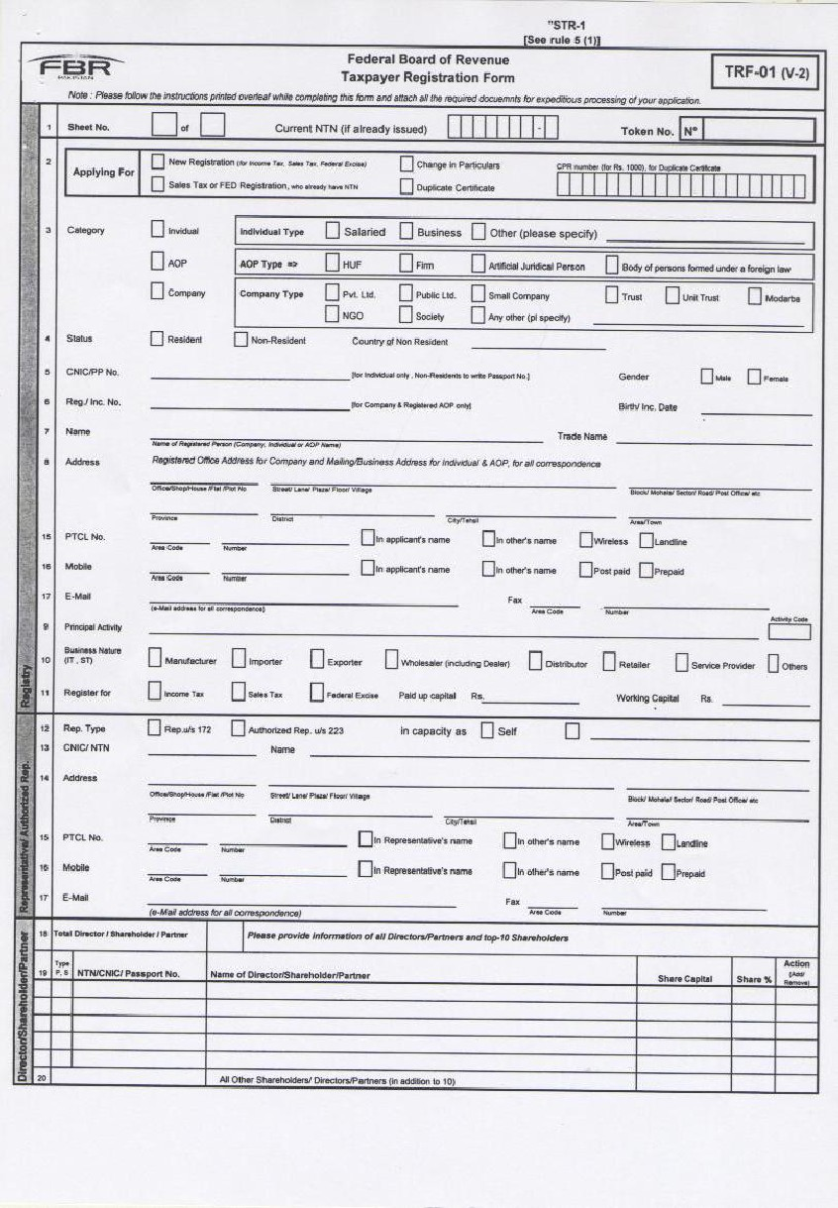

75

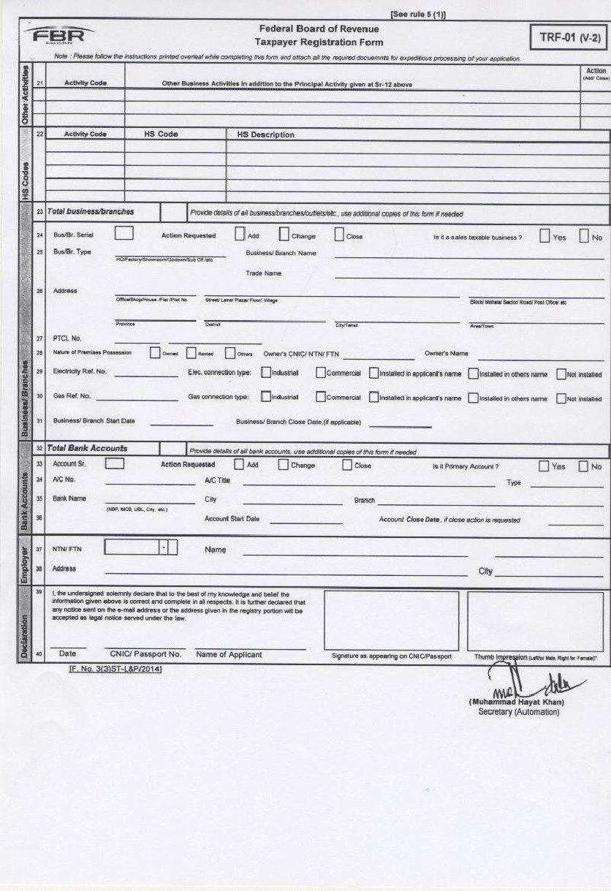

76

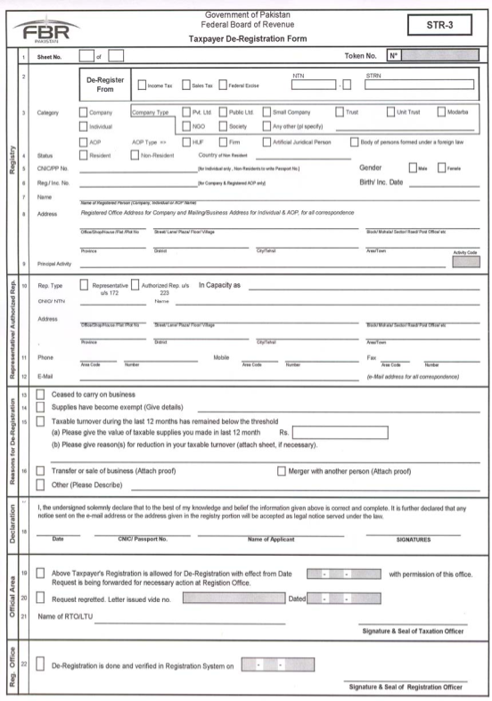
¹[STKR-2 omitted]

Sales Tax Rules 2006

STR-4 [See rule 5(2)]
STOCKS DECLARATION FORM
Name: _____________________ Date: ______________________

Description of taxable goods available in stock | Name and ¹⁸⁷[National Tax Number] of the supplier* | Sales Tax Invoice No. and date or name of customs station of clearance vessel name, IGM No. and date, Index No. BE, cash No. & date. | Value (exclusive of Sales Tax) | Sales Tax involved
(1) | (2) | (3) | (4) | (5)

* In case of local goods, mention name and ¹⁸⁷[National Tax Number] of the supplier from whom such taxable goods were purchased during a period of 30 days prior to the date of application for registration. In case of goods imported during a period of 90 days prior to the date of application for registration, mention the exporter's name and country.

-----

¹⁸⁷ Substituted for the words “registration number” by Notification No. S.R.O. 610(I)/2010, dated 1st July, 2010, reported as PTCL 2010 St. 1194, w.e.f. 1st October, 2010 as amended by Notification No. S.R.O. 821(I)/2010, dated 19th August, 2010.

78

Sales Tax Rules 2006

188[STR-5]

TAXPAYER REGISTRATION CERTIFICATE

NTN Category Status
CNIC/Passport No. Reg./Inc. No.
Name Address
Principal Activity Other Activities Registered for Representative's

Tax Office
¹⁸⁹[National Tax Number]

Birth Date: Reg./Inc. Date:

CNIC Name
E-Mail Address

This Certificate shall be prominently displayed at a conspicuous place of the premises in which business or work for gain is carried on. It is also required to be indicated on the signboard where it is affixed.

Note: The NTN must be written on all returns, payment challans, invoices, letter heads, advertisements etc. and all correspondence made with the tax departments.]

^{188.} Form STR-5 substituted by Notification No. S.R.O. 429(1)/2009, dated 2nd June, 2009. Earlier Form STR-5 was substituted by Notification No. S.R.O. 530(1)/2008, dated 11th June, 2008, w.e.f 1st July, 2008, reported as PTCL 2008 SL 1882 and amended by Notification No. S.R.O. 761 (1)12008, dated 19th July, 2008, reported as PTCL 2009 St. 41.

_{189.} Form STR-7 substituted by Notification No. S.R.O. 761(1)/2008, dated 19th July, 2008, reported as PTCL 2009 St. 41. Earlier Form STR-7 was substituted by Notification Nos. S.R.O. 530(1)/2008, dated 11th June, 2008, w.e.f. 1st July, 2008, reported as PTCL 2008 St. 1882, S.R.O. 1000(1)/2007, dated 29th September, 2007, reported as PTCL 2008 St. 632, w.e.f. 8th September, 2007 and S.R.O. 824(1)/2007, dated 16th August, 2007, reported as PTCL 2008 St. 543, w.e.f.1st July, 2007.

79

Sales Tax Rules 2006

STR-6 [See rule 6(2)]

C. No. __________________________ Date _________________

M/s. __________________________ ______________________________ ______________________________ ______________________________

SUBJECT: COMPULSORY REGISTRATION.

Whereas it has been ascertained that you are liable to be registered under the Sales Tax Act, 1990, for the reason that:

_______________________________________________________________________________ ______________________________________________________________________________;

Whereas you have not yet got yourself registered; therefore, you are hereby given an opportunity to apply for registration in the form attached with this notice. You may also declare the stocks in hand, if any, in terms of section 59 of the Sales Tax Act, 1990, read with rule 5(2) of Chapter I of the Sales Tax Rules, 2006 in the Form at STR-4 to the Sales Tax Rules, 2006.
2. Kindly note that in case you fail to apply for registration by _______________ (date),--

(a) you shall be compulsorily registered under section 14 of the Act, read with rule 6 of the Sales Tax Rules, 2006, without any further notice;

(b) you shall render yourself liable to penalty under clause 7 of section 33(1) of the Sales Tax Act,1990; and

(c) you shall also render yourself liable to arrest and prosecution in terms of section 37 A of the Sales Tax Act, 1990.

Encl. Registration Form (STR-l)

Local Registration Officer Telephone:
Fax:
E-mail

-----

80

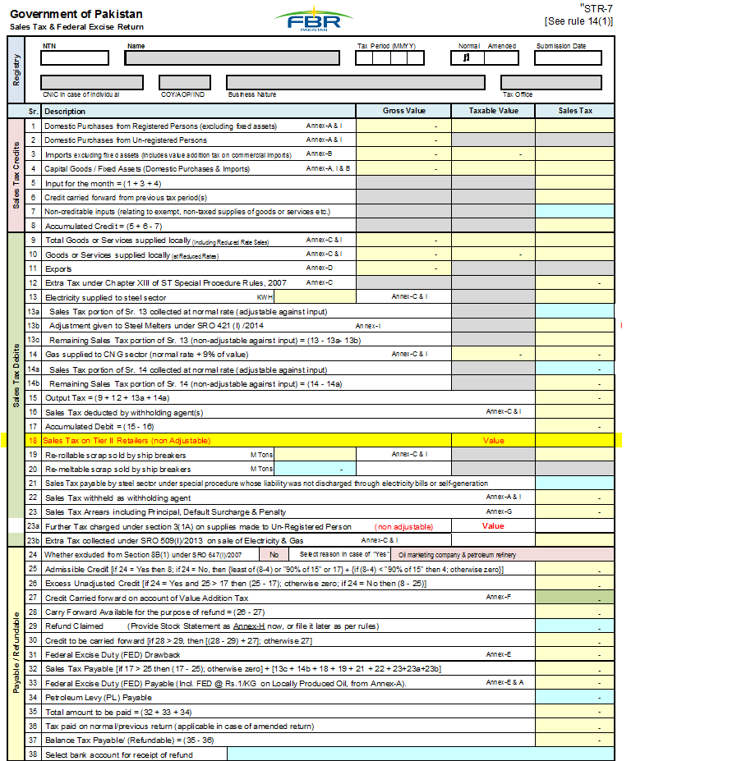

81

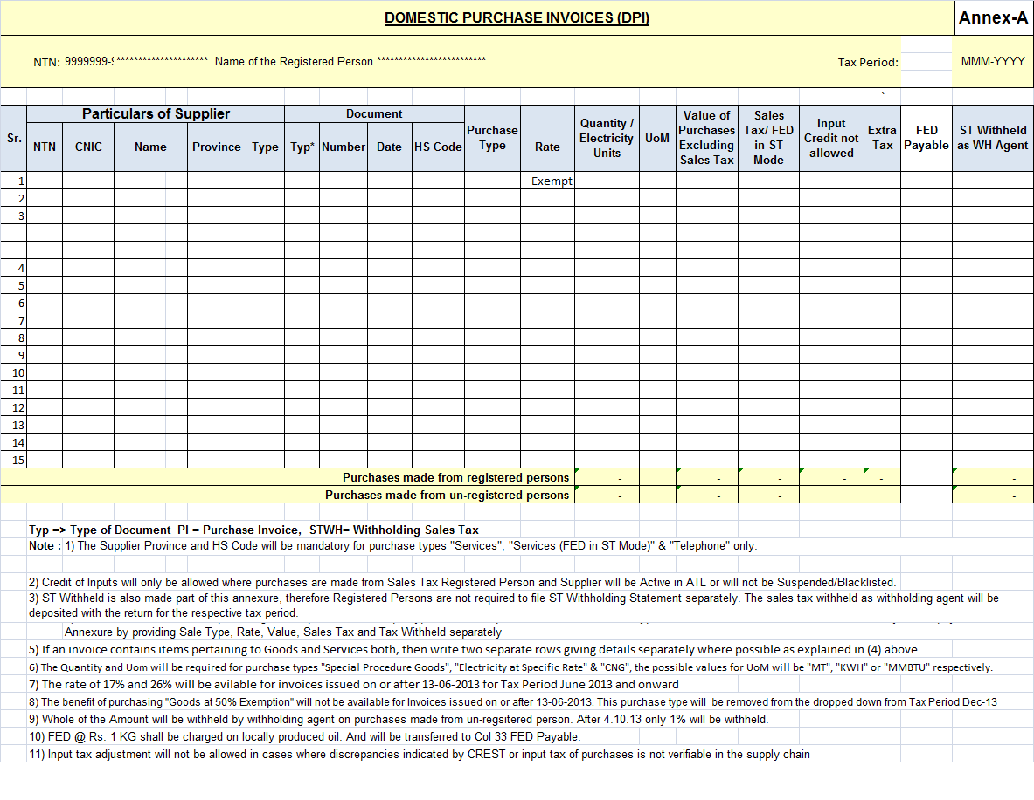

82

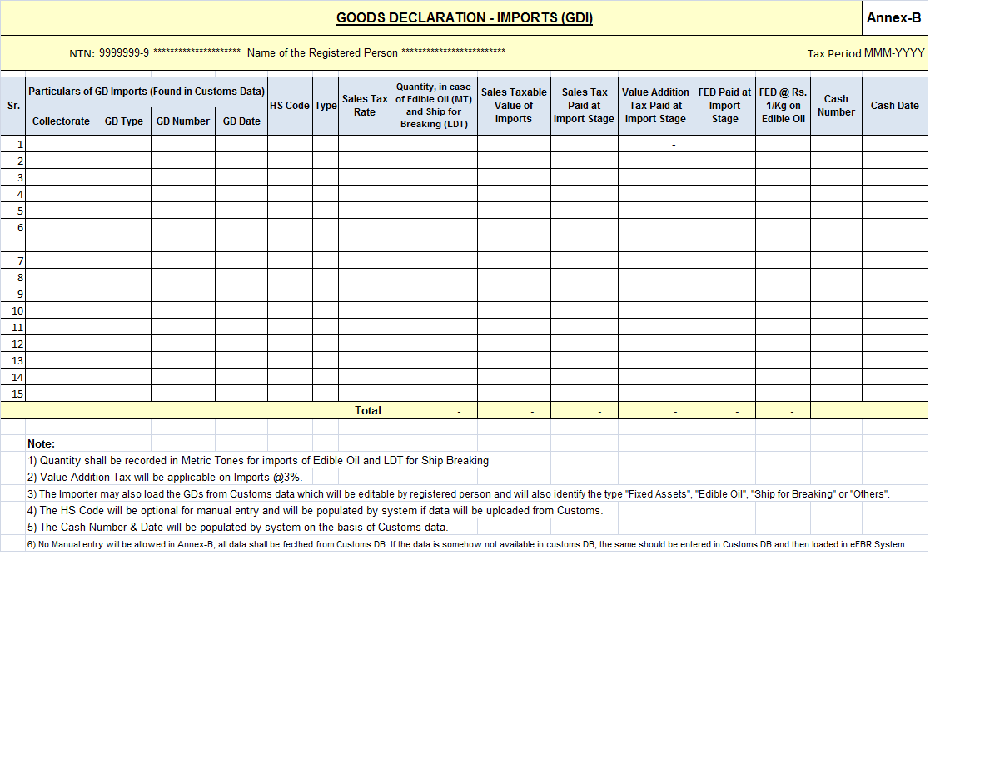83

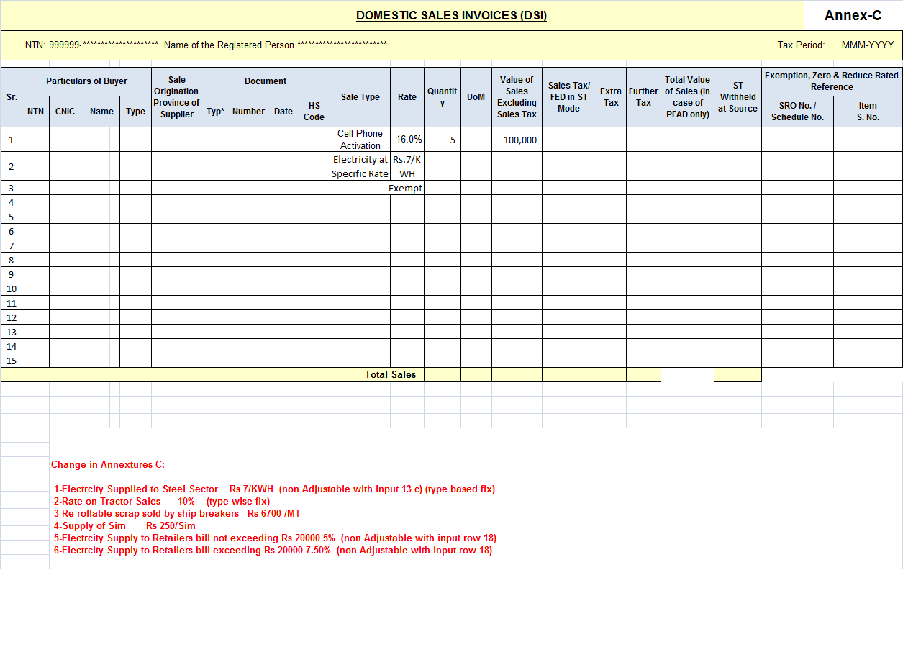

84

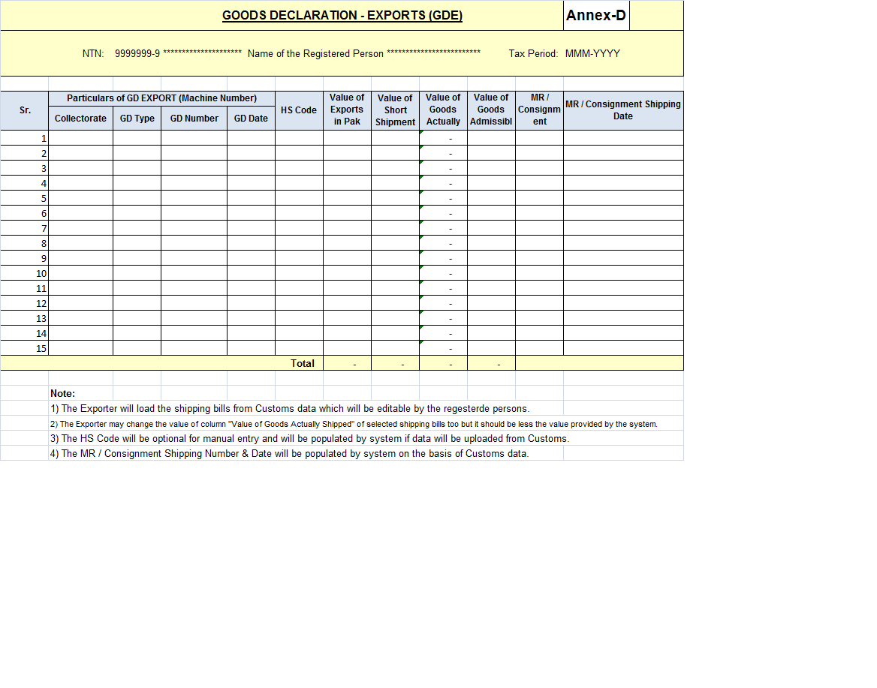

85

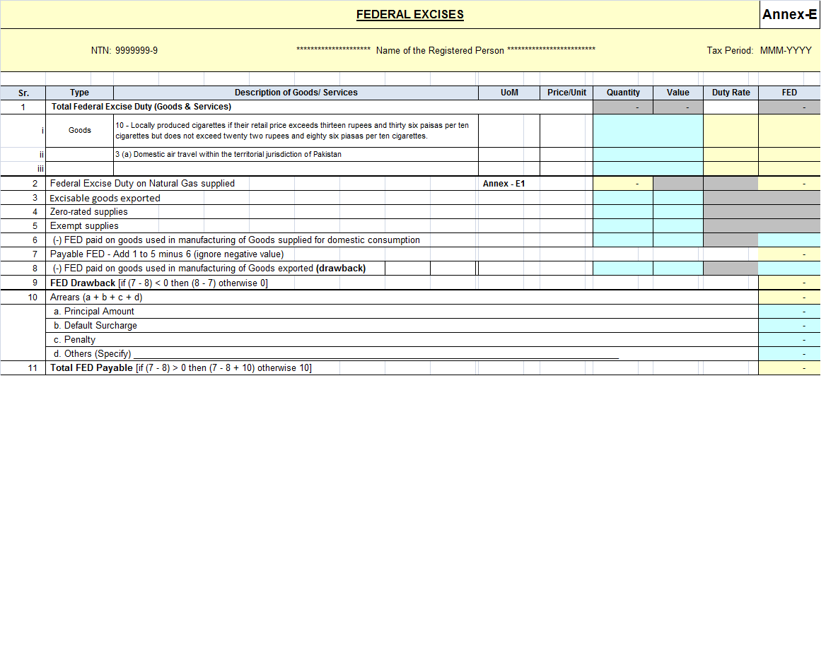

86
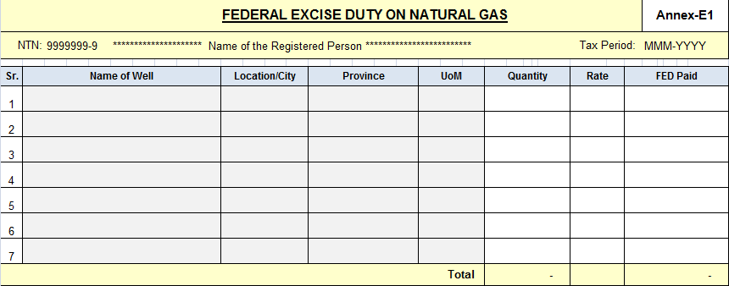

87

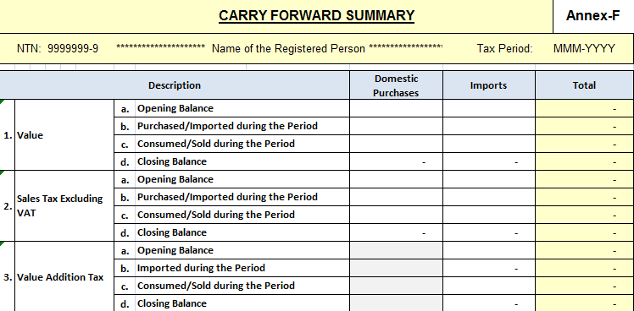

88

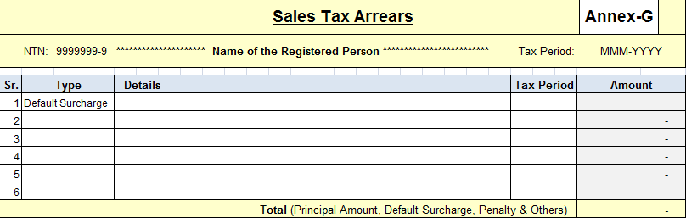

89

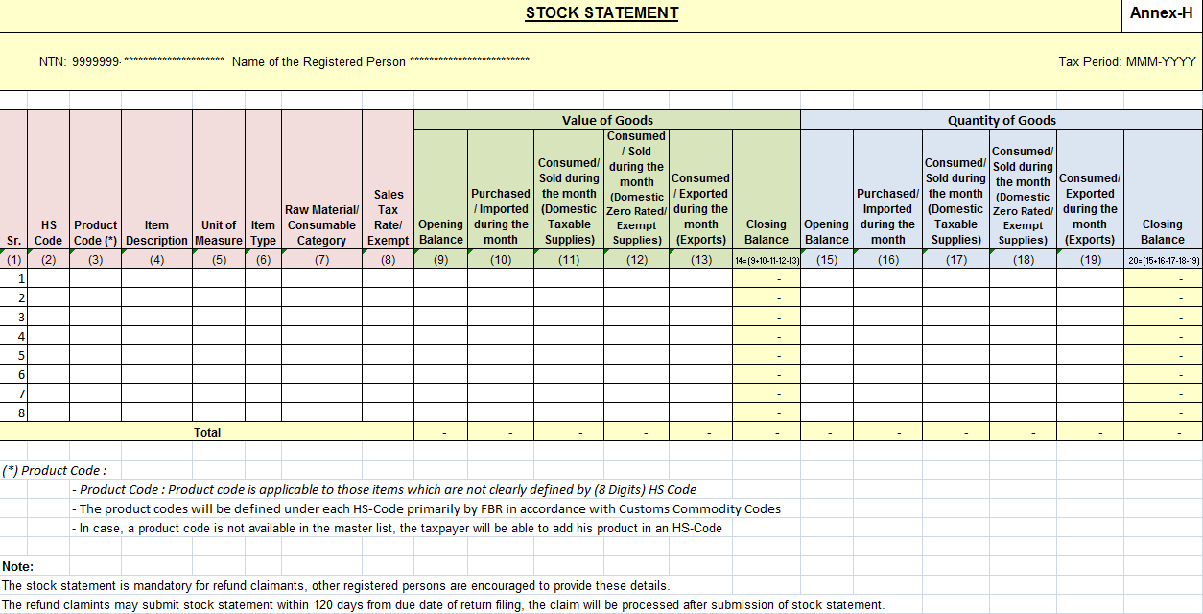

90
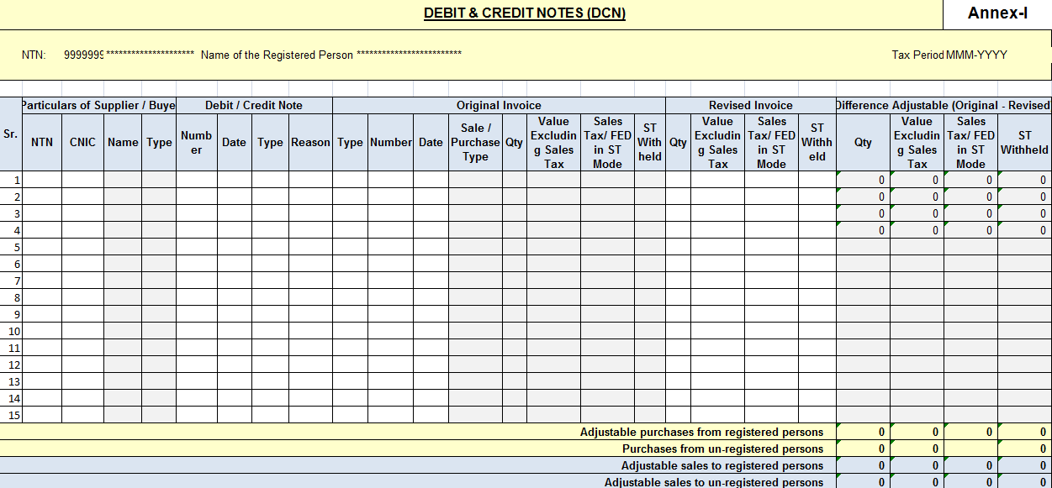

91

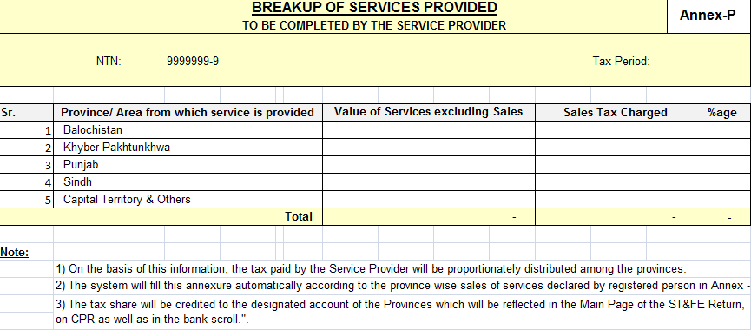

92
190[STR-8 Omitted]

191[STR-9 Omitted]

Sales Tax Rules 2006

[STR-10] [See rule 17]
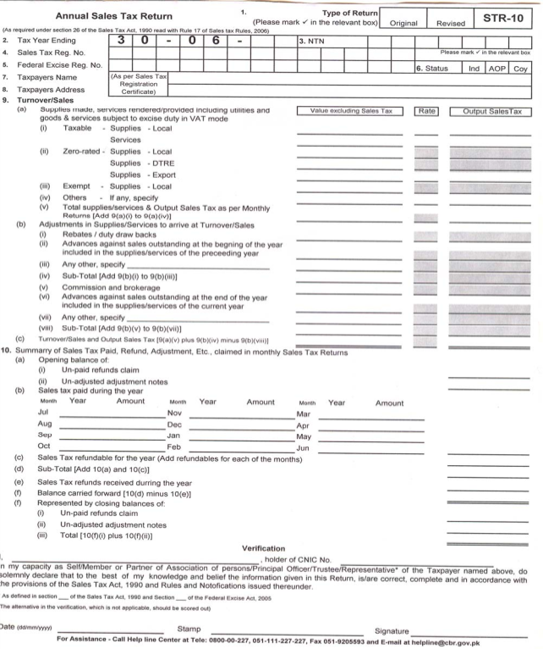

93

---------------------------------------------------

190 Form STR-8 omitted by Notification No. S.R.O. 470(I)/2007, dated 9th June, 2007, w.e.f. 1st day of July, 2007, reported as PTCL 2007 St. 1726.

191 Form STR-9 omitted by Notification No. S.R.O. 824(I)/2007, dated 16th August, 2007, reported as PTCL 2008, St. 543. This amendment shall be made and shall be deemed to have been so made on the 1st day of July, 2007.

192 Substituted for the words “Sales Tax Reg. No.” by Notification No. S.R.O. 610(I)/2010, dated 1st July, 2010, reported as PTCL 2010 St. 1194, w.e.f. 1st October, 2010 as amended by Notification No. S.R.O. 821(I)./2010, dated 19th August, 2010.

Sales Tax Rules 2006
193[STR-11 [See rule 18(2)]
PART-I

Federal Board Of Revenue Government of Pakistan
SALES TAX PAYMENT CHALLAN

INPUT FORM
¹⁹⁴[National Tax Number]. NTN :

Month Year Name ______________________________________ Tax Period

Address ________________________________________________________________

HEAD OF ACCOUNT Amount in Pak. Rupees

B-02341 Sales Tax

B-02366 Sales Tax on Services

B-02367 Federal Excise Duty Levy in VAT Mode

Total Amount
Amount in words _____________________________________________________

DECLARATION

I hereby declare that the particulars mentioned in this challan are correct.

CNIC of Depositor

Name of Depositor _________________________________________________

Stamp & Signatures
Date __________________

Note: This is an Input Form and should not be signed/ stamped by Bank. However, a CPR should be issued after receipt of payment by the Bank.

¹⁹³ Form STR-II substituted by Notification No. S.R.O. 840(I)/2008, dated 13th August, 2008, reported as PTCL 2009 St. 284. Earlier Form STR-II was substituted by Notification No. S.R.O. 824(I)/2007, dated 16th August, 2007, reported as PTCL 2008 St. 543, w.e.f. 1st day of July, 2007.

¹⁹⁴ Sbstituted for the words “Sales Tax Reg. No.” by Notification No. S.R.O. 610(I)/2010, dated 1st July, 2010, reported as PTCL 2010 St. 1194, w.e.f. 1st October, 2010 as amended by Notification No. S.R.O. 821(I)/2010, dated 19th August, 2010.

95

Sales Tax Rules 2006

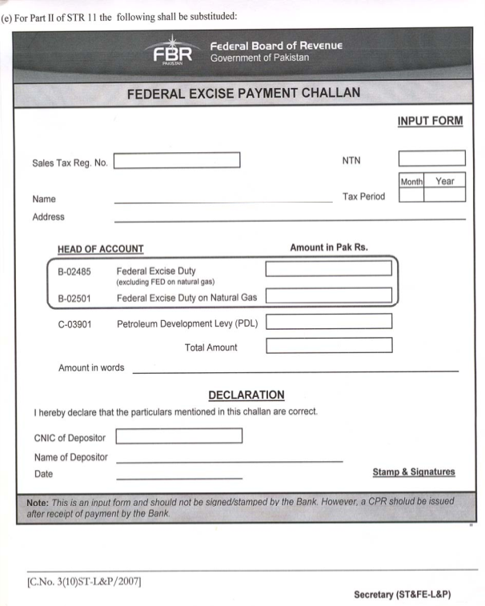
[STR-11] [Continued…] ¹⁹⁵[PART-II]

¹⁹⁵ Part-II of STR-II substituted by Notification No. S.R.O. 716(I)/2009, dated 10th August, 2009, reported as PTCL 2010 St. 3(ii).

¹⁹⁶ Substituted for the words “Sales Tax Reg. No.” by Notification No. S.R.O. 610(I)/2010, dated 1st July, 2010, reported as PTCL 2010 St. 1194, w.e.f. 1st October, 2010 as amended by Notification No. S.R.O. 821(I)/2010, dated 19th August, 2010.

96
Sales Tax Rules 2006
STR-12
[See rules 52, 53, 55 & 57]

AUTHORIZATION FOR ZERO- RATED SUPPY

S.NO.______________ Date: _________

Messrs. _______________________________________have applied for zero-rated (Name of buyer)

Supply under chapter viii of sales Tax Rules, 2006, on the basis of the following document: __

1. FBR Booklet No._________________________________________________

2. M/O foreign Affairs Exemption Order No.____________________

3. Other______________________________________________________

The claim for zero-rating has been found in order and the formalities specified in the said Rules have been fulfilled by this office.

M/s _______________________________are, therefore, authorised to (Name& ¹⁹⁷[National Tax Number] of registration supplier)

deliver the following goods to the said applicant against a zero-rated invoice:--

S.NO. | Description | Quantity and/ or value
1.

2.

3.

4.

5.

6.

¹⁹⁸[Assistant/Deputy Collector]
(Signature, name and official seal)

¹⁹⁷ Substituted for the words “Registration No.” by Notification No. S.R.O. 610((I)/2010, dated 1st July, 20201, reported as PTCL 2010 St. 1194, w.e.f. 1st October, 2010 as amended by Notification No. S.R.O. 821(I)/2010, dated 19th August, 2010.

¹⁹⁸ Any reference to “Deputy Collector and Assistant Collector” shall be construed as reference to “Deputy Commissioner Inland Revenue and Assistant Commissioner Inland Revenue” respectively by virtue of section 72A of the Sales Tax Act, 1990. Powers and functions of “Deputy Collector of Sales Tax” and “Assistant Collector of Sales Tax” shall be exercised by “Deputy Commissioner Inland Revenue” and “Assistant Commissioner Inland Revenue” respectively vide FBR’s Order C. No. 1(6)IR-Judicial/2009, dated 11th November, 2009, w.e.f. 28th October, 2009.
97

Sales Tax Rules 2006
STR-13 [See rule 61]

LETTER OF AUTHORIZATION

I, ___________________________________ , Proprietor/Partner/Director of

M/s. _________________________________________________, hereby authorize

Mr. ___________________ S/o Mr. ______________________________________

N.I.C.No. ___________________________ to represent before the adjudicating authority or the Customs, Excise and Sales Tax Appellate Tribunal, __________ Bench on behalf of M/s._______________ Sales Tax/Federal Excise ¹⁹⁹[National Tax Number] ____________ for single hearing on _________________________ (date)/till the decision of the case. (Cross out whichever is not applicable) or till withdrawal of this authorization, whichever is earlier.
I also affirm and certify that he fulfils the conditions of an authorized representative as prescribed in Chapter IX of the Sales Tax Rules, 2006.

Dated: ___________ Signature: ________________ Name: ____________________ (Proprietor/Partner/Director) N.I.C.No. _________________
Company or Business Seal/Stamp ______

¹⁹⁹ Substituted for the words “Registration No.” by Notification No. S.R.O. 610((I)/2010, dated 1st July, 2010, reported as PTCL 2010 St. 1194, w.e.f. 1st October, 2010 as amended by Notification No. S.R.O. 821(I)/2010, dated 19th August, 2010.

98

Sales Tax Rules 2006

STR-14 [(See rule 73)]
FORM OF DEMAND NOTE

C. No. ___________________ Dated: _________________

SUBJECT: ______________________________________________________________

Reference _______________________________________________________________ (e.g. Order-in-Original No., Bank Guarantee No., Insurance Guarantee No., etc.)
WHEREAS a sum of Rs.___________________ (Rupees ________________ only), as Government dues (as per Schedule attached) is outstanding and needs to be recovered from the following:
M/s. ________________________________________________________________ Address _____________________________________________________________ Phone No ____________________________________________________________ ²⁰⁰[National Tax Number] _______________________________________________ N.T.N. No.___________________________________________________________ Known properties:_____________________________________________________ 2. The above-mentioned Government dues are on account of Sales Tax and
other levies under the Sales Tax Act,1990. It is certified that all other formalities under the Act and rules made thereunder have been completed as follows, and there exists no bar or stay order against recovery:--
(a) Action taken under clause (a) of section 48 of the Sales Tax Act, 1990, (b) Action taken under clause (b) of section 48 of the Sales Tax Act, 1990,

²⁰⁰ Substituted for the words “Sales Tax Registration No.” by Notification No. S.R.O. 610((I)/2010, dated 1st July, 2010, reported as PTCL 2010 St. 1194, w.e.f. 1st October, 2010 as amended by Notification No. S.R.O. 821(I)/2010, dated 19th August, 2010.

99
(c) Action taken under clauses ( c) and (ca) of section 48 of the Sales Tax Act, 1990, and
(d) Action taken under clause (d) of section 48 of the Sales Tax Act, 1990.

3. You are, therefore, requested to recover the above-mentioned Government dues in terms of section 48 of the Sales Tax Act, 1990 and rules made thereunder. The Government dues may be remitted to the undersigned as soon as the same are recovered.

Referring Authority (Name)
²⁰¹[Assistant/Deputy Collector of Sales Tax]

Seal _____________
To,

The Sales Tax Recovery Officer,
____________________________
…….

SCHEDULE

S.No. | Description | Amount
1. | Serial No. _______
2. | File No. ________
3. | Sales Tax | Rs. __ (Rupees ___________________________ only)
4. | Default surcharge | Rs. __ (Rupees ___________________________ only)
5. | Federal Excise duty | Rs. __ (Rupees ___________________________ only)
6. | Customs duty | Rs. __ (Rupees ___________________________ only)
7. | Fines | Rs. __ (Rupees ___________________________ only)
8. | Penalty | Rs. __ (Rupees ___________________________ only)

²⁰¹ Any reference to “Deputy Collector and Assistant Collector” shall be construed as reference to “Deputy Commissioner Inland Revenue and Assistant Commissioner Inland Revenue” respectively by virtue of section 72A of the Sales Tax Act, 1990. Powers and functions of “Deputy Collector of Sales Tax” and “Assistant Collector of Sales Tax” shall be exercised by “Deputy Commissioner Inland Revenue” and “Assistant Commissioner Inland Revenue” respectively vide FBR’s Order C. No. 1(6)IR-Judicial/2009, dated 11th November, 2009, w.e.f. 28th October, 2009.

100
Sales Tax Rules 2006

9. | Personal Penalty | Rs. __ (Rupees ___________________________ only)
10. | Surcharge | Rs. __ (Rupees ___________________________ only)
11. | Penal surcharge | Rs. __ (Rupees ___________________________ only)
12. | License fee | Rs. __ (Rupees ___________________________ only)
13. | Income Tax | Rs. __ (Rupees ___________________________ only)
14. | Other | Rs. __ (Rupees ___________________________ only)
 | (i) | Rs. __ (Rupees ___________________________ only)
 | (ii) | Rs. __ (Rupees ___________________________ only)
 | (iii) | Rs. __ (Rupees ___________________________ only)
 | (iv) | Rs. __ (Rupees ___________________________ only)
 | TOTAL | Rs. __ (Rupees ___________________________ only)

-------

STR-15 [(See rule 75)]
FORM OF MASTER REGISTER

1. Sr. No. ____________________________________________________________

2. Defaulters Name, Address and Phone No._______________________________ __________________________________________________________________ __________________________________________________________________

3. Referring Authority __________________________________________________________________ __________________________________________________________________

4. (i) No. and date of issue and date of Receipt of demand Note ___________________________________________________

(ii) Reference Nos. _________________________________

5. Details of Government dues ______________________________

S.No. | Description | Amount
1. | Sales Tax | Rs. __ (Rupees ___________________________ only)
2. | Default surcharge | Rs. __ (Rupees ___________________________ only)
3. | Federal Excise duty | Rs. __ (Rupees ___________________________ only)
4. | Customs duty | Rs. __ (Rupees ___________________________ only)
5. | Fines | Rs. __ (Rupees ___________________________ only)
6. | Penalty | Rs. __ (Rupees ___________________________ only)

101
Sales Tax Rules 2006

7. | Personal Penalty | Rs. __ (Rupees ___________________________ only)
8. | Surcharge | Rs. __ (Rupees ___________________________ only)
9. | Penal surcharge | Rs. __ (Rupees ___________________________ only)
10. | License fee | Rs. __ (Rupees ___________________________ only)
11. | Income Tax | Rs. __ (Rupees ___________________________ only)
12. | Other | Rs. __ (Rupees ___________________________ only)
 | (i) | Rs. __ (Rupees ___________________________ only)
 | (ii) | Rs. __ (Rupees ___________________________ only)
 | (iii) | Rs. __ (Rupees ___________________________ only)
 | (iv) | Rs. __ (Rupees ___________________________ only)
 | TOTAL | Rs. __ (Rupees ___________________________ only)

STR-15 [ Continued ….]

(6) Date of issue of notice under rule 71 (7) Date of issue of notice under rule 72

(8) Date of issue of notice and action taken under rule 74 ________ (9) Known properties of the defaulter:--
(i) Movable ________________________________________
(ii) Immovable ______________________________________
(10) Name and designation of Attachment Officer _______________ (11) Details of movable properties attached:--
(i) ___________________________________________ (ii) ___________________________________________ (iii) ___________________________________________
(12). Date of proclamation of attachment of immovable properties:
(i) ___________________________________________ (ii) ___________________________________________

(13) Details of immovable properties attached:--
(iii) ___________________________________________ (iv) ___________________________________________ (v) ___________________________________________
(14) Date of appointment of receiver, name of receiver and details of business or properties:--

102
Sales Tax Rules 2006

(i) ___________________________________________ (ii) ___________________________________________

15. Date of sales of properties and their details:--
(i) ___________________________________________ (ii) ___________________________________________
16. Amount of sale proceeds or amount of profits along with mode of receipt:--(i) ___________________________________________
(ii) ___________________________________________ 17. Disposal of sale proceeds _________________________________
_______________________________________________________
18. Date of recovery and details of Government dues shown in column recovered along with the manner of recovery. __________________________________________________________________

STR-16 [See rule 71(2)]

FORM OF NOTICE TO SALES TAX, CUSTOMS, FEDERAL EXCISE AND INCOME TAX AUTHORITIES
No. _________________ Dated: _________

SUBJECT: __________________________________________________________________

WHEREAS, Government dues amounting to Rs._________(Rupees only), are outstanding against
M/s._______________________________________________________________________ (Name and Complete Address)

having ²⁰⁰[National Tax Number] _______________________________________________ which they have failed to pay so far.

2. NOW, THEREFORE, in exercise of the powers conferred by clause (a) of sub-section (1) of section 48 of the Sales Tax Act, 1990, I do hereby require all Customs, Federal Excise, Sales Tax and Income Tax Authorities that with immediate effect and till further orders:--

²⁰² Substituted for the words “Sales Tax Registration No.” by Notification No. S.R.O. 610(I)/2010, dated 1st July, 20201, reported as PTCL 2010 St. 1194, w.e.f. 1st October, 2010 as amended by Notification No. S.R.O. 821(I)/2010, dated 19th August, 2010.

103

Sales Tax Rules 2006

(a) to deduct the aforesaid amount from any money owing to the said M/s.__________________________________________ which may be under the control of respective authorities; and
(b) the Government dues so recovered should be sent to the undersigned immediately.

Referring Authority
(Name)
²⁰³[Assistant/Deputy Collector of Sales Tax]
Seal _________________________
To,
(i) M/s. _____________________________________ (defaulter).
(ii) M/s. _____________________________________ (clearing agent or representative). (iii) All other concerned.

--------
STR-17 [See rule 72(1)]

FORM OF NOTICE OF RECOVERY
No. _________________ Dated: _________

SUBJECT: Notice for Recovery under Section 48 of the Sales Tax Act, 1990.

WHEREAS, Government dues amounting to Rs._________(Rupees only), are recoverable from you (M/s.______________________________________________________________________________) on account

of _______________________________________________.

2. AND WHEREAS, you have failed to deposit the above said Government dues recoverable from you and it is believed that the outstanding Government dues cannot be recovered from you in the manner so far followed;

3. NOW, THEREFORE, you (M/s. ______________________________________ ) are hereby served with this notice in terms of section 48 of the Sales Tax Act,

²⁰³ Any reference to “Deputy Collector and Assistant Collector” shall be construed as reference to “Deputy Commissioner Inland Revenue and Assistant Commissioner Inland Revenue” respectively by virtue of section 72A of the Sales Tax Act, 1990. Powers and functions of “Deputy Collector of Sales Tax” and “Assistant Collector of Sales Tax” shall be exercised by “Deputy Commissioner Inland Revenue” and “Assistant Commissioner Inland Revenue” respectively vide FBR’s Order C. No. 1(6)IR-Judicial/2009, dated 11th November, 2009, w.e.f. 28th October, 2009.

104

Sales Tax Rules 2006

1990 to pay the amount within fifteen days from the date of service of -this notice, failing which following proceedings under section 48 of the Sales Tax Act, 1990 will be initiated without any further notice:--

Removal of goods from your business premises shall be stopped and the business premises sealed after fifteen days of issue of this notice till such time the amount of tax is paid or recovered in full.

4. You are also directed not to directly or indirectly, sell, mortgage, charge, lease or otherwise deal with all movable and immovable property belonging to you except with the permission of the undersigned.
Referring Authority
(Name)
²⁰⁴[Assistant/Deputy Collector of Sales Tax]
Seal _________________________
To,
(i) M/s. _____________________________________ (defaulter).
(ii) M/s. _____________________________________ (clearing agent or representative). (iii) All other concerned.

--------

Sales Tax Rules 2006
STR-18 [See rule 74]
FORM OF NOTICE FOR ATTACHMENT AND RECOVERY

Subject: Notice for Recovery under section 48 of the Sales Tax Act, 1990

WHEREAS, Government dues amounting to Rs. _____________________ (Rupees __________________________________________________ only) are recoverable from you, M/s._____________________________________ __________________________________________________ on account of _____________________________________________________________.

2. AND, WHEREAS, you have failed to deposit the above said Government dues recoverable from you and no recovery could be made in the terms of clauses (a), (b), (c), (ca), (d) and (f) of sub-section (1) of Section 48

²⁰⁴ Any reference to “Deputy Collector and Assistant Collector” shall be construed as reference to “Deputy Commissioner Inland Revenue and Assistant Commissioner Inland Revenue” respectively by virtue of section 72A of the Sales Tax Act, 1990. Powers and functions of “Deputy Collector of Sales Tax” and “Assistant Collector of Sales Tax” shall be exercised by “Deputy Commissioner Inland Revenue” and “Assistant Commissioner Inland Revenue” respectively vide FBR’s Order C. No. 1(6)IR-Judicial/2009, dated 11th November, 2009, w.e.f. 28th October, 2009.

105
Sales Tax Rules 2006

of the Sales Tax act, 1990.

3. AND WHEREAS, it is believed that the outstanding Government dues can not be recovered from you in the manner so far followed.
4. NOW, THEREFORE, you are hereby served with this notice in terms of Section 48 of the Sales Tax Act, 1990 to pay. the amount within fifteen days from the date of service of this notice, failing which following proceedings under Section 48 of the Sales Tax Act, 1990 and the rules made there under shall be initiated without any further notice:-

(a) attachment and sale of moveable and immovable property; and

(b) appointment of receiver for the management of the movable or immovable property.

5. You are also directed not to directly or indirectly, sell, mortgage, charge, lease or otherwise deal with all movable and immovable property belonging to you except with the permission of the undersigned.

7. Such attached properties can be seized/sold under Chapter XI of the Sales Tax Rules, 2006, or a receiver can be appointed to manage them. To avoid such a situation it shall be in your own interest to pay the Government dues within fifteen days from the date of service of this Notice.

________________________ (Name)
Sales Tax Recovery Officer _____________________
Seal

To,
(i) M/s. _____________________________________ (defaulter).
(ii) M/s. _______________________________ (agent or representative). (iii) M/s. _____________________________________ (other concerned).

------

106

Sales Tax Rules 2006

STR-19 [See rule 88]
FORM OF WARRANT OF ATTACHMENT

C. No. ________________________ Dale: ____________________

Subject: ___________________________________________________________________

WHEREAS Mr. ____________________________(Designation ) has been appointed as Attachment Officer in terms of the Chapter Xl of the Sales Tax Rules, 2006, to attach the movable properties of M/s.________________________________ for the recovery of outstanding Government dues amounting to Rs.__________ (Rupees ________________________only), recoverable from the above-mentioned defaulter.

THEREFORE, Mr. _________________________________________________ (, Designation __________________________ ) is hereby directed to seize the movable properties belonging to the defaulter while observing the provisions of Chapter XI of the Sales Tax Rules, 2006, save exceptions as provided under the above said rules. He is also directed to report to the undersigned about the completion of attachment formalities as soon as these are completed.

______________________________ (Name)
Sales Tax Recovery Officer

_______________________ Seal
To,
(i) The Attachment Officer, ___________________, ___________________,
along with a copy to be served on the defaulter or his agent.

(ii) Notice Board.

---------

107

Sales Tax Rules 2006
205[STR-20
[See rule 150J (1)]
Application for appointment as e-Intermediary

²⁰⁶[Collectorate]:_________________________________ (where registration desired)

(1) Business Name

(2) NTN

(3) Business Status

(4) Address of Registered Head office

(i) City

(ii) Post Code

(iii) Premises (Tick) Self Owned Rented

(iv) Phone no.

(v) Fax No.

(vi) E-Mail address

(vii) Bank Account No.

(viii) Bank name & Address

I,___________________________ , the undersigned, hereby, certify that the information above is true and correct and further that the applicant has not been involved in any case of tax fraud.

Signature & Stamp: ________________ Name: ____________________________ Designation: _______________________

***

²⁰⁵ Form STR-20 added by Notification No. S.R.O. 470(I)/2007, dated 9th June, 2007, w.e.f. Ist day of July, 2007, reported as PTCL 2007 St. 1726.

²⁰⁶ ^{Now Regional Tax Office (RTO).}

108

