Consultancy for Customization and Configuration of SAP FI and MM at FBR

USER MANUAL

Budgeting

Prepared By:

Siemens SAP Team

Date: 10-02-2010

Document Number:

Document Number | Document date
1.0 | 10-02-2010

Version History:

Version Number | Version date | Summary of Changes | Ref: Minutes of review
Final Version | 10-02-2010

Table of Contents

Section 1 Original Budging Process 5
1.1 Budget Preparation (Budget Document Creation 5
1.2 Approving Budget 14
1.3 Budget Approval (DFA/FA Authority) 24
Section 2 Supplementary Budget 31
2.1 Prepare Supplementary Budget 31
2.2 Budget Approval/Change in Budget 42
2.3 Budget Approval/change in Budget (DFA/FA Authority) 57
Section 3 Budgeting: Entry Document 65
3.1 Release Budget 65
3.2 RE-APPROPRIATION/ TRANSFER BUDGET 68
3.3 Surrender/Return Budget 78

Note

This training document does not cover all knowledge areas of SAP ERP System. It has been specifically prepared keeping in view the Business Processes of FBR, therefore, it should be treated as a supplement and/or guide to your daily work and nothing further.

This training document will only provide explanation of the key and mandatory data fields and not of all the fields appearing on the screen. However, users may use online help facility provided by SAP ERP System by placing the cursor on the field that requires explanation and pressing FI button.

Legend for R/O/C

R = Required field
O = Optional field
C = Check box

Budget Processing Transaction

Original Budging Process

Before the start of financial year every Department (DDO) is responsible to prepare the budget for next fiscal year. Each DDO after getting information from Sections prepare the budget for next fiscal year containing revised estimates for current year budget estimates for next fiscal year.

Budget Preparation (Budget Document Creation)

User Input:

Enter Transaction Code ZMOF in Command Field or navigate through tree menu.

On screen MOF Budget-Initial Screen, select the Fresh data entry option.

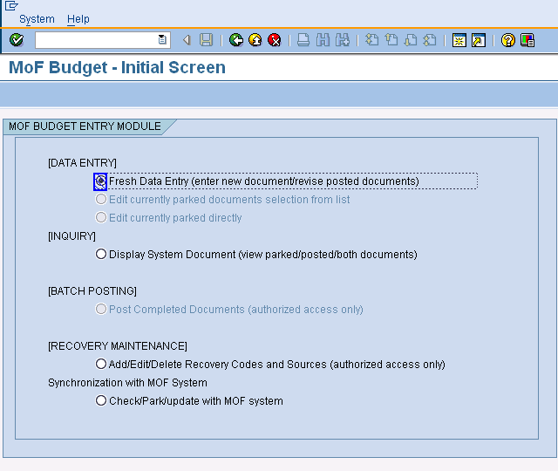
Press enter or to run the transaction.

On screen MOF Budget-Initial Entry Screen, enter the required information that is specified as below table.

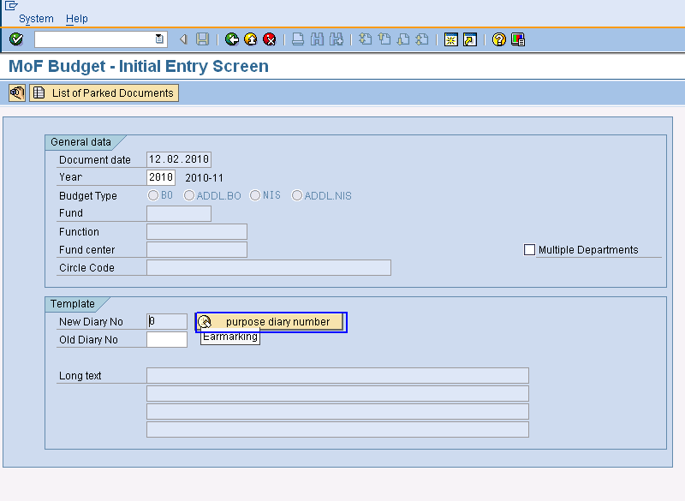

User Input:

SAP Required Fields | User Inputs Required
Template
New Diary No | Enter diary no or click on “Purpose Diary Number” it will automatic created.
Old Diary No | Optional
Long Text | Enter Any description
General Data
Document date | Enter date (optional) automatic created current date.
Year | Enter year
Budget Type | Select one budget type form given option.
Fund | Enter the Fund number
Function | Enter Function which are going to proceed
Fund Center | Enter Fund Center
Circle Code | Optional

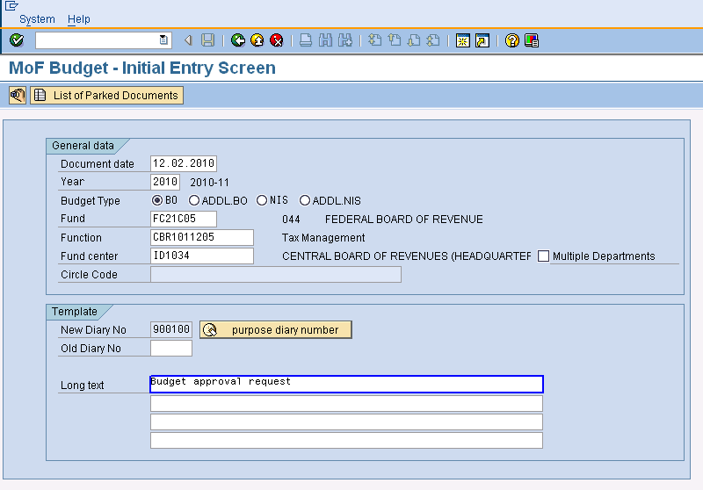

Press enter or to run the transaction.

MOF Budget: Detail Entry Screen will be opened. Enter the following information.

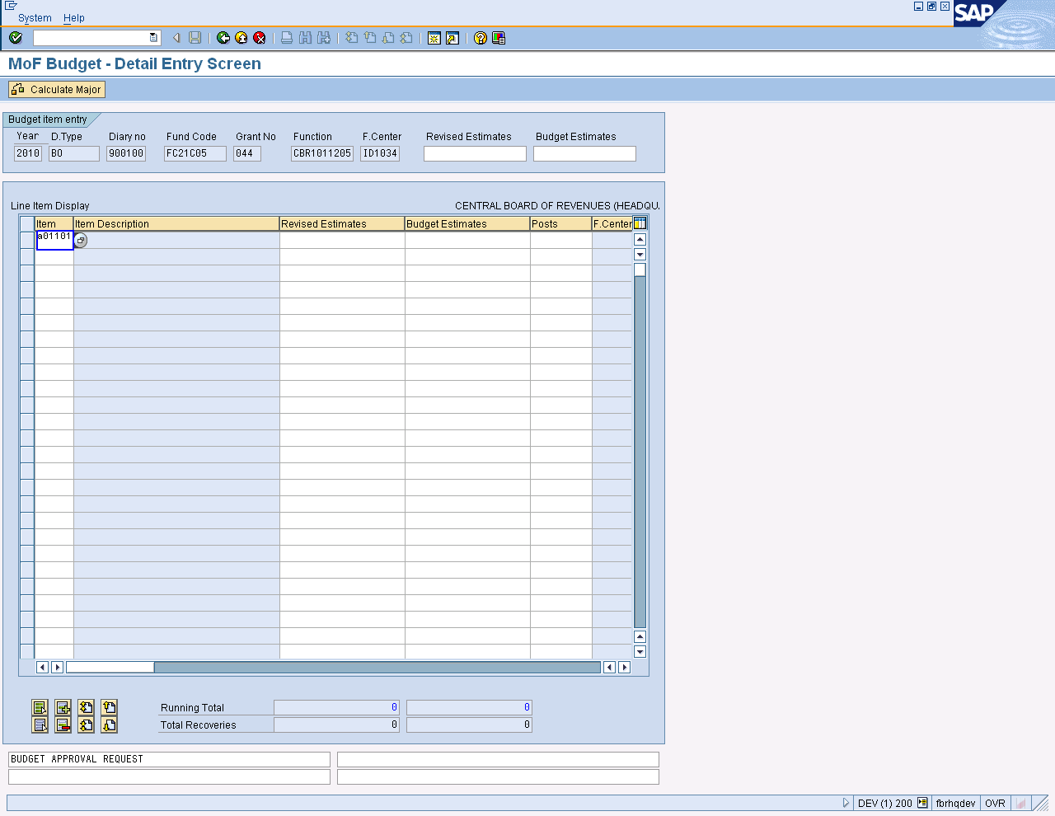

User Input:

SAP Required Fields | User Inputs Required
Line item Display
Item | Enter Item one by one which are estimated.
Item Description | Description of item (Optional)
Revised Estimates | Enter amount
Budget Estimates | Enter amount
Post | Optional

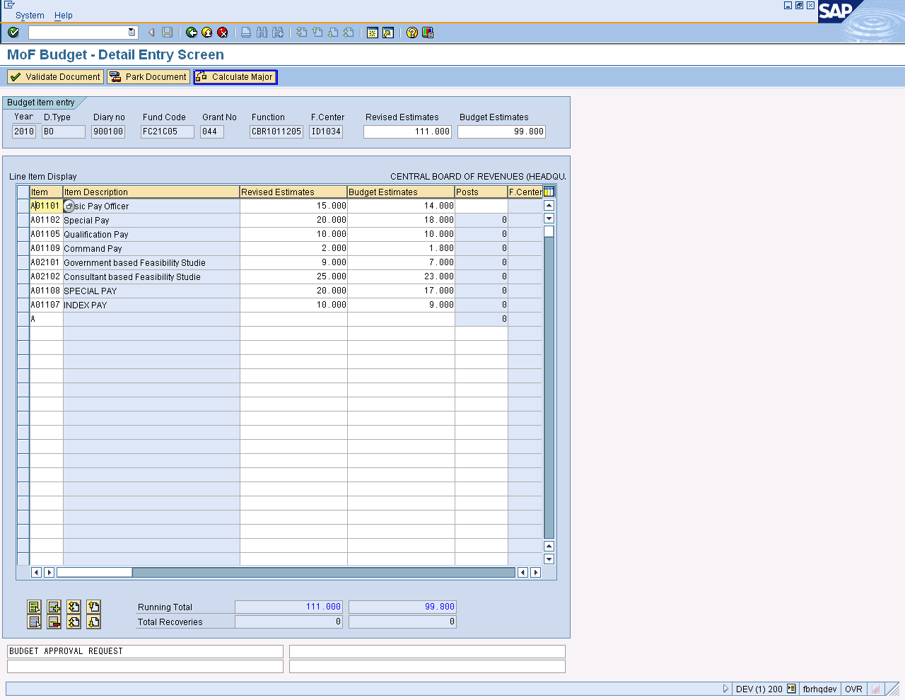

After Putting values, give total amount of revised and budget estimates in Budget item entry.
Press Calculate Major Button.
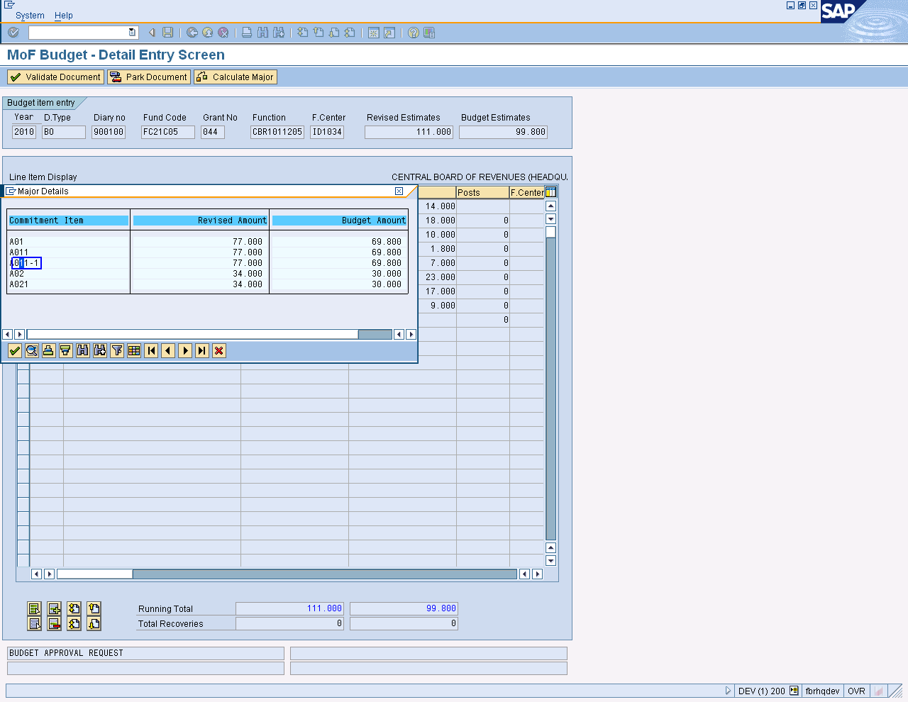

Double click on any commitment item in “Major Detail’s box”.
It will show more detail.
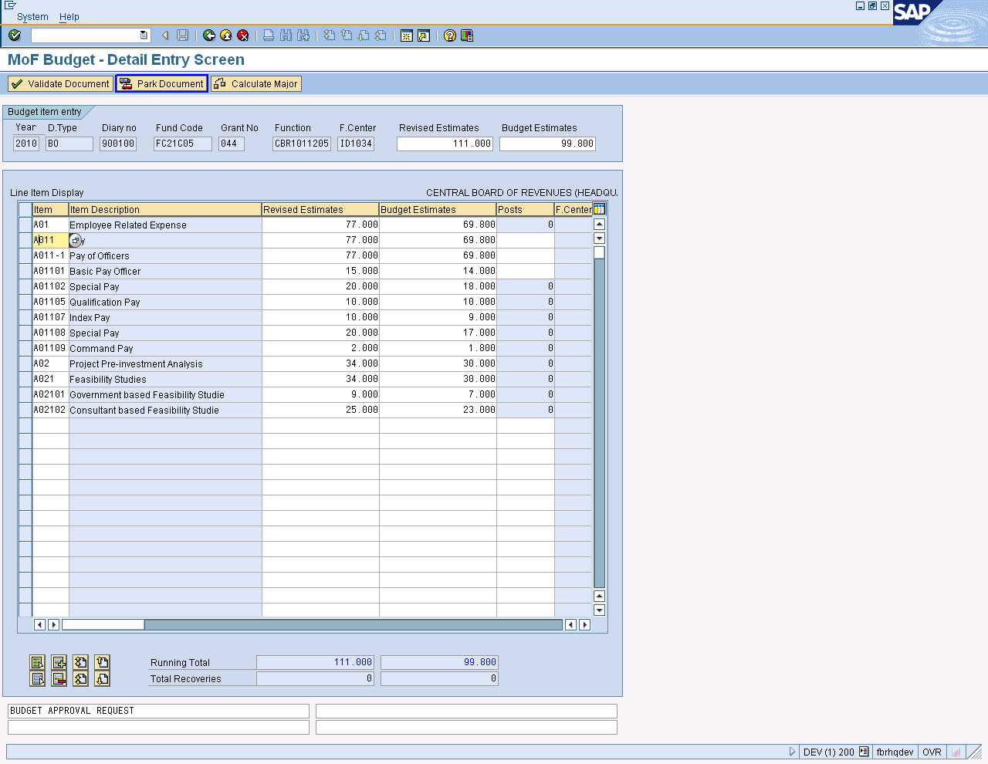

Major detail of selected commitment item

Press “Park Document button.

User will be received a validation Prompt.

Click “Yes” to park the document.

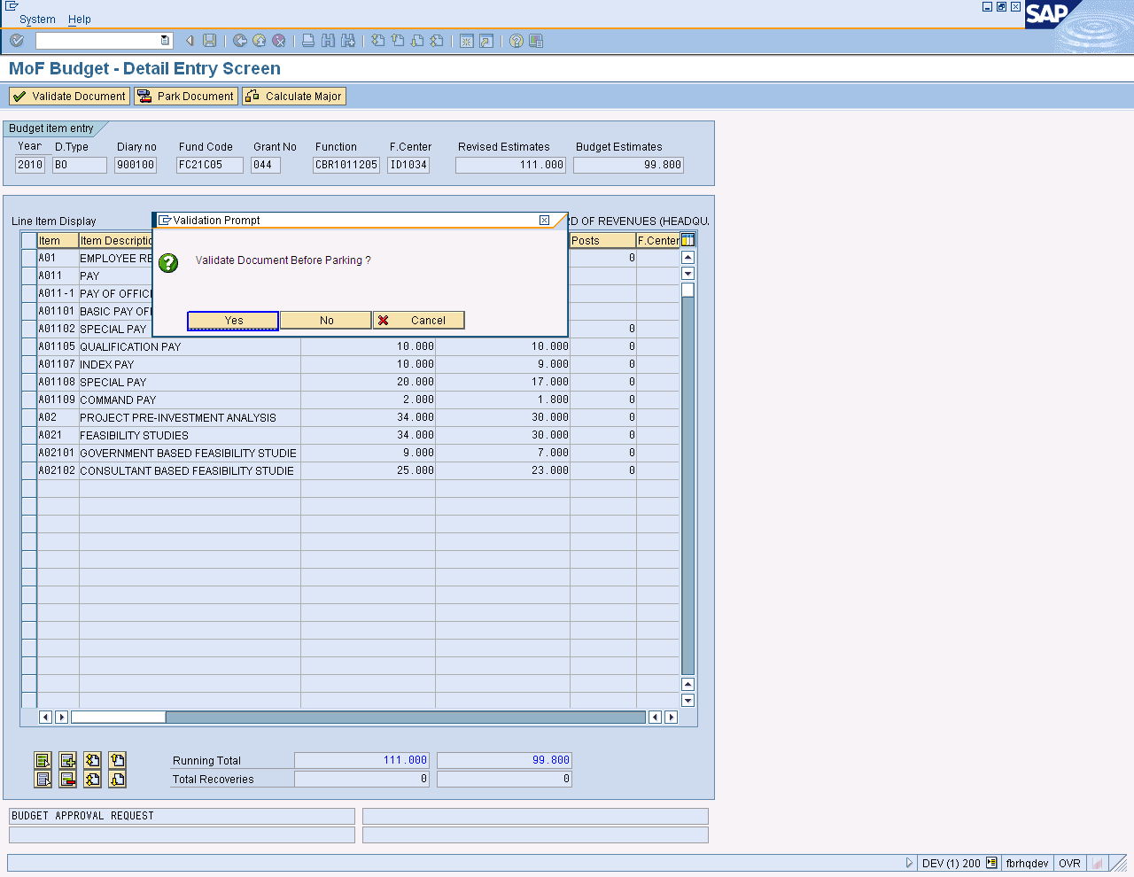

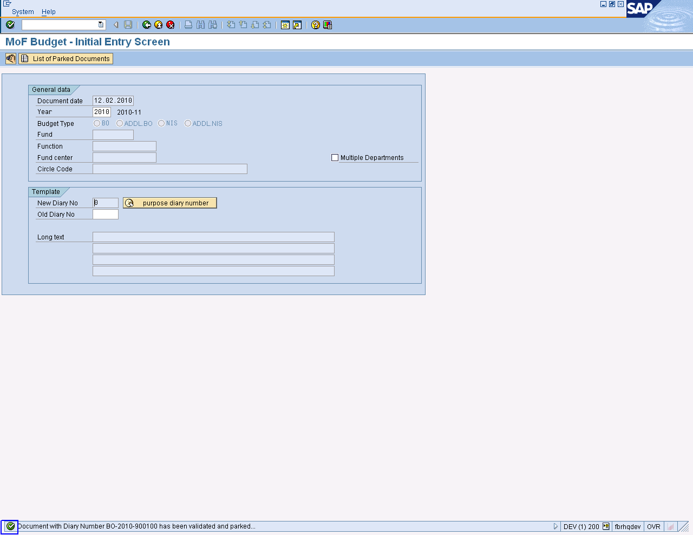

Document has been validated and parked.

Press Button to Exit

Approving Budget

Document can be approved through “Approving Authority of FBR” Process Will as. Select Business Workplace Icon from SAP Easy Access Screen

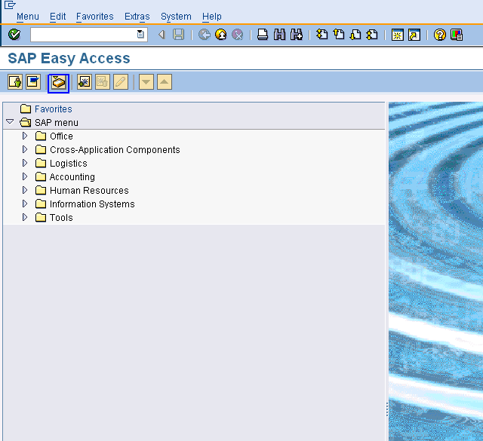

On screen “Business Workplace of budget Test, User Path as

Workplace: Budget Test➢ Inbox ➢ Workflow

Select Document which are Parked.
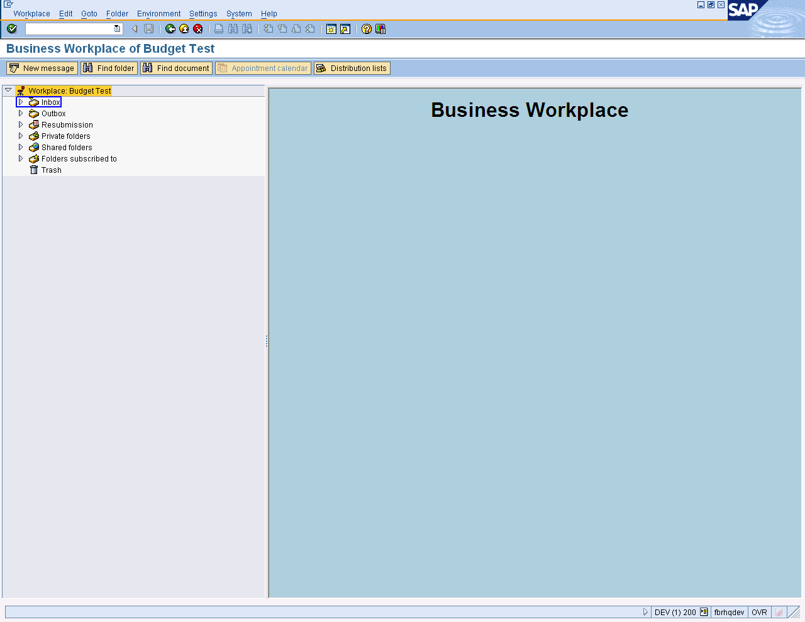

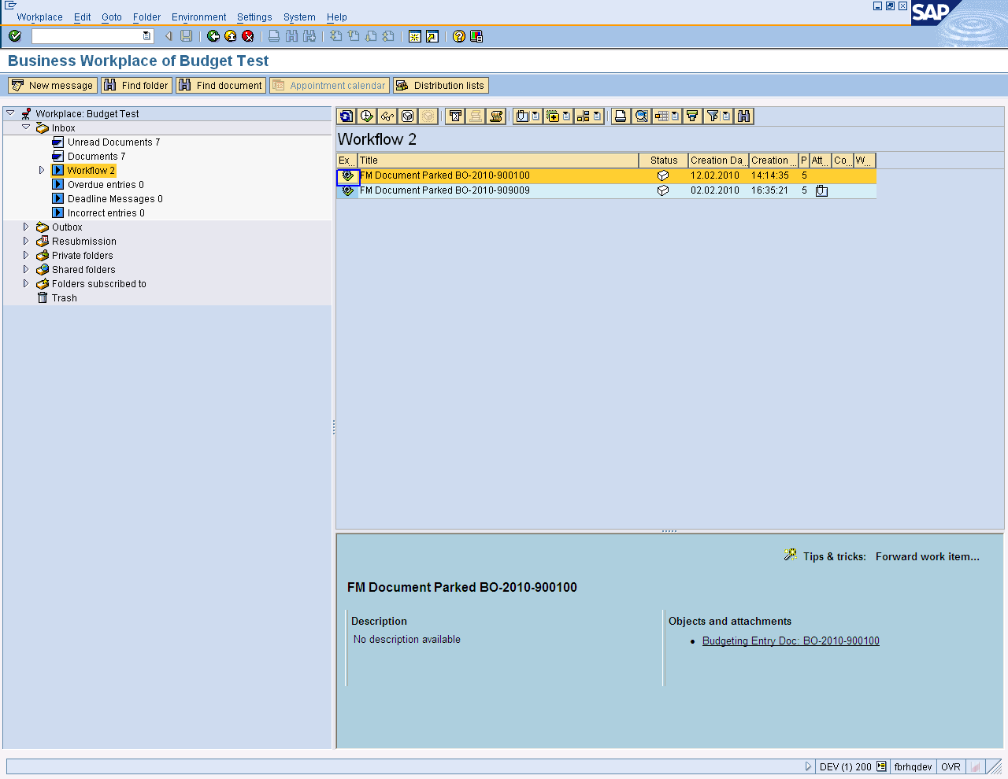
Open document by left clicking

User can view parked Documents.

It can be changed on this stage, as shown below on the screen

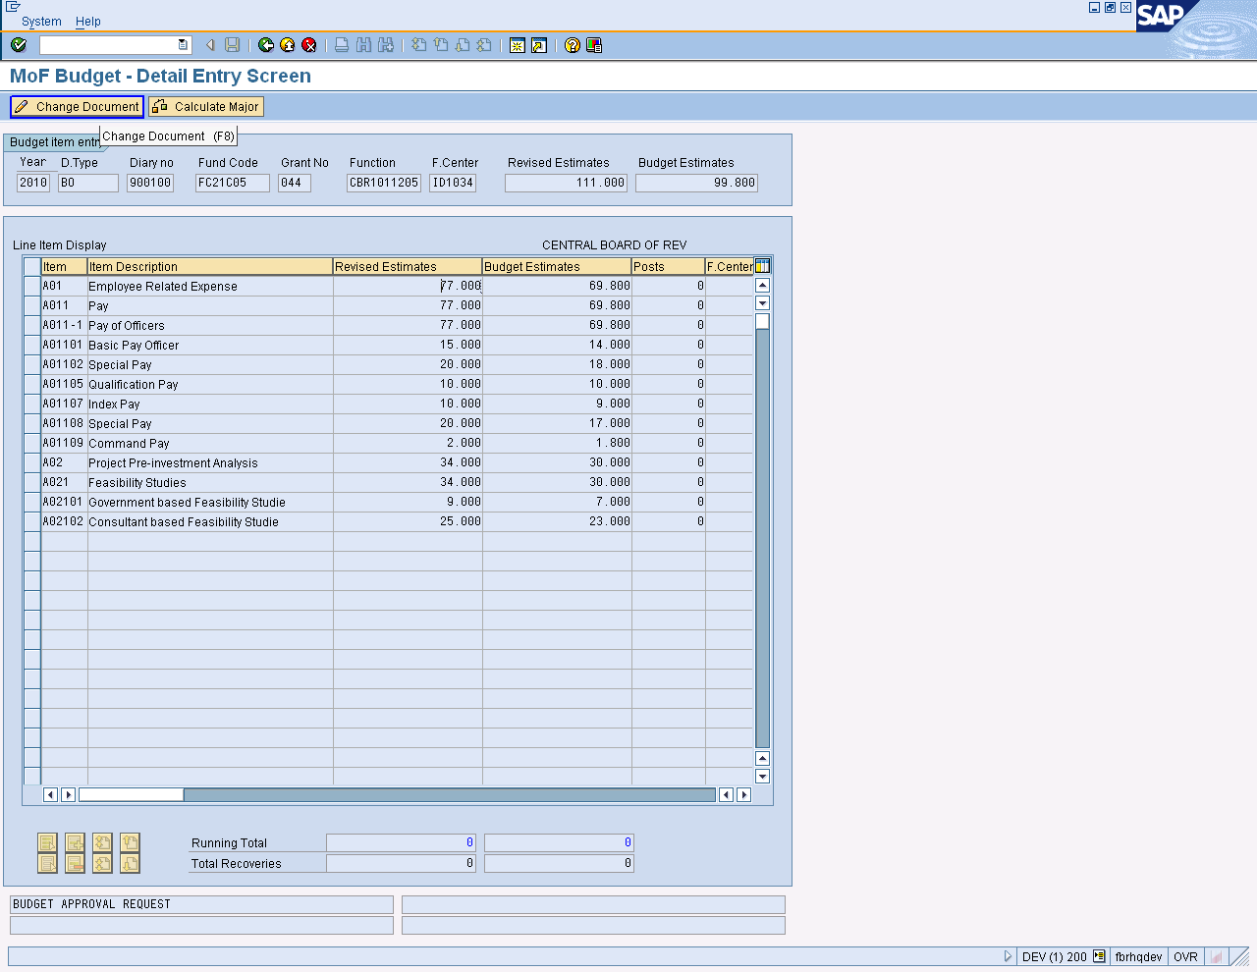

Click on Change Document

- Change any entry which you want
- Check total of Revised and budget estimates values
- Calculate major
- Press Park Document Button
- Changes will be saved
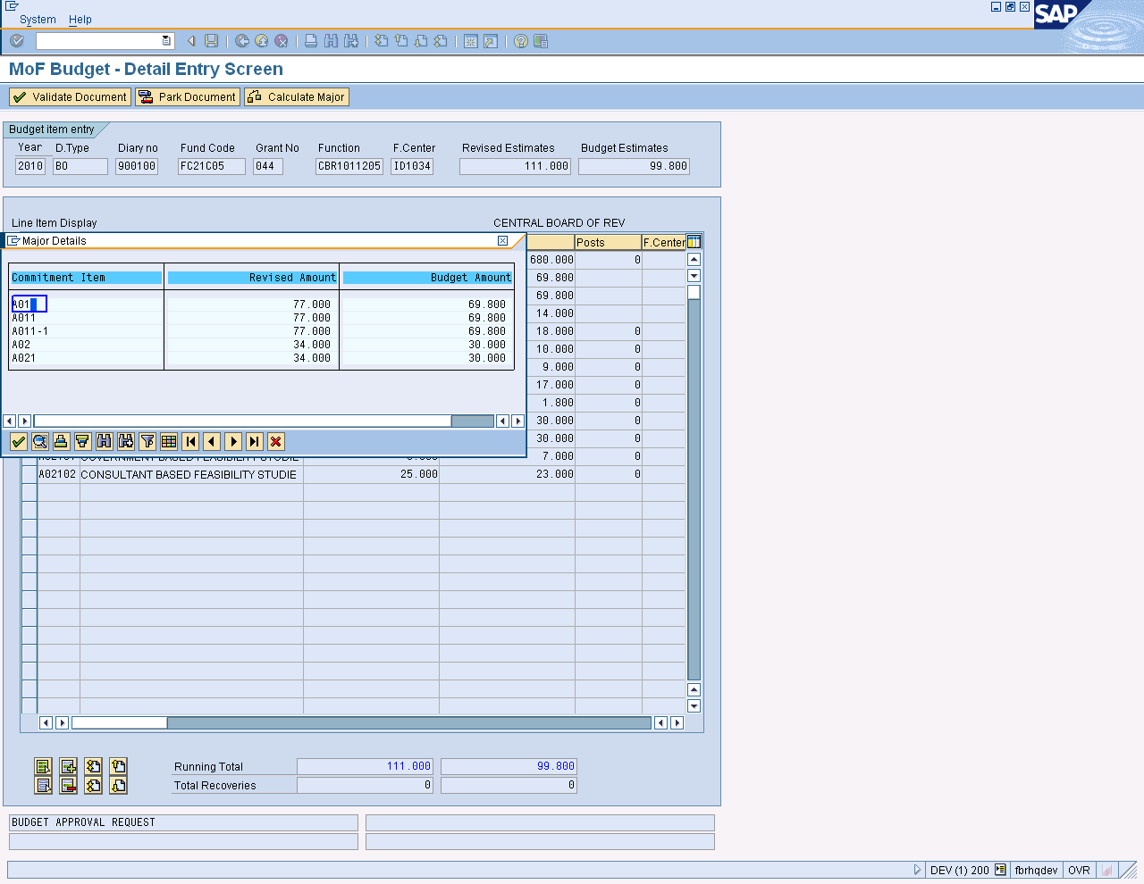
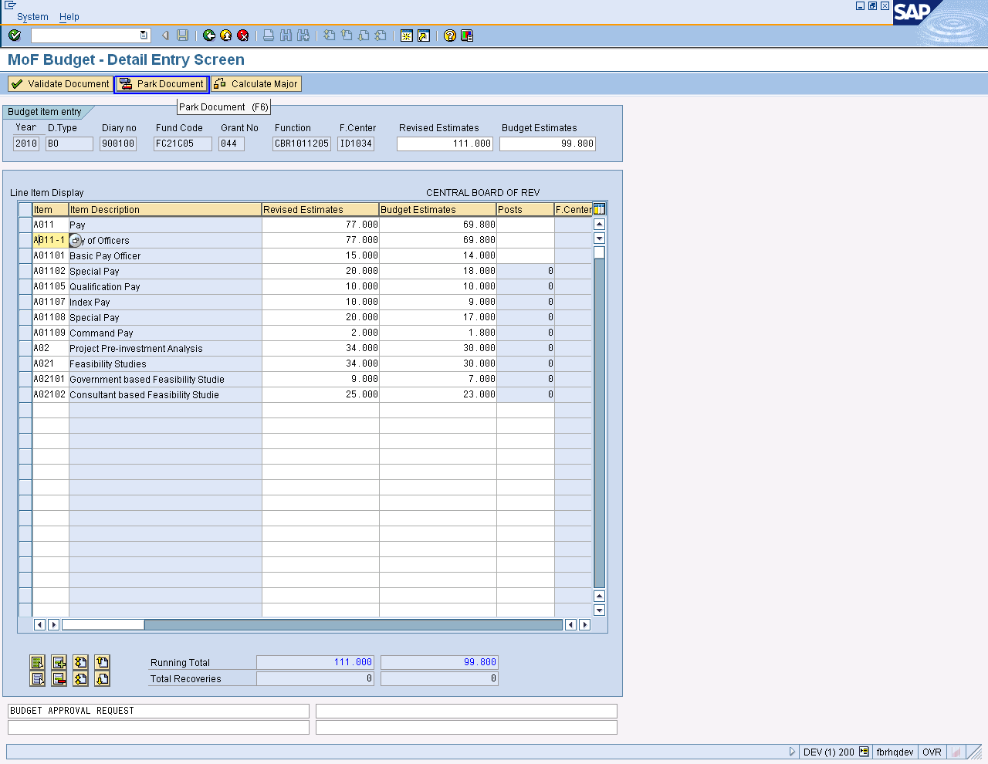

Press button after changing.
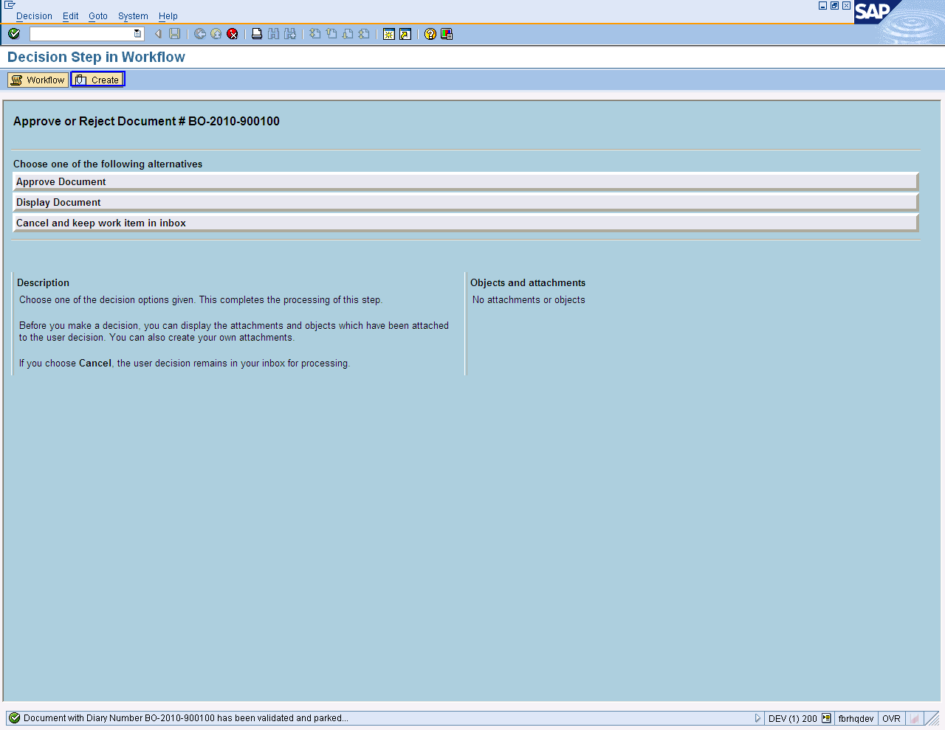

Press Create Button To Add Objects and Attachments.

Create Document header screen open.

- Select Document type
- Enter tile of document
- Click on import Button give path for saving
- Press enter or to run the transaction.

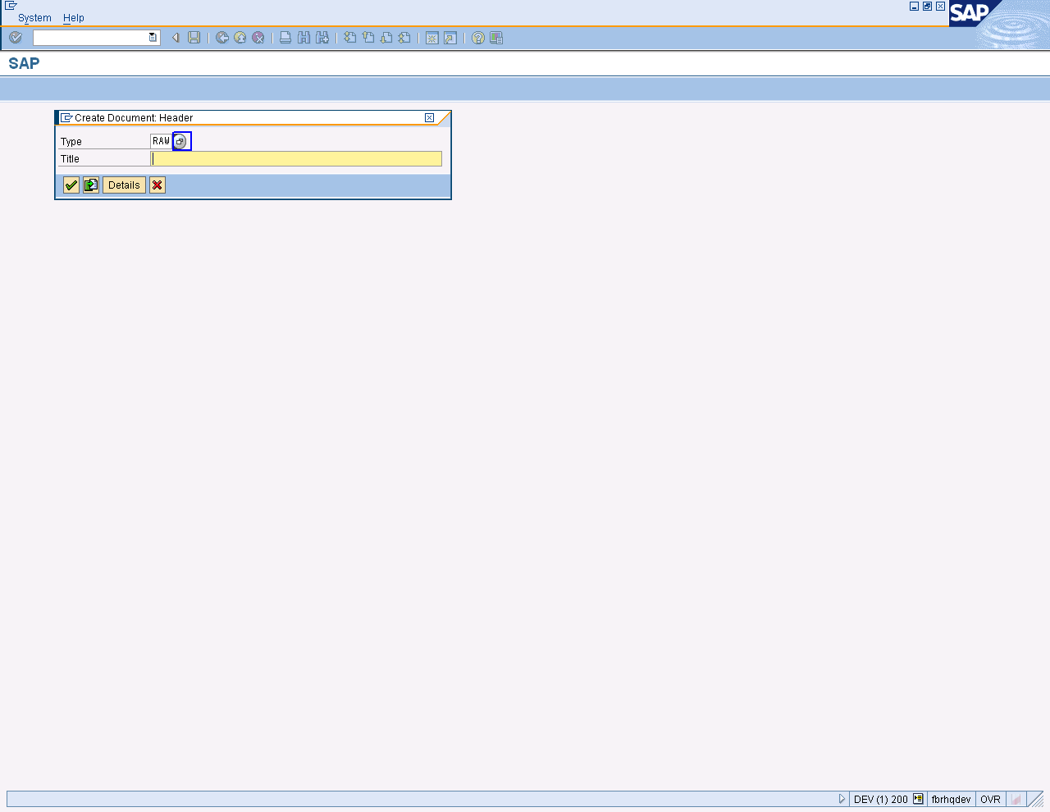

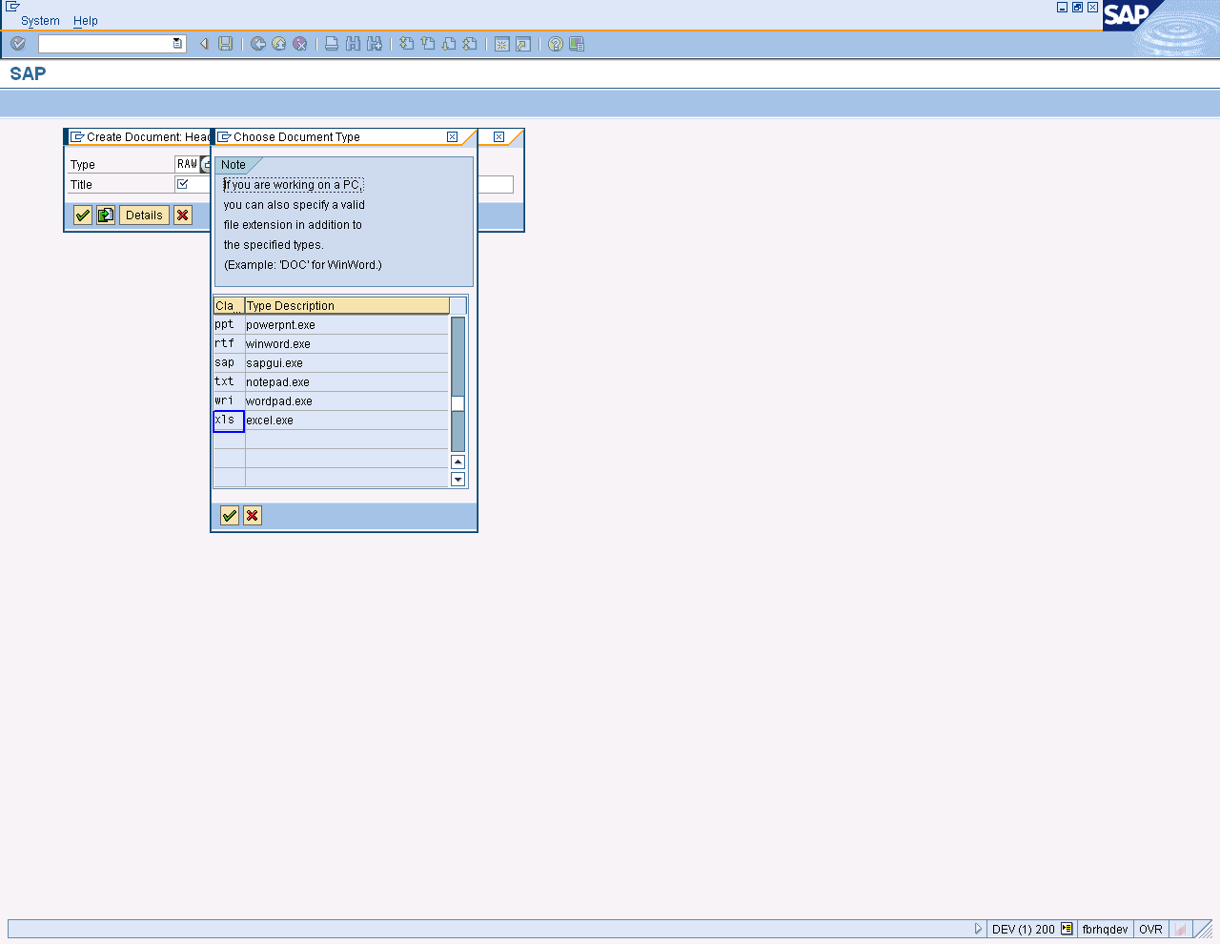

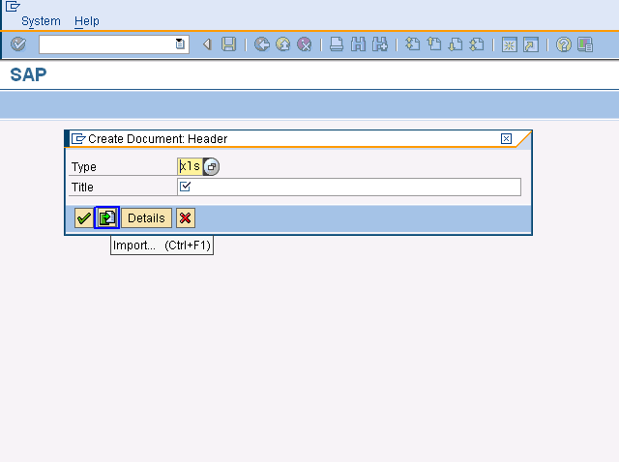
Click on Import Button

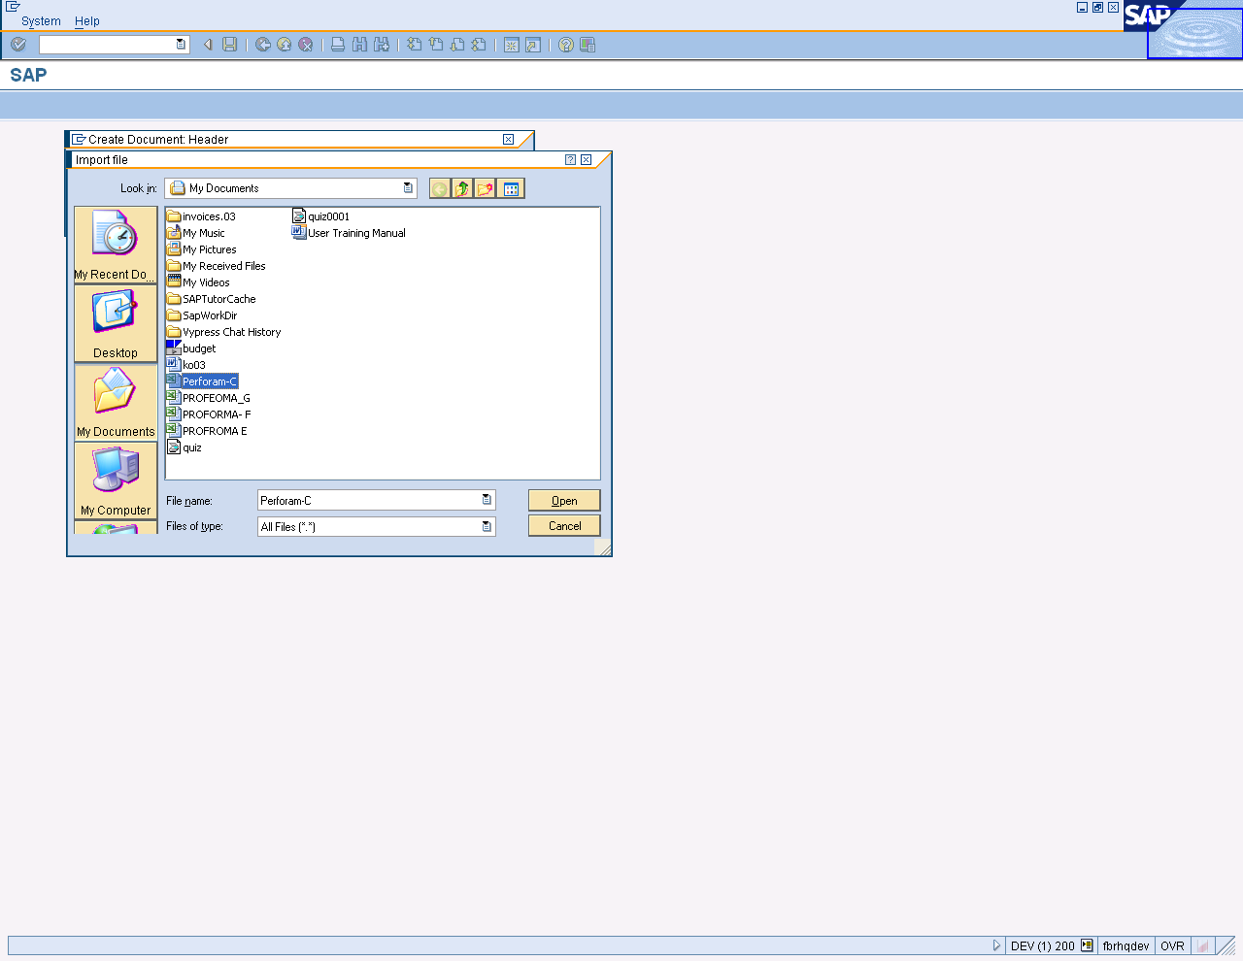
- Attachment added to work item message received.
- Click on “Approve Document” tag.

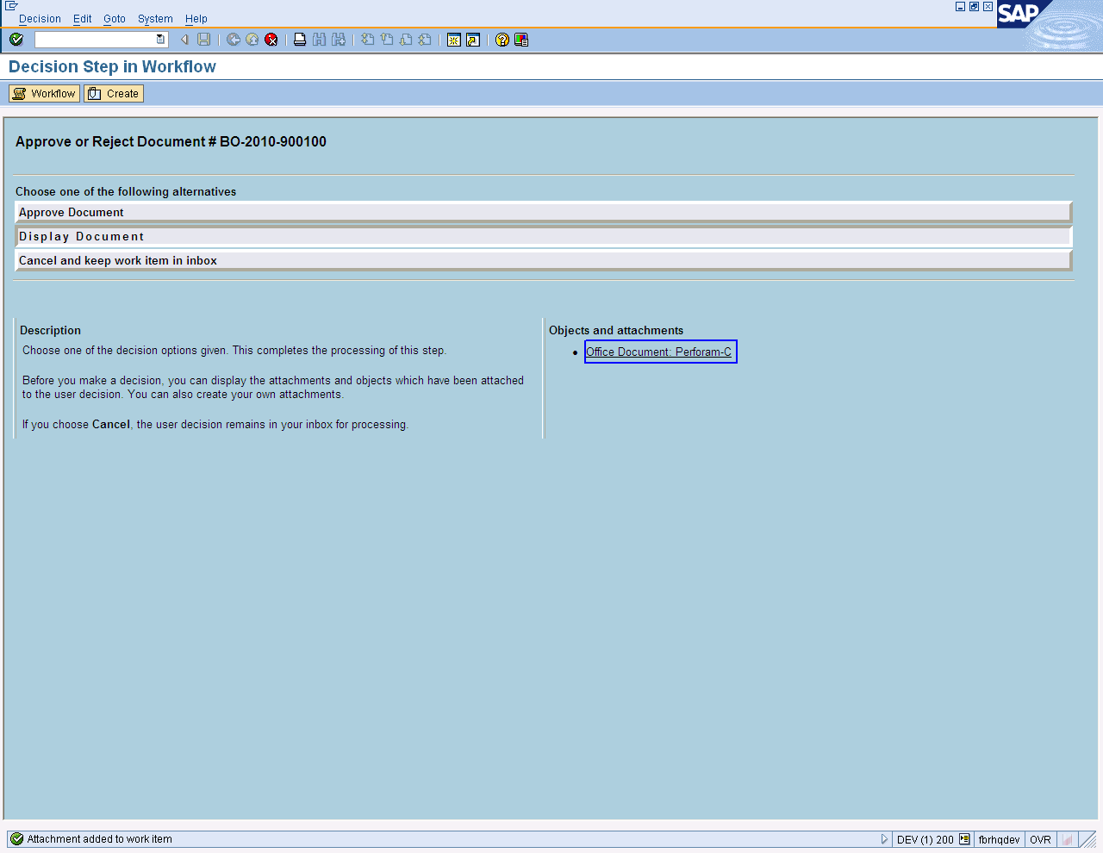

On screen “Display Step in Workflow” click the approve Document option.

Press Button to Exit

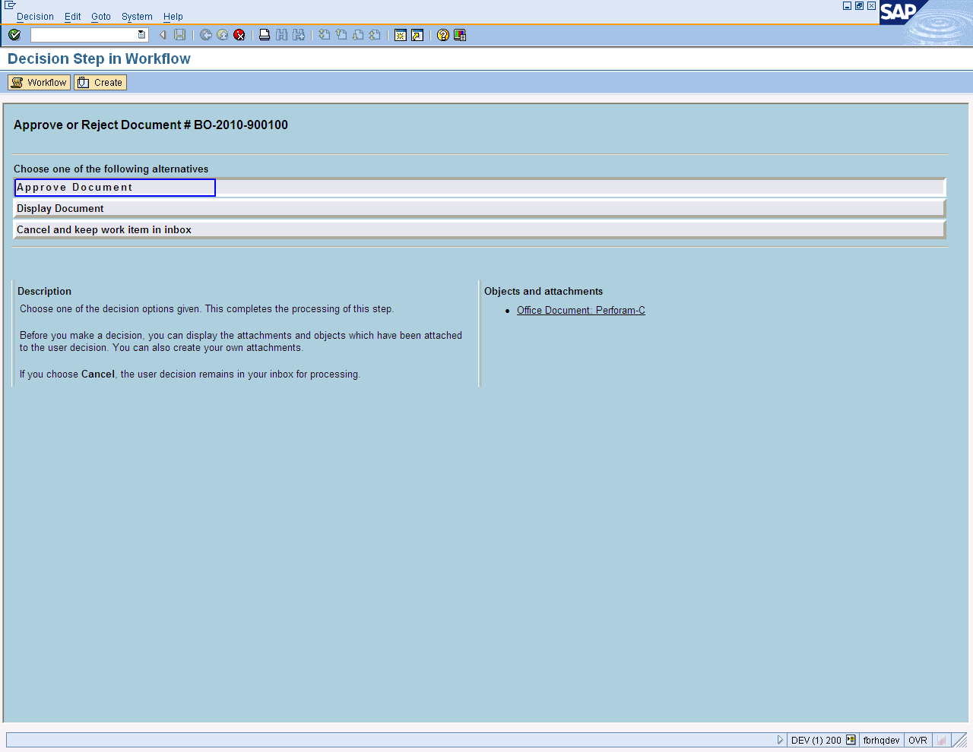
Once approved by FA organization the DDO will receive the following information in his inbox
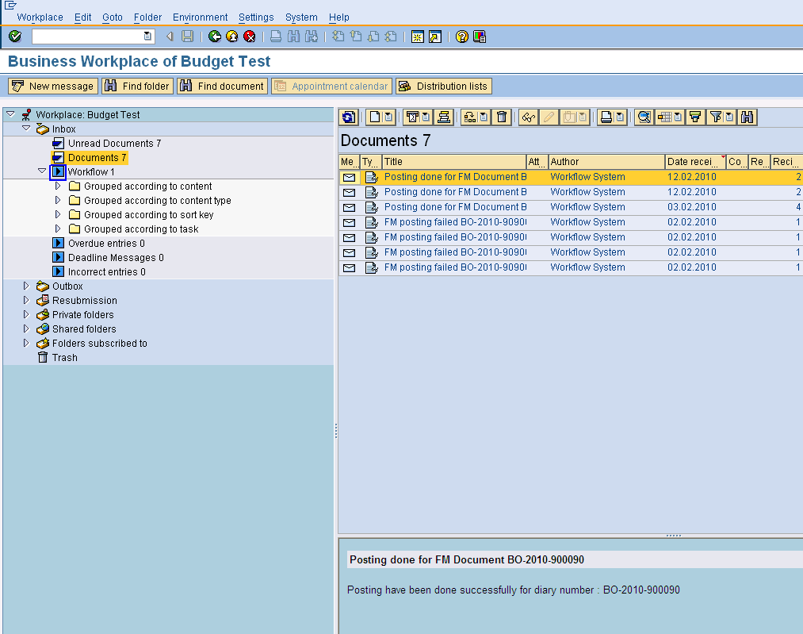
Posting done Message

Budget Approval (DFA/FA Authority)

Document is approved from DFA/FA Authority of FBR.
Incase of budget approval/non approval, data will be flow as
- Approval ➢ send Electronic data transfer by the authority➢Budget Document➢Budget document posting at server.
- Non Approval➢FBR Budget data (First parked then posted by approving authority) ➢ Budget Document➢Budget document posting at server.

User Path

SAP➢Workplace icon➢Workplace: Budget Test➢ Inbox ➢ Workflow

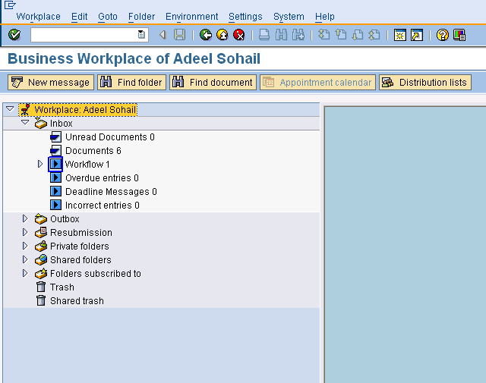
Click on workflow 1

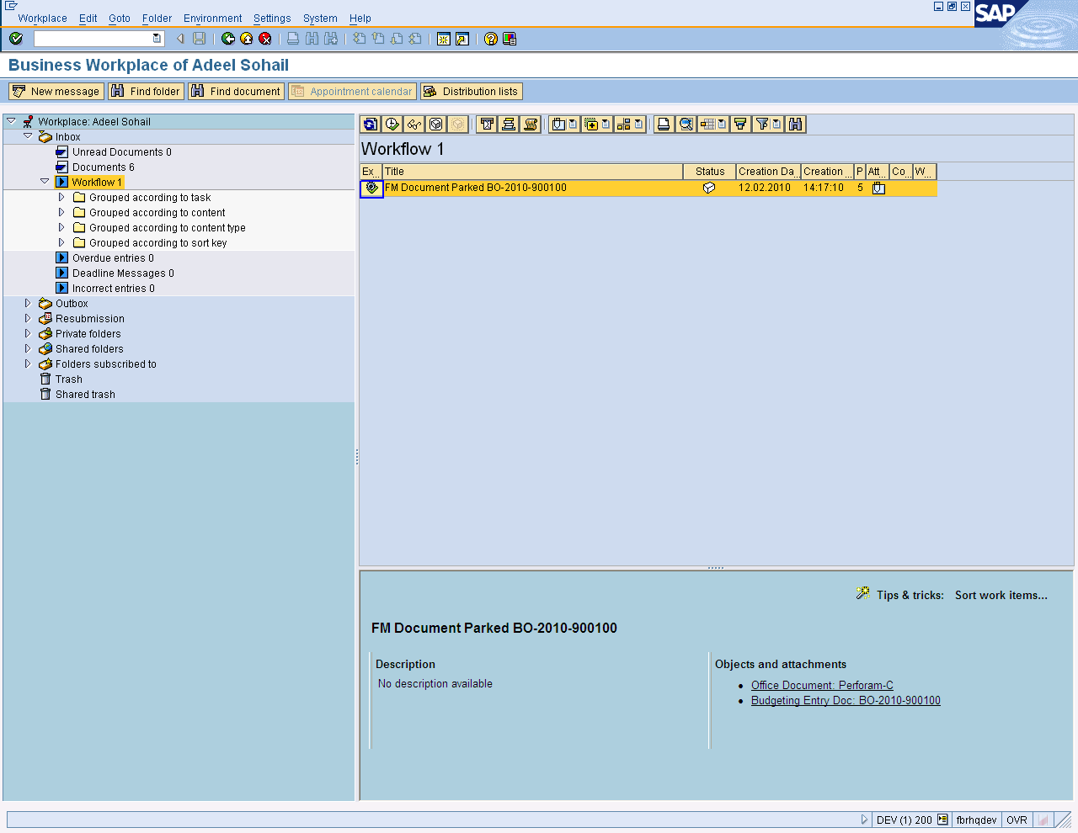
Select Document
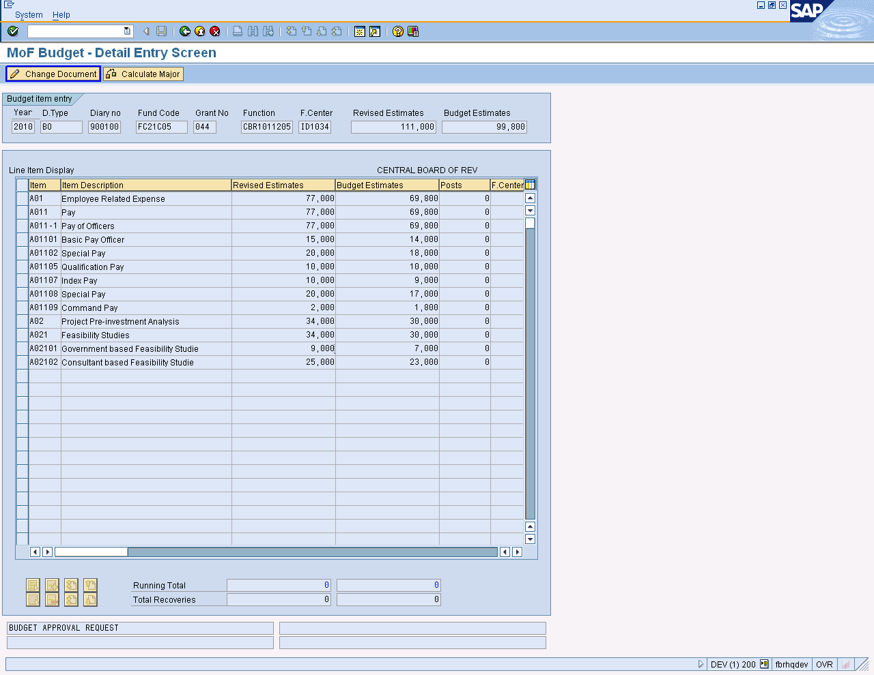
Click on Change Document

If user wants to change in budget, then before approving budget, he can change it. Like as

- Change any entry which you want
- Check total of Revised and budget estimates values
- Calculate major
- Press Park Document Button
- Changes will be saved

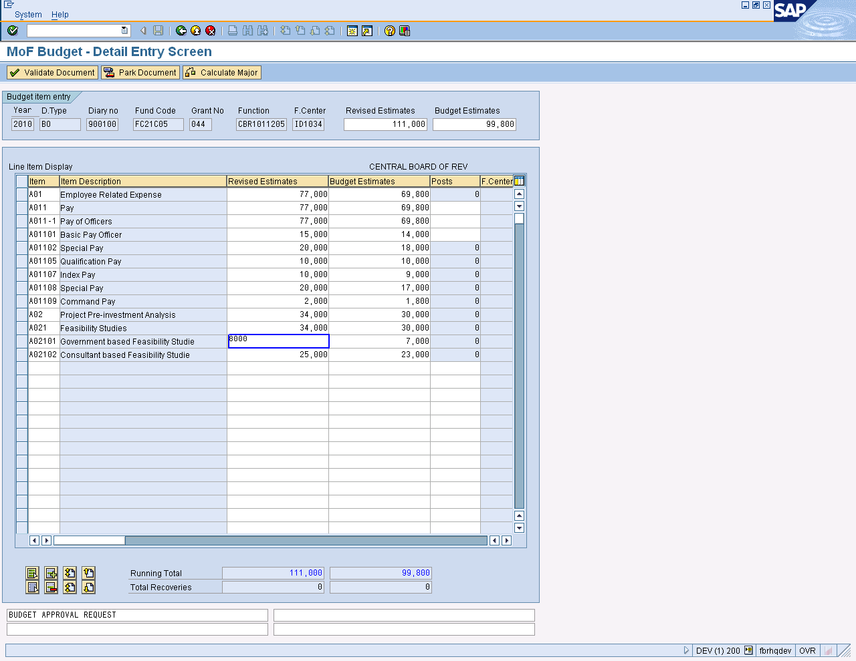
Changing fields

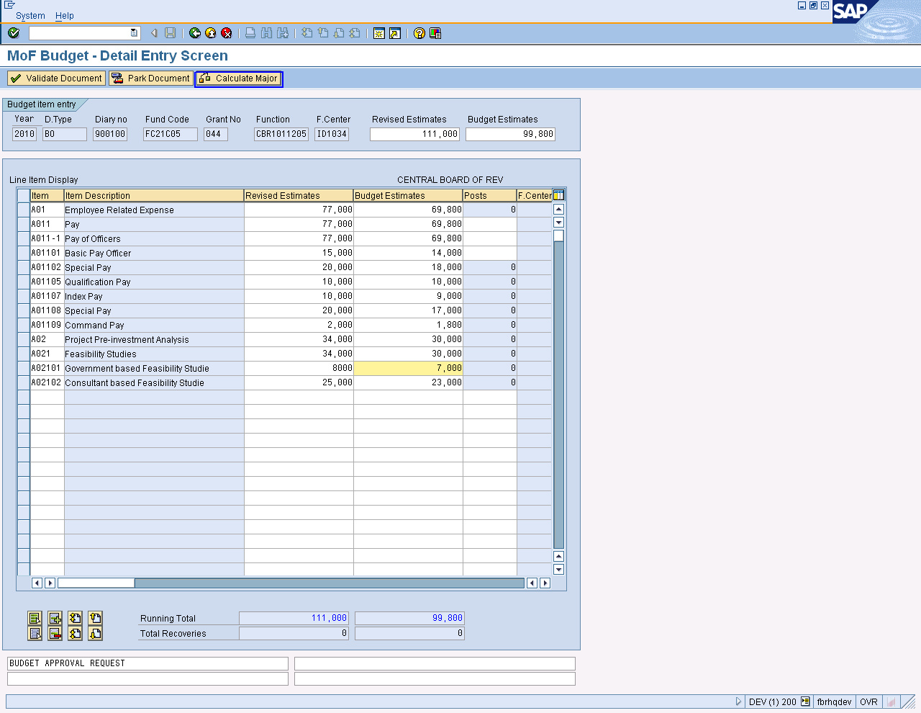

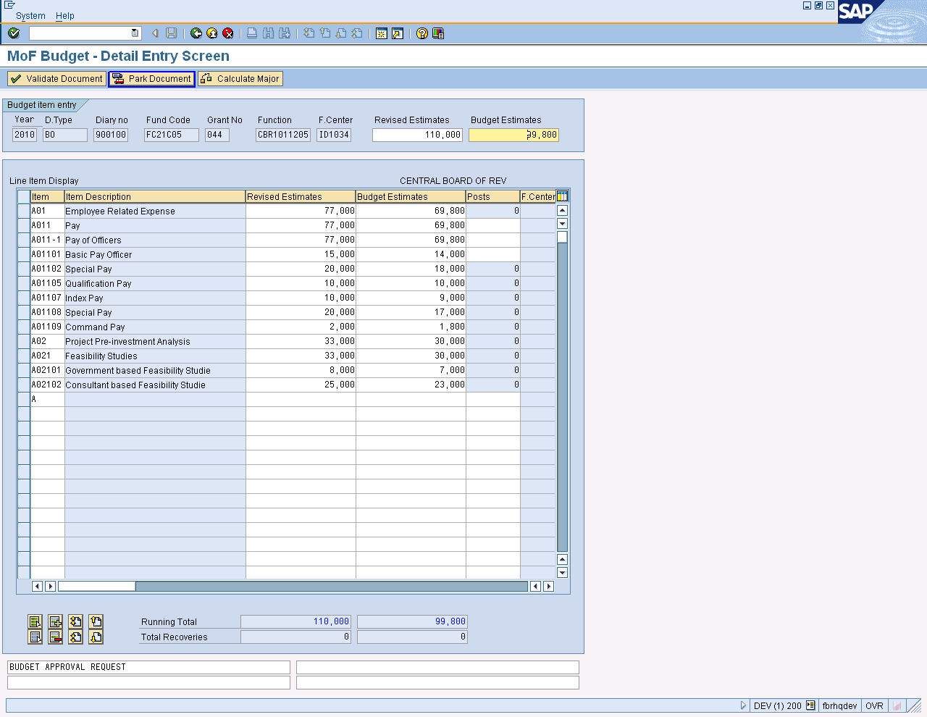
Park document

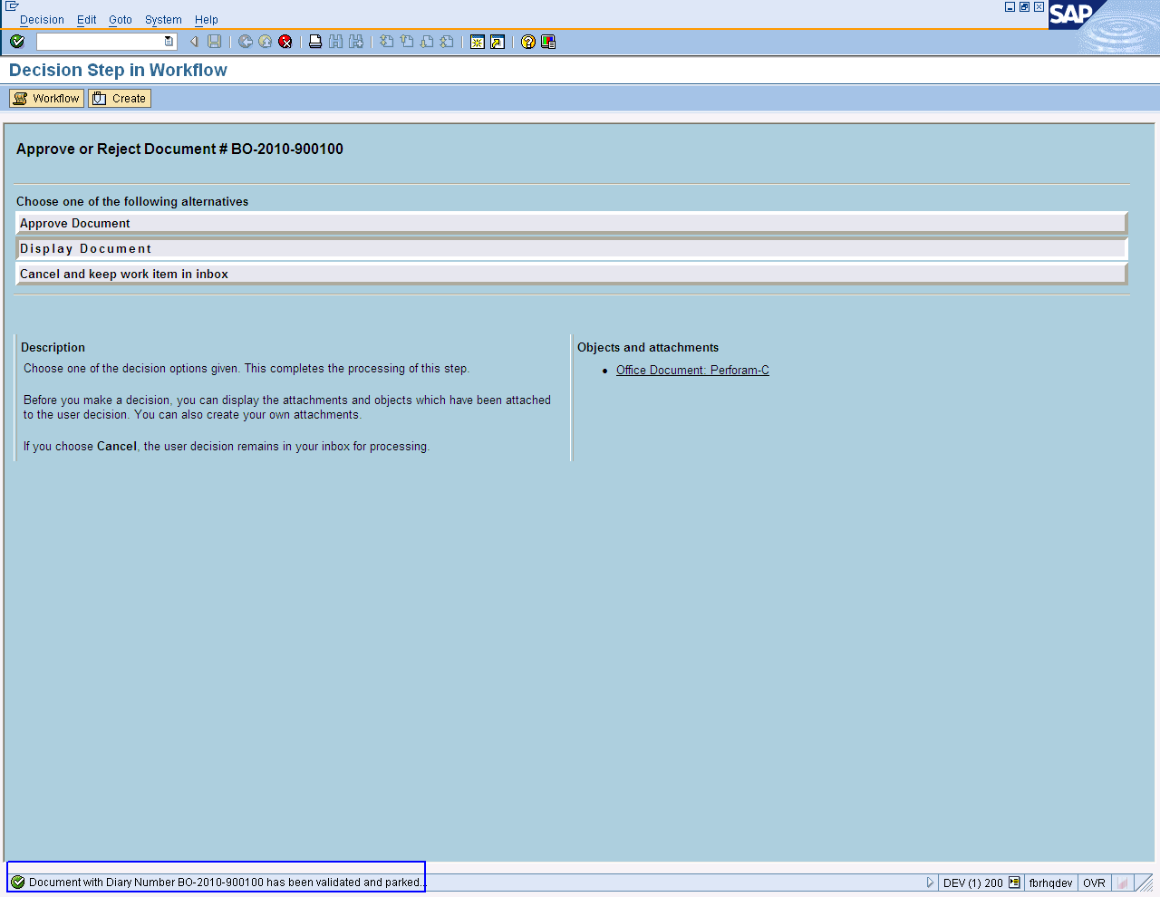

Document is parked

On screen “Display Step in Workflow” click the approve Document option.

Press Button to Exit

. 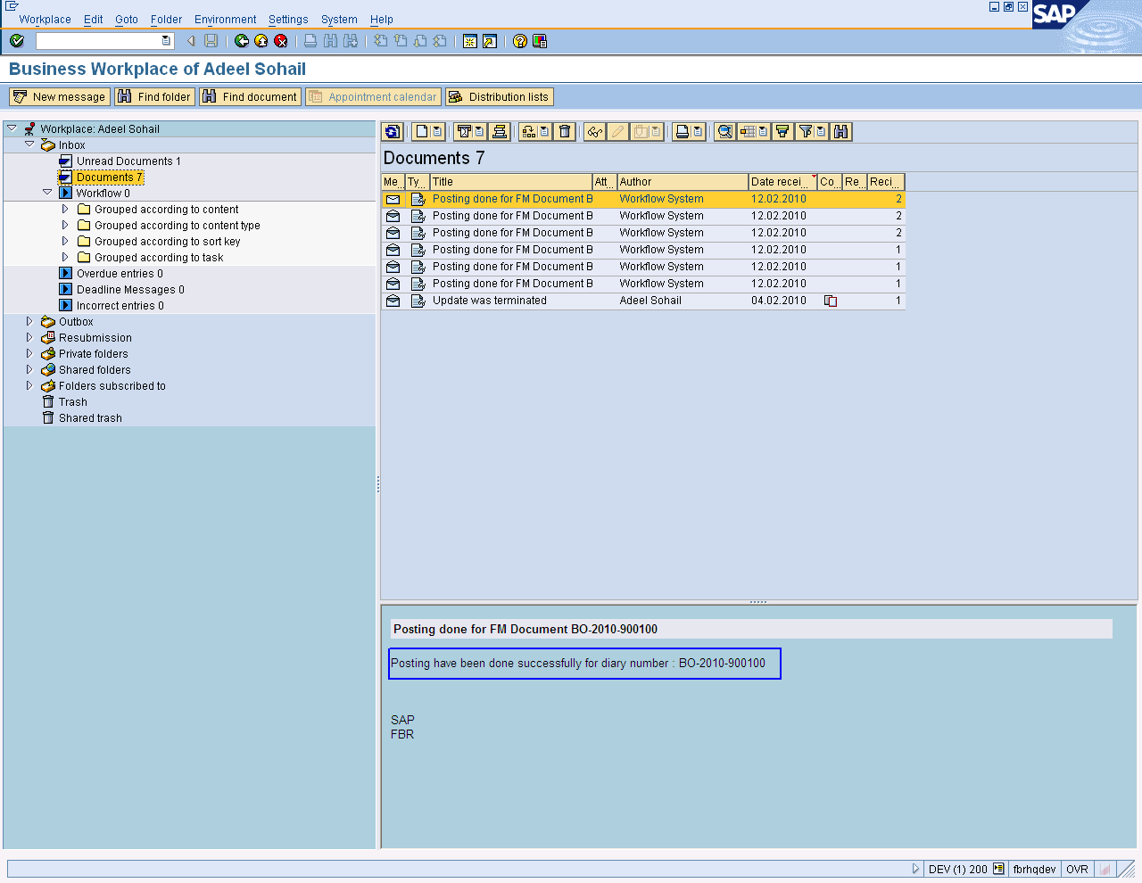

End of Transaction

Supplementary Budget

During the course of the fiscal year if the original budget falls short in any expenditure head, the DDO will prepare the supplementary budget. The supplementary budget is an addition in existing budget which increases the total budget for the DDO.

DDO’s FBR:

Prepare Supplementary Budget

Enter Transaction Code ZSUP in Command Field or navigate through tree menu.

On screen Supplementary Budget-Initial Screen, select the Fresh data entry option

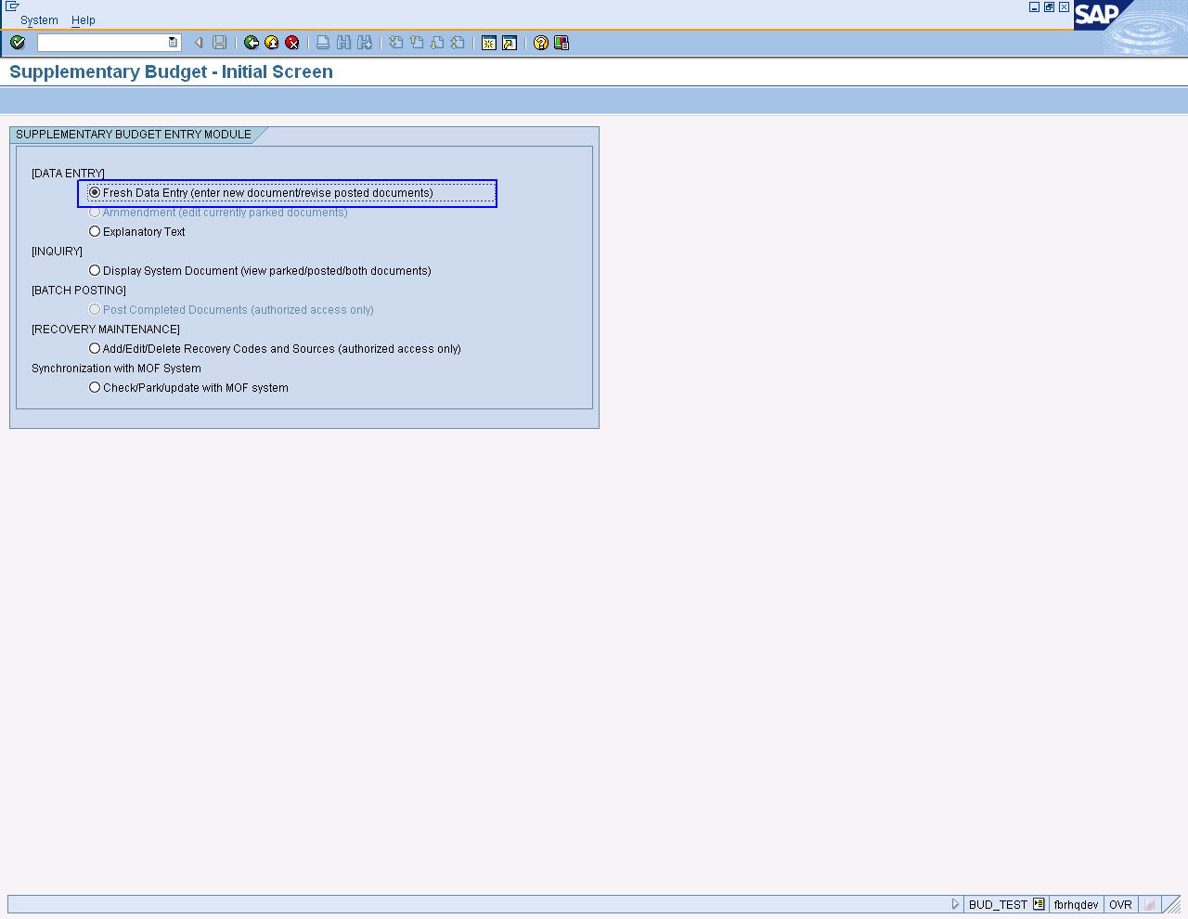

Press enter or to run the transaction.

On screen Supplementary Budget-Initial Entry Screen, enter the required information that is specified as below table.

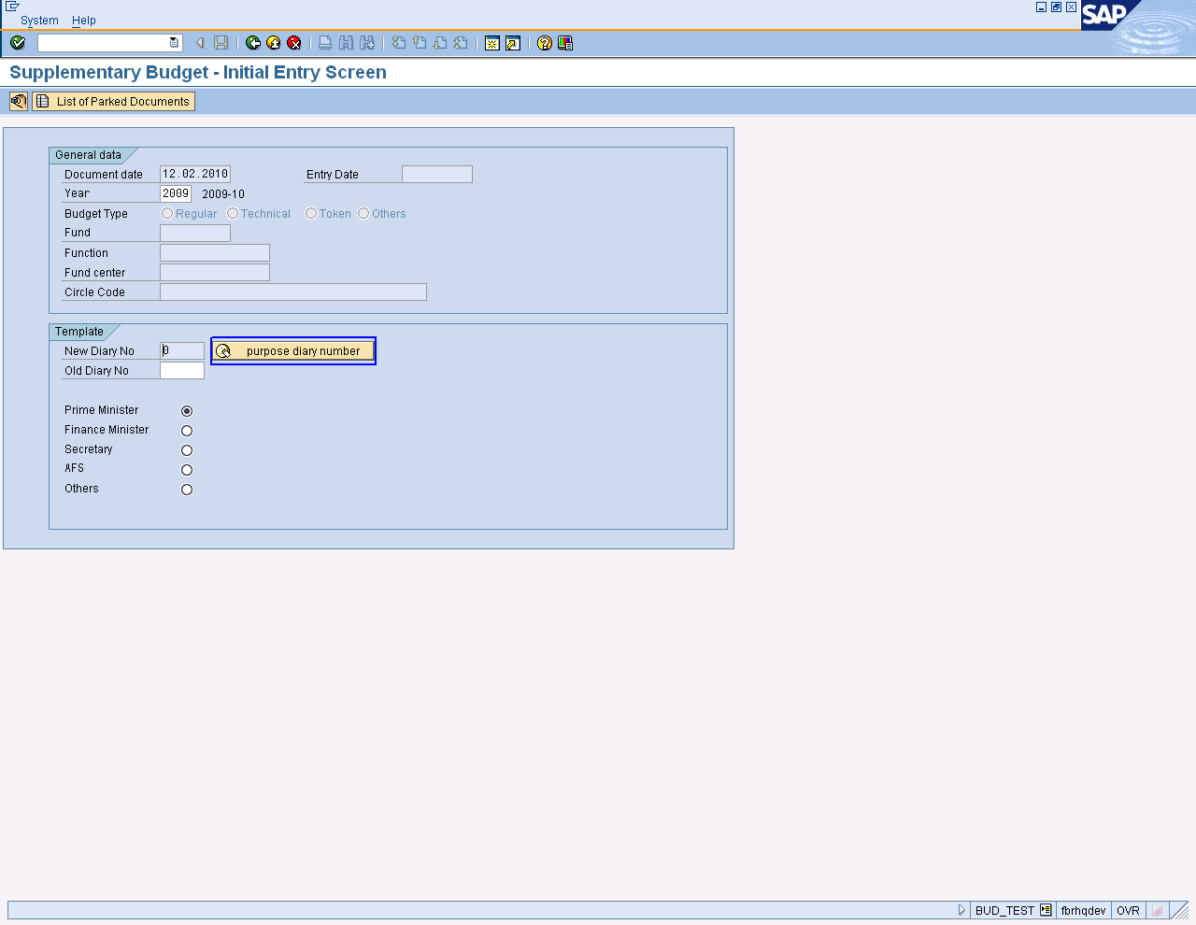

User Input:

SAP Required Fields | User Inputs Required
Template
New Diary No | Enter diary no or click on “Purpose Diary Number” it will automatic created.
Old Diary No | Optional
General Data
Document date | Enter date
Year | Enter year
Budget Type | Select one budget type form given option.
Fund | Enter the Fund number
Function | Enter Function which are going to proceed
Fund Center | Enter Fund Center
Circle Code | Optional

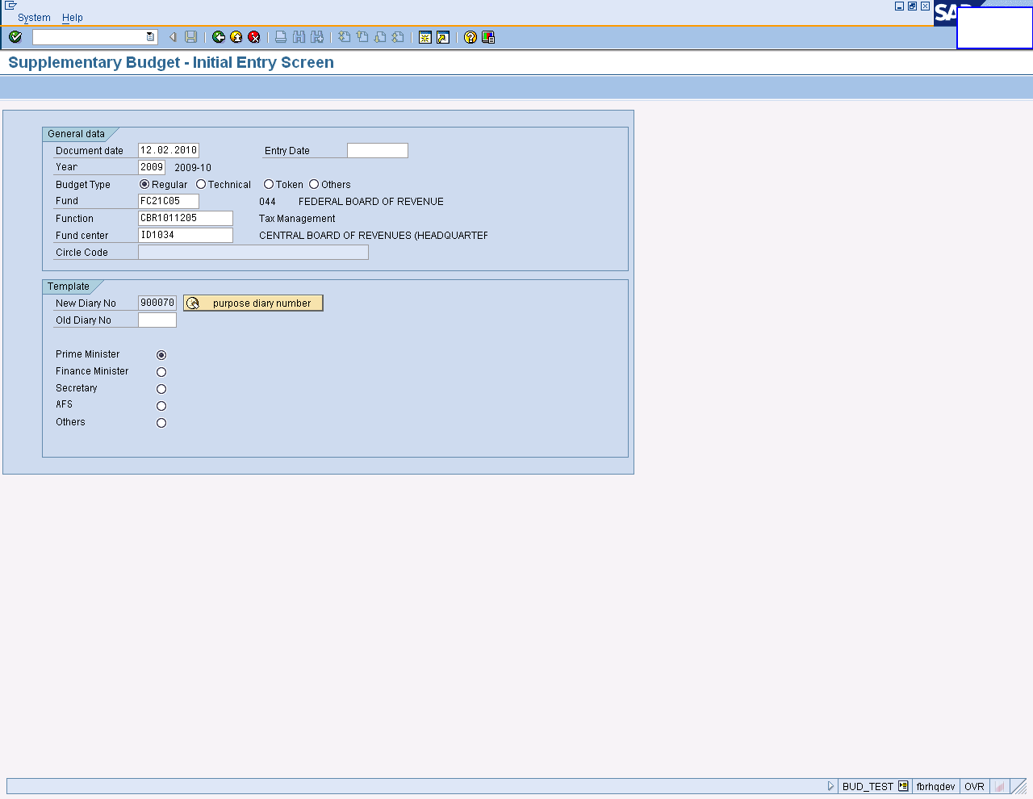

Press enter or to run the transaction

Supplementary Budget: Detail Entry Screen will be opened. Enter the following information

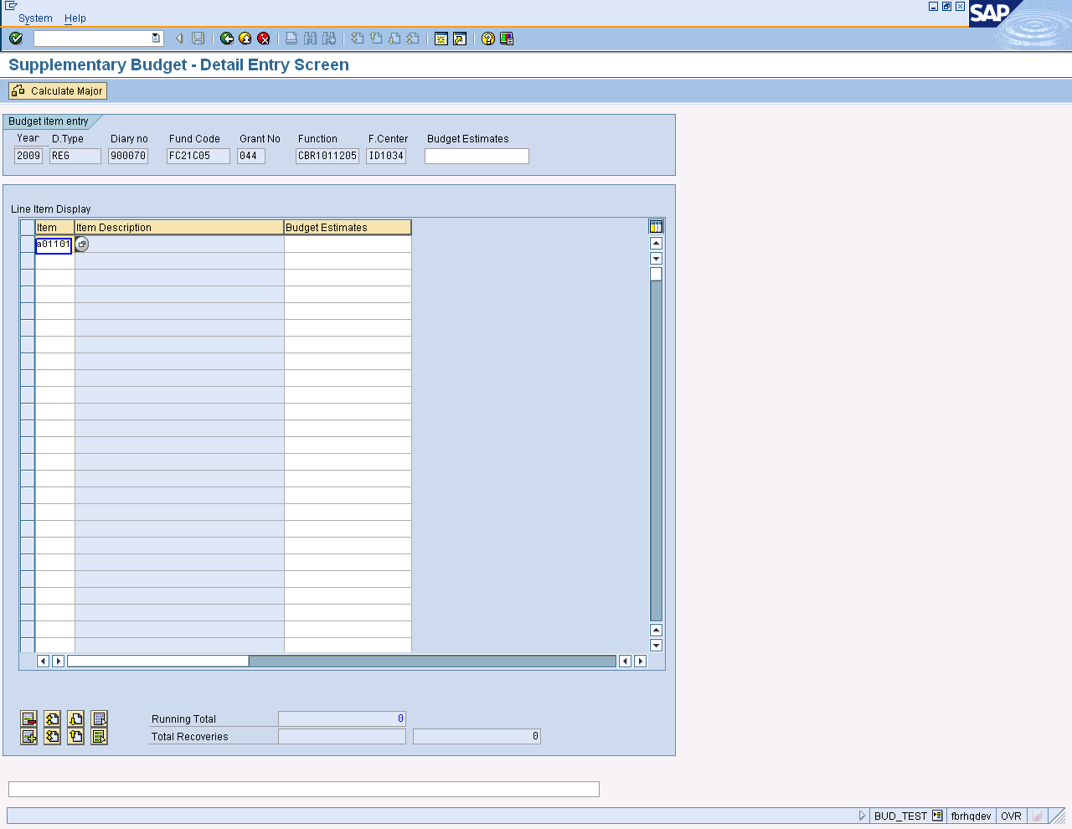

User Input:
SAP Required Fields | User Inputs Required
Line item Display
Item | Enter Item one by one which are estimated.
Item Description | Description of item (Optional)
Budget Estimates | Enter amount

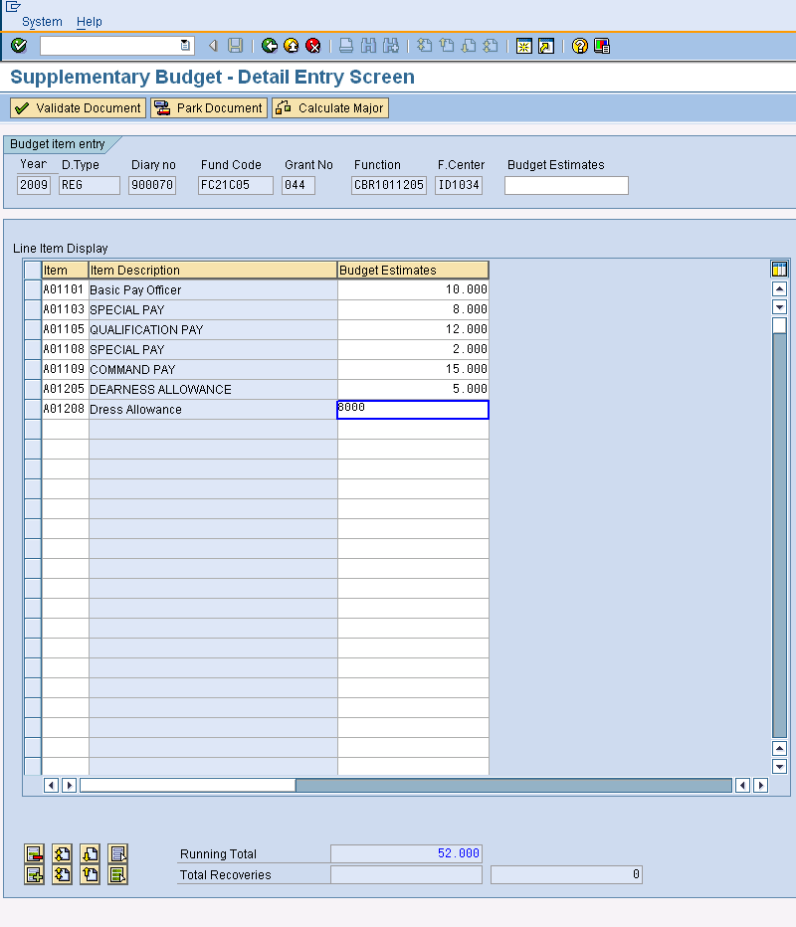
Press Calculate Major Button
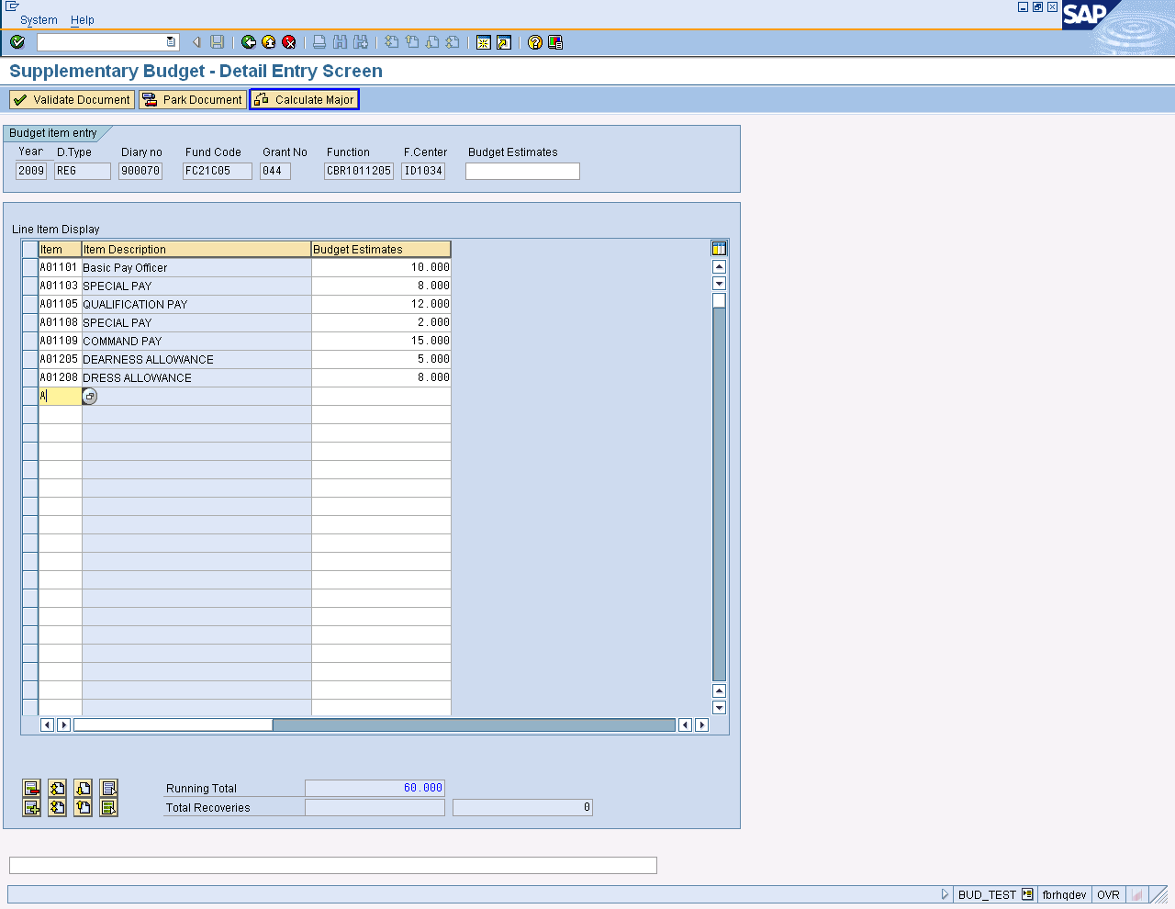

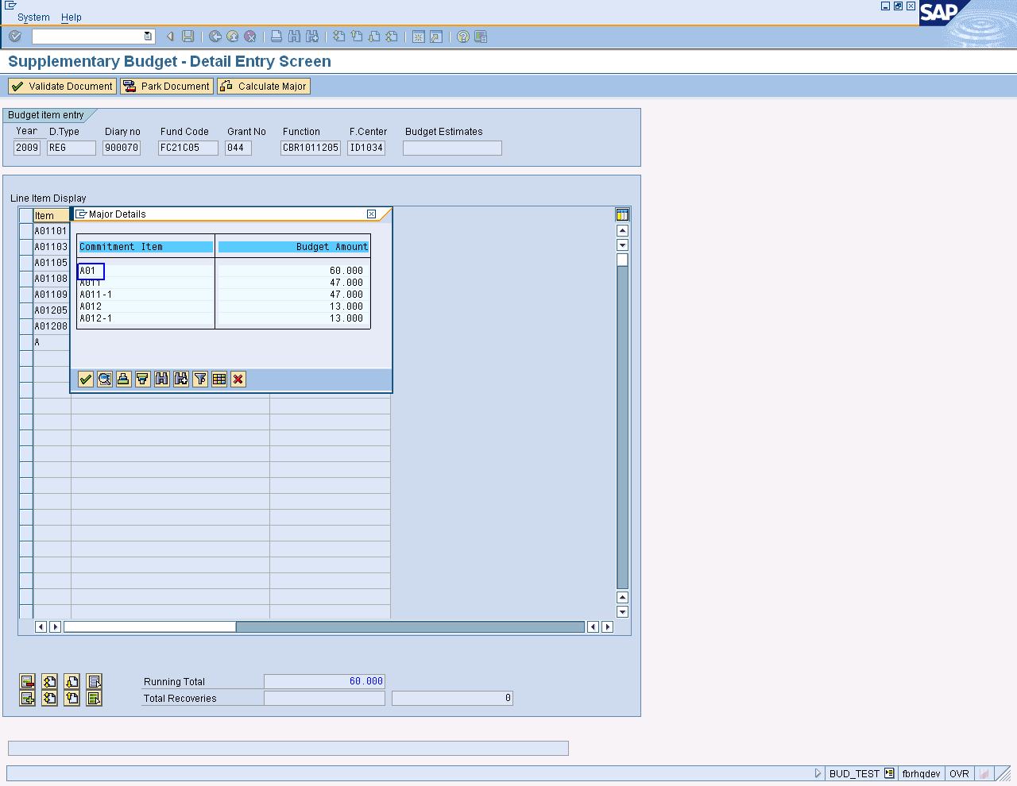
Select commitment item
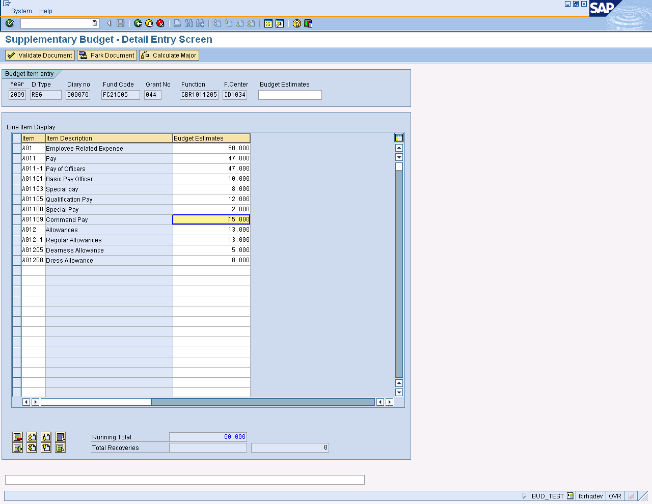

Major detail of selected commitment item

Press “Park Document button.

User will be received a validation Prompt.

Click “Yes” to park the document.

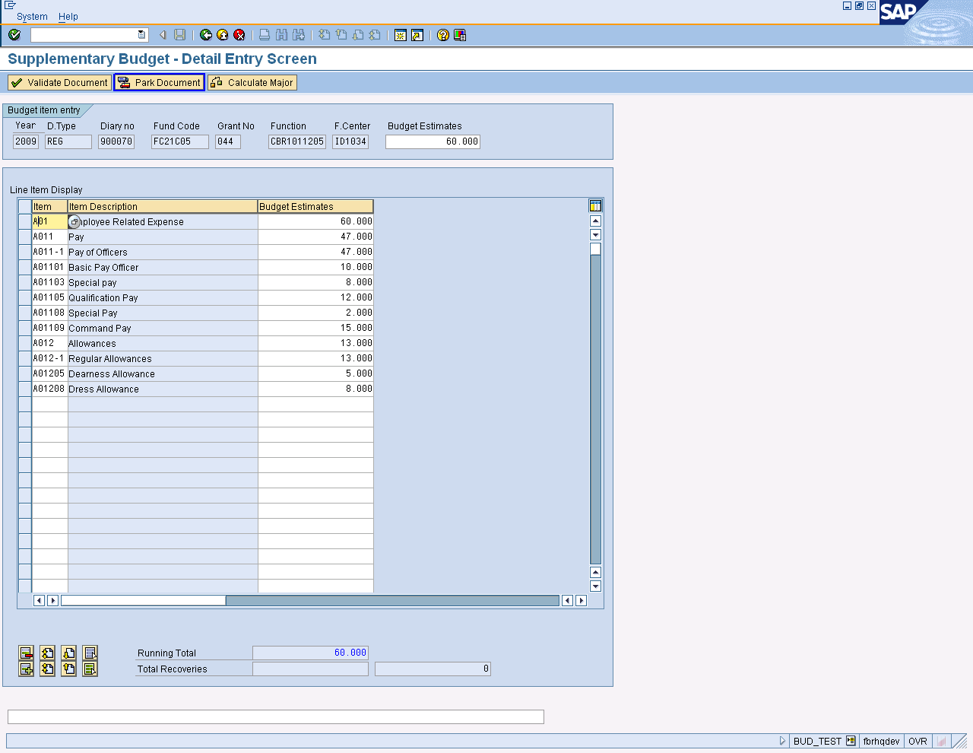

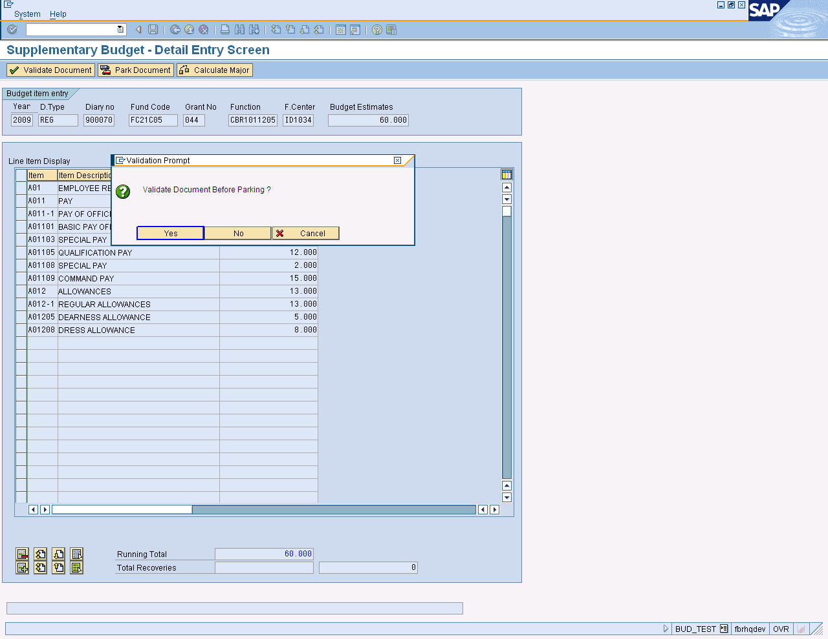
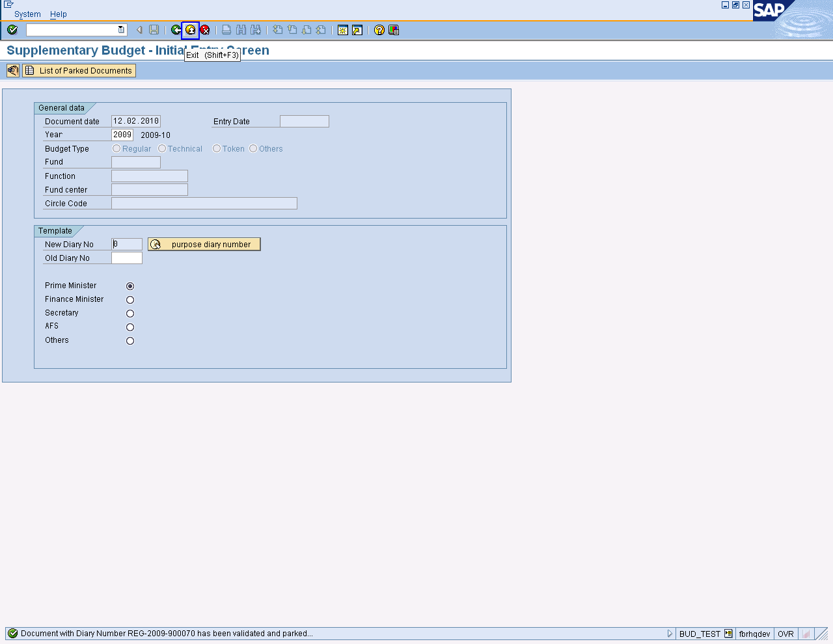

Document has been validated and parked.

Press Button to Exit

Budget Approval/Change in Budget

Approving Authority FBR will be doing this activity then budget will transfer to FA/DFA Authority.

User Path:

Select Business Workplace Icon from SAP Easy Access Screen

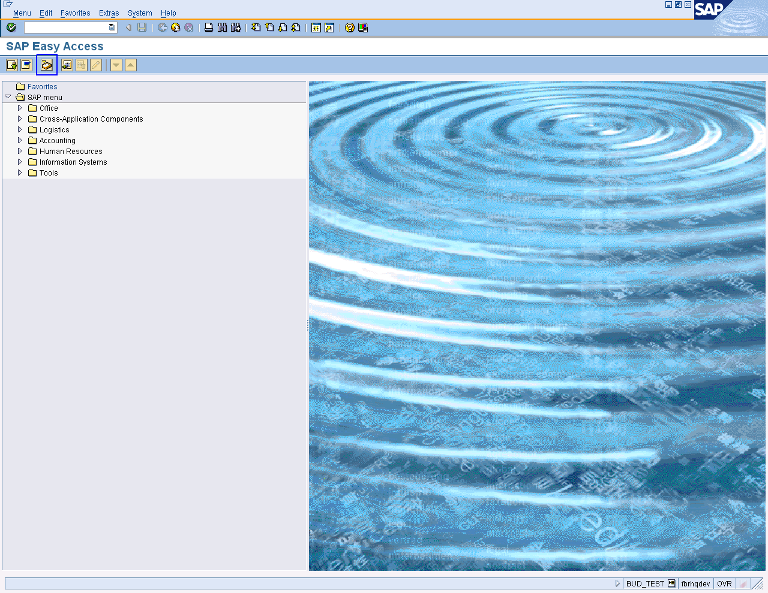

On screen “Business Workplace of budget Test, User Path as

Workplace: Budget Test➢ Inbox ➢ Workflow

Select Document which are Parked.

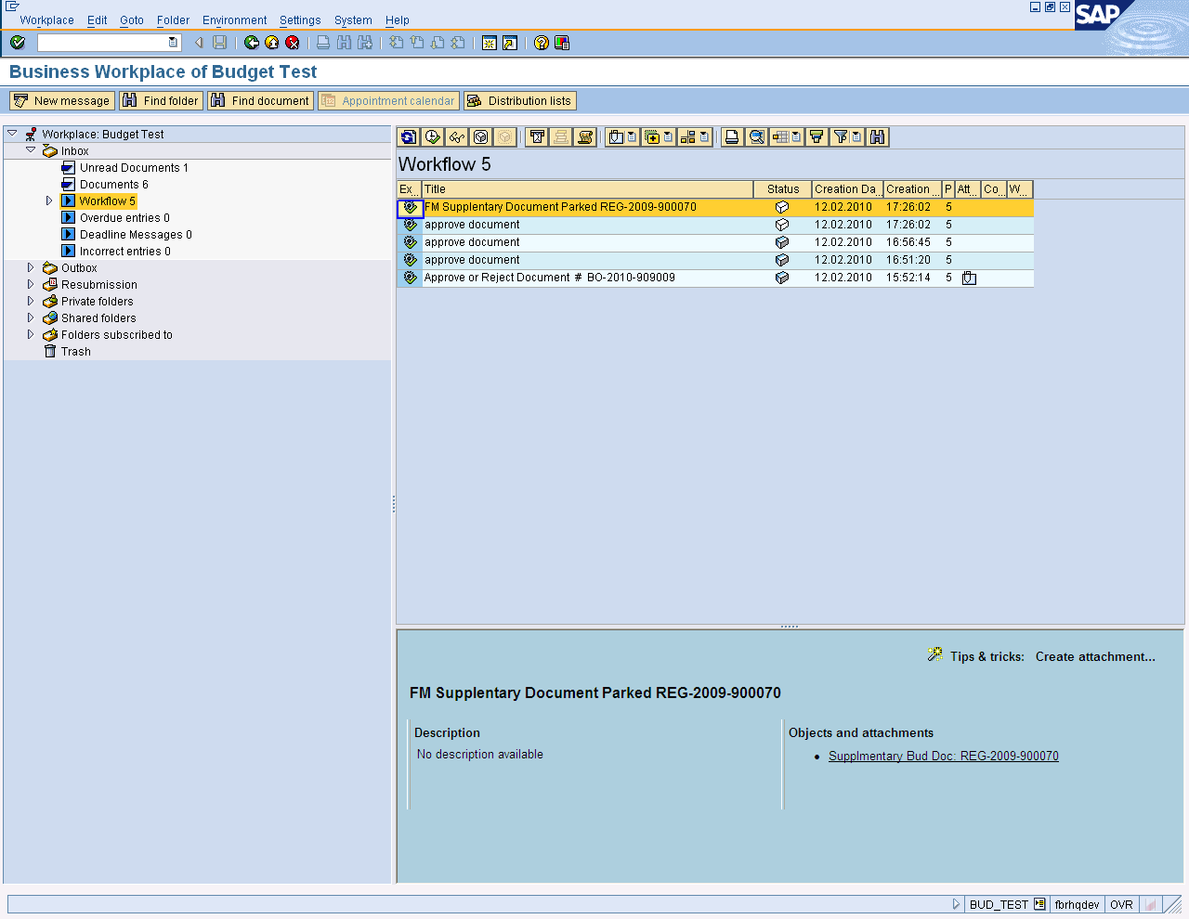
Open document by left clicking

User can view parked Documents.

It can be changed on this stage, as shown below on the screen

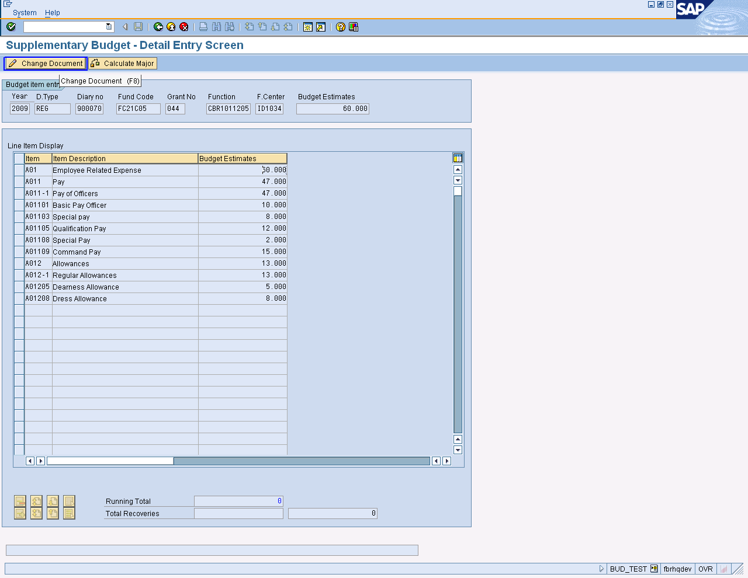

Click on Change Document

- Change any entry which you want
- Check total of Revised and budget estimates values
- Calculate major
- Press Park Document Button
- Changes will be saved
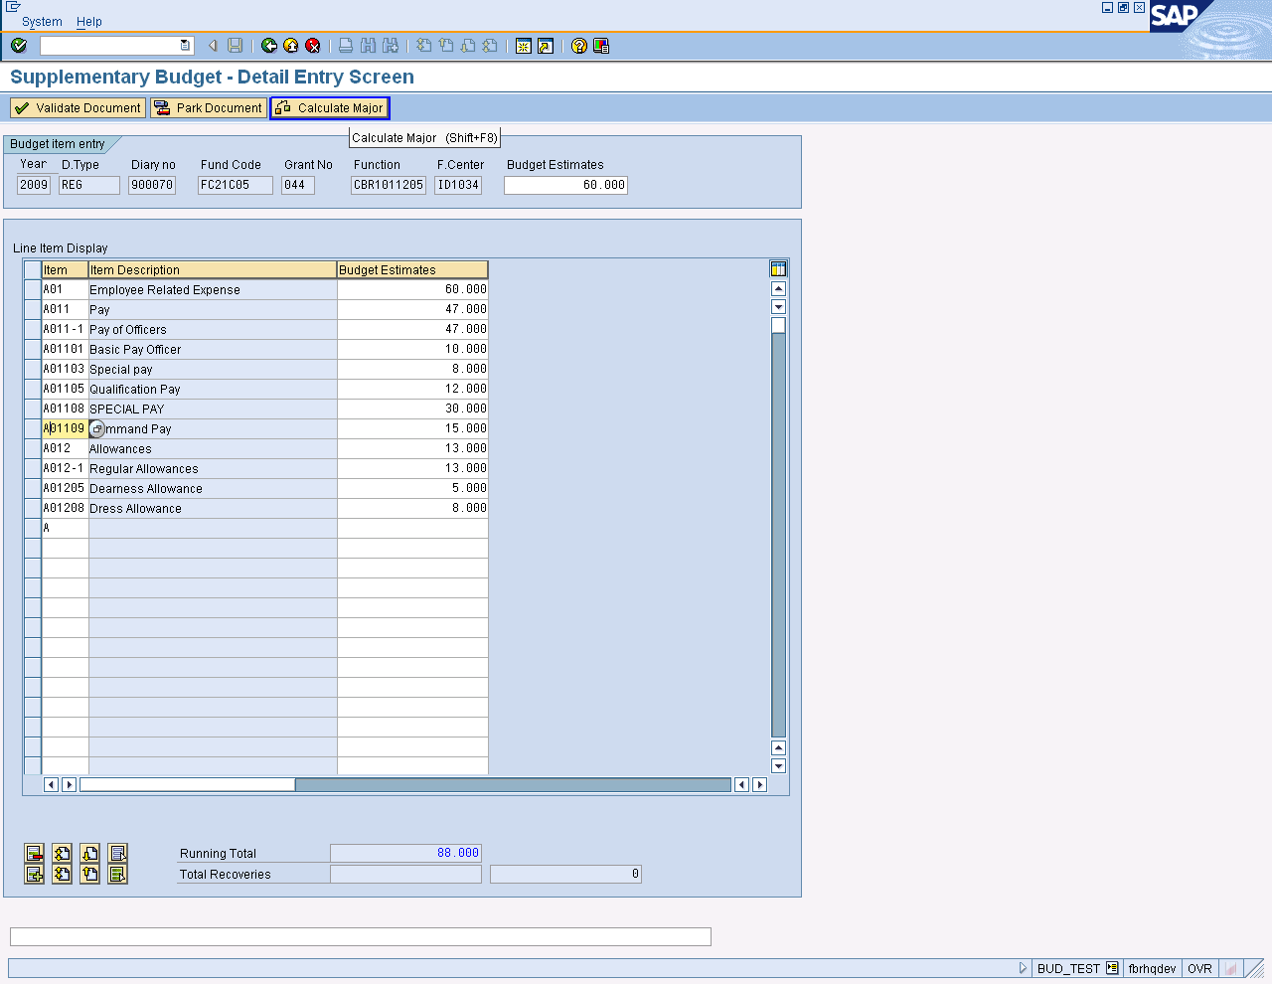

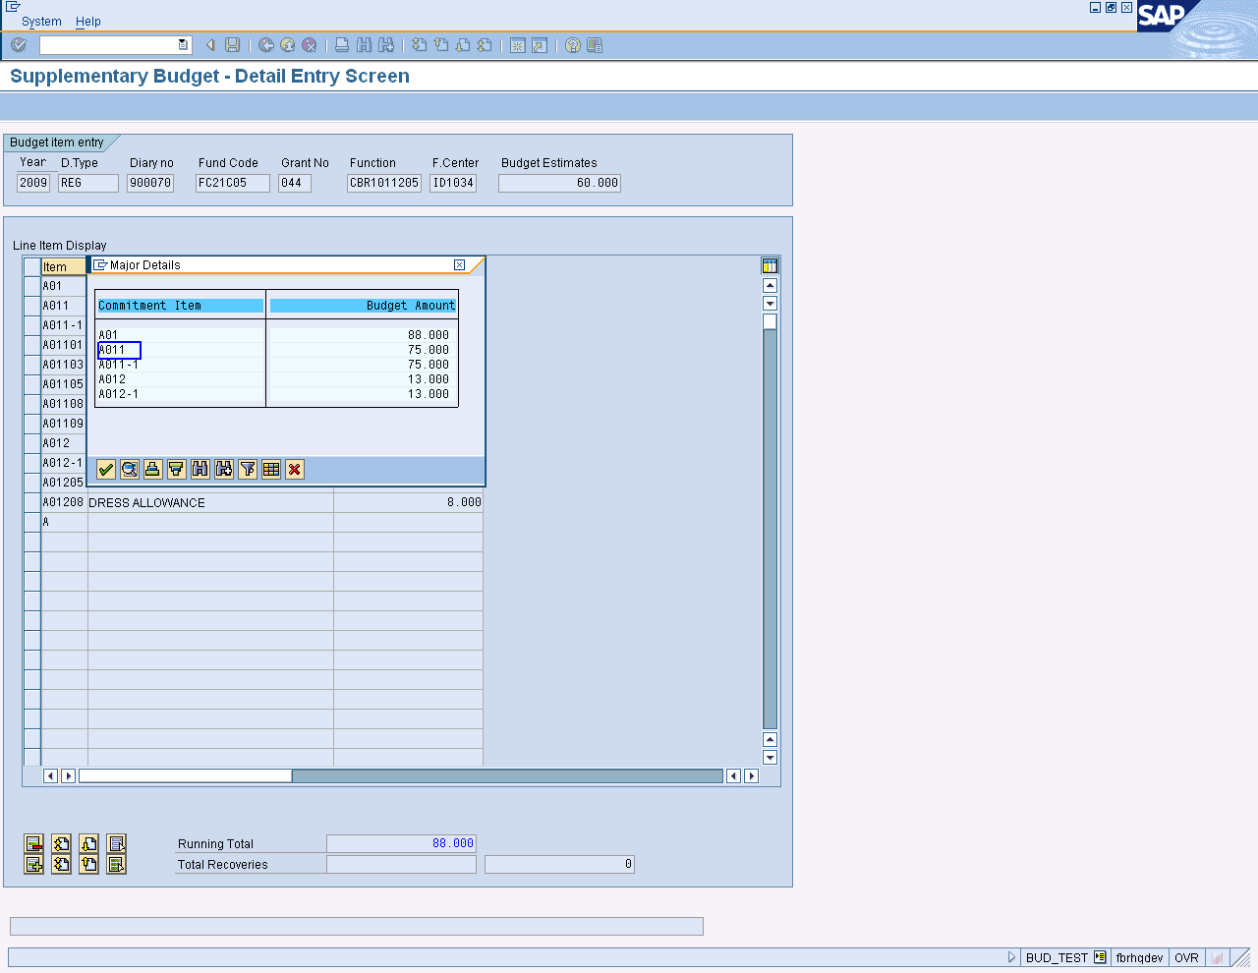
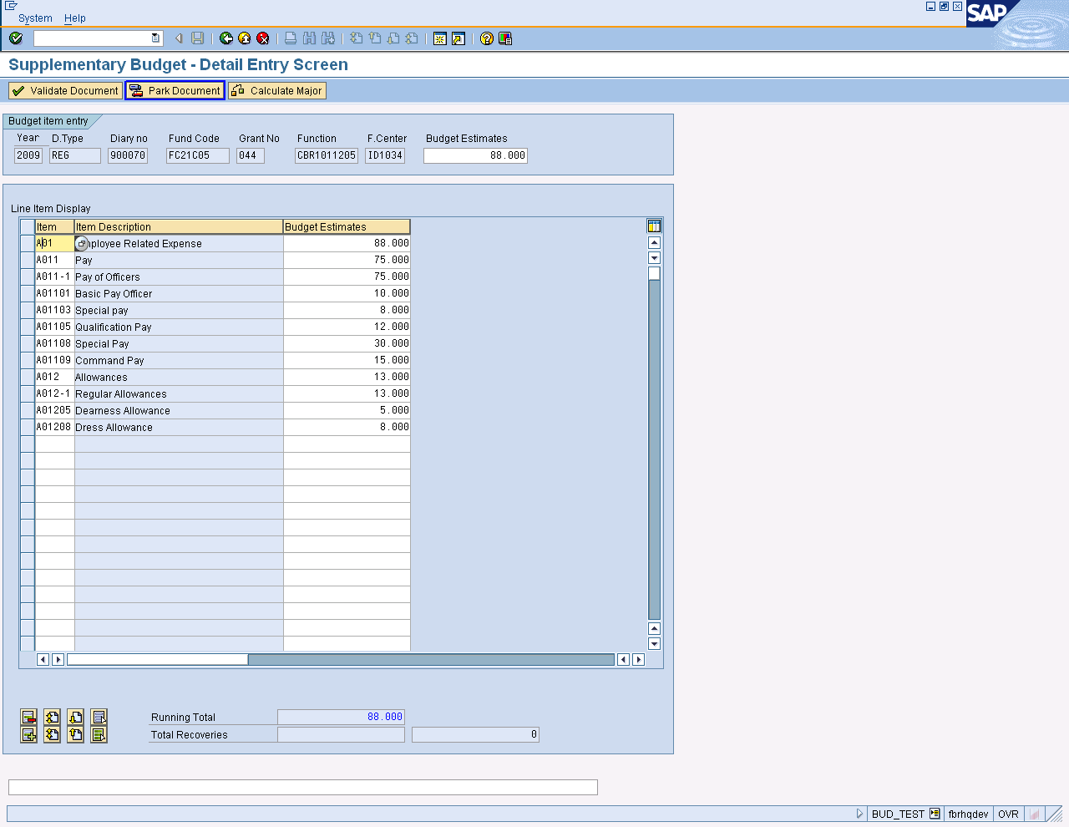

Press button after changing.
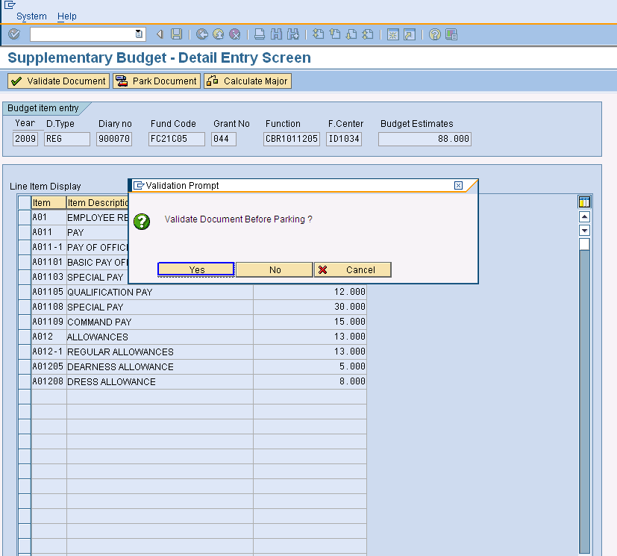
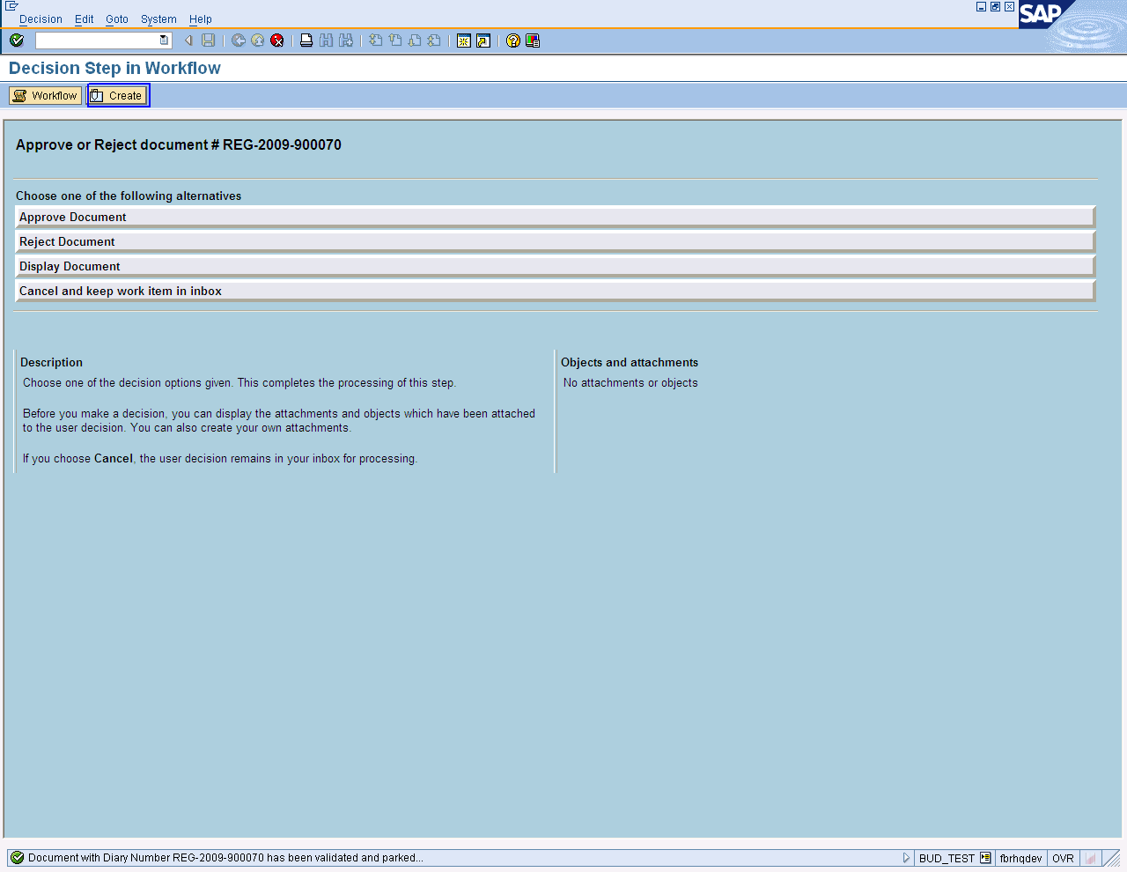

Press Create Button To Add Objects and Attachments.

Create Document header screen open.

- Select Document type
- Enter tile of document
- Click on import Button give path for saving
- Press enter or to run the transaction.

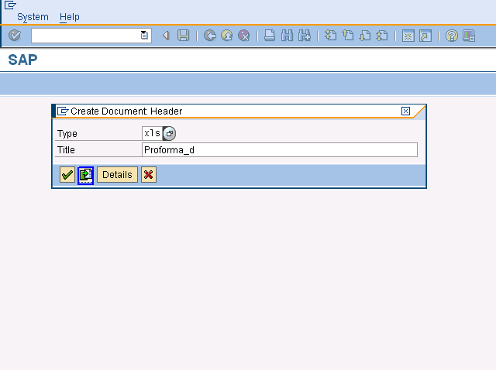
Click on Import Button

- Attachment added to work item message received.
- Click on “Approve Document” tag.

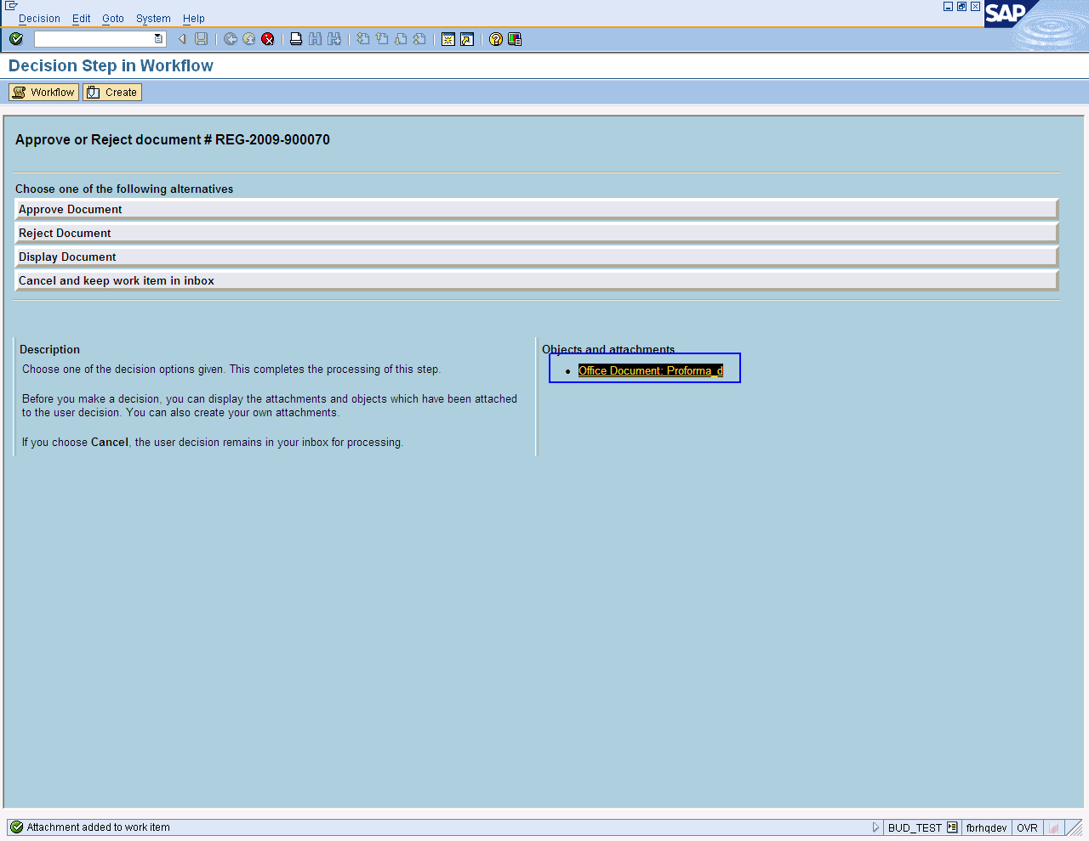

On screen “Display Step in Workflow” click the approve Document option.

Press Button to Exit

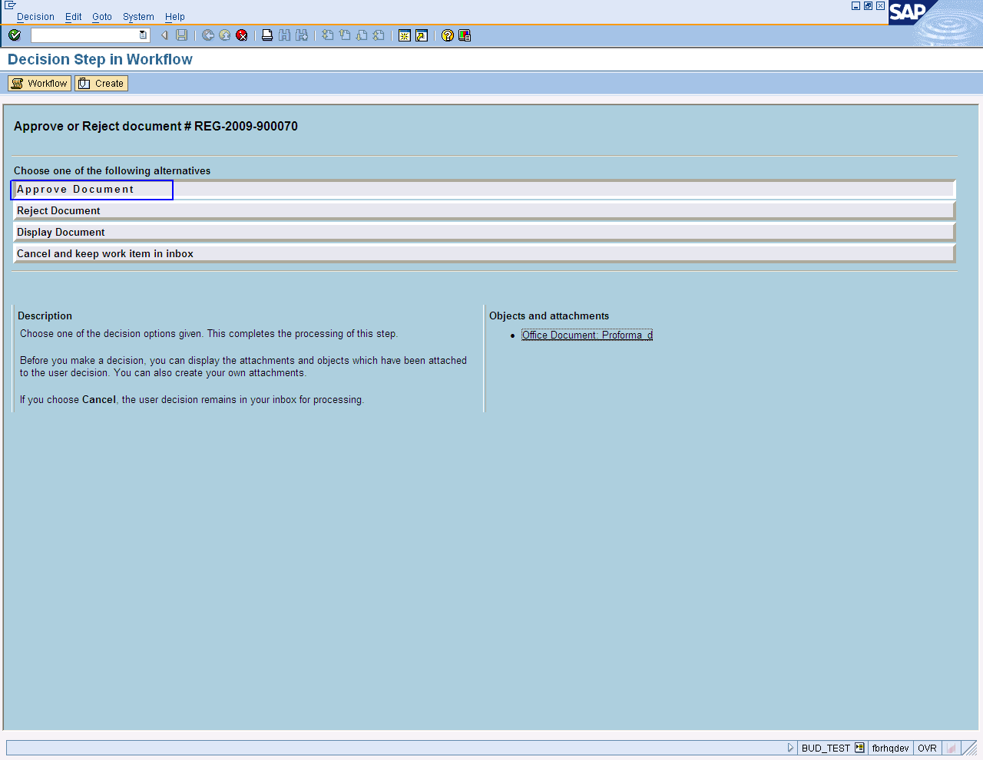

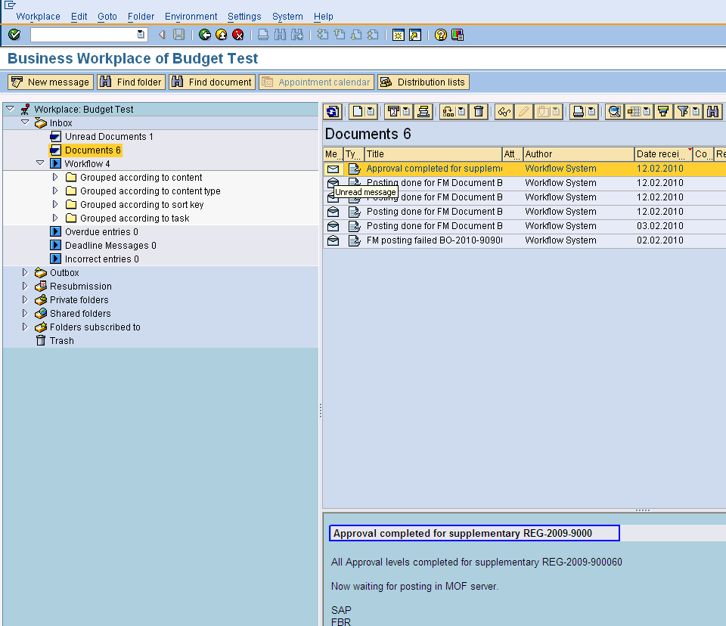
Approval done Message

Budget Approval/change in Budget (DFA/FA Authority)

User Path

SAP➢Workplace icon➢Workplace: Budget Test➢ Inbox ➢ Workflow

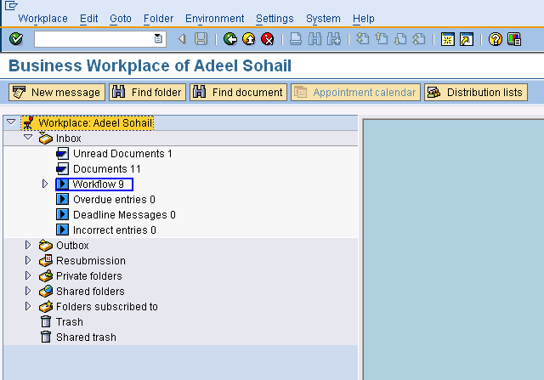

Click on workflow 9
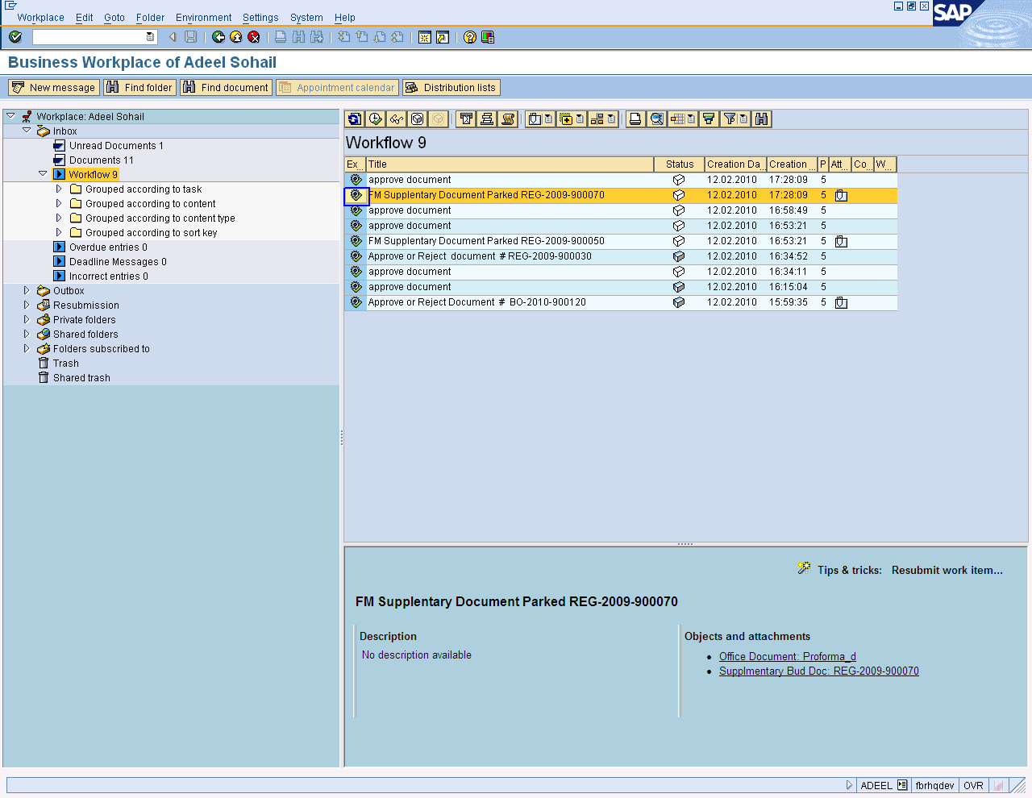
Select Document
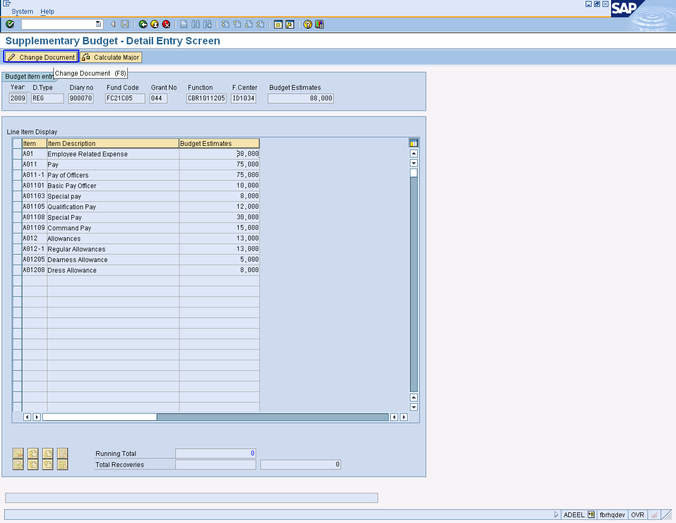
Click on Change Document

If user wants to change in budget then before approve it, he can change it. Like as

- Change any entry which you want
- Check total of budget estimates values
- Calculate major
- Press Park Document Button
- Changes will be saved

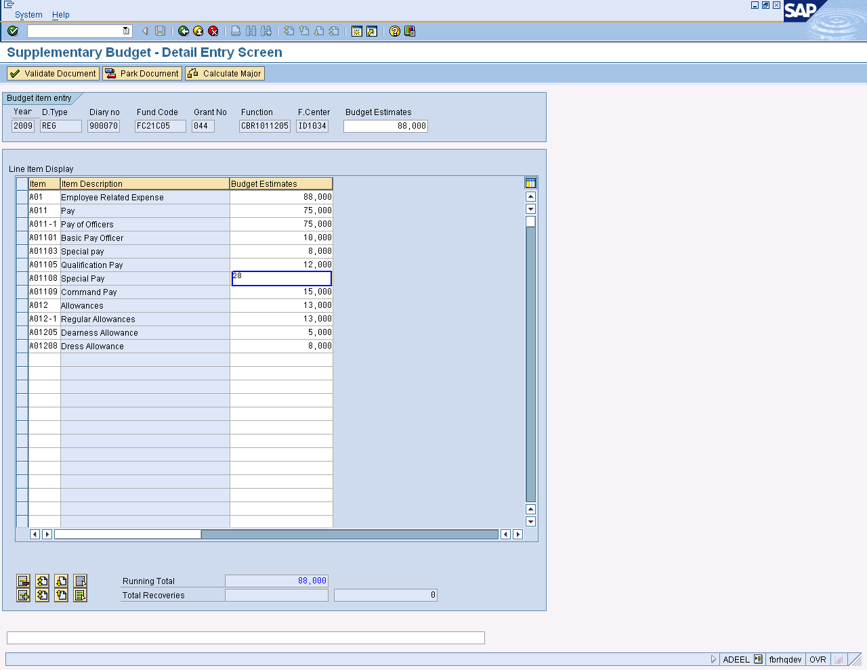
Changing fields

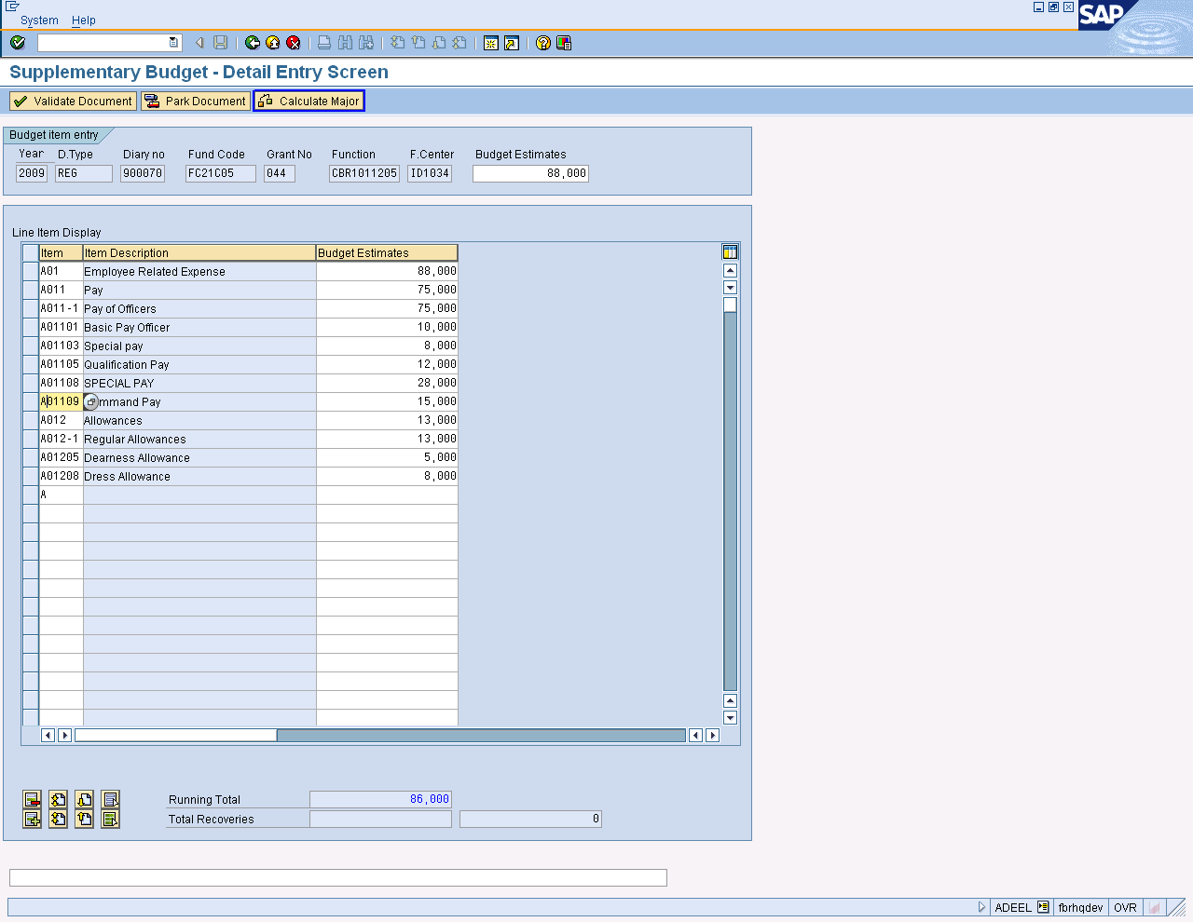

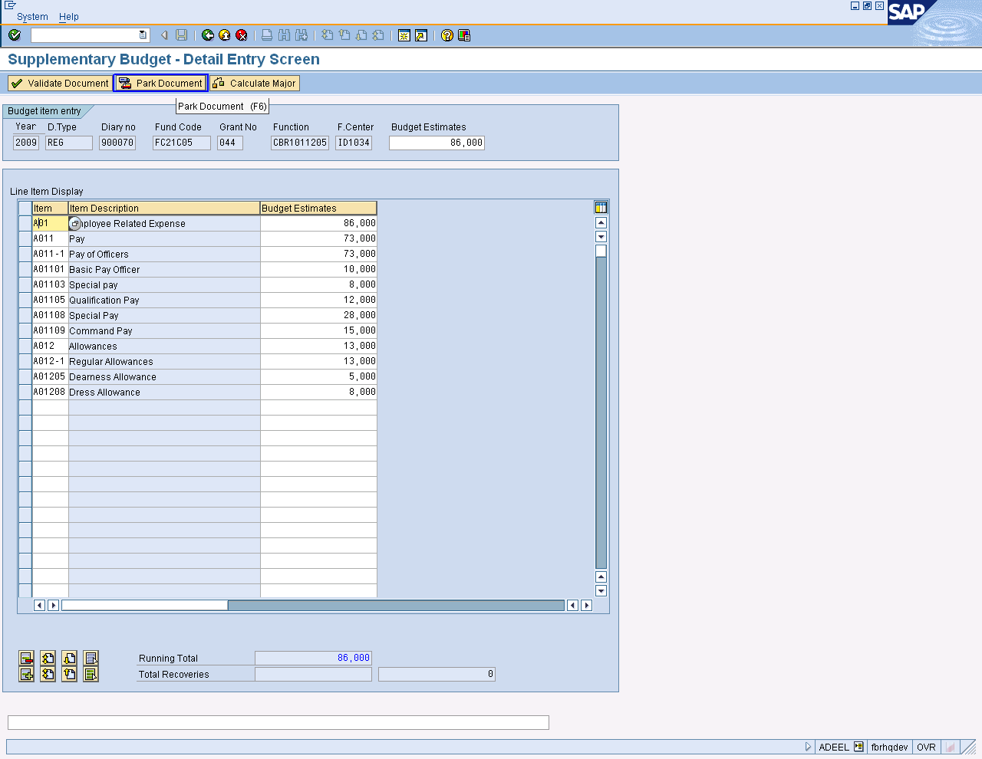
Park document

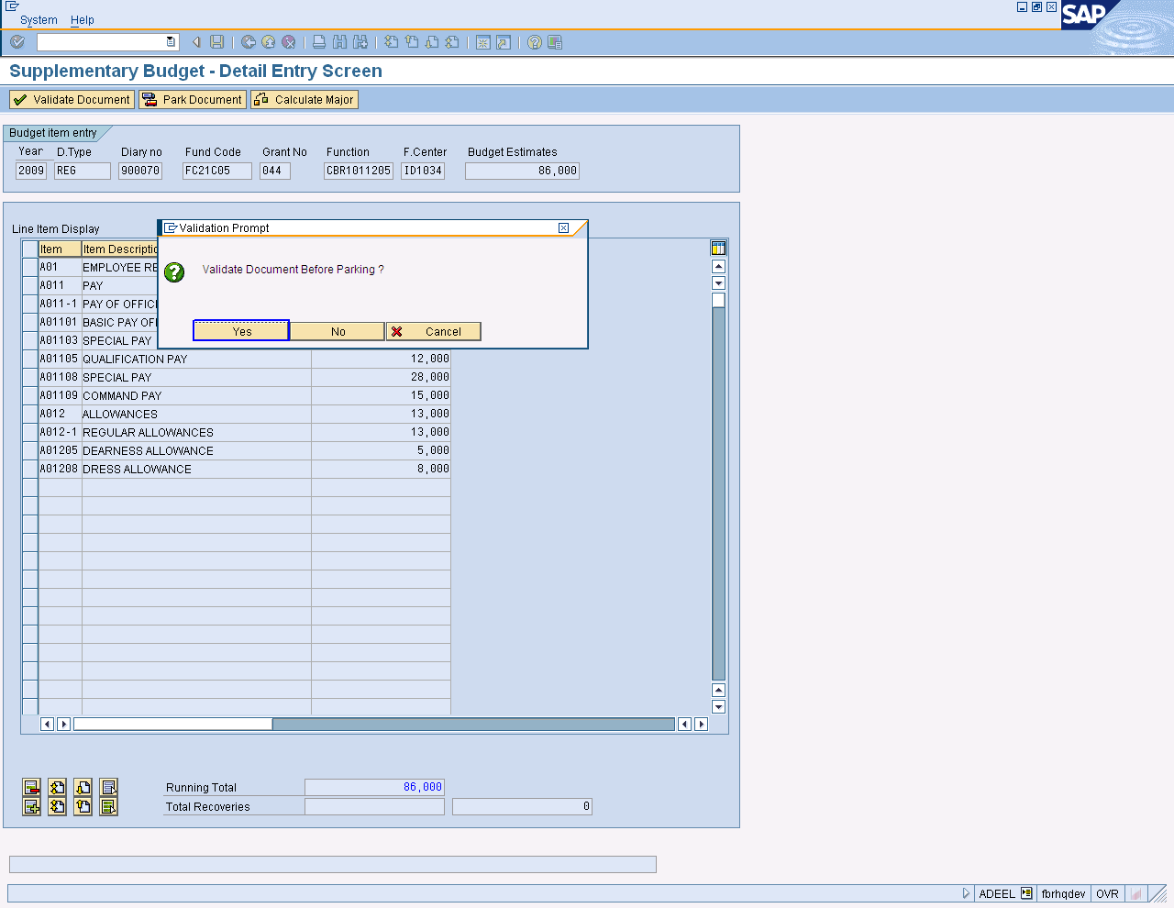
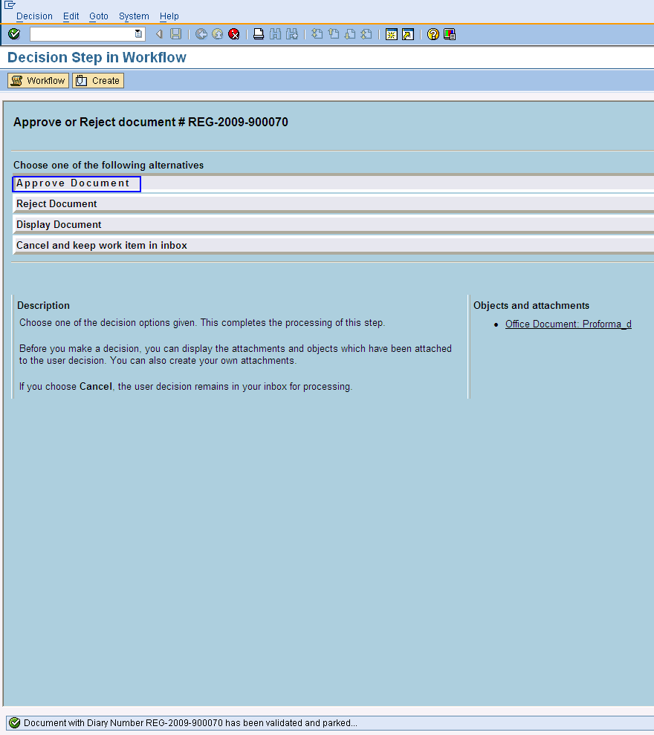

Document is parked

On screen “Display Step in Workflow” click the approve Document option.

Press Button to Exit

. 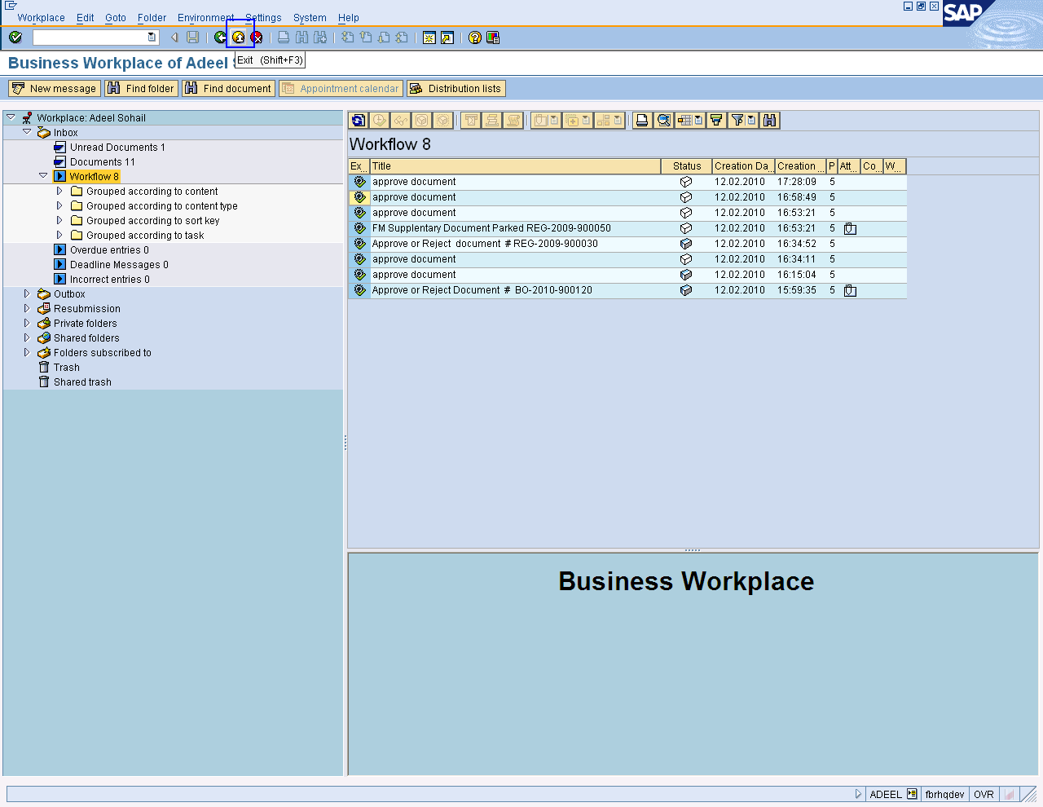

After approving data document will be sent to MOF/AGPR/Sub Offices

End of Transaction

Budgeting: Entry Document

Release Budget

Using the same command and steps which are mentioned above, go to budget workbench: Create document screen and enter information for release budget.

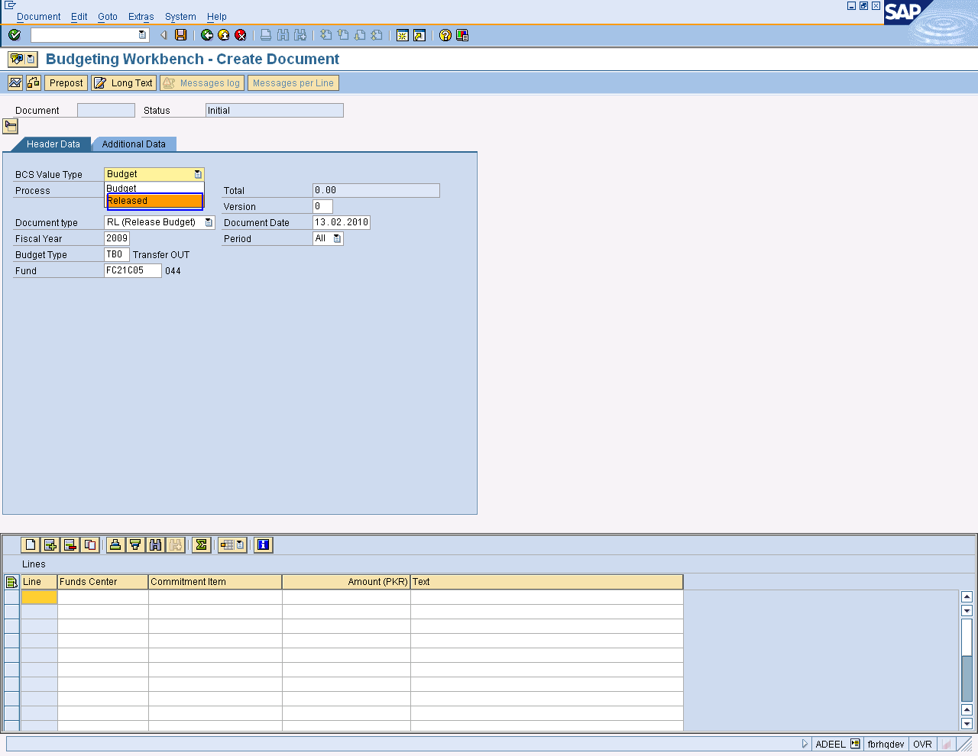

- Select “Released” as BCS value Type.
- Select “RL (Released Budget)” as Document Type
- Select “RELE” as Budget type.

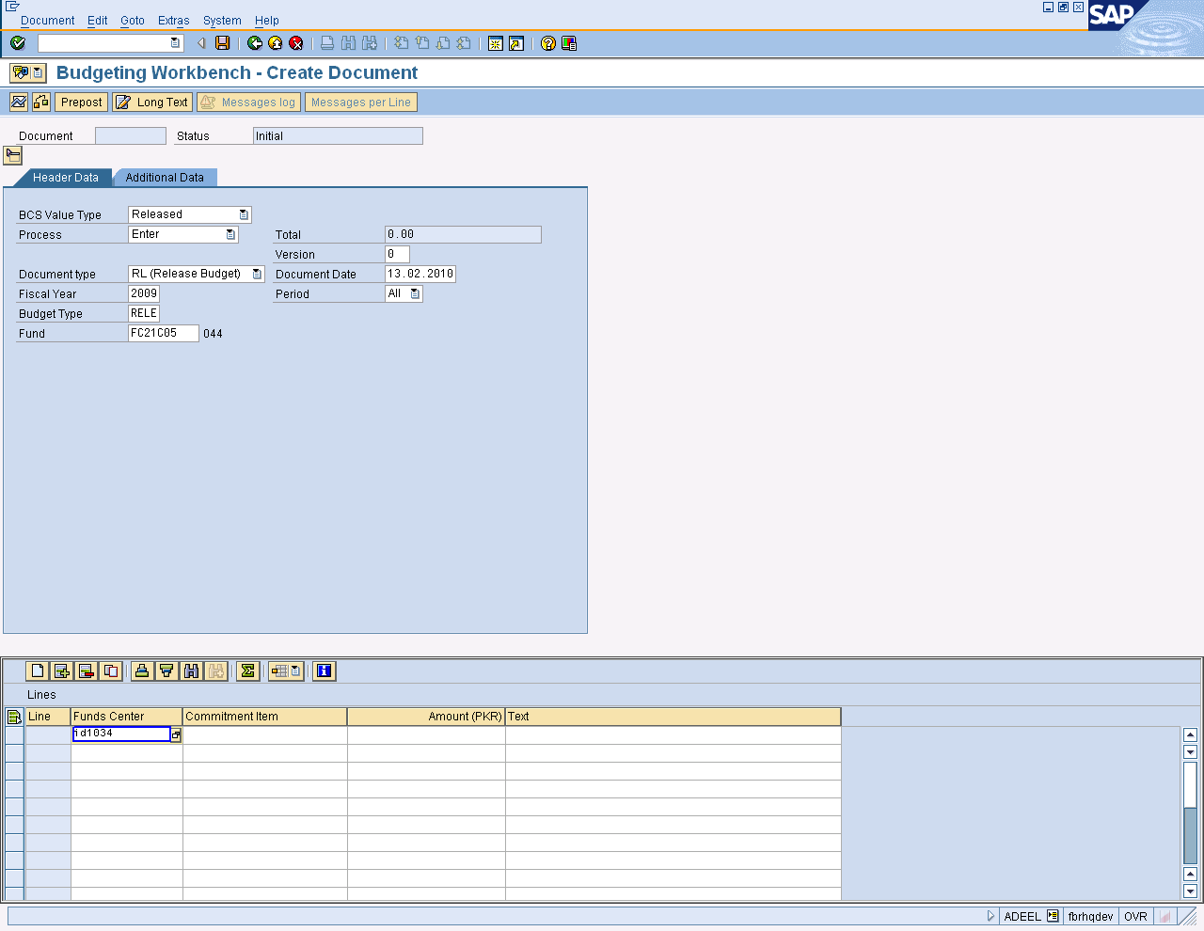
Required inputs for release budget

Enter Fund center, commitment item and amount for release budget.

Press button to save the task.

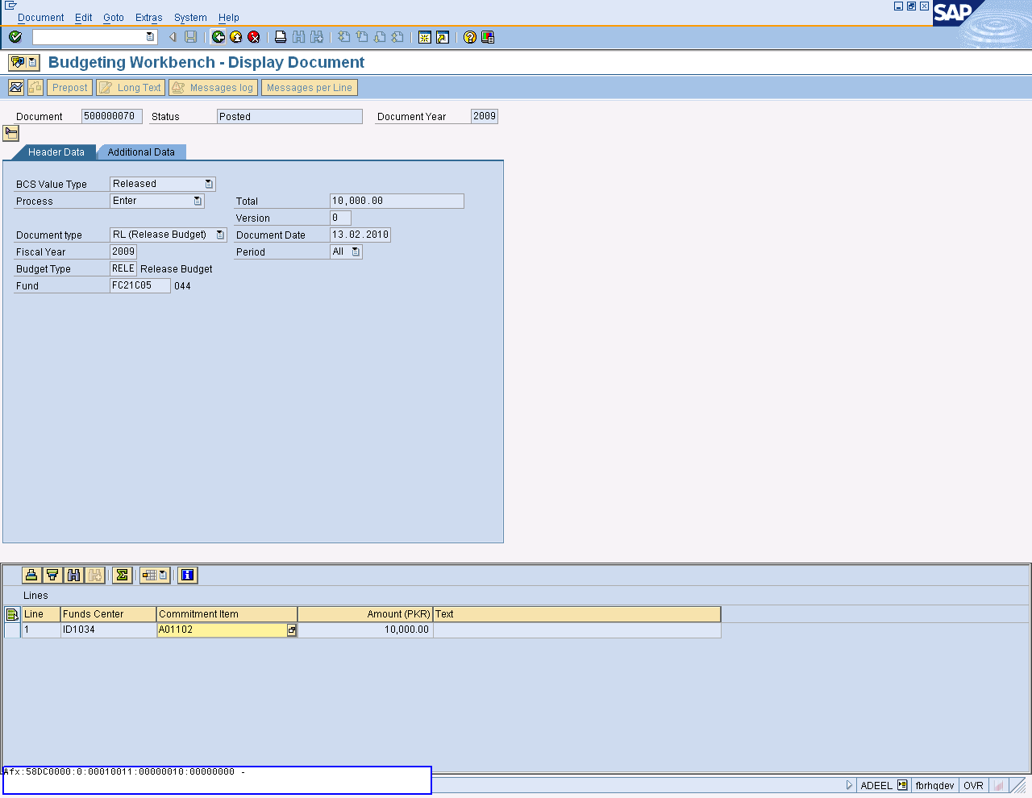

Document is created as for Release budget in FBR code.

Press Button to Exit.

RE-APPROPRIATION/ TRANSFER BUDGET

Enter Transaction Code FMBBC in Command Field or navigate through tree menu.
Via Transaction Code | FMBBC
Menu | Accounting➢Public Sector Management➢Fund Management➢Budgeting➢Budgeting Control System➢Entry Documents➢Create

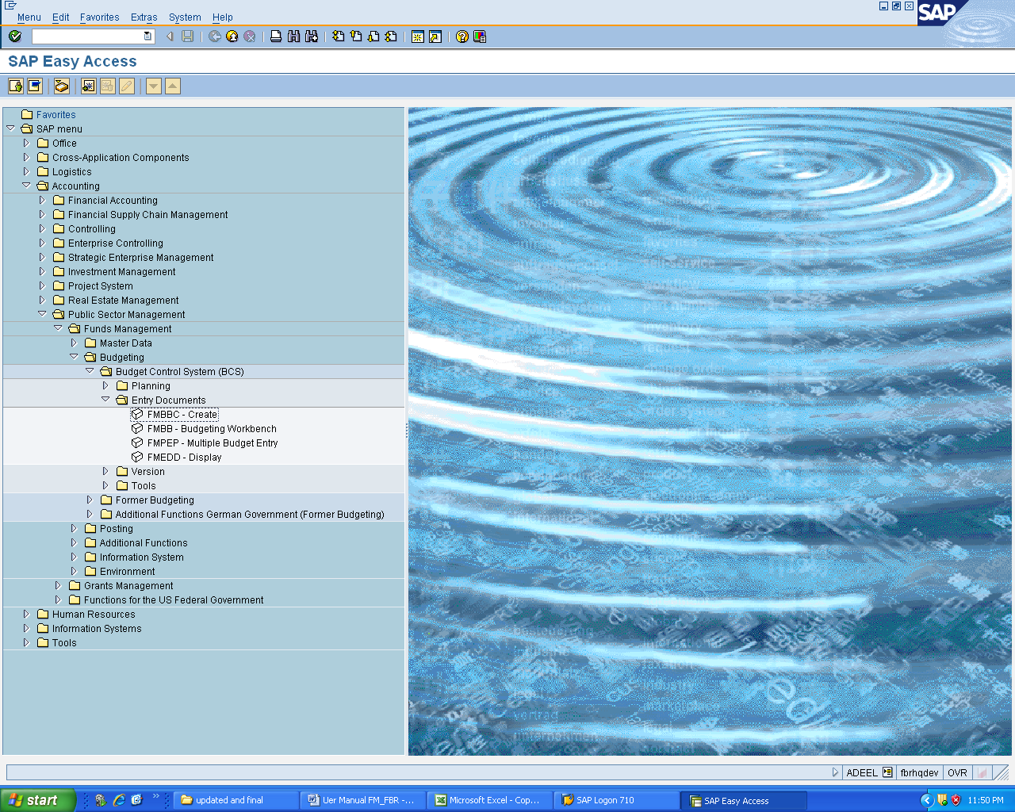
On sap screen, enter Layout variant or copy it from copy menu, default layout selected and press enter.

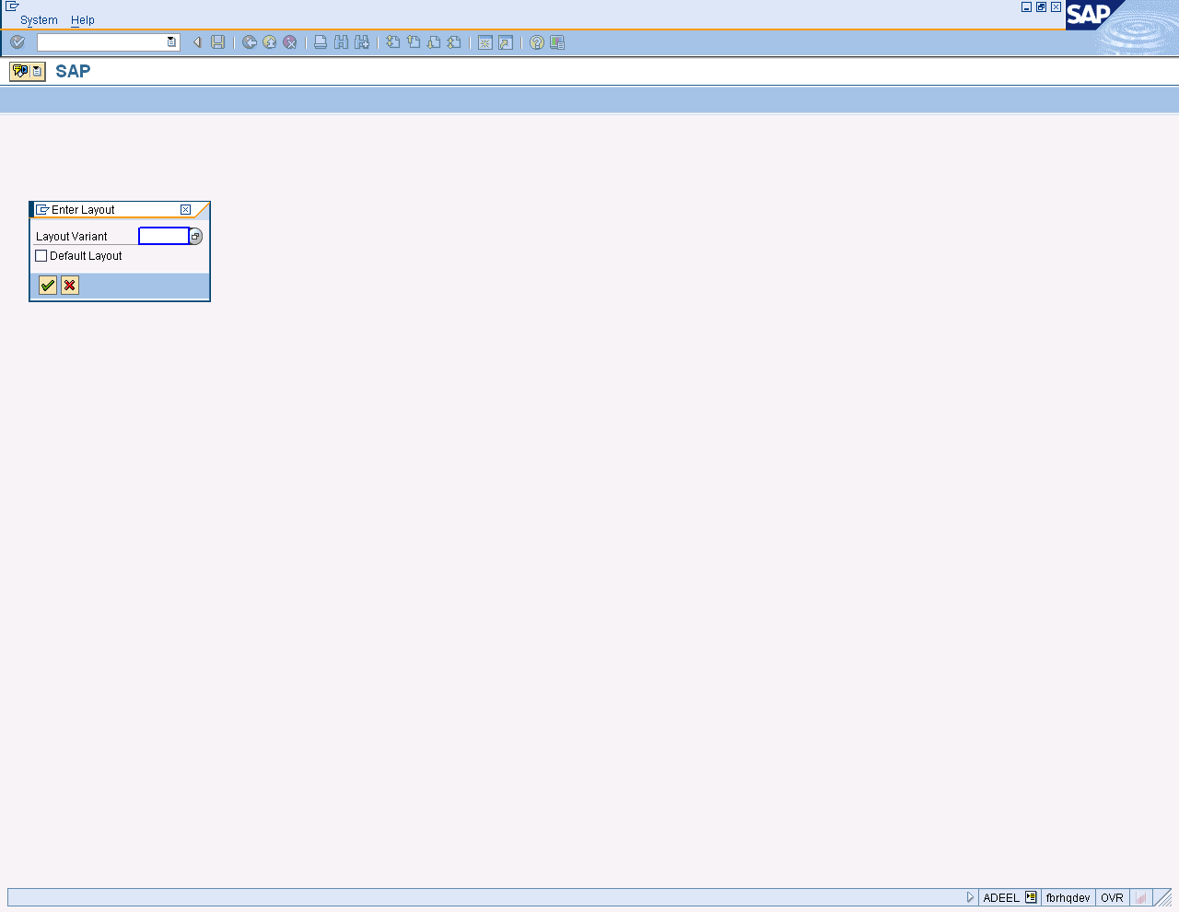
Click Copy Icon

Copying step is shown below on the screen.

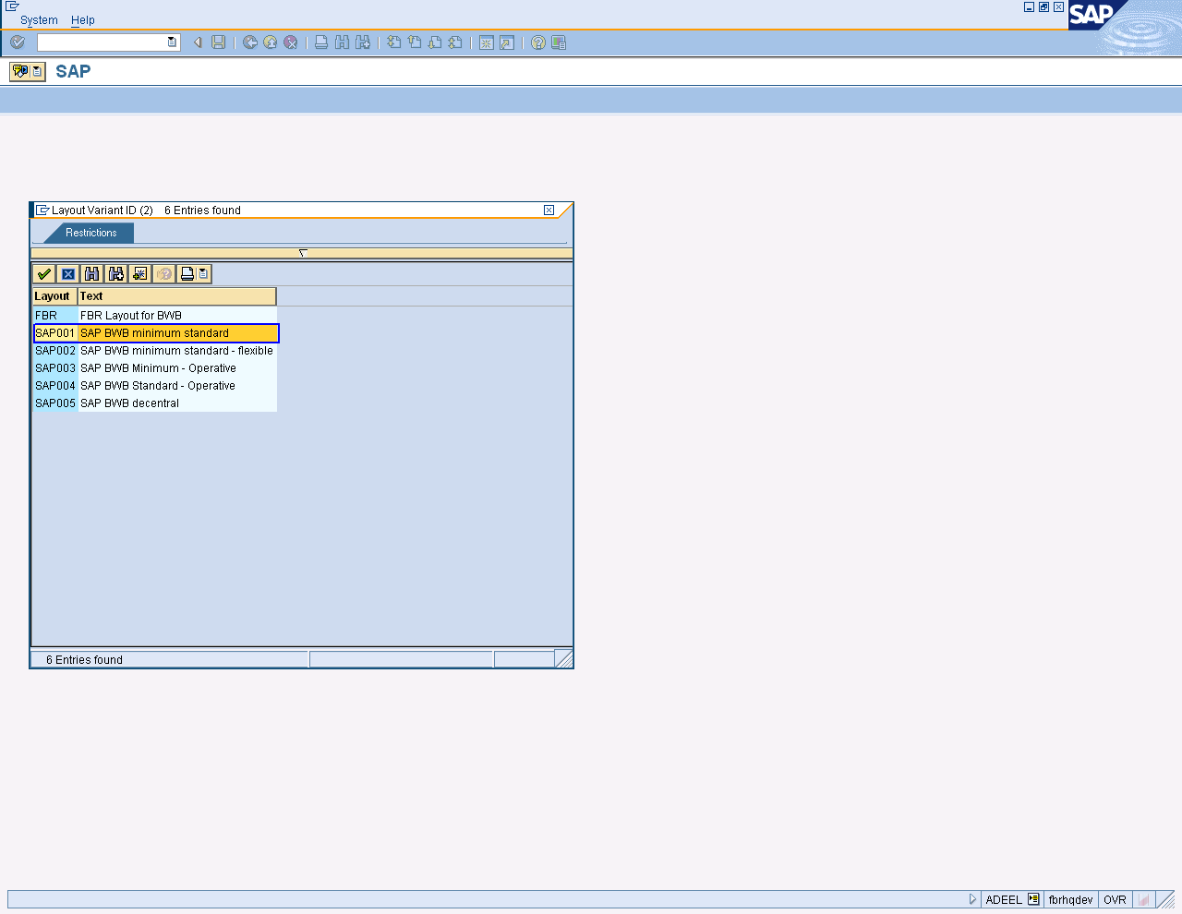

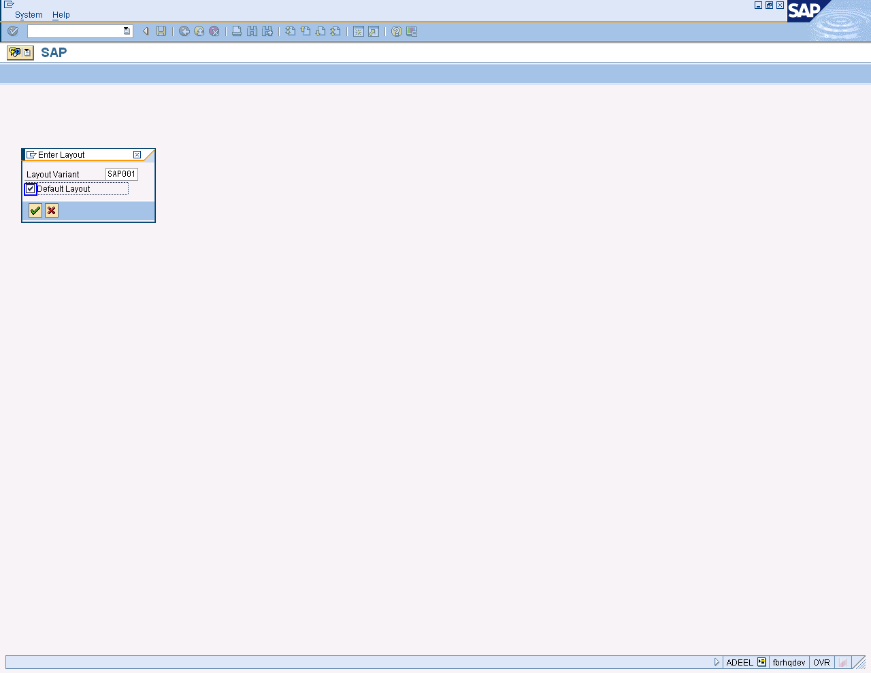

Press enter or to run the transaction.

On screen Budgeting workbench: Create Document”, enter the information in the field which are specified below table.

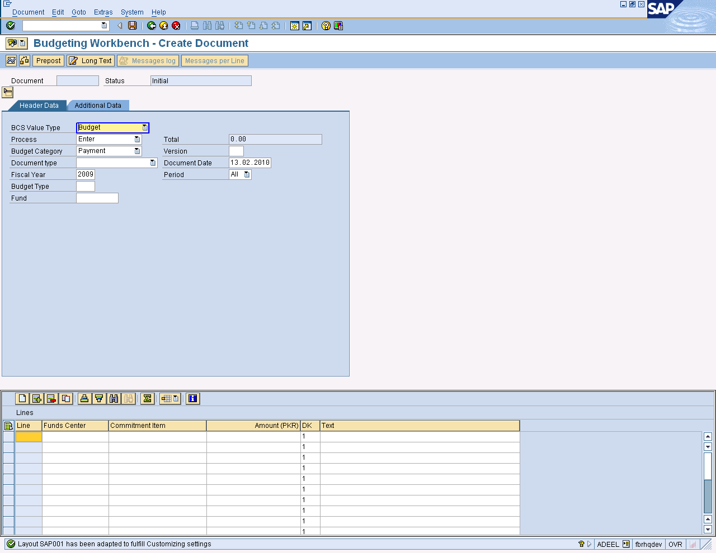

User Input:

SAP Required Fields | User Inputs Required
BCS Value Type | Select “Budget” from list
Process | Select “Transfer” From List
Budget Category | Select “Payment” From List as Budget category
Document Type | Select “TB-Transfer Budget” From List as type
Sender  Fiscal Year | Enter year
Budget Type | Enter budget type or copy from list
Fund | Enter fund for sender
Receiver
Fiscal Year | Enter year for budget
Budget Type | Enter budget type or copy from list
Fund | Enter fund for receiver

Press enter or click on list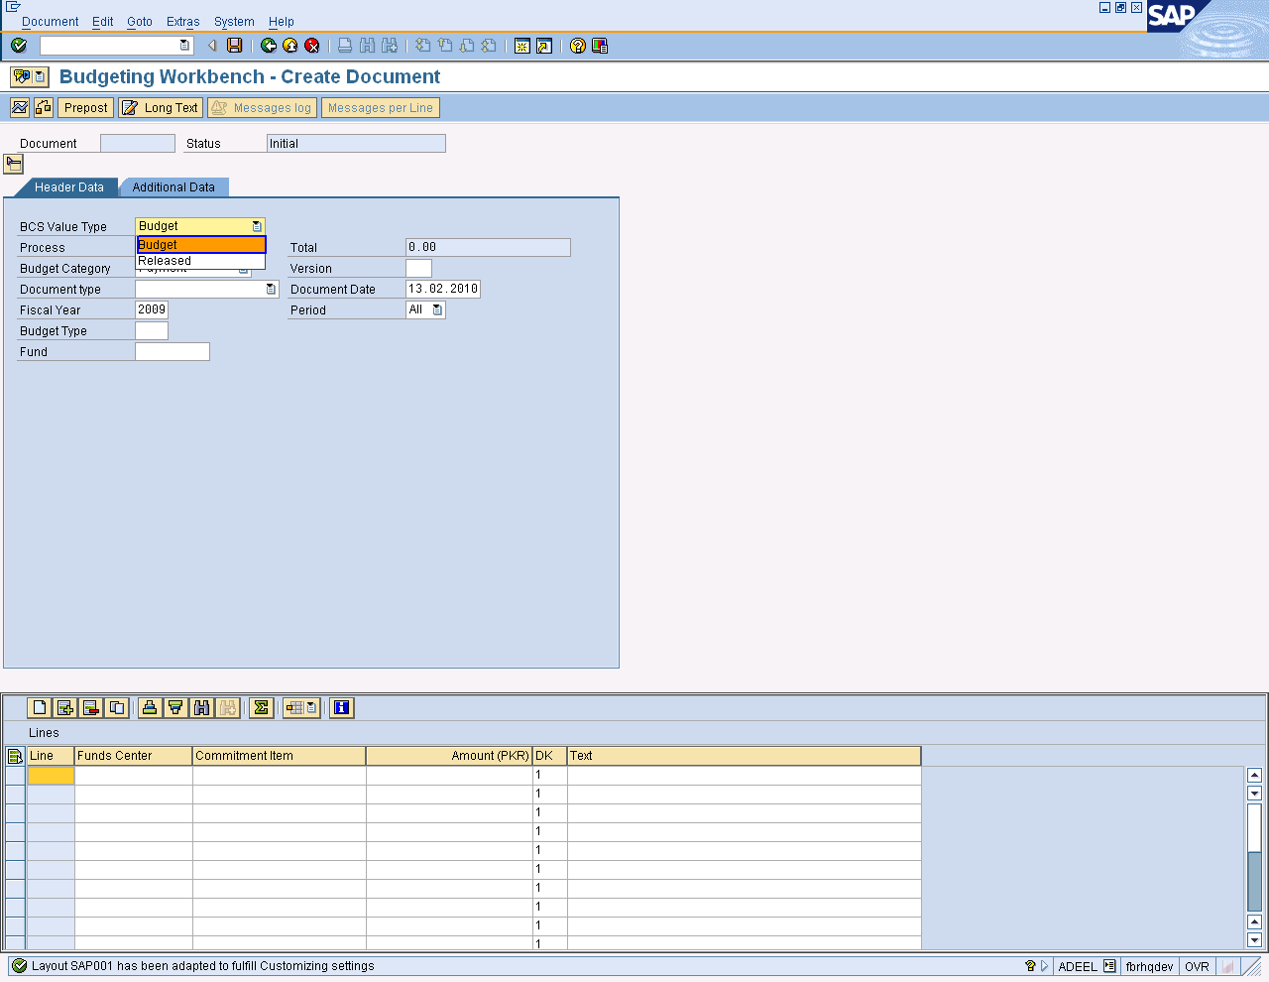 .A drill down list will be open and select required option. Transfer Budget is selected from list that is shown below on the screen.

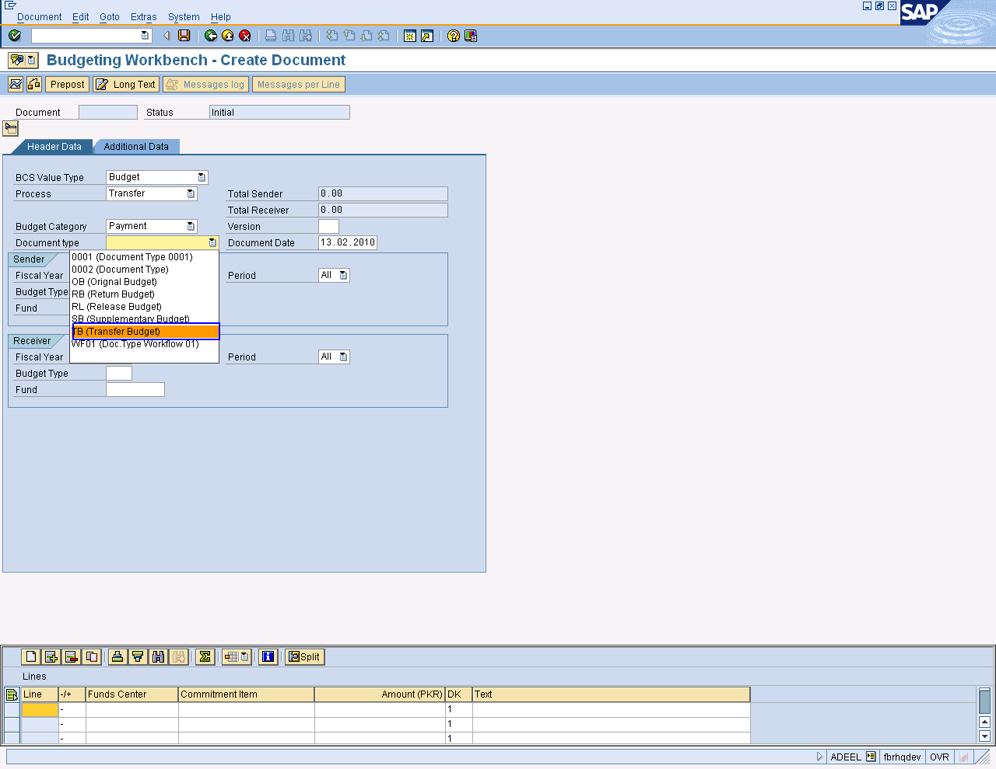

Press enter and Putting values which shown below.

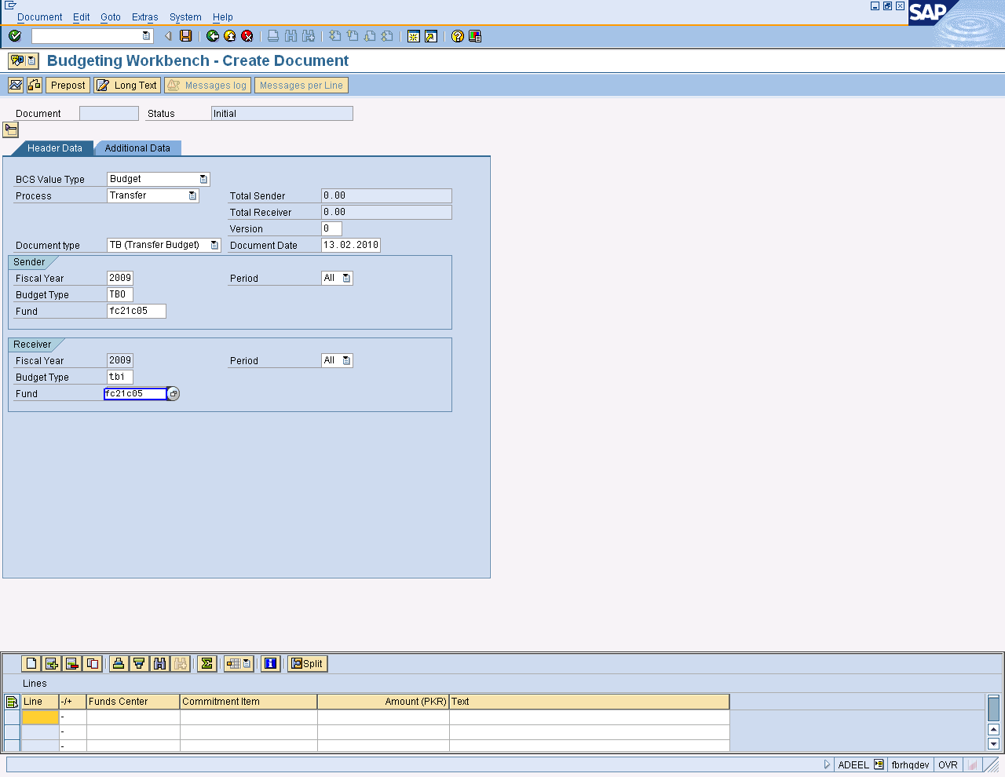

No sender Line/ receiver line message come. It will confirm from user to allow automatic then press enter and allow it.

Lines are automatic generated. Enter funds center, commitment item and amount.

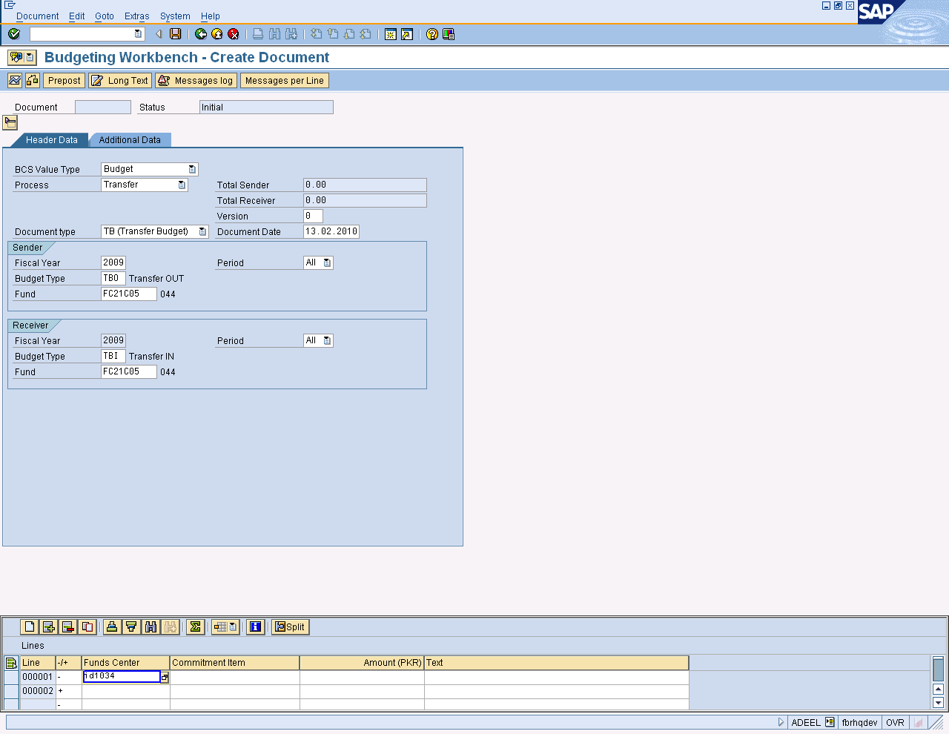
Sender and Receiver Lines

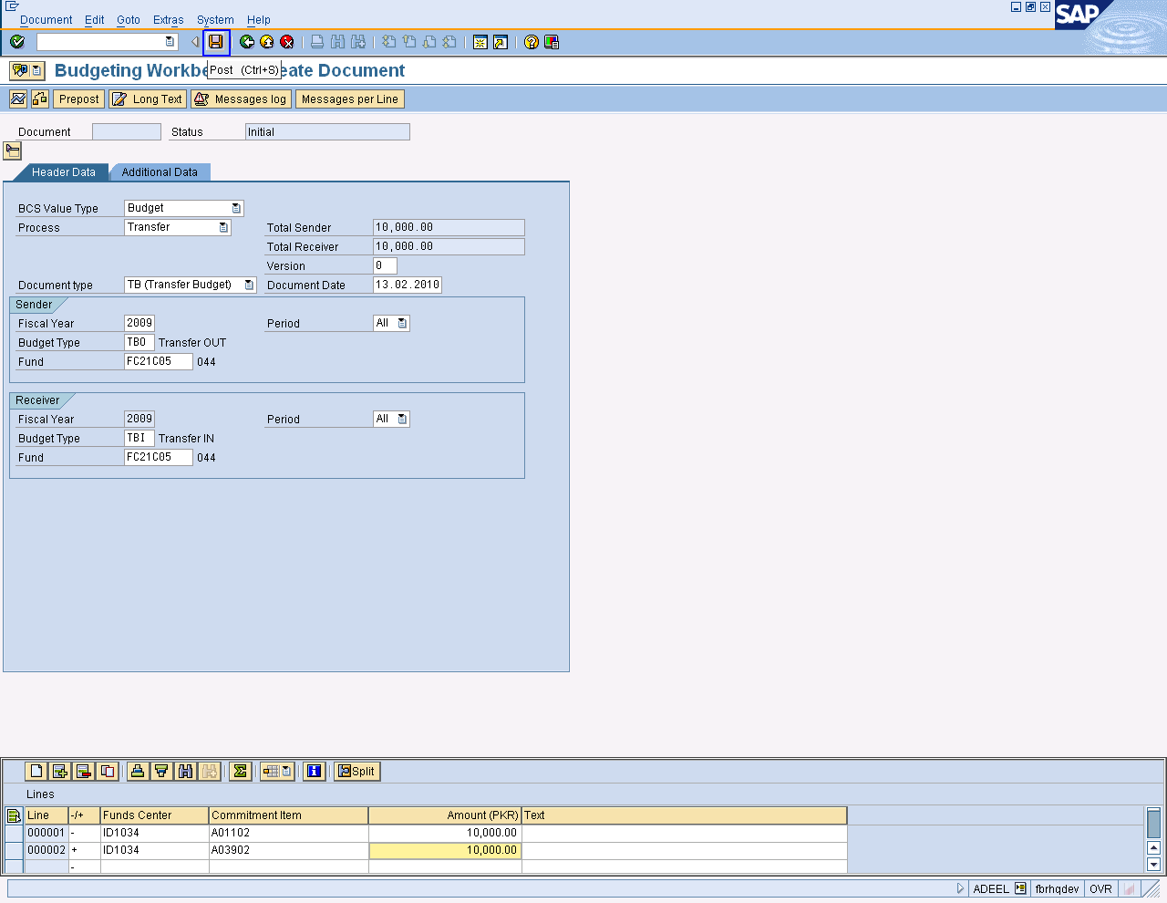

Press button to save the task.

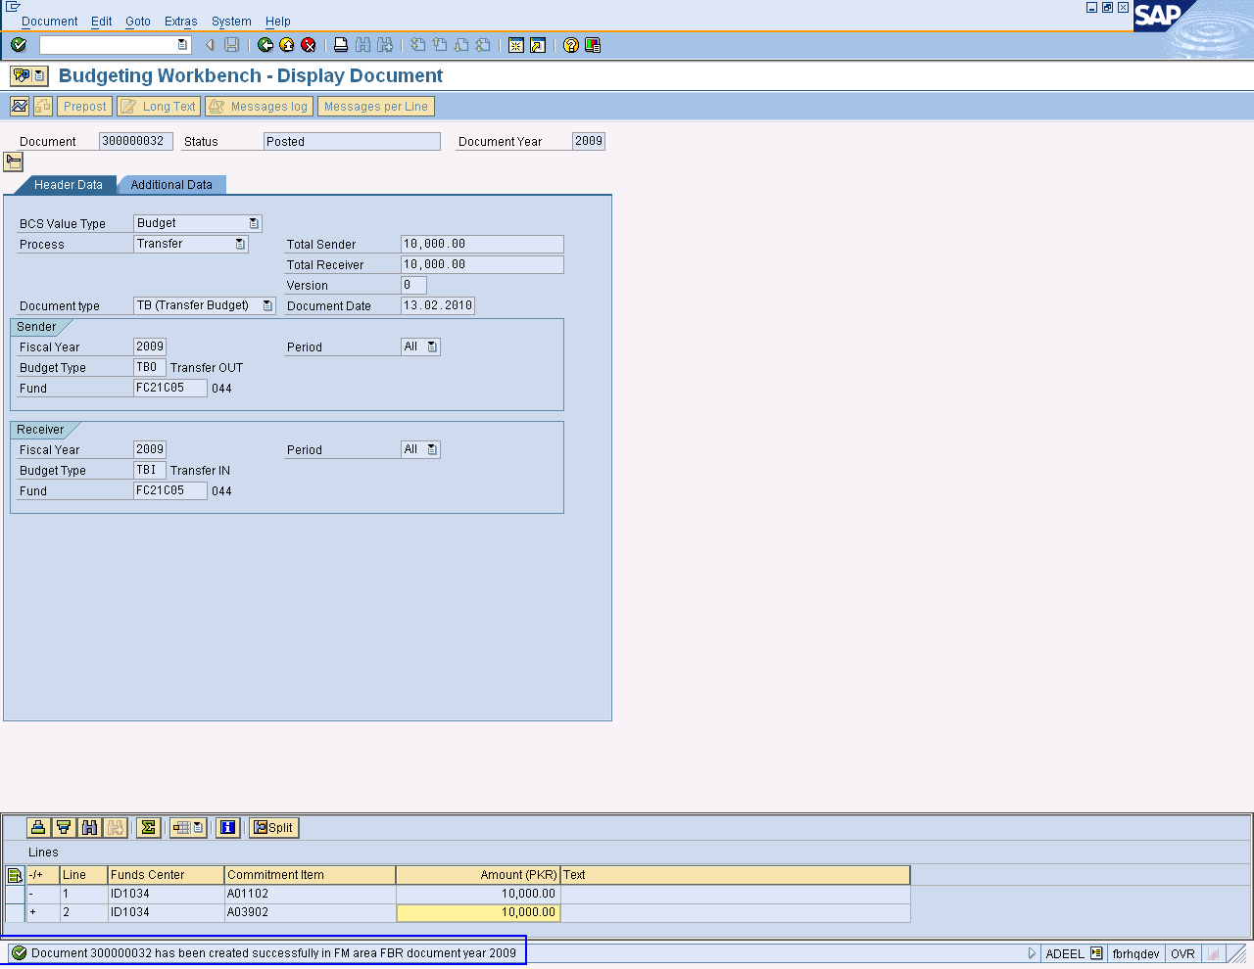

Document has been created. Note its number

Press button to Exit

Surrender/Return Budget

Using the same command and steps which are mentioned above, go to budget workbench: Create document screen and enter information for Return budget.

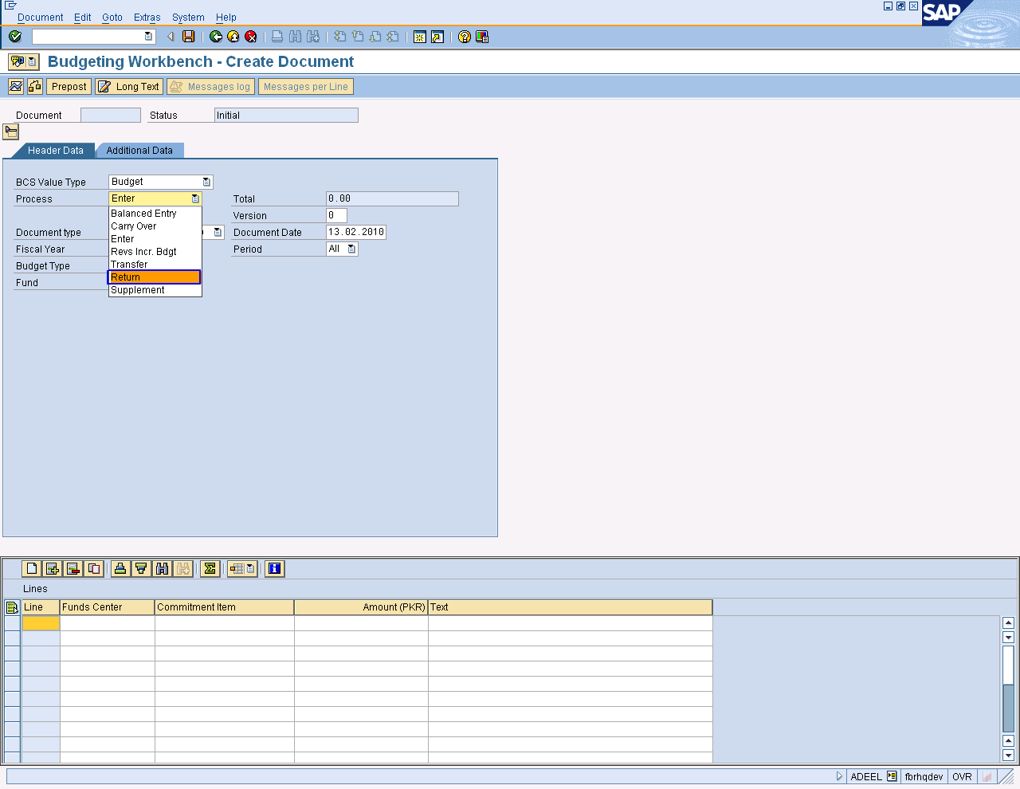

- Select “Return” as BCS value Type.
- Select “RB (Return Budget) Document Type
- Select “RTN” as Budget type.

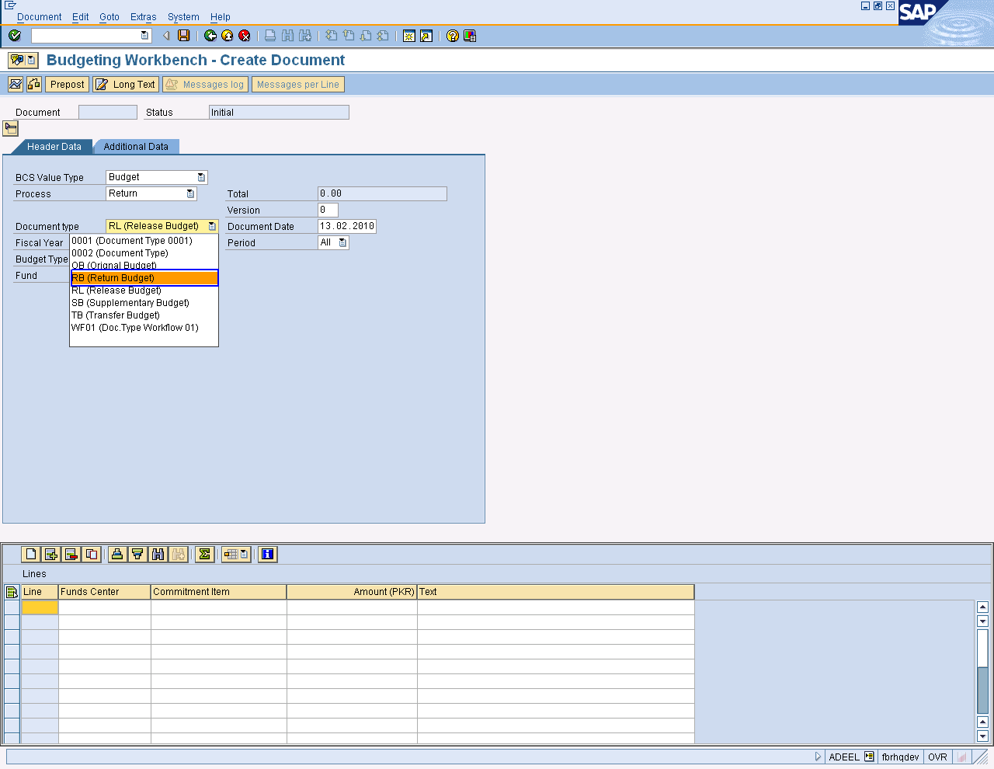

Enter Fund center, commitment item and amount for release budget.

Press button to save the task.

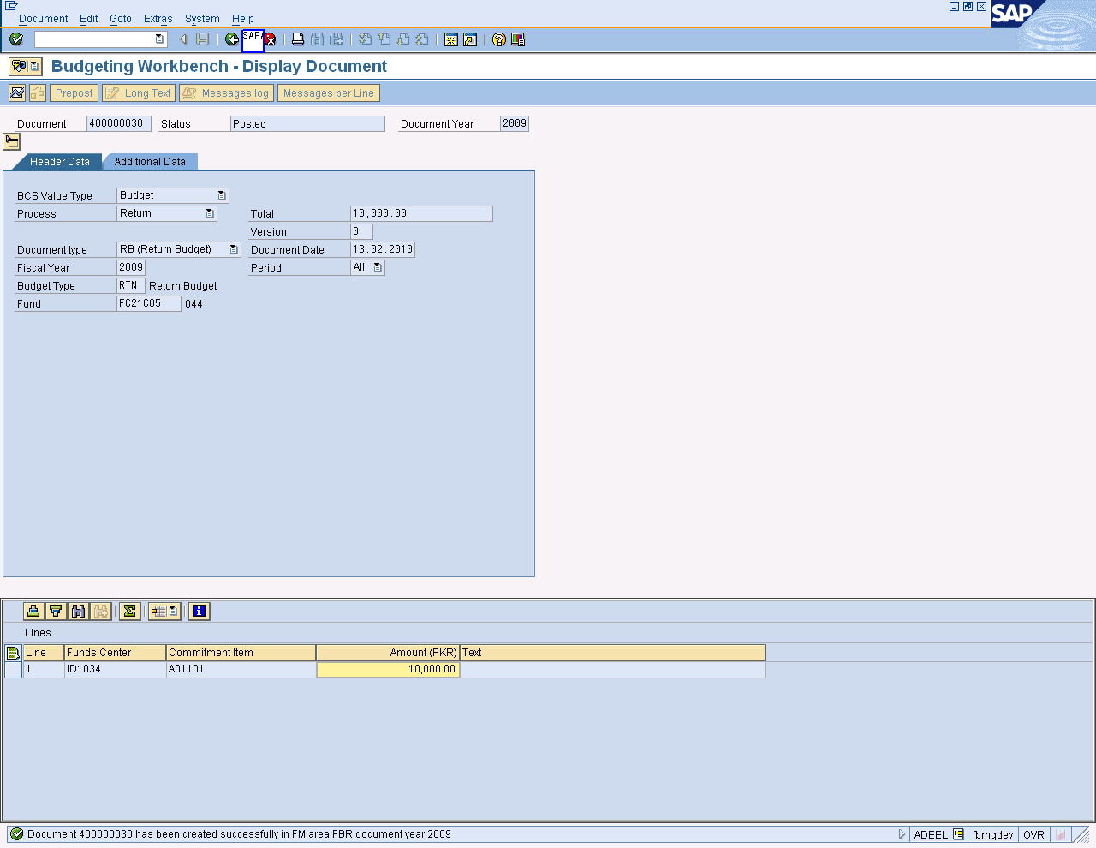

Document has been created as for Return budget in FBR code.

Press Button to Exit.

